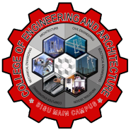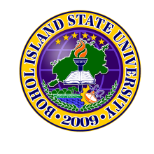Republic of the Philippines

BOHOL ISLAND STATE UNIVERSITY

MAIN CAMPUS

COLLEGE OF ENGINEERING AND ARCHITECTURE

Tel: 038-4113289 Telefax: 038-5017516

6300 Tagbilaran City

*Vision: A premiere S&T university for the formation of world class and virtuous human resource for sustainable development in Bohol and the Country.*

*Mission: BISU is committed to provide quality higher education in the arts and sciences, as well as in the professional and technological fields: undertake research and development, and extension services for the sustainable development of Bohol and the country.*

**Name**: Marijun Apalisok **Subject**: CpE 422

Angelou Kates Ganados **Instructor**: Engr. Max Angelo Perin

Bradley Anoba

Ma. Lyka Lood

Celmar John Ortiz

**Yr/Sec**: BSCPE 4

**Problem: Valid Statement**

Note: Expr is only available to + and -.

**DFA:**

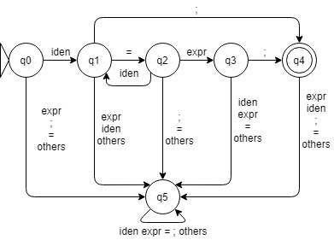

Works:

Ma. Lyka Lood - GUI & React.js

Bradley Anoba – GUI & React.js

Marijun Apalisok – Code Javascript

Celmar Ortiz - Code Javascript

Angelou Kates Ganados - Code Javascript