Republic of the Philippines

**BOHOL ISLAND STATE UNIVERSITY**

**MAIN CAMPUS**

**COLLEGE OF ENGINEERING AND ARCHITECTURE**

Tel: 038-4113289 Telefax: 038-5017516

6300 Tagbilaran City

*Vision: A premiere S&T university for the formation of world class and virtuous human resource for sustainable development in Bohol and the Country.*

*Mission: BISU is committed to provide quality higher education in the arts and sciences, as well as in the professional and technological fields: undertake research and development, and extension services for the sustainable development of Bohol and the country.*

NAME: RENZO A. BELDEROL SUBJECT: CpE 412

YR/SEC: BSCPE 4 INSTRUCTOR: ENGR. MAX ANGELO PERIN

ID NO.: 527106

**PROGRAMMING ASSIGNMENT #0-M**

d. L= {w ϵ {a,b}* | every **a** in w is immediately followed by **bbb**}

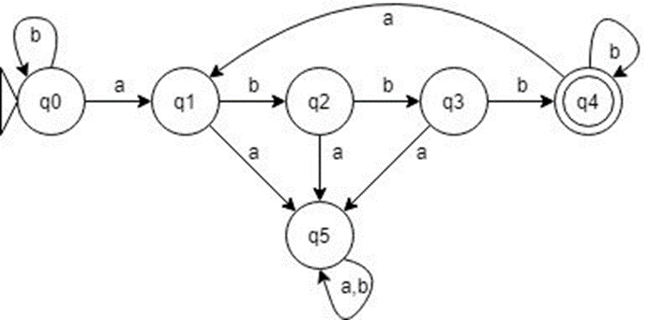

|  |  |  |
| --- | --- | --- |
|  | A | B |
| 0 | 1 | 0 |
| 1 | 5 | 2 |
| 2 | 5 | 3 |
| 3 | 5 | 4 |
| 4 | 1 | 4 |
| 5 | 5 | 5 |

L={ {q0,q1,q2,q3,q4,q5},{a,b}, δ,q0,{q5} }

**CODE:**

#include<iostream>

#include<cstring>

using namespace std;

int main(){

char str[100];

int j,count=0,count1;

cout<<"Enter String: ";

cin>>str;

for(j=0;j<strlen(str);j++){

if(str[j]=='a'){

if(str[j+1]=='b'&&str[j+2]=='b'&&str[j+3]=='b'){

count1++;

}

else{

cout<<"Invalid";

count++;

break;

}

}

if(str[j]!='a'&&str[j]!='b'){

cout<<"Invalid";

count++;

break;

}

}

if(count1>0&&count==0){

cout<<"Accepted";

}

return 0;

}