Republic of the Philippines

BOHOL ISLAND STATE UNIVERSITY

MAIN CAMPUS

COLLEGE OF ENGINEERING AND ARCHITECTURE

Tel: 038-4113289 Telefax: 038-5017516

6300 Tagbilaran City

*Vision: A premiere S&T university for the formation of world class and virtuous human resource for sustainable development in Bohol and the Country.*

*Mission: BISU is committed to provide quality higher education in the arts and sciences, as well as in the professional and technological fields: undertake research and development, and extension services for the sustainable development of Bohol and the country.*

**Name**: Kyarra B. Cinconiegue **Subject**: CpE 412

**Yr/Sec**: BSCPE 4A **Instructor**: Engr. Max Angelo Perin

ID NO.: 748956

**MIDTERM**

**Problem: Valid Statement**

1. L = accept simple number

Q= { 0,1,2}

∑= {digits, . , others}

Q0= 0

F= { 0, 2}

**Transition Table**

|  |  |  |  |
| --- | --- | --- | --- |
| **Q** | **digit** | **.** | **others** |
| **0** | **1** | **4** | **4** |
| **1** | **1** | **2** | **4** |
| **2** | **3** | **4** | **4** |
| **3** | **3** | **4** | **4** |
| **4** | **4** | **4** | **4** |

**Transition Diagram**

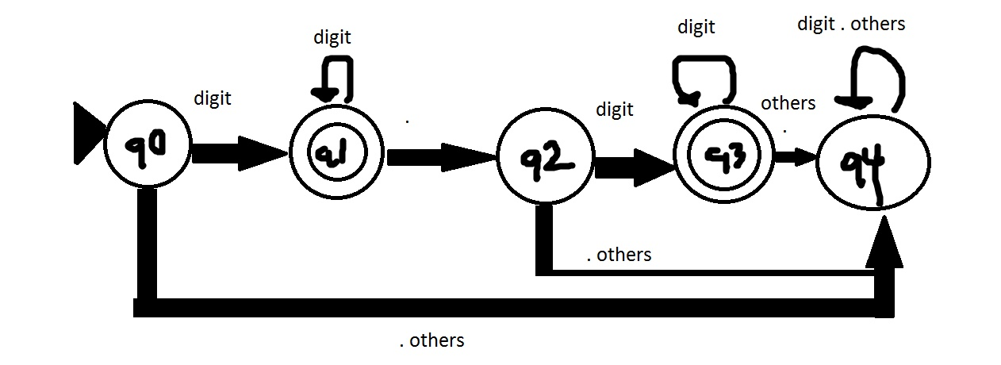

1. L = accept simple identifier

Q= { 0 , 1, 2}

∑= { _ , letter, digit, others }

Q0= 0

F= { 1 }

**Transition Table**

|  |  |  |  |  |
| --- | --- | --- | --- | --- |
| **q** | **_** | **letter** | **digit** | **others** |
| **0** | **1** | **1** | **2** | **2** |
| **1** | **1** | **1** | **1** | **2** |
| **2** | **2** | **2** | **2** | **2** |

**Transition Diagram**

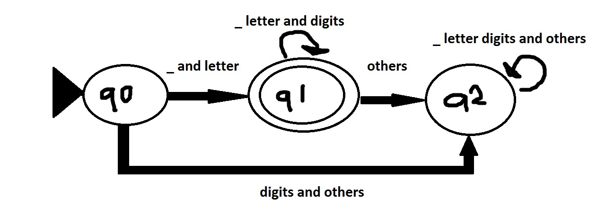

1. L = accepts expression

Q= { 0 , 1, 2 , 3 , 4 }

∑= { num, identifier, operator, others}

Q0= 0

F= 3

**Transition Table**

|  |  |  |  |  |
| --- | --- | --- | --- | --- |
| **q** | **num** | **Operator** | **Identifier** | **Others** |
| **0** | **1** | **4** | **1** | **4** |
| **1** | **4** | **2** | **4** | **4** |
| **2** | **3** | **4** | **3** | **4** |
| **3** | **4** | **2** | **4** | **4** |
| **4** | **4** | **4** | **4** | **4** |

**Transition Diagram**

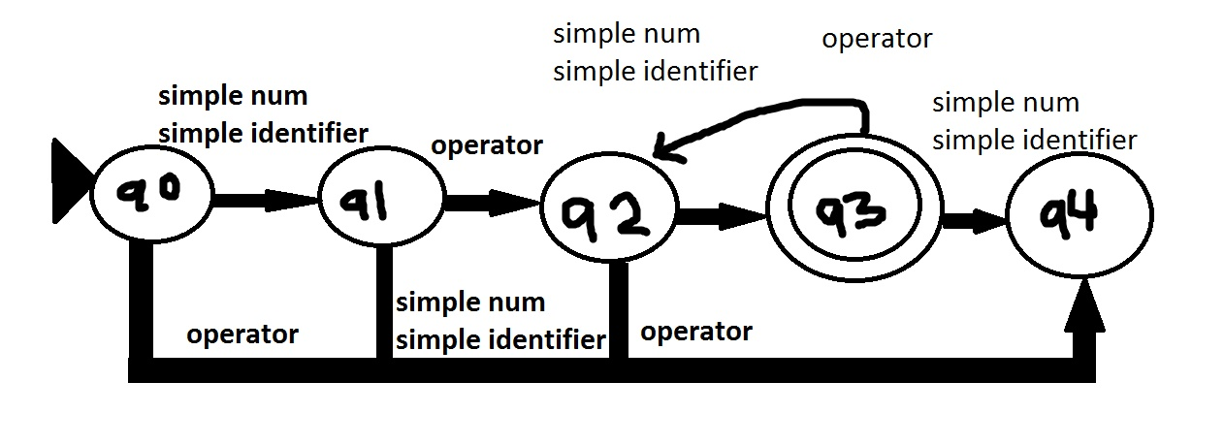

1. L = accepts statements

Q= { 0 , 1 , 2 , 3 , 4 , 5 }

∑= { identifier , = , num , expr , ; , others }

Q0= 0

F= 4

**Transition Table**

|  |  |  |  |  |  |  |
| --- | --- | --- | --- | --- | --- | --- |
| **q** | **identifier** | **=** | **expr** | **;** | **Others** | **num** |
| **0** | **1** | **5** | **5** | **5** | **5** | **5** |
| **1** | **5** | **2** | **5** | **4** | **5** | **5** |
| **2** | **1** | **5** | **3** | **5** | **5** | **3** |
| **3** | **5** | **5** | **5** | **4** | **5** | **5** |
| **4** | **5** | **5** | **5** | **5** | **5** | **5** |
| **5** | **5** | **5** | **5** | **5** | **5** | **5** |

**Transition Diagram**

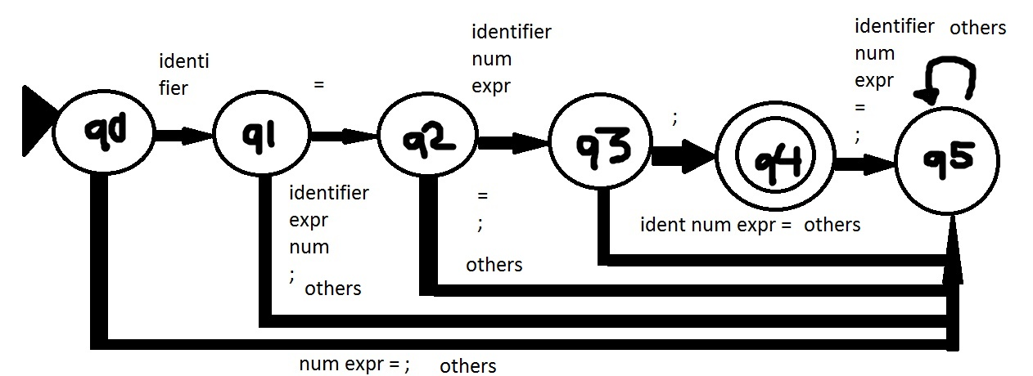

**Source Code:**

// 241918

|  |
| --- |
| /* |
|  |

|  |
| --- |
| * Created by SharpDevelop. |
|  |

|  |
| --- |
| * User: Dalugdog |
|  |

|  |
| --- |
| * Date: 04/11/2019 |
|  |

|  |
| --- |
| * Time: 4:35 PM |
|  |

|  |
| --- |
| * |
|  |

|  |
| --- |
| * To change this template use Tools | Options | Coding | Edit Standard Headers. |
|  |

|  |
| --- |
| */ |
|  |

|  |
| --- |
| using System; |
|  |

|  |
| --- |
| using System.Collections.Generic; |
|  |

|  |
| --- |
|  |
|  |

|  |
| --- |
| namespace midterm |
|  |

|  |
| --- |
| { |
|  |

|  |
| --- |
| class Program |
|  |

|  |
| --- |
| { |
|  |

|  |
| --- |
| char []save1; |
|  |

|  |
| --- |
| string []save2; |
|  |

|  |
| --- |
| string []save3; |
|  |

|  |
| --- |
|  |
|  |

|  |
| --- |
| public int splitting(string state_ment) |
|  |

|  |
| --- |
| { |
|  |

|  |
| --- |
| //converting string to char array |
|  |

|  |
| --- |
| char []str = state_ment.ToCharArray(); |
|  |

|  |
| --- |
| //to save the delimiter, make a copy |
|  |

|  |
| --- |
| char []strdup = state_ment.ToCharArray(); |
|  |

|  |
| --- |
| save1 = state_ment.ToCharArray(); |
|  |

|  |
| --- |
|  |
|  |

|  |
| --- |
| string[]split = state_ment.Split(new char[] {'=',';'},StringSplitOptions.RemoveEmptyEntries); |
|  |

|  |
| --- |
| try{ |
|  |

|  |
| --- |
| var str1 = new List <string>(); |
|  |

|  |
| --- |
| int from = 0; |
|  |

|  |
| --- |
| int testme=0; |
|  |

|  |
| --- |
|  |
|  |

|  |
| --- |
|  |
|  |

|  |
| --- |
| //hello=num; |
|  |

|  |
| --- |
| //5 |
|  |

|  |
| --- |
| // |
|  |

|  |
| --- |
| // Console.WriteLine("adding on the list"); |
|  |

|  |
| --- |
| foreach(string ch in split) |
|  |

|  |
| --- |
| { |
|  |

|  |
| --- |
|  |
|  |

|  |
| --- |
| // Console.WriteLine("string {0}",ch); |
|  |

|  |
| --- |
| str1.Add(ch); |
|  |

|  |
| --- |
| // Console.WriteLine("inserting {0}",ch); |
|  |

|  |
| --- |
| from = ch.Length+from; |
|  |

|  |
| --- |
| // Console.WriteLine(from); |
|  |

|  |
| --- |
| str1.Add(str[from+testme].ToString()); |
|  |

|  |
| --- |
| testme++; |
|  |

|  |
| --- |
|  |
|  |

|  |
| --- |
| } |
|  |

|  |
| --- |
| //testing the List |
|  |

|  |
| --- |
| //saving it to public variable |
|  |

|  |
| --- |
| // Console.WriteLine("Transferring"); |
|  |

|  |
| --- |
| int cap = str1.Count; |
|  |

|  |
| --- |
| save2 = new String[cap]; |
|  |

|  |
| --- |
| int count=0; |
|  |

|  |
| --- |
| foreach(string gh in str1) |
|  |

|  |
| --- |
| { |
|  |

|  |
| --- |
| // Console.WriteLine(gh); |
|  |

|  |
| --- |
| save2[count] = gh.ToString(); |
|  |

|  |
| --- |
| // Console.WriteLine(save2[count]); |
|  |

|  |
| --- |
| count++; |
|  |

|  |
| --- |
| } |
|  |

|  |
| --- |
| } |
|  |

|  |
| --- |
| catch{ |
|  |

|  |
| --- |
| // Console.WriteLine("Invalid"); |
|  |

|  |
| --- |
| } |
|  |

|  |
| --- |
|  |
|  |

|  |
| --- |
|  |
|  |

|  |
| --- |
| return 1; |
|  |

|  |
| --- |
| } |
|  |

|  |
| --- |
|  |
|  |

|  |
| --- |
|  |
|  |

|  |
| --- |
| int check_simpleno(string simplenum) |
|  |

|  |
| --- |
| { |
|  |

|  |
| --- |
| int state=0; |
|  |

|  |
| --- |
| int [,]table = new int [,] { |
|  |

|  |
| --- |
| {1,4,4}, |
|  |

|  |
| --- |
| {1,2,4}, |
|  |

|  |
| --- |
| {3,4,4}, |
|  |

|  |
| --- |
| {3,4,4}, |
|  |

|  |
| --- |
| {4,4,4} |
|  |

|  |
| --- |
| }; |
|  |

|  |
| --- |
| int input=0; |
|  |

|  |
| --- |
| int flag = 0; |
|  |

|  |
| --- |
|  |
|  |

|  |
| --- |
| //test simple number function |
|  |

|  |
| --- |
| //checking each char if its digits |
|  |

|  |
| --- |
| foreach (char n in simplenum) |
|  |

|  |
| --- |
| { |
|  |

|  |
| --- |
| // Console.WriteLine(n); |
|  |

|  |
| --- |
| if(n=='.') |
|  |

|  |
| --- |
| { |
|  |

|  |
| --- |
| input = 1; |
|  |

|  |
| --- |
| // Console.WriteLine("state_1"); |
|  |

|  |
| --- |
| } |
|  |

|  |
| --- |
| else if (char.IsDigit(n)) |
|  |

|  |
| --- |
| { |
|  |

|  |
| --- |
| input=0; |
|  |

|  |
| --- |
| // Console.WriteLine("state_0"); |
|  |

|  |
| --- |
| } |
|  |

|  |
| --- |
| else { |
|  |

|  |
| --- |
| input=2; |
|  |

|  |
| --- |
| // Console.WriteLine("state_2"); |
|  |

|  |
| --- |
| } |
|  |

|  |
| --- |
|  |
|  |

|  |
| --- |
| state = table[state,input]; |
|  |

|  |
| --- |
| if(state==1) |
|  |

|  |
| --- |
| { |
|  |

|  |
| --- |
| flag=1; |
|  |

|  |
| --- |
| } |
|  |

|  |
| --- |
| else if (state==3) |
|  |

|  |
| --- |
| { |
|  |

|  |
| --- |
| flag =1; |
|  |

|  |
| --- |
| } |
|  |

|  |
| --- |
| else { |
|  |

|  |
| --- |
| flag =0; |
|  |

|  |
| --- |
| } |
|  |

|  |
| --- |
| } |
|  |

|  |
| --- |
|  |
|  |

|  |
| --- |
| if(flag == 1) |
|  |

|  |
| --- |
| { |
|  |

|  |
| --- |
| // Console.WriteLine("simplenumber_accepted"); |
|  |

|  |
| --- |
| return 1; |
|  |

|  |
| --- |
| } |
|  |

|  |
| --- |
| else |
|  |

|  |
| --- |
| { |
|  |

|  |
| --- |
| // Console.WriteLine("simplenumber_notaccepted"); |
|  |

|  |
| --- |
| return 0; |
|  |

|  |
| --- |
| } |
|  |

|  |
| --- |
| } |
|  |

|  |
| --- |
|  |
|  |

|  |
| --- |
|  |
|  |

|  |
| --- |
| int check_identifier(string simpleidentifier) |
|  |

|  |
| --- |
| { |
|  |

|  |
| --- |
| int state =0; |
|  |

|  |
| --- |
| int [,] table = new int [,] { |
|  |

|  |
| --- |
| {1,1,2,2}, |
|  |

|  |
| --- |
| {1,1,1,2}, |
|  |

|  |
| --- |
| {2,2,2,2} |
|  |

|  |
| --- |
| }; |
|  |

|  |
| --- |
| int input; |
|  |

|  |
| --- |
| int flag=0; |
|  |

|  |
| --- |
|  |
|  |

|  |
| --- |
| // Console.WriteLine("identifier function"); |
|  |

|  |
| --- |
|  |
|  |

|  |
| --- |
| foreach (char m in simpleidentifier) |
|  |

|  |
| --- |
| { |
|  |

|  |
| --- |
| if(m=='_') |
|  |

|  |
| --- |
| { |
|  |

|  |
| --- |
| input=0; |
|  |

|  |
| --- |
| // Console.WriteLine("identifier detects _ "); |
|  |

|  |
| --- |
| } |
|  |

|  |
| --- |
| else if (char.IsLetter(m)) |
|  |

|  |
| --- |
| { |
|  |

|  |
| --- |
| input = 1; |
|  |

|  |
| --- |
| // Console.WriteLine("identifier detects letter"); |
|  |

|  |
| --- |
| } |
|  |

|  |
| --- |
| else if (char.IsDigit(m)) |
|  |

|  |
| --- |
| { |
|  |

|  |
| --- |
| input = 2; |
|  |

|  |
| --- |
| // Console.WriteLine("identifier detects digit"); |
|  |

|  |
| --- |
| } |
|  |

|  |
| --- |
| else { |
|  |

|  |
| --- |
| input =3; |
|  |

|  |
| --- |
| // Console.WriteLine("?"); |
|  |

|  |
| --- |
| } |
|  |

|  |
| --- |
|  |
|  |

|  |
| --- |
| state = table [state,input]; |
|  |

|  |
| --- |
| if (state==1) |
|  |

|  |
| --- |
| { |
|  |

|  |
| --- |
| flag =1; |
|  |

|  |
| --- |
| } |
|  |

|  |
| --- |
| else { |
|  |

|  |
| --- |
| flag = 0; |
|  |

|  |
| --- |
| } |
|  |

|  |
| --- |
| } |
|  |

|  |
| --- |
| // Console.WriteLine("identifing"); |
|  |

|  |
| --- |
|  |
|  |

|  |
| --- |
| if(flag==1) |
|  |

|  |
| --- |
| { |
|  |

|  |
| --- |
| // Console.WriteLine("identifier"); |
|  |

|  |
| --- |
| return 1; |
|  |

|  |
| --- |
| } |
|  |

|  |
| --- |
| else { |
|  |

|  |
| --- |
| // Console.WriteLine("Not identifier"); |
|  |

|  |
| --- |
| return 0; |
|  |

|  |
| --- |
| } |
|  |

|  |
| --- |
| } |
|  |

|  |
| --- |
|  |
|  |

|  |
| --- |
| int check_expression(string expressme) |
|  |

|  |
| --- |
| { |
|  |

|  |
| --- |
| // Console.WriteLine("New string {0}",expressme); |
|  |

|  |
| --- |
| int state=0; |
|  |

|  |
| --- |
| int input; |
|  |

|  |
| --- |
| int [,] table= new int [,] { |
|  |

|  |
| --- |
| {1,4,1,4}, |
|  |

|  |
| --- |
| {4,2,4,4}, |
|  |

|  |
| --- |
| {3,4,3,4}, |
|  |

|  |
| --- |
| {4,2,4,4}, |
|  |

|  |
| --- |
| {4,4,4,4} |
|  |

|  |
| --- |
| }; |
|  |

|  |
| --- |
| char a='+'; |
|  |

|  |
| --- |
| char b = '-'; |
|  |

|  |
| --- |
| char c = '*'; |
|  |

|  |
| --- |
| char d = '/'; |
|  |

|  |
| --- |
| char e = '%'; |
|  |

|  |
| --- |
| string plus = a.ToString(); |
|  |

|  |
| --- |
| string minus = b.ToString(); |
|  |

|  |
| --- |
| string multi = c.ToString(); |
|  |

|  |
| --- |
| string divide = d.ToString(); |
|  |

|  |
| --- |
| string modul= e.ToString(); |
|  |

|  |
| --- |
| int l = splitting2(expressme); |
|  |

|  |
| --- |
| int flag = 0; |
|  |

|  |
| --- |
|  |
|  |

|  |
| --- |
| foreach (string lastme in save3) |
|  |

|  |
| --- |
| { |
|  |

|  |
| --- |
| if(check_identifier(lastme)==1) |
|  |

|  |
| --- |
| { |
|  |

|  |
| --- |
| input=0; |
|  |

|  |
| --- |
| // Console.WriteLine("identifier"); |
|  |

|  |
| --- |
| } |
|  |

|  |
| --- |
| else if (lastme == plus || lastme== minus || lastme == multi || lastme==divide || lastme==modul) |
|  |

|  |
| --- |
| { |
|  |

|  |
| --- |
| input=1; |
|  |

|  |
| --- |
| // Console.WriteLine("operator"); |
|  |

|  |
| --- |
| } |
|  |

|  |
| --- |
| else if (check_simpleno(lastme)==1) |
|  |

|  |
| --- |
| { |
|  |

|  |
| --- |
| input=2; |
|  |

|  |
| --- |
| // Console.WriteLine("simple number"); |
|  |

|  |
| --- |
| } |
|  |

|  |
| --- |
| else { |
|  |

|  |
| --- |
| input=3; |
|  |

|  |
| --- |
| } |
|  |

|  |
| --- |
| state=table[state,input]; |
|  |

|  |
| --- |
| if(state==3) |
|  |

|  |
| --- |
| { |
|  |

|  |
| --- |
| flag=1; |
|  |

|  |
| --- |
| } |
|  |

|  |
| --- |
| else { |
|  |

|  |
| --- |
| flag=0; |
|  |

|  |
| --- |
| } |
|  |

|  |
| --- |
| } |
|  |

|  |
| --- |
|  |
|  |

|  |
| --- |
|  |
|  |

|  |
| --- |
| if (flag == 1) |
|  |

|  |
| --- |
| { |
|  |

|  |
| --- |
| // Console.WriteLine("expressing"); |
|  |

|  |
| --- |
| return 1; |
|  |

|  |
| --- |
| } |
|  |

|  |
| --- |
| else { |
|  |

|  |
| --- |
| // Console.WriteLine("not expressing"); |
|  |

|  |
| --- |
| return 0; |
|  |

|  |
| --- |
| } |
|  |

|  |
| --- |
|  |
|  |

|  |
| --- |
| } |
|  |

|  |
| --- |
|  |
|  |

|  |
| --- |
| int splitting2(string state_ment) |
|  |

|  |
| --- |
| { |
|  |

|  |
| --- |
| Console.WriteLine(); |
|  |

|  |
| --- |
| // Console.WriteLine("expression: {0} ",state_ment); |
|  |

|  |
| --- |
| char [] str = state_ment.ToCharArray(); |
|  |

|  |
| --- |
| string[]split = state_ment.Split(new char[] {'+','/','-','*','%'},StringSplitOptions.RemoveEmptyEntries); |
|  |

|  |
| --- |
|  |
|  |

|  |
| --- |
| var str1 = new List <string>(); |
|  |

|  |
| --- |
| str1.Clear(); |
|  |

|  |
| --- |
| int from = 0; |
|  |

|  |
| --- |
| int testme=0; |
|  |

|  |
| --- |
| // Console.WriteLine("max capacity {0} ",str1.Count); |
|  |

|  |
| --- |
|  |
|  |

|  |
| --- |
| //hello=num; |
|  |

|  |
| --- |
| //5 |
|  |

|  |
| --- |
| // |
|  |

|  |
| --- |
| // Console.WriteLine("split array lenght {0}",split.Length); |
|  |

|  |
| --- |
| foreach(string ch in split) |
|  |

|  |
| --- |
| { |
|  |

|  |
| --- |
|  |
|  |

|  |
| --- |
| // Console.WriteLine("string {0} length {1}",ch,ch.Length); |
|  |

|  |
| --- |
| str1.Add(ch); |
|  |

|  |
| --- |
| // Console.WriteLine("inserting {0}",ch); |
|  |

|  |
| --- |
|  |
|  |

|  |
| --- |
| if(from+ch.Length+testme < str.Length) |
|  |

|  |
| --- |
| { |
|  |

|  |
| --- |
| from = ch.Length+from; |
|  |

|  |
| --- |
| // Console.WriteLine("{0} {1}",from,str[from+testme]); |
|  |

|  |
| --- |
| str1.Add(str[from+testme].ToString()); |
|  |

|  |
| --- |
| testme++; |
|  |

|  |
| --- |
| } |
|  |

|  |
| --- |
| // Console.WriteLine("list count {0} from {1} testme {2}",str1.Count,from,testme); |
|  |

|  |
| --- |
|  |
|  |

|  |
| --- |
| } |
|  |

|  |
| --- |
| // Console.WriteLine("data in list str1 {0}",str1.Count); |
|  |

|  |
| --- |
| int cap = str1.Count; |
|  |

|  |
| --- |
| save3 = new String[cap]; |
|  |

|  |
| --- |
| int count=0; |
|  |

|  |
| --- |
| // Console.WriteLine("transferring list count= {0}",str1.Count); |
|  |

|  |
| --- |
| foreach (string hh in str1) |
|  |

|  |
| --- |
| { |
|  |

|  |
| --- |
| // Console.WriteLine(hh); |
|  |

|  |
| --- |
| save3[count] = hh.ToString(); |
|  |

|  |
| --- |
| // Console.WriteLine(save3[count]); |
|  |

|  |
| --- |
| count++; |
|  |

|  |
| --- |
| } |
|  |

|  |
| --- |
| return 1; |
|  |

|  |
| --- |
| } |
|  |

|  |
| --- |
|  |
|  |

|  |
| --- |
|  |
|  |

|  |
| --- |
| public static void Main(string[] args) |
|  |

|  |
| --- |
| { |
|  |

|  |
| --- |
| Program a = new Program(); |
|  |

|  |
| --- |
| int [,]table = new int[,] { |
|  |

|  |
| --- |
| {1,5,5,5,5,5}, |
|  |

|  |
| --- |
| {5,2,5,4,5,5}, |
|  |

|  |
| --- |
| {1,5,3,5,5,3}, |
|  |

|  |
| --- |
| {5,5,5,4,5,5}, |
|  |

|  |
| --- |
| {5,5,5,5,5,5} |
|  |

|  |
| --- |
|  |
|  |

|  |
| --- |
| }; |
|  |

|  |
| --- |
| string statement; |
|  |

|  |
| --- |
| /*getting the string statement */ |
|  |

|  |
| --- |
| statement = Console.ReadLine(); |
|  |

|  |
| --- |
| int h=0; |
|  |

|  |
| --- |
| int state=0; |
|  |

|  |
| --- |
| int input; |
|  |

|  |
| --- |
| char eq='='; |
|  |

|  |
| --- |
| char semi=';'; |
|  |

|  |
| --- |
| string equall = eq.ToString(); |
|  |

|  |
| --- |
| string semicol = semi.ToString(); |
|  |

|  |
| --- |
| int flag=0; |
|  |

|  |
| --- |
| /*splitting the statement */ |
|  |

|  |
| --- |
| try{ |
|  |

|  |
| --- |
| h = a.splitting(statement); |
|  |

|  |
| --- |
| // Console.WriteLine(a.save2.Length); |
|  |

|  |
| --- |
| // valid statement operation |
|  |

|  |
| --- |
| foreach(string testme in a.save2) |
|  |

|  |
| --- |
| { |
|  |

|  |
| --- |
| try{ |
|  |

|  |
| --- |
| // Console.ReadKey(true); |
|  |

|  |
| --- |
| if(a.check_identifier(testme)==1) |
|  |

|  |
| --- |
| { |
|  |

|  |
| --- |
| input=0; |
|  |

|  |
| --- |
| // Console.WriteLine("identifier"); |
|  |

|  |
| --- |
| } /* |
|  |

|  |
| --- |
| else if (a.check_simpleno(testme)==1) |
|  |

|  |
| --- |
| { |
|  |

|  |
| --- |
| Console.WriteLine("simple number"); |
|  |

|  |
| --- |
| }*/ |
|  |

|  |
| --- |
| else if (testme == equall) |
|  |

|  |
| --- |
| { |
|  |

|  |
| --- |
| input=1; |
|  |

|  |
| --- |
| // Console.WriteLine("equal detected"); |
|  |

|  |
| --- |
| } |
|  |

|  |
| --- |
| else if (a.check_expression(testme)==1) |
|  |

|  |
| --- |
| { |
|  |

|  |
| --- |
| input=2; |
|  |

|  |
| --- |
| // Console.WriteLine("expression"); |
|  |

|  |
| --- |
| } |
|  |

|  |
| --- |
| else if(testme == semicol) |
|  |

|  |
| --- |
| { |
|  |

|  |
| --- |
| input=3; |
|  |

|  |
| --- |
| // Console.WriteLine("semi"); |
|  |

|  |
| --- |
| } |
|  |

|  |
| --- |
| else if (a.check_simpleno(testme)==1) |
|  |

|  |
| --- |
| { |
|  |

|  |
| --- |
| input=5; |
|  |

|  |
| --- |
| // Console.WriteLine("simple number"); |
|  |

|  |
| --- |
| } |
|  |

|  |
| --- |
| else { |
|  |

|  |
| --- |
| input=4; |
|  |

|  |
| --- |
| // Console.WriteLine("error detected"); |
|  |

|  |
| --- |
| } |
|  |

|  |
| --- |
|  |
|  |

|  |
| --- |
| state=table[state,input]; |
|  |

|  |
| --- |
| if(state==4) |
|  |

|  |
| --- |
| { |
|  |

|  |
| --- |
| flag =1; |
|  |

|  |
| --- |
| } |
|  |

|  |
| --- |
| } |
|  |

|  |
| --- |
| catch(Exception) |
|  |

|  |
| --- |
| { |
|  |

|  |
| --- |
| // Console.WriteLine("error"); |
|  |

|  |
| --- |
| } |
|  |

|  |
| --- |
|  |
|  |

|  |
| --- |
|  |
|  |

|  |
| --- |
| } |
|  |

|  |
| --- |
| } |
|  |

|  |
| --- |
| catch |
|  |

|  |
| --- |
| { |
|  |

|  |
| --- |
|  |
|  |

|  |
| --- |
| } |
|  |

|  |
| --- |
|  |
|  |

|  |
| --- |
| if(flag==1) |
|  |

|  |
| --- |
| { |
|  |

|  |
| --- |
| Console.WriteLine("Valid Assignment Statement"); |
|  |

|  |
| --- |
| } |
|  |

|  |
| --- |
| else { |
|  |

|  |
| --- |
| Console.WriteLine("Invalid Assignment Statement"); |
|  |

|  |
| --- |
| } |
|  |

|  |
| --- |
| // TODO: Implement Functionality Here |
|  |

|  |
| --- |
|  |
|  |

|  |
| --- |
| // Console.Write("Press any key to continue . . . "); |
|  |

|  |
| --- |
| // Console.ReadKey(true); |
|  |

|  |
| --- |
| } |
|  |

|  |
| --- |
| } |
|  |

}