Republic of the Philippines

BOHOL ISLAND STATE UNIVERSITY

MAIN CAMPUS

COLLEGE OF ENGINEERING AND ARCHITECTURE

Tel: 038-4113289 Telefax: 038-5017516

6300 Tagbilaran City

*Vision: A premiere S&T university for the formation of world class and virtuous human resource for sustainable development in Bohol and the Country.*

*Mission: BISU is committed to provide quality higher education in the arts and sciences, as well as in the professional and technological fields: undertake research and development, and extension services for the sustainable development of Bohol and the country.*

**Name**: Clark Dalugdog **Subject**: CpE 412

**Yr/Sec**: BSCPE 3 **Instructor**: Engr. Max Angelo Perin

ID NO.: 241918

**Programming Assignment #0-M**

**Problem:**

1. L = { W ϵ {a, b }* | w contains at least 5 occurrences of **b**}

L= (a+b)*b(a+b)*b(a+b)*b(a+b)*b(a+b)*b(a+b)*

Q= { 0,1,2,3,4,5}

∑={a,b}

Q0= 0

F= 5

Transition Table

|  |  |  |
| --- | --- | --- |
| **q** | **a** | **b** |
| **0** | **0** | **1** |
| **1** | **1** | **2** |
| **2** | **2** | **3** |
| **3** | **3** | **4** |
| **4** | **4** | **5** |
| **5** | **5** | **5** |

**Transition Diagram**

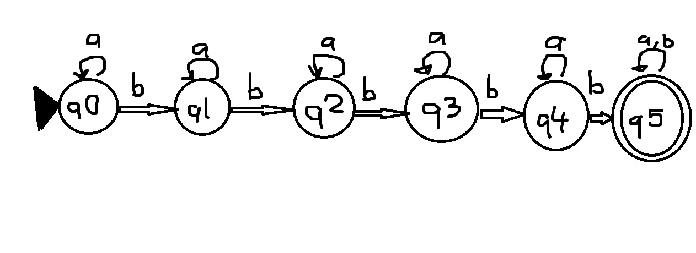

**Source Code:**

// 241918

#include <iostream>

#include <cstring>

using namespace std;

int main()

{

int j=0, state=0;

int table[6][2] = { {0,1}, {1,2}, {2,3}, {3,4} , {4,5}, {5,5} };

int input;

int flag = 0;

char st[100];

gets(st);

while (st[j] != '\0' && (st[j] == 'a' || st[j] == 'b') )

{

switch(st[j])

{

case 'a' :

input=0;

break;

case 'b' :

input=1;

break;

}

state = table[state][input];

// just wanna check the state in every character

// cout<<st[j]<<" State "<<state<<endl;

if(state==5)

{

flag=1;

break;

}

j++;

}

if(flag == 1)

{

cout<<"Accepted"<<endl;

}

else

{

cout<<"Not Accepted"<<endl;

}

return 0;

}