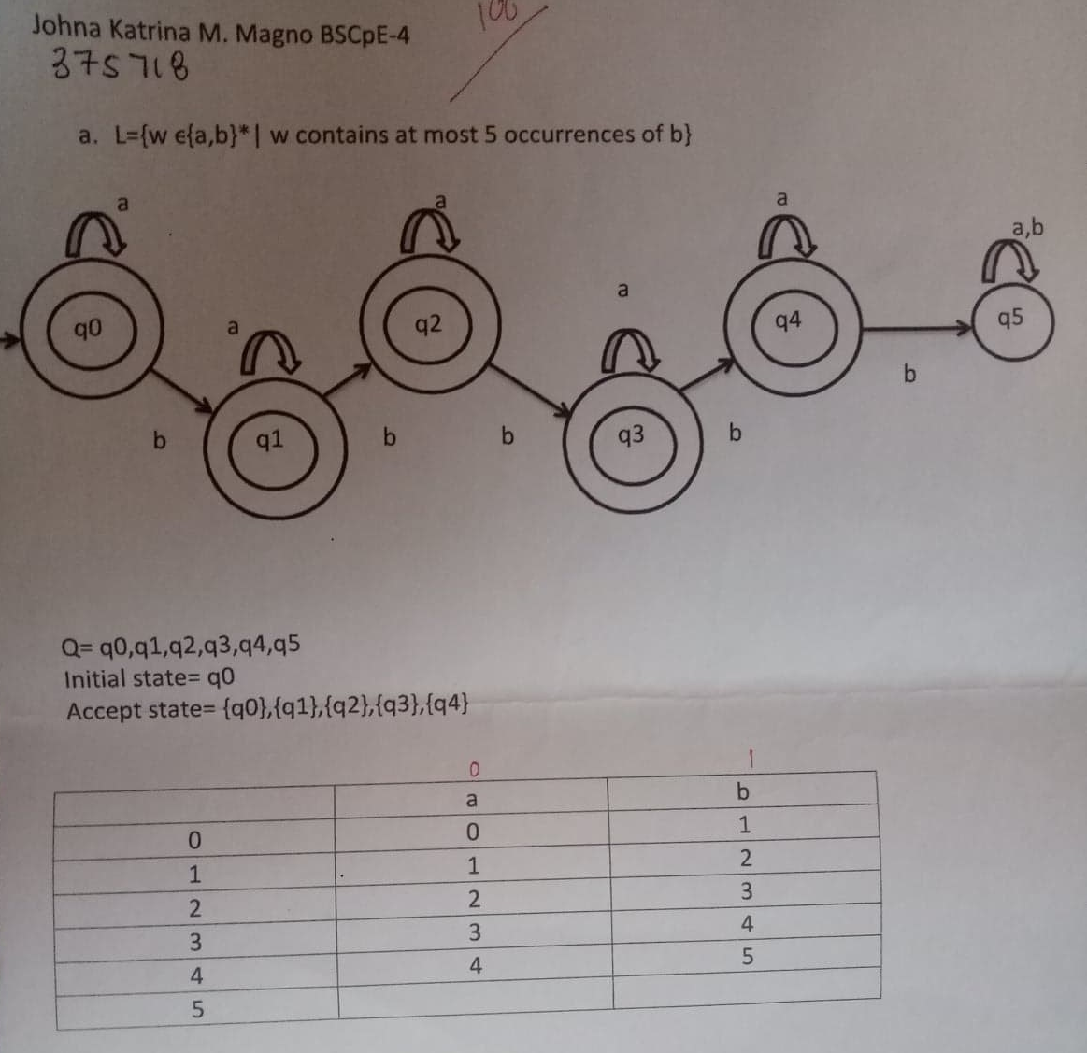

#include<cstring>

#include<iostream>

using namespace std;

int main (int argc, char \* argv[])

{

int x,z;

char str[100];

cout<<"Input:";

gets(str);

x=0;

z=0;

cout<<"Output:";

while(str[x]!='\0')

{

if(str[x]=='b')

{

z++;

}

x++;

}

if(z<6)

{

cout<<"Accepted";

}

else

{

cout<<"Not";

}

cout<<endl;

}