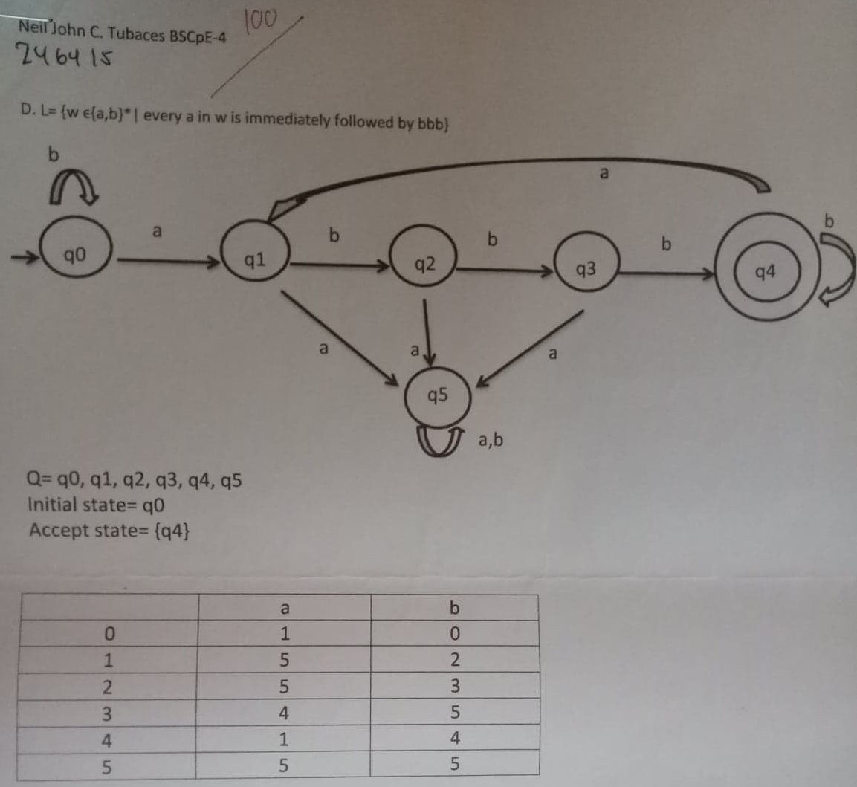

#include<cstring>

#include<iostream>

#include<cstdlib>

using namespace std;

int main (int argc, char * argv[])

{

int i,j,l,x,z,n,num[100],sum,y,rem,nn[100];

char str[100],arr[100][100];

cout<<"Input:";

gets(str);

x=0;

z=0;

l=0;

cout<<"Output:";

while(str[x]!='\0')

{

if(str[x]=='a'&&str[x+1]=='b'&&str[x+2]=='b'&&str[x+3]=='b')

{

z++;

}

if(str[x]=='a')

{

l++;

}

x++;

}

if(z==l)

{

cout<<"Accepted";

}

else

{

cout<<"Not";

}

cout<<endl;

system("PAUSE");

return EXIT_SUCCESS;

}