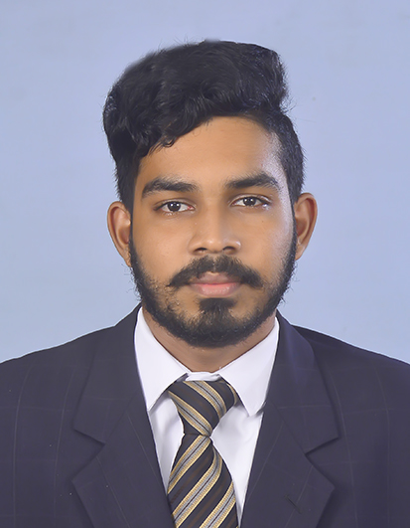

sdagwerg | qegqeg |

# About me

rqgqgqgeqg

# working experience

**gjacjaf***hagfjbajf-vhvjavja*vgahvjhav

ytfhagdjqagdujagdjqgdjqgfdajvfjqjfgqj