CCSICT Digital Grading System
Team Members:
Bazar, Cyrus Troy C.
Name 2
Name 3
Course: DSA 214 – Programming for Data Science
Instructor: Mr. Bendick Yamat
Institution: Isabela State University
Date of Submission: Month Day, Year

Abstract
This project presents a compact system for managing student records using SQLite, supporting essential CRUD (Create, Read, Update, Delete) operations. The dataset encompasses student grades, study habits, attendance, and exam scores. A linear regression model is trained on this data to predict student performance based on input features. Additionally, the system provides visualization capabilities using Matplotlib, allowing users to explore and analyze the data effectively.

1. Introduction
Effective management of student records is essential for tracking academic performance and supporting learning outcomes. Traditional methods of recording grades and attendance can be inefficient and error-prone, particularly in courses with multiple assessments. This project presents a system that stores student records, consolidates quiz and exam data, calculates overall grades, and predicts future performance using linear regression. Additionally, the system provides visualization tools to analyze performance trends by section or course. By combining data management, predictive analytics, and graphical representation, the system offers a practical solution for monitoring student progress throughout an ongoing semester.

1.1 Background of the Project
Educational institutions increasingly rely on data to monitor and support student performance. Managing student records manually can be time-consuming and prone to error, especially when handling multiple quizzes, exams, and attendance records. This project develops a compact system for storing student data, calculating grades, and predicting future performance using linear regression. By integrating database management, data preprocessing, and visualization, the system offers a practical approach for educators and students to track academic progress and identify areas that may need improvement.

1.2 Purpose of the System
The primary purpose of the system is to store and manage student records, including grades, study habits, attendance, and exam scores. It calculates overall grades from current scores and uses a linear regression model to predict future performance, providing a simple yet effective tool for monitoring academic progress during an ongoing semester.

1.3 Scope and Limitations
The system is designed primarily for offline management and analysis of student records. It does not support real-time grade conversion or immediate predictions upon data entry, as calculations are performed only after data preprocessing. The database operates locally and is not connected to an online server, limiting access to a single device at a time. While it is possible to run the system on Android devices using Termux and Python package installation, setup can be complex and may require technical familiarity. The system has not been tested on macOS, so compatibility with Apple devices cannot be guaranteed. Despite these limitations, the system provides reliable functionality for data storage, processing, predictive analysis, and visualization within the supported environments.

1.4 Significance of the Study
Although the development of this system is a course requirement, it demonstrates practical applications of database management, data processing, and predictive analytics in an educational context. The project provides a structured way to organize student records, calculate grades, and forecast academic performance, which can help students and educators monitor progress more efficiently. Additionally, the visualization tools offer insights into trends and patterns in student performance, supporting better understanding of academic data. Even as a structured assignment, the system illustrates how computational methods can be applied to real-world educational scenarios.

2. System Design
2.1 System Overview
The system is a command-line interface (CLI) application designed to manage student records efficiently. Users interact with the system by selecting options from numbered menus, allowing them to perform tasks such as adding, updating, deleting, or viewing student information. The system tracks grades, study habits, attendance, and exam scores, consolidating multiple quiz and exam columns for accurate processing. It also supports conversion between CSV files and the SQLite database, providing flexibility for data storage and external analysis. Additionally, the system can calculate overall grades and predict student performance using a linear regression model. Through its simple CLI design, the system offers a convenient and straightforward way to manage and analyze academic data without the need for a graphical interface.

2.2 Database Schema
The system uses a SQLite database to store student records. The primary table contains the following fields:
- id: a unique identifier for each record (primary key).
- student_id: a unique identifier for each student.
- program: the student’s program of study (e.g., BSCS, BSDSA, BSIT, BLIS).
- grade: the current calculated grade.
- status: indicates whether the student has passed or failed.
- age: the student’s age in years.
- study_hours: average weekly study hours.
- attendance_rate: percentage of attendance.
- quiz_score: consolidated score from multiple quiz columns.
- midterm_score: score from midterm exams.
- final_score: score from final exams.
- gpa: current grade point average.
For predictive analysis, the system uses selected fields as input features for the linear regression model. These predictors include quiz_score, exams_score, attendance_rate, performance_task, and activities, while final_grade serves as the target variable. This structure allows the system to calculate overall grades and forecast student performance.
Relationships between fields are straightforward: student_id uniquely identifies each student, while other fields provide attributes used for record management, grade calculation, and prediction. The database is designed for simplicity and efficiency, supporting both CRUD operations and CSV import/export for analysis.

2.3 Core Functions
The system provides several core functions for managing student records:
- Create: Adds new student records to the database, including grades, attendance, and other relevant fields.
- Read: Displays stored records for review and analysis.
- Update: Modifies existing records as needed.
- Delete: Removes records using the id field, which is an INTEGER PRIMARY KEY AUTOINCREMENT.
- Input Validation: Ensures that entered data meets expected formats and constraints.
- Error Handling: Detects and manages potential runtime or user-input errors to prevent system crashes.
- Menu and CLI Flow: Provides a simple, numbered command-line interface for navigating system functions.
The system operates on student_grade.db but can also work with CSV datasets containing quiz and exam columns. It supports conversion between database and CSV formats for flexibility, allowing users to import or export data as needed.

3. Data Analysis Section
3.1 Description of Data Used
The system uses structured student data stored in a SQLite database and, optionally, in CSV format. The dataset includes basic student information and academic performance indicators such as quiz scores, exam scores, attendance rate, study hours, grades, and GPA. Multiple quiz and exam columns are consolidated into single fields to ensure consistency and compatibility with the predictive model. The data is numeric and categorical in nature, allowing it to be used for record management, grade calculation, and performance prediction.

3.2 Analysis Techniques Implemented
The system applies several analysis techniques to process and interpret student data. Descriptive statistics are used to summarize key performance indicators such as quiz scores, exam scores, attendance rate, and overall grades. Aggregation is performed by consolidating multiple quiz and exam columns into single fields to support accurate grade calculation and prediction.
Visualization techniques are implemented using Matplotlib and Seaborn to display performance trends by course and section, allowing patterns in student outcomes to be easily observed. Additionally, a linear regression model is used to analyze trends in academic performance and to predict a student’s expected final grade based on current scores. These techniques collectively support data-driven insights and simplified performance reporting.

3.3 Presentation of Results
The results of the system are presented using bar graphs, tables, and statistical outputs. Bar graphs, created with Matplotlib and Seaborn, illustrate student performance by course, allowing easy comparison of grades across different sections. Tables summarize key data such as quiz scores, exam scores, attendance rates, and overall grades. Statistical outputs from the linear regression model show the predicted final grades based on current performance, supporting evaluation and analysis. Figures and tables are saved and referenced to provide clear, visual representation of student performance within the system.
- column grade is the predicted or final grade of the student
- bar graph of different student program
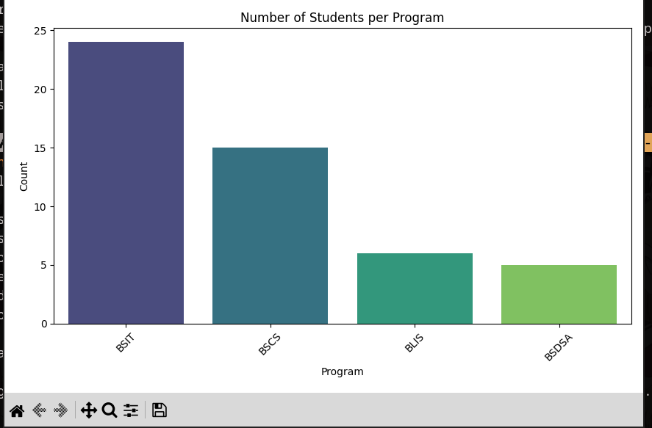
4. Implementation Challenges
Several challenges were encountered during the development of the system. Dependency issues in Python occasionally caused conflicts between required libraries, which were resolved by carefully managing package versions and virtual environments. Logical errors in Python code, including unexpected behaviors and edge cases, required step-by-step debugging and careful testing. Database issues, such as unusual SQLite behavior during certain queries or updates, were addressed by reviewing SQL syntax and implementing proper error handling. Limitations of the command-line interface were mitigated by designing a simple, numbered menu system, and occasional errors from Python libraries were resolved through documentation review and troubleshooting.

5. User Manual
5.1 System Requirements
- Python 3.13+
- Libraries required
- Arch Linux, Debian Linux, mint and Android

5.2 Installation Instructions
- make sure python and git is installed in your system
- run git clone https://github.com/bsdsa-isu/digital-grading-system
- go to that directory
- run pip install -r requirements
- finally run python Main.py and you can do some operations on that file like insert etc..

5.3 Using the System
Write instructions for:
- Insert a data
  - run python Main.py
  - choose 1 and hit enter(1 - Insert new student)
  - Follow the instruction and thats it
- Viewing records
  - run python Main.py
  - choose 2 and hit enter()
  - alternatively you can choose 2.5 to search for specific student
- Deleting
  - run python Main.py
  - choose 6 and hit enter
  - search for the id you want to delete for example 2024-Xxxx
  - copy the exact id to delete
- Grade predicting and calculating
  - run python Main.py
  - type 3 and enter and it will predict it for you

6. Conclusion and Lessons Learned
6.1 Summary of Project Outcomes
The project successfully developed a command-line interface (CLI) system for managing student records using SQLite. The system supports core functions such as creating, reading, updating, and deleting records, and can process both CSV and database formats. It consolidates multiple quiz and exam columns for consistent grade calculation and uses a linear regression model to predict final grades. Visualization tools, implemented with Matplotlib and Seaborn, provide bar graphs by course to help analyze student performance trends. Overall, the system meets its objectives of organizing student data, calculating grades, and forecasting academic performance.
6.2 Key Insights
Technically, the project highlighted the importance of careful database design, data preprocessing, and input validation for reliable system performance. From an analytical perspective, consolidating quiz and exam columns and applying linear regression provided clear insights into student performance trends. Additionally, working within a CLI environment reinforced the value of designing user-friendly menus and flow. The project also offered practical experience in troubleshooting Python dependencies, debugging logical errors, and handling unexpected SQLite behaviors, strengthening problem-solving and technical skills.

6.3 Recommendations for Future Improvements
Future enhancements could include a graphical user interface for easier navigation, real-time grade calculation upon data entry, expanded visualization options beyond bar graphs, and testing on additional platforms such as macOS. Integrating more advanced predictive models and incorporating additional performance metrics would further improve the system’s accuracy and usability.

References
scikit-learn. Python machine learnng module. http://scikit-learn.org/stable/
seaborn: statistical data visualization. https://seaborn.pydata.org/
pandas documentation. https://pandas.pydata.org/docs/
Python Software Foundation. (2023). Python documentation. https://docs.python.org
Hunter, J. (2023). Matplotlib documentation. https://matplotlib.org

