Ai Impact on Students
Team Members
Bazar, Cyrus Troy C.
Dataset Collection and Description
AI Impact on Students
Source: Kaggle / Public Dataset
Dataset Link: https://www.kaggle.com/datasets/dspritom/ai-impact-on-students
Number of Variables: total 15 columns
Number of Observations: 2885
Variables
Variable | Data Type | Description
Student_ID | Integer | A unique identification number assigned to each student.
Major_Category | Categorical | The student's academic major or field of study.
Year_of_Study | Categorical | The student's current year level in their academic program.
Pre_Semester_GPA | Numerical (Float) | The student's GPA before the semester began.
Weekly_GenAI_Hours | Numerical (Float) | The number of hours per week the student spends using generative AI tools.
Primary_Use_Case | Categorical | The student's main purpose for using generative AI, such as studying, coding, research, or writing.
Prompt_Engineering_Skill | Categorical | The student's level of skill in creating and designing effective prompts for generative AI tools.
Tool_Diversity | Numerical (Integer) | The number of different generative AI tools used by the student.
Paid_Subscription | Categorical | Indicates whether the student uses a paid subscription to a generative AI service.
Traditional_Study_Hours | Numerical (Float) | The number of hours per week the student spends studying without generative AI tools.
Perceived_AI_Dependency | Numerical (Integer) | A score representing how dependent the student feels on generative AI for their academic activities.
Institutional_Policy | Categorical | Indicates the level or type of institutional policy governing the use of generative AI in the student's academic environment.
Anxiety_Level_During_Exams | Numerical (Integer) | A score representing the student's level of anxiety experienced during examinations.
Post_Semester_GPA | Numerical (Float) | The student's GPA after completing the semester.
Burnout_Risk_Level | Categorical | The student's categorized level of risk for experiencing academic burnout.

Unit of Observation
Each row represents one student.
Data Collection
This data set comes with a codebook on the Kaggle site.
Broad Research Question
- Does Ai Impacts students performance on academics?
- Do students with high AI usage decrease their traditional study hours proportionately, and how does this tradeoff impact performance?
- Primary Use Case Impact: How do different primary uses of AI (e.g., coding assistance, essay writing, summarizing notes, or test prep) vary in their effect on student GPA?
Data Exploration
The dataset was first inspected to determine its size, variables, data types, missing values, duplicate records, and possible invalid values.
The dataset contains 15 variables and 28856 observations.
Initial inspection showed that 8 variables were numeric and suitable for statistical analysis.
Data Cleaning and Pre-processing
The following preprocessing steps were performed:
- Checked the dataset for missing values.
- Checked for duplicate records.
- Checked whether numerical variables contained invalid values.
- Verified the data types of each variable.
- Examined extreme values and possible outliers.
- Removed or corrected invalid records where necessary.
After preprocessing, the dataset was considered suitable for exploratory analysis.
Missing Data Analysis
Column | Non-Null Count | Dtype
0 Student_ID | 28856 | non-null int64
1 Major_Category | 28856 | non-null object
2 Year_of_Study | 28856 | non-null object
3 Pre_Semester_GPA | 28856 | non-null float64
4 Weekly_GenAI_Hours | 28856 | non-null float64
5 Primary_Use_Case | 28856 | non-null object
6 Prompt_Engineering_Skill | 28856 | non-null object
7 Tool_Diversity | 28856 | non-null int64
8 Paid_Subscription | 28856 | non-null object
9 Traditional_Study_Hours | 28856 | non-null float64
10 Perceived_AI_Dependency | 28856 | non-null int64
11 Institutional_Policy | 28856 | non-null object
12 Anxiety_Level_During_Exams | 28856 | non-null int64
13 Post_Semester_GPA | 28856 | non-null float64
14 Burnout_Risk_Level | 28856 | non-null object
This shows that theres no missing values in our dataset.

Descriptive Statistics
Demographic and AI Usage:
Metric | Student_ID | Pre_Semester_GPA | Weekly_GenAI_Hours | Tool_Diversity
count | 28856.00000 | 28856.000000 | 28856.000000 | 28856.000000
mean | 114428.50000 | 3.151702 | 9.218165 | 2.800353
std | 8330.15402 | 0.478808 | 9.300575 | 1.189669
min | 100001.00000 | 1.183000 | 0.000000 | 1.000000
25% | 107214.75000 | 2.838000 | 2.350000 | 2.000000
50% | 114428.50000 | 3.218000 | 5.950000 | 3.000000
75% | 121642.25000 | 3.527000 | 12.980000 | 4.000000
max | 128856.00000 | 3.997000

Study Habits, Wellbeing & Academic Outcomes:
Metric | Traditional_Study_Hours | Perceived_AI_Dependency | Anxiety_Level_During_Exams | Post_Semester_GPA
count | 28856.000000 | 28856.000000 | 28856.000000 | 28856.000000
mean | 11.150396 | 3.608296 | 4.344261 | 3.350033
std | 5.187562 | 1.947710 | 2.195916 | 0.497251
min | 1.000000 | 1.000000 | 1.000000 | 1.000000
25% | 7.450000 | 2.000000 | 3.000000 | 3.025000
50% | 11.110000 | 3.000000 | 4.000000 | 3.423000
75% | 14.670000 | 5.000000 | 6.000000 | 3.750000
max | 35.860000 | 10.000000 | 10.000000 | 4.000000
Visualization
GenAi Use Case Distribution by Major 100% stacked bar:
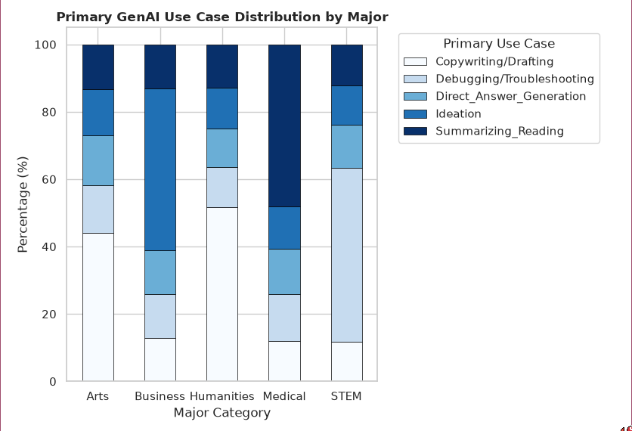
This stacked bar shows the percentage of primary use case of ai in different Major categories.
- Humanities and Arts Students uses Ai for drafting.
- Buseness Students use it mostly for ideas.
- Medical Students use it to Summarize reading
- And STEM Students use it for Direct answer generations.

Multivariate Corelation Martix:
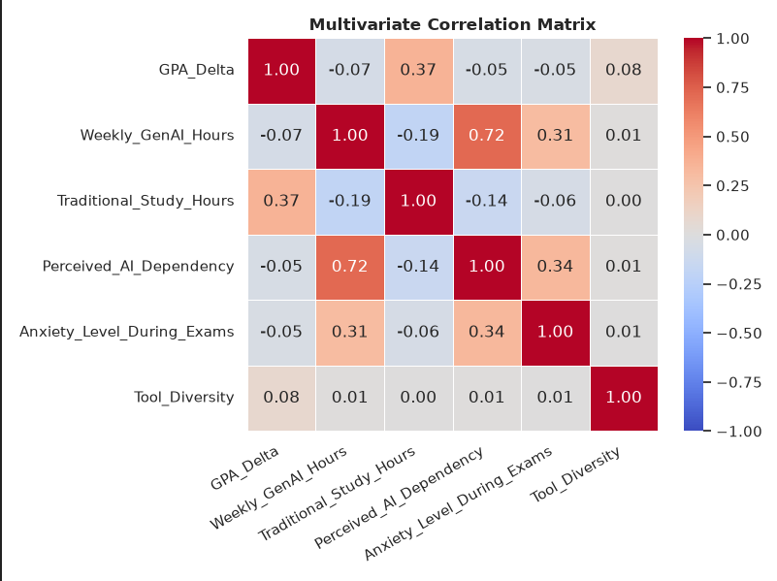
The correlation matrix shows the strength and direction of the relationships between `GPA Delta`, `GenAI usage`, `traditional study hours`, `perceived AI dependency`, `exam anxiety`, and `tool diversity`.
- `GPA Delta & Traditional Study Hours` have 0.37 Moderate positive relationship. Students who spend time on Traditional Study hours are likely to have higher GPA.
- `Weekly GenAI Hours & Anxiety During Exams` have 0.31 Weak to moderate positive relationship, meaning Greater Genai Usage is somewhat associated with anxiety levels during exam.

Grouped Box Plot (AI Dependency vs. Burnout Risk):
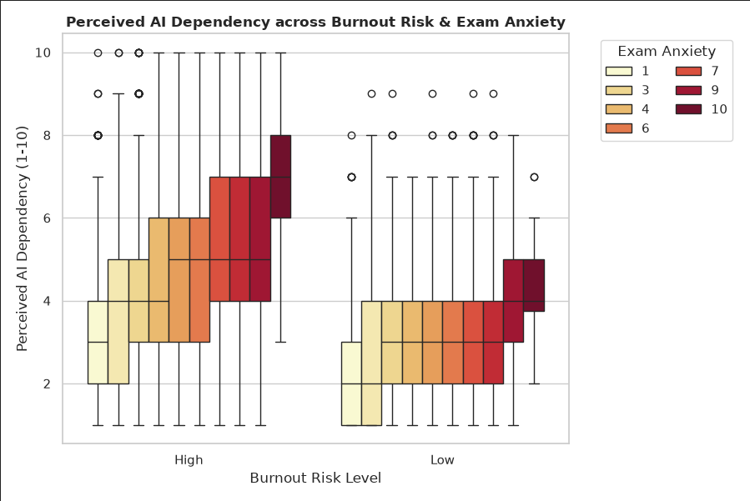
The box plot shows how students' perceived AI dependency (1–10) varies according to their burnout risk level and exam anxiety level. Each box/bar represent Exam Anxiety levels.
- Low burnout risk level: AI dependency is generally lower, with most median values around 2–4.
- High Burnout Risk: Students generally show higher AI dependency with median values mostly around 3–6 depending on exam anxiety.
- Outliers: This also shows the data outliers as a dot.
- Exam Anxiety: Within the High burnout group, higher anxiety levels tend to be associated with higher AI dependency.
Specific Research Question
- Specific Research Question: What is the relationship between students generative AI usage (Weekly_GenAI_Hours, Perceived_AI_Dependency) and their psychological well-being (Anxiety_Level_During_Exams, Burnout_Risk_Level)?
- Specific Hypothesis: We hypothesized that higher Ai usage on academics leads to less burnout risks and stress thinking.
- Findings: The graphs reveal that students spending more time on Ai most likely to develop burnout and stress.

