LAB Activity 2
Members:
Bazar, Cyrus Troy C.
Fernandez, Bryan
Company and Business problems
Jollibee Foods Corporation (JFC) is a global quick-service restaurant enterprise operating thousands of stores worldwide. This analysis focuses on JFC's Supply Chain Operations and Inventory Management, a core business area responsible for store-level replenishment, waste control, and product availability across its restaurant network.
The central business problem is a lack of real-time visibility and integrated analytics across store inventory and distribution networks, leading to stockouts during peak hours and excessive food wastage. The purpose of the proposed Business Intelligence (BI) system is to centralize supply chain data into a single platform—delivering automated demand forecasting and real-time tracking to help managers optimize stock levels, prevent stockouts, and reduce waste.
Stakeholder and BI Users
Stakeholder | Information Needed | Decision Supported
VP of Global Supply Chain (Primary Decision-Maker) | Real-time aggregate inventory levels, demand forecasts across regions, supplier lead times, and fulfillment efficiency metrics | Strategic decisions on supplier contract renewals, buffer stock allocations, central distribution center capacity planning, and regional logistics investments
Store Operations Manager | Daily store-level raw material consumption rates, real-time stock-on-hand counts, localized product sales trends, and shelf-life expiration alerts | Operational decisions on daily store ordering quantities, localized safety stock levels, shift prep planning (e.g., batch cooking chicken), and waste reduction measures
Procurement Specialist | Commodity price trends, supplier order fulfillment rates, raw material defect/return ratios, and delivery lag times | Tactical decisions on daily purchase order placement, vendor re-evaluation or re-allocation, and mitigating raw material supply disruptions

Management Questions:
- Demand Forecasting & Stockouts: Which menu items experience the highest frequency of localized stockouts during peak hours, and how accurately does our current safety stock predict shifts in store-level demand across regions?
- Waste & Cost Control: What is the financial cost of raw material waste and spoilage per store brand, and which specific inventory items contribute most heavily to shelf-life loss before utilization?
- Supplier Performance: Which third-party suppliers consistently fail to meet on-time, in-full (OTIF) delivery targets, and how do those supplier delays impact store inventory fulfillment cycles?
Data Sources
Data Source | Example Data | InternalExternal | Purpose
Store Point-of-Sale (POS) Systems | Itemized sales transactions, order timestamps, payment methods, channel type (dine-in, drive-thru, delivery app), raw material usage triggers | Internal | Tracks real-time product demand and inventory depletion rates at the store level to feed short-term demand forecasting and automated replenishment algorithms.
Enterprise Resource Planning (ERP) System (e.g., SAP/Oracle) | Central warehouse stock levels, purchase orders, goods receipts, transfer orders between central commissaries and stores, stock adjustments, batch/lot tracking | Internal | Provides centralized visibility over inventory movement across distribution centers, tracks safety stock levels, and reconciles bulk supply availability against store purchase requests.
Supplier & Logistics Portals (SCM / Portal API) | Purchase order confirmations, expected shipment delivery dates, backorder statuses, On-Time In-Full (OTIF) fulfillment rates, transit temperature logs | External | Monitors vendor performance, tracks inbound raw materials in transit, and alerts logistics teams to potential supply delays before they cause store-level stockouts.
Food Waste & Spoilage Logs | Daily waste counts, discarded raw material weight, reason codes (e.g., past expiration, prep error, cold chain break), unit costs of discarded items | Internal | Measures the cost of lost inventory, identifies high-spoilage items, and helps optimize prep schedules and safety stock rules to minimize food waste.
Data Collection, Integration, and Cleaning
ETL Process:
- Extract: Data is gathered from disparate source environments on automated schedules. Real-time store POS sales and inventory depletion logs are extracted via API calls at 15-minute intervals. Bulk operational data from JFC's central ERP (SAP/Oracle) and regional waste logs are batch-extracted nightly using scheduled SQL queries. Supplier order statuses are pulled from external vendor portals via secure REST APIs.
- Transform: Raw data is fed into a staging area to be cleaned and formatted. Timestamps are converted to a single standard timezone (PST), product menu codes are matched to uniform SKU master numbers (e.g., mapping "Yumburger" store sales to "Beef Patty" raw inventory units), and missing data entries are flagged. Data ranges are validated to strip out system errors (e.g., negative waste quantities or missing supplier lead times).
- Load: The transformed data is loaded into a centralized Data Warehouse (e.g., Snowflake or AWS Redshift) using a Star Schema layout. Fact tables store transactional data (POS sales, stock transfers, waste entries), while Dimension tables hold reference details (Store Location, Product SKUs, Supplier Profiles). This centralized storage provides clean data directly to BI dashboards for real-time reporting.
Data Quality Problems & Proposed Solutions
Data Problem | Example | Proposed Solution
Duplicate data | A store POS experiences a temporary network lag and re-transmits the same hourly sales batch twice, creating duplicate raw material depletion records. | Implement a deduplication rule during the ETL transform phase that checks for unique primary key combinations (Store_ID + Transaction_ID + Timestamp) and drops duplicate records before loading.
Missing values | A daily waste log is submitted by a store manager without filling in the Reason_Code field (e.g., leaving it blank instead of selecting "Expired" or "Prepped Overstock"). | Program default value imputation during transformation (e.g., flagging blank fields as "Unspecified Waste") and enforce mandatory form field entry at the store-level input UI to prevent future omissions.
Inconsistent formats | Dates are logged as DD/MM/YYYY in Philippine stores, MM/DD/YYYY in US locations, and currency values are recorded in PHP, USD, and SGD across regions. | Standardize all date values into ISO 8601 format (YYYY-MM-DD) and apply automated currency conversion using daily central bank exchange rates to store all financial metrics in base PHP currency.

Data Storage
Recommended Storage Solution:
A Cloud-Based Data Warehouse (e.g., Snowflake or AWS Redshift)
What Will Be Stored:
Structured operational data, including store POS sales transactions, central warehouse stock levels, purchase orders, supplier delivery records, and daily store food waste logs.
Why Centralized Storage is Necessary:
Jollibee's data is currently scattered across individual store registers, regional distribution systems, and local spreadsheets. Centralizing this data creates a single "source of truth," ensuring every manager works from identical, consistent metrics across all locations.
Why It Fits the Business Case:
- Seamless Scalability for Expansion: As Jollibee opens new stores or acquires new brands globally, a cloud data warehouse instantly adds storage and compute power without needing costly physical server installs.
- Fast Analytical Performance: It is built specifically to process large volumes of data quickly, allowing BI dashboards to deliver real-time stock alerts and trend reports across hundreds of stores at once.
- Easy Onboarding: New store branches and franchise locations can be connected to the central system quickly with standardized reporting.

Data Analysis
Type of Analytics | Main Question | Business Question for the Company
Descriptive | What happened? | What were our total food waste costs and stockout frequencies across all Jollibee store branches by region over the last quarter?
Diagnostic | Why did it happen? | Why did specific store locations in Metro Manila experience severe chicken ingredient stockouts during weekend peak hours?
Predictive | What may happen next? | What will be the forecasted demand for raw materials (e.g., burger patties and chicken) for each store during the upcoming holiday season?
Prescriptive | What should we do? | What automated reorder quantities and safety stock levels should the system recommend to each store manager to minimize wastage while maintaining a 99% fulfillment rate?
BI Presentation and Visualization
To communicate the analysis results to decision-makers, Jollibee Food Corporation will use Interactive Analytics Dashboards in Power BI. An analytics application dashboard provides real-time tracking, drill-down capabilities by region or store, and visual alert indicators.
KPI / Information | Intended User | Recommended Visualization | Purpose
Stockout Rate & Incident Frequency | Store Operations Managers & Regional Directors | Bar Chart with Red Threshold Line | Highlights store locations experiencing ingredient shortages during peak hours, enabling regional leads to reallocate safety stock.
Food Waste & Spoilage Variance | Store Operations Managers & Inventory Specialists | Donut Chart / Breakdown Pie Chart | Displays total financial loss from expired or spoiled raw materials grouped by category (e.g., poultry, produce, sauce bases).
Inventory Turnover Ratio | Supply Chain Analysts & Procurement Specialists | Line Chart (Month-over-Month Trend) | Tracks how rapidly inventory is moved and replenished across central commissaries, preventing overstocking.
On-Time In-Full (OTIF) Delivery Rate | VP of Global Supply Chain & Logistics Managers | Gauge Chart / Metric Card with Target Line | Measures supplier delivery performance against contract agreements to identify vendor delays before they impact store operations.
Business Action Plan
Possible BI Insight | Recommended Management Action
Peak-Hour Demand Bottlenecks: Analysis reveals that 65% of store stockouts for key items (e.g., Chickenjoy) occur specifically on Friday and Saturday evenings between 6:00 PM and 8:00 PM due to static daily prep schedules. | Transition from fixed daily batching to a dynamic, hourly prep schedule driven by predictive POS demand forecasts to ensure high-demand items are prepped ahead of peak windows.
High Spoilage in Perishable Produce: Data shows that short-shelf-life ingredients (such as lettuce and tomatoes) account for 40% of total store-level food waste, driven by over-ordering safety stock on weekdays. | Adjust automated reorder parameters in the inventory system to lower weekday safety stock buffers for perishable items and implement daily automatic order adjustments based on actual store foot-traffic trends.
Supplier Delivery Inconsistencies: BI tracks reveal that a key regional poultry supplier consistently averages a 2-day delivery lag and an 82% On-Time In-Full (OTIF) rate compared to the required 95% target. | Reallocate 25% of purchase order volumes to higher-performing secondary suppliers in that region and enforce contractual penalty clauses with the underperforming vendor.
Over-Stocking in Low-Volume Branches: Certain suburban and provincial branches maintain excess raw material buffer stocks exceeding 14 days of inventory, raising holding costs and increasing cold-chain spoilage risks. | Lower the maximum inventory thresholds for slow-moving SKUs at low-volume stores and re-route surplus stock to high-demand central commissaries nearby.
Promotional Surge Discrepancies: Historical data indicates that marketing campaigns and new menu launches cause localized stockouts within 48 hours because store reordering limits do not automatically adjust for promotional spikes. | Integrate marketing campaign calendars directly into the BI demand-forecasting module to automatically increase store replenishment thresholds 5 days prior to a promotional launch.

Analytics System vs Technology System
Analytics System Components | Technology System Components
1. Demand Forecasting & Inventory Optimization Models (Statistical algorithms and predictive rules used to project raw material consumption) | 1. Cloud Data Warehouse Infrastructure (Hardware, storage units, and database engines like AWS Redshift or Snowflake)
2. Key Performance Indicators (KPIs) & Metrics (Calculated business metrics such as Stockout Frequency, Waste Variance, and OTIF rates) | 2. ETL Pipeline & Data Integration Tools (Data ingestion software, API connectors, and transformation middleware)
3. Interactive Power BI Dashboards (Data visual layers, reports, and drill-down interfaces built for decision-makers) | 3. Store Point-of-Sale (POS) & ERP Databases (Transactional operational systems and local servers housing raw daily logs)
4. Automated Reorder & Spoilage Alert Rules (Prescriptive decision logic determining when and how much safety stock to order) | 4. Enterprise Network & Cybersecurity Protocols (Cloud security layers, encrypted API gateways, and user access management)
Difference Between Systems:
- The Technology System serves as the underlying technical foundation. It focuses on how data is captured, moved, stored, and secured using hardware, cloud infrastructure, networking, and software systems.
- The Analytics System builds upon that technology layer. It focuses on how raw data is transformed into business value using analytical logic, mathematical models, visualization layouts, and decision-making frameworks to guide management actions

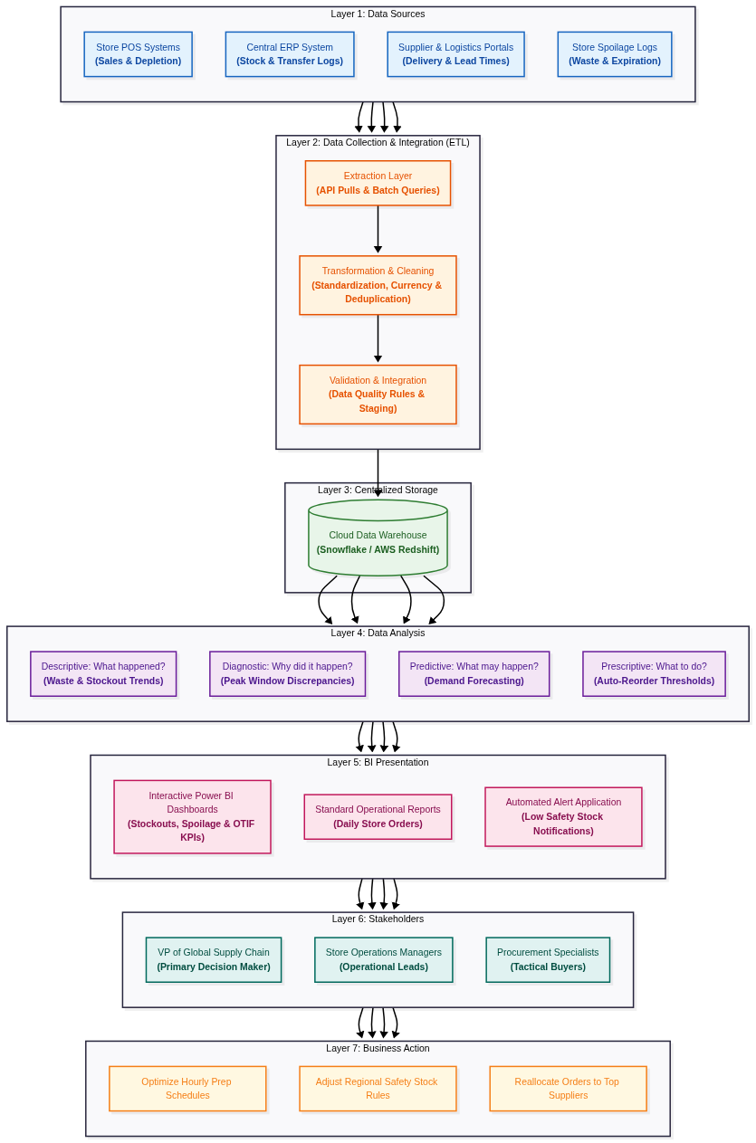
BI Architecture Diagram Requirements

