Data-Driven Insights into Global Internet Censorship
Team Members
Bazar, Cyrus Troy C.
Dataset Collection and Description
AI Impact on Students
Source: Huggingface / Public Dataset
Dataset Link: https://huggingface.co/datasets/emperor-mew/global-censorship-index
Number of Variables: 8
Number of Observations: 37518
Variables
Column | Non Null Count | Dtype | Description
country_code | 200 non-null | str | Country Codename
country_name | 200 non-null | str | Country name
censorship_score | 200 non-null | int64 | Score on how intense the censorship are
threat_level | 200 non-null | str | Categorical severity of the censorship threat (e.g. high, severe)
block_rate | 200 non-null | float64 | The ratio or percentage of measurements that were blocked
total_measurements | 200 non-null | int64 | Total number of network connectivity tests conducted
blocked_measurements | 200 non-null | int64 | Number of network measurements that resulted in a blocked connection
web_connectivity_tests | 200 non-null | int64 | Number of general website connectivity tests performed
telegram_tests | 200 non-null | int64 | Telegram app connectivity tests
whatsapp_tests | 200 non-null | int64 | whatsapp app connectivity tests
isp_count | 200 non-null | int64 | How many Interner providers
top_blocking_isps | 200 non-null | object | Top isp blocking on a country
data_source | 200 non-null | str | Source of the data
last_updated | 200 non-null | str | Date/timestamp when it is updated
rank | 200 non-null | int64 | Country rank

Unit of Observation
Each row represents a Country.

Data Collection
This dataset came from Huggingface.

Broad research questions
- Are messaging services (WhatsApp and Telegram) blocked at disproportionately higher rates than general web traffic (web_connectivity_tests) in countries classified under high or severe threat levels?
- Does having a higher number of active ISPs (isp_count) make widespread internet censorship statistically more difficult to enforce compared to centralized network infrastructures?
- How accurately can a country's censorship rank be predicted using the combination of block_rate and specialized app testing data (telegram_tests, whatsapp_tests)?

Data Exploration
The dataset was first inspected to determine its size, variables, data types, missing values, duplicate records, and possible invalid values.
The dataset contains 15 variables and 28856 observations. Initial inspection showed that 8 variables were numeric and suitable for statistical analysis.

Data Cleaning and Pre-processing
The following preprocessing steps were performed:
- Checked the dataset for missing values.
- Checked for duplicate records.
- Checked whether numerical variables contained invalid values.
- Verified the data types of each variable.
- Examined extreme values and possible outliers.
- Removed or corrected invalid records where necessary.
After preprocessing, the dataset was considered suitable for exploratory analysis.

Missing data analysis
Variable | Number of nulls
country_code | 0
country_name | 0
censorship_score | 0
threat_level | 0
block_rate | 0
total_measurements | 0
blocked_measurements | 0
web_connectivity_tests | 0
telegram_tests | 0
whatsapp_tests | 0
isp_count | 0
top_blocking_isps | 0
data_source | 0
last_updated | 0
rank | 0
This shows that theres no missing values in our dataset, so we don’t need to handle missing values.

Descriptive Statistics
censorship_score to web_connectivity_tests:
Metric | censorship_score | block_rate | total_measurements | blocked_measurements | web_connectivity_tests
count | 200.00 | 200.00 | 200.00 | 200.00 | 200.00
mean | 3.90 | 0.04 | 193902.24 | 15764.50 | 180289.88
std | 8.29 | 0.08 | 317353.32 | 54629.13 | 287684.48
min | 0.00 | 0.00 | 1.00 | 0.00 | 0.00
25% | 0.00 | 0.00 | 6.00 | 0.00 | 0.00
50% | 0.00 | 0.00 | 61.00 | 0.00 | 0.00
75% | 4.00 | 0.04 | 315255.75 | 10753.00 | 307590.25
max | 61.00 | 0.61 | 1259865.00 | 541311.00 | 929915.00

Telegram_tests to rank:
Metric | telegram_tests | whatsapp_tests | isp_count | rank
count | 200.00 | 200.00 | 200.00 | 200.00
mean | 6774.72 | 6820.98 | 6.68 | 100.50
std | 25078.75 | 25211.09 | 17.00 | 57.88
min | 0.00 | 0.00 | 0.00 | 1.00
25% | 0.00 | 0.00 | 0.00 | 50.75
50% | 0.00 | 0.00 | 0.00 | 100.50
75% | 3266.75 | 3254.75 | 7.00 | 150.25
max | 244253.00 | 242831.00 | 176.00 | 200.00

Visualization
Top 15 Countries By censorship score:
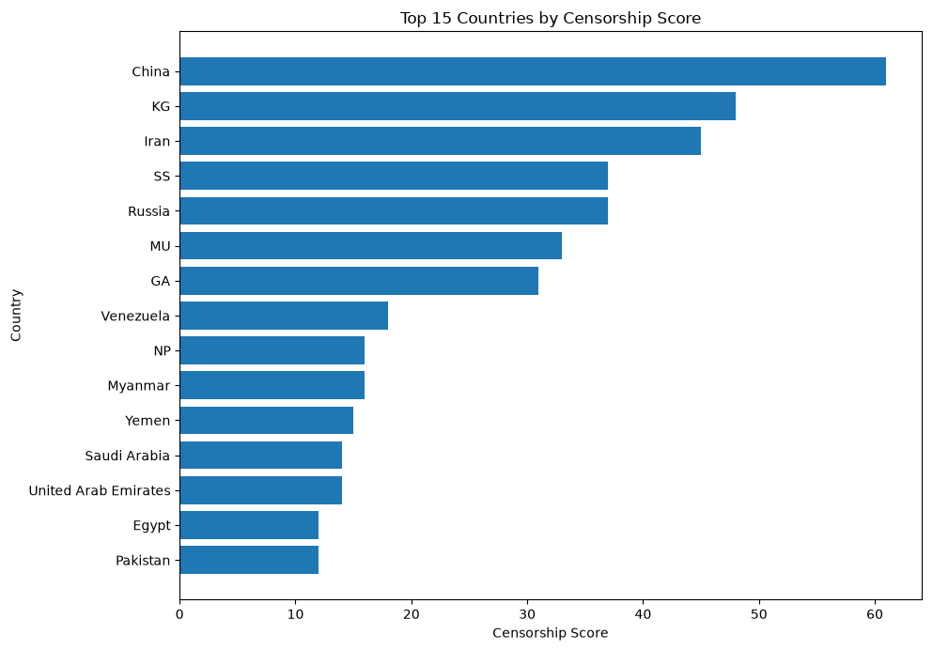
This horizontal bar chart shows the Top 15 Countries by Censorship Score.
- China has the highest censorship score, leading the list at over 60.
- KG (Kyrgyzstan), Iran, SS (South Sudan), and Russia follow with high censorship scores ranging between roughly 35 and 48.
- MU (Mauritius), GA (Gabon), and Venezuela show moderate censorship scores, staying between 18 and 33.
- Countries like NP (Nepal), Myanmar, Yemen, Saudi Arabia, United Arab Emirates, Egypt, and Pakistan round out the list with lower scores between 12 and 16.

Threat distribution:
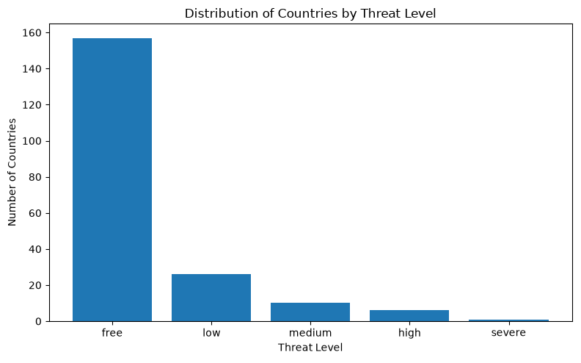
This vertical bar chart shows the Distribution of Countries by Threat Level.
- The free category represents the majority, with around 157 countries.
- The low category follows with 26 countries.
- The medium category consists of 10 countries.
- The high category includes 6 countries, while severe represents only 1 country.

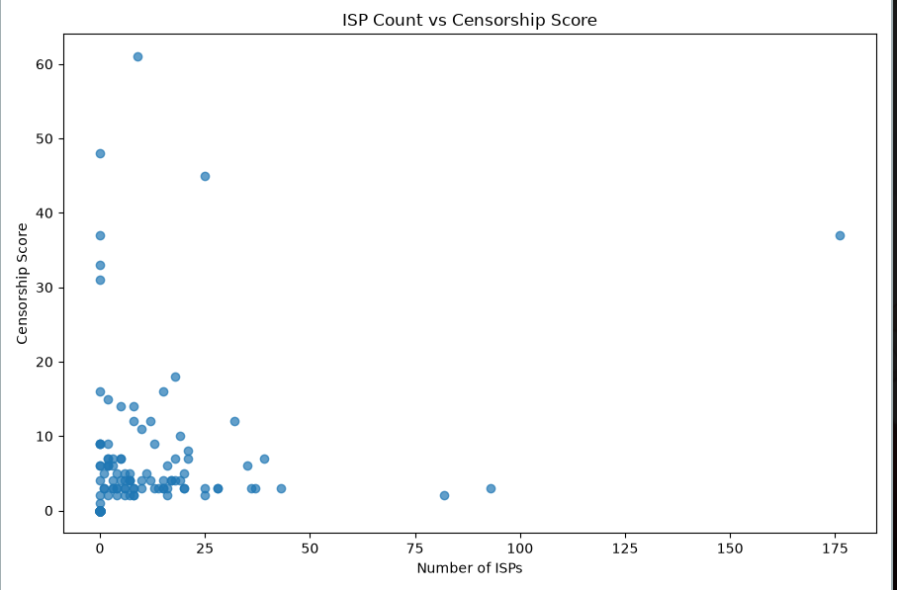
ISP count vs censorship score
This scatter plot shows the relationship between ISP Count and Censorship Score across countries.
- Most countries cluster heavily near the bottom-left, with low ISP counts (under 25) and low censorship scores (under 20).
- High censorship scores (above 30) appear mainly in countries with very low ISP counts (0 to 25), with China as a noticeable outlier near a score of 61.
- Russia serves as a major outlier on the far right, maintaining a high censorship score near 37 despite a high ISP count of 176.

Total Measurements vs. Block Rate by Threat Level
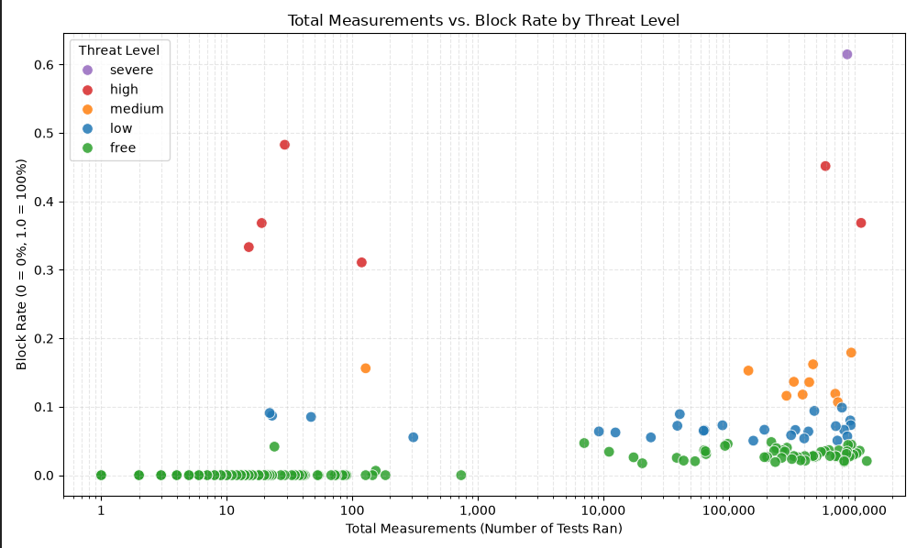
This scatter plot evaluates how testing volume aligns with detected block rates across threat categories:
- Free Category Cluster: Most countries categorized as "free" cluster near a block rate of 0.0, spanning low to high test volumes (up to 1,000,000+ tests).
- Severe & High Threat Levels: High (red) and severe (purple) threat countries consistently show elevated block rates ranging from ~0.30 up to 0.60+.
- Low Sample Noise: Several low-volume points (< 200 tests) show noticeable spikes in block rate due to small-sample variability.

Correlation Heatmap of Key Censorship Metrics
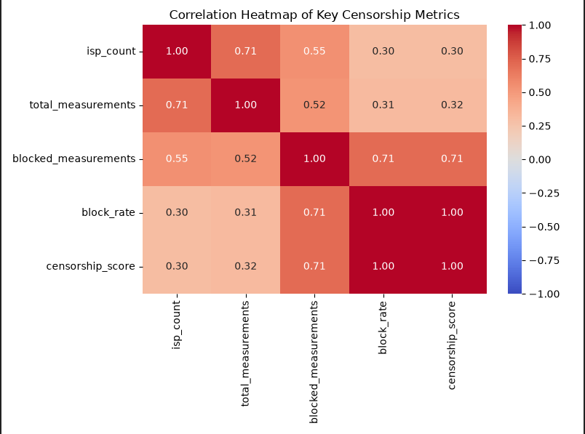
This heatmap measures the strength of linear relationships between core variables:
- Perfect Alignment (1.00): block_rate and censorship_score show a perfect positive correlation ($r = 1.00$), indicating that block rate directly drives the scoring metric.
- Volume Coupling (0.71): isp_count correlates strongly with total_measurements ($r = 0.71$), showing that countries with more service providers generate higher overall testing activity.
- Blocking Volume (0.71): blocked_measurements shows strong ties to both block_rate and censorship_score ($r = 0.71$).
- Weak Direct Impact (0.30): isp_count and total_measurements show weak positive correlations (~0.30 to 0.32) with block_rate and censorship_score.

Specific Research Question
- Specific Research Question: How does network infrastructure/testing density (isp_count, total_measurements) relate to a nation's experienced intensity of censorship (block_rate, censorship_score)?
- Specific Hypothesis: We hypothesized that increased isp_count would reduce a nation's censorship score via the presumed greater difficulty of universal blocking across multiple ISPs.
- Findings: Our visualizations suggest that isp_count has little direct relationship with censorship_score (r = 0.30), while censorship_score is directly explained by block_rate (r = 1.00) and indirectly explained by blocked_measurements (r = 0.71). Thus, while Russia has a large ISP market (176 ISPs), it has a high censorship score comparable to nations with much smaller ISP markets due to its high block_rate.

Conclusion
Analysis suggests that internet censorship intensity is primarily a function of policy, not network infrastructure constraints. While greater infrastructure diversity increases the aggregate number of tests (r = 0.71), the block_rate within each nation remains high enough to have a significant impact on censorship_score. State level censorship resistance seems to be unable to overcome the threat perception of any given government regardless of the market diversity at the ISP level.

