TRANSFORMING BARANGAY GOVERNANCE THROUGH TECHNOLOGY: DEVELOPING AN INFORMATION SYSTEM FOR POBLACIÓN   
DISTRICT I OF BARUGO, LEYTE

A Capstone Project

Presented to the

Faculty of the Department of Information Technology

College of Engineering

Eastern Visayas State University

Tacloban City

In Partial Fulfillment

of the Requirements for the Degree

Bachelor of Science in Information Technology

By

Jaymark P. Feniza

Dinah Marie D. Animos

Hazel Rosemarie T. Pontilla

June 2023

APPROVAL SHEET

The Capstone Project Study entitled COLLEGE OF INFORMATION AND COMPUTER STUDIES ONLINE INFORMATION SYSTEM prepared and submitted by Juan D. Dela Cruz, Peter R. Reyes, and Luke S. Santos in partial fulfillment of the requirements for the degree of BACHELOR OF SCIENCE IN INFORMATION TECHNOLOGY has been examined and is recommended for acceptance and approval for FINAL DEFENSE.

**LYRA K. NUEVAS, PhD**

Adviser

=============================================================

APPROVED by the members of the Evaluation Panel on FINAL DEFENSE with a grade of _________________.

|  |  |
| --- | --- |
| **CAPSTONE PROJECT COMMITTEE** | |
| **MEMBER A. PANELIST, MSIT**  Panelist | **MEMBER B. PANELIST, MSIT**  Panelist |
| **LEAD C. PANELIST, MSIT**  Lead Panelist | |

=============================================================

Accepted and approved in partial fulfillment of the requirements for the degree of BACHELOR OF SCIENCE IN INFORMATION TECHNOLOGY.

|  |  |
| --- | --- |
|  | **RAMON I. LIM, PME**  Dean, College of Engineering |
| **JESSIE R. PARAGAS, DIT**  Head, IT Department |  |
| July 9, 2024  Date of Defense |  |

ACKNOWLEDGEMENTS

The road to this point in your studies couldn’t have been travelled alone. Along the way, someone somewhere helped you. This is your chance to thank them.

The acknowledgments are personal for the student and may contain appropriate information, written in a professional manner, that the student may wish to share with the reader. There is no word limit, but the acknowledgments must not exceed two pages in length. Any quotes listed in this section need to be cited; however, use of copyrighted material in this section is discouraged.

TABLE OF CONTENTS

APPROVAL SHEET ii

ACKNOWLEDGEMENTS iii

TABLE OF CONTENTS iv

LIST OF TABLES vii

LIST OF FIGURES viii

ABSTRACT ix

Chapter I 1

INTRODUCTION 1

Objectives of the Project 2

Scope and Delimitations of the Project 3

Significance of the Project 3

Chapter II 4

THEORETICAL FRAMEWORK 4

Review of Related Literature 4

Concept of the Study 7

Definition of Terms 8

Chapter III 9

OPERATIONAL FRAMEWORK 9

Materials 9

Software 9

Hardware 9

Data 10

Systems Environment 11

Methods 12

SLDC Model 12

Analysis 13

Design 15

Implementation 16

Deployment 17

Evaluation 17

Chapter IV 18

RESULTS AND DISCUSSIONS 18

[Results by phase of study] 18

[Verification studies] 18

Chapter V 19

SUMMARY, CONCLUSIONS, AND RECOMMENDATIONS 19

Summary 19

Conclusions 19

Recommendations 19

REFERENCES 20

APPENDICES 21

1. Letter Request to Client 21
2. Relevant Source Codes 21
3. Evaluation Tool 21
4. Sample Input/Output/Reports 21
5. User’s Guide/Manual 21
6. [Other Relevant Documents] 21
7. Acceptance Sheet 21
8. 20% Plagiarism in Grammarly 21

CURRICULUM VITAE 22

LIST OF TABLES

Table 3‑1. Software Specifications 9

Table 3‑2. Hardware Specifications 9

Table 3‑3. Data Requirements 10

Table 3‑4. Functional and Non-functional Requirements 13

LIST OF FIGURES

Figure 2‑1. Conceptual Framework 7

Figure 3‑1. Locale 11

Figure 3‑2. Organization Chart of the Barangay 11

Figure 3‑3. Iterative SDLC Model 12

Figure 3‑4. Use Case Diagram 14

Figure 3‑5. Context Diagram 14

Figure 3‑6. Data Flow Diagram 15

Figure 3‑7. System Architecture 16

ABSTRACT

Insert your abstract here. This portion is not to be indented and should be clear, concise, and complete. As much as possible, limit the introductory part to a few sentences and make sure that the last sentence reiterates the achievement of the general objective of the research.

The last sentence of the abstract must start with the word “Keywords:” followed by project area [select appropriate project area as written here: Software Development, Cybersecurity, Game Development, E-Learning System, Interactive System, Information Kiosks, Network Design and Implementation], capstone project adviser’s full name, and up to five additional keywords that are included in the abstract.

Example of last sentence: Keywords: Game Development, Prof. Juan Cruz,

multiplayer, interactive, social, educational, hobby

# Chapter I

INTRODUCTION

Information and communication technology (ICT) refers to the technologies and tools used for managing, processing, storing, and communicating information. ICT encompasses a wide range of technologies, including computers, software applications, telecommunications networks, internet services, and digital devices.It plays a crucial role in various aspects of our lives, such as education, business, government, communication, entertainment, and more.

In recent years, there has been a growing recognition of the importance of ICT for improving governance and public service delivery in the Philippines. The government has launched various initiatives aimed at promoting the use of ICT in local governance, such as the Barangay Integrated Development Approach for Nutrition Improvement (BIDANI) program, which seeks to leverage ICT to improve nutrition outcomes at the barangay level (DICT, 2021). Additionally, the COVID-19 pandemic has highlighted the crucial role of ICT in ensuring continuity of government services and communication during times of crisis, (Lagura, 2021).

Barangay system is a fundamental component of local governance in the Philippines. As the smallest administrative unit in the country, barangays play a crucial role in delivering basic services and implementing government programs at the grassroots level (Department of the Interior and Local Government, 2019). However, the barangay system is facing numerous challenges, including limited resources, weak capacity, and inadequate infrastructure (Balderrama, 2018). Moreover, recent changes in the political landscape, such as the shift to federalism, have raised questions about the future of the barangay system and its place within the larger framework of governance, (Pilapil, 2018).

Despite the importance of the barangay system, there is a lack of comprehensive research on this topic. While some studies have examined specific aspects of barangay governance, such as community participation and local leadership (Mirafuentes, 2017), there is a need for more in-depth and nuanced research that explores the complexities of the system as a whole. By addressing this gap in the literature, this research aims to provide a better understanding of the challenges and opportunities facing the barangay system in the Philippines.

The proposed project intends to tackle the issues present in Barangay Población District I, Barugo, Leyte. Specifically, the project aims to address three major problems: first, the time-consuming, error-prone, and inefficient information retrieval process of records on barangay inhabitants; second, the inefficient and labor-intensive process of updating the records of barangay inhabitants; and third, the unwieldy and inconvenient record-keeping of transactions for document requests, such as certificates of residency and indigency. By identifying and addressing these problems, the project seeks to provide potential solutions that can enhance the efficiency and effectiveness of record-keeping processes in the barangay, ultimately improving the delivery of public services to the residents.

## Objectives of the Project

The general objective of the project is to develop an information system for Población District I, Barugo, Leyte for managing records of barangay inhabitants and logging of document requests. Explode the general objective into Specific Objectives that will help realize the proposed study.

Specifically, the project aims to accomplish the following:

1. To compare the time taken to retrieve records manually versus using the system.
2. To compare the time taken to furnish the requested documents manually versus using the system.
3. To evaluate the system's compliance with the ISO 25010 standard.

## Scope and Delimitations of the Project

The scope of the project covers the information and processes of the barangay hall of Poblacion District I. The system is focused on the tasks of managing the records of barangay inhabitants and document requests. It is designed to assist the barangay secretary and relevant staff in executing those tasks.

While the project aims to provide a system to aid in the aforementioned tasks of the barangay hall, it does not extend to functions outside the scope of the barangay level. This boundary is defined for the implementation to be effectively carried out within the defined scope.

## Significance of the Project

The project is significant towards improving the efficiency of managing records of barangay inhabitants and managing document requests.

Specifically, the project has significant benefits to the following population:

**Barangay Secretary/Staff**. The barangay secretary and relevant staff will be able to use the system to manage and access records of the barangay inhabitants and document requests.

**Barangay Residents**. Barangay residents may be able to obtain requested documents faster due to the functionality of the system to generate requested documents.

**Municipality of Barugo**. The municipality may be able to obtain more structured information on the barangay from the data stored by the system.

**Proponents**. The proponents stand to gain knowledge and experience in managing and implementing software projects.

**Future Researchers**. The proposed project may be used as a reference by future researchers in the pursuit of their own projects.

# Chapter II

THEORETICAL FRAMEWORK

This literature review aims to explore the related literature on the development and implementation of barangay information systems. The purpose of this review is to identify the features and technologies that were incorporated in existing systems. Furthermore, the review aims to explore the benefits and challenges to implementing information systems for barangays. By examining the existing literature, this review aims to provide insights and recommendations for the development and implementation of an effective and efficient information system that can contribute to the transformation of barangay governance through technology.

## Review of Related Literature

In a study by Carpio (2020) , a barangay management system was developed with various features, including registration of resident profiles, online complaint reporting, document requests with SMS notifications, and reports that aid in planning and implementation of projects. The system had three user roles—the barangay chairman, secretary, and residents. A protoype methodology was used, which involved creating and testing system features, graphical user interface, and scheduling iterations. This process ensured functionality and usability testing for an effective, efficient, and reliable system. The researcher also used data from the target local government unit to conceptualize the system, ensuring it met specific needs and requirements.

In another study (Villones, 2021), the developed barangay system incorporated several key features designed to enhance the information management and delivery of services within a barangay setting. One of these features included the ability to search and access barangay records efficiently, thereby enabling barangay officials to retrieve relevant information about their constituents with greater ease. The system also allowed for the effective management of health records, which are essential for identifying the health needs of barangay residents and providing timely interventions where necessary. Another notable feature of the system is the ability to generate comprehensive barangay reports, which serves as a valuable tool for planning and implementing targeted programs to address the needs of the community. In addition, the system offers graphical analysis of barangay census data, which can provide valuable insights into the demographic characteristics of the barangay, such as age distribution and gender balance. This information can be used to inform policies and programs aimed at improving the welfare of barangay residents. Overall, the system offers a range of features that can enhance the delivery of services and improve the quality of life for those living within a barangay.

In the system developed by Bondoc (2019), the System Development Life Cycle (SDLC) methodology was utilized in building the e-Barangay system. The system implemented features such handling documents such as Community Tax Certificate, Indigency Form, Business Permit, and many others. It also managed the list of barangay residents and projects. Furthermore, it provided a platform for complaints. Evaluation of the completed system was conducted by barangay officials and IT experts using the ISO 9126 stand, which quantified the benefit of the system in streamlining barangay processes, especially in managing document requests.

In another study (Aparici & Ruelan, 2018) that covered thirty (30) barangays, a web-based information system was developed to automate barangay processes such as handling changes in the number of barangay households. The system included geotagging for locating commodities using the Google Maps Application Interface (API). In addition to users at the barangay level, the system also has users at the municipal level. It was intended to give the municipality up-to-date information regarding the commodities and population in barangays. The use of geotagging technology in the system can be particularly helpful in identifying areas that require more attention and resources. However, safeguards should be in place to protect data privacy and security in developing a system with such features.

On the other hand, a study conducted by (Olipas et al., 2019) aimed to design and develop a web-based barangay information and record management system (BIRMS) that can assist barangay officials in their daily operations. The system provides features such as keeping, managing, and monitoring old and new files, creating and updating the barangay profile, changing the details of the census, disseminating old and upcoming activities, and managing transactions. The researchers utilized the prototype methodology in developing the system, which involves creating and testing system features, graphical user interface, and scheduling iterations. This process served as the foundation for system development, which involved functionality and usability testing to ensure the effectiveness, efficiency, and reliability of the developed system. Additionally, the researchers utilized available data from the target barangay to conceptualize the entire system.

A website application developed by (Andal et al., 2023) comprises features that enables barangay officials to manage the barangay's information effectively. These features include but are not limited to the organization, prediction, modification, and identification of datasets related to personal information, barangay identification, certificates, and income records. The system has three connected users: the admin, staff, and residents. The administrative responsibilities involve the management of citizen data, creation of new staff accounts, document printing for residents, and customization of the login page banner. The staff members are responsible for managing resident credentials and printing certificates upon request. The residents can access the kiosk to view their information and update their personal data to the administrators and staff. The Barangay Management System will display the data to all users.

Based on the review of the related systems, the researchers conclude that while existing systems were shown to be effective in streamlining administrative processes and managing data, they lack a crucial feature—the ability to generate requested documents with pre-filled information from the database. This poses a significant challenge for barangays in terms of time spent on manual data input and document creation. Thus, this study emphasizes the need to incorporate a document generation function in barangay information systems to better serve the needs of the community.

## Concept of the Study

BARANGAY INFORMATION SYSTEM

INPUT

OUTPUT

BARANGAY INHABITANTS' RECORDS

DOCUMENT REQUEST

REPORTS ON BARANGAY INHABITANTS

REQUESTED DOCUMENT + TRANSACTION LOG

Figure ‑. Conceptual Framework

The conceptual framework of the project shows a simplified view of the function of the system. The inputs of the system are the records of barangay inhabitants and document requests. The records of barangay inhabitants will include personal information, residency status, and other relevant data. Document requests may include certificates of residency and indigency.

The main function of the system is to manage and organize the records of barangay inhabitants and document requests. The system will allow for the logging and tracking of document requests. The outputs of the system are reports on barangay inhabitants and requested documents. The system will generate reports that aid in the planning and implementation of targeted programs. These reports will provide accurate and up-to-date information on the population and document requests in the barangay, allowing for more efficient retrieval of information.

## Definition of Terms

The definition of terms is essential in a study as it establishes a shared understanding and clarity of key concepts within the research domain.

**API**. Stands for Application Programming Interface. It is a set of protocols, tools, and routines used by software applications to communicate with each other

**Barangay**. The smallest administrative unit of the Philippine government (PSA, n.d.). In this project, this refers to level of the locale on which the project is conducted.

**Document Request**. Refers to a process in which an individual or organization formally requests a document or information from another party. In the context of the project, this refers to the process of an individual or business requesting a document from the barangay.

**Figma**. A cloud-based design tool used for creating user interfaces, icons, and other graphics for web and mobile applications.

**Git**. A version control system used to track changes in software code and collaborate on projects. It will be used to save snapshots of the source code of the system.

**GitHub**. A web-based platform that provides a version control system through Git and provides collaborative tools for software development projects.

**Information System**. A is a set of components that work together to collect, store, process, and distribute data and information within an organization. The information system in the project will work within the context of the barangay.

**Transaction Log**. A record of all the transactions or activities that occur within a system or application. Specifically, it is used to keep track of document requests made through the barangay system.

# Chapter III

OPERATIONAL FRAMEWORK

## Materials

### Software

Table ‑. Software Specifications

|  |  |  |  |
| --- | --- | --- | --- |
| Software | Description | Vendor | Version |
| Windows 11 | Operation system | Microsoft | 22H2 |
| Visual Studio Code | Source-code editor | Microsoft | 1.79 |
| Google Chrome | Web browser | Google | 144.0 |
| Git | Version control system | Git Development Community | 2.39 |
| GitHub Desktop | Git/GitHub GUI | GitHub | 3.2 |
| CPython | Interpreter for Python language | Python Software Foundation | 3.11 |
| Django | Python-based web framework | Django Software Foundation | 4.1 |

The table above indicates the software used for developing the system. Software tools such as Git and GitHub Desktop are used for tracking changes to source code, while Django serves as the framework for developing and testing the system.

### Hardware

Table ‑. Hardware Specifications

|  |  |  |  |  |
| --- | --- | --- | --- | --- |
| Name | Vendor | Processor | Memory | Storage |
| ASUS Laptop | ASUS | Intel Core i3 11th Generation | 8 GB | 512 GB |
| Acer Laptop | Acer | Intel Core i5 11th Generation | 8 GB | 500 GB |

The table above specifies the vendor and basic hardware specifications of the devices used in developing the system.

### Data

Table ‑. Data Requirements

|  |  |  |  |
| --- | --- | --- | --- |
| Name | Description | Source | Year Acquired |
| RBI Form A | Record form barangay inhabitants by household | Barangay Secretary | 2023 |
| RBI Form B | Record form for individual barangay inhabitant | Barangay Secretary | 2023 |
| Logbook | Transaction log for document requests | Barangay Secretary | 2023 |

The table above indicates the materials used for identifying the type of information the system must contain and provide.

### Systems Environment

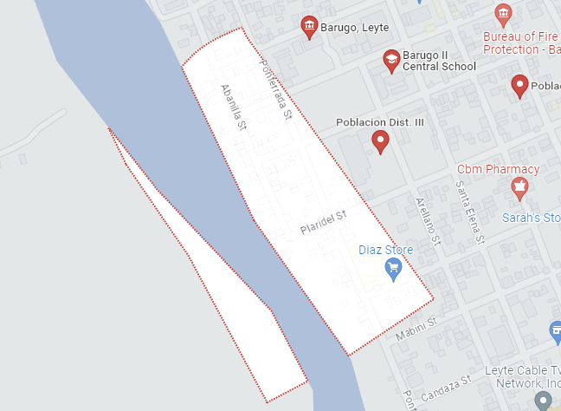

Figure ‑. Locale

The local of the project is at Poblacion District I of Barugo, Leyte. The barangay secretary was interviewed to acquire the issues with the present system and to acquire information for the development of the system.

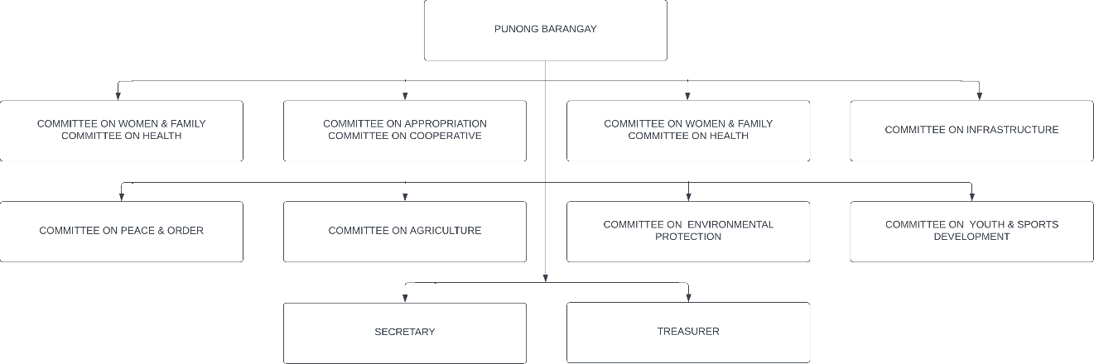

Figure ‑. Organization Chart of the Barangay

The figure above shows the organizational structure of the barangay local government unit. Shown are the barangay captain, secretary, treasurers, and councilors.

The population of the study are the barangay inhabitants of Poblacion District I of Barugo, Leyte. The current system relies on the manual record of writing down the each record of barangay inhabitants in both individual and household forms. The encoding of requested documents is manually done word processors and the transaction logbook is written by hand. The current system used by the barangay is prone to errors and more labor intensive due to the manual steps involved. The present medium of storage used is inefficient for the purposes of retrieval of facts and other information from the data collected by the barangay.

## Methods

### SLDC Model

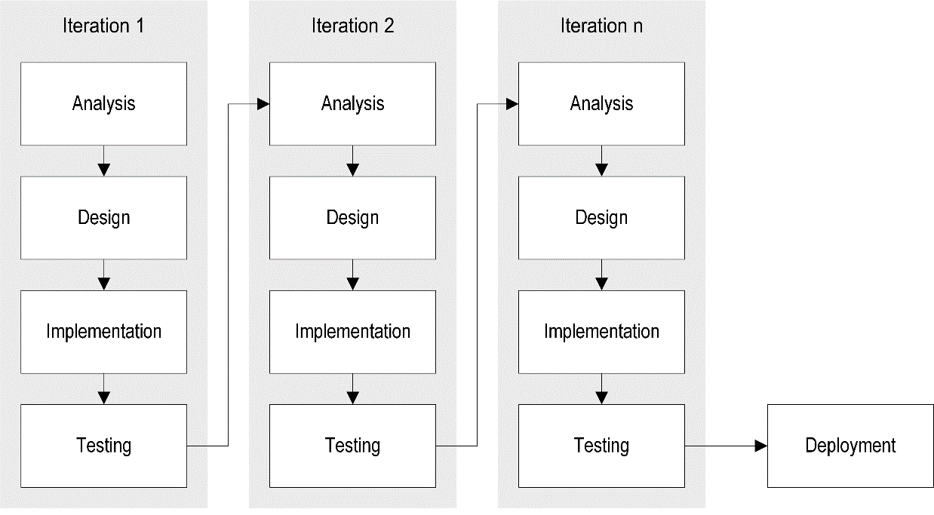

Figure ‑. Iterative SDLC Model

The development of the project follows the iterative model of software development. The iterative model divides the project into a series of iterations, with each iteration containing a set of phases. This model allows the implementation of a system that is enhanced as further requirements are identified.

### Analysis

In this phase, the requirements of the system are gathered and analyzed. The goal of the analysis phase is to understand the needs of the users and stakeholders, and to define the scope of the project.

Table ‑. Functional and Non-functional Requirements

|  |  |
| --- | --- |
| Functional Requirements | Non-Functional Requirements |
| 1. Records of Barangay Inhabitants (RBI) Management    1. Store RBI data in electronic form.    2. Retrieve demographic information on barangay inhabitants. 2. Documents Management    1. Store document requests in electronic form.    2. Retrieve information on pending payments for document requests    3. Store document requests.    4. Generate requested documents.    5. Confirm payment for document requests.    6. Retrieve a log of document requests. | 1. Performance    1. Run on a system with at least 1 GHz processor, 2 GB of memory, and 16GB of storage. 2. Security    1. Only authorized users can access system functionalities. 3. Usability    1. The user interface must be easy to use. 4. Maintainability    1. Business logic must be decoupled from the user interface.    2. Source code must be stored in a version control system (VCS). |

The proponents grouped the functional requirements into two categories: the records of barangay inhabitants (RBI) management, and documents management. For the non-functional requirements, the proponents consider the performance, security, usability, and maintainability characteristics of the system.

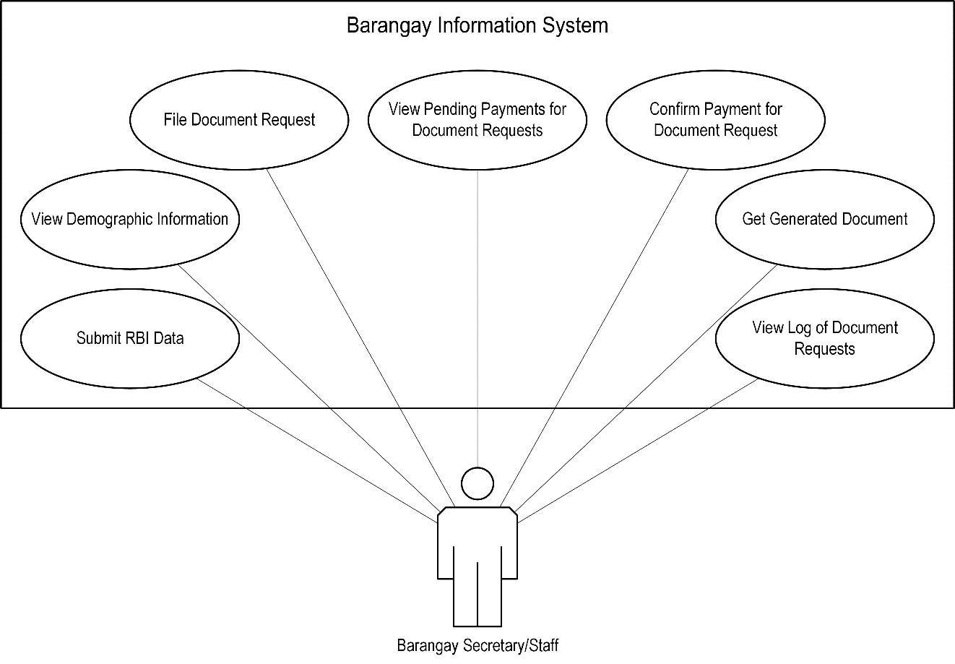

Figure ‑. Use Case Diagram

The use case diagram depicts the system’s functionality from the user perspective. The use cases for the barangay secretary/staff pertains to managing the records of barangay inhabitants and managing document requests.

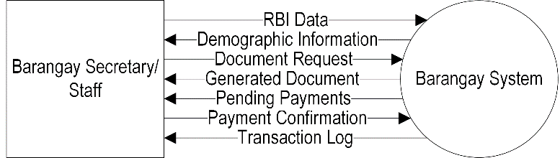

Figure ‑. Context Diagram

The context diagram depicts a high-level view of the system boundaries and the flow of information between the users and the system. The barangay secretary provides RBI data, which is used by the system to provide demographic information. The barangay secretary may also file document requests and confirm payments. The system is able to generate the requested documents and provide a log of document requests.

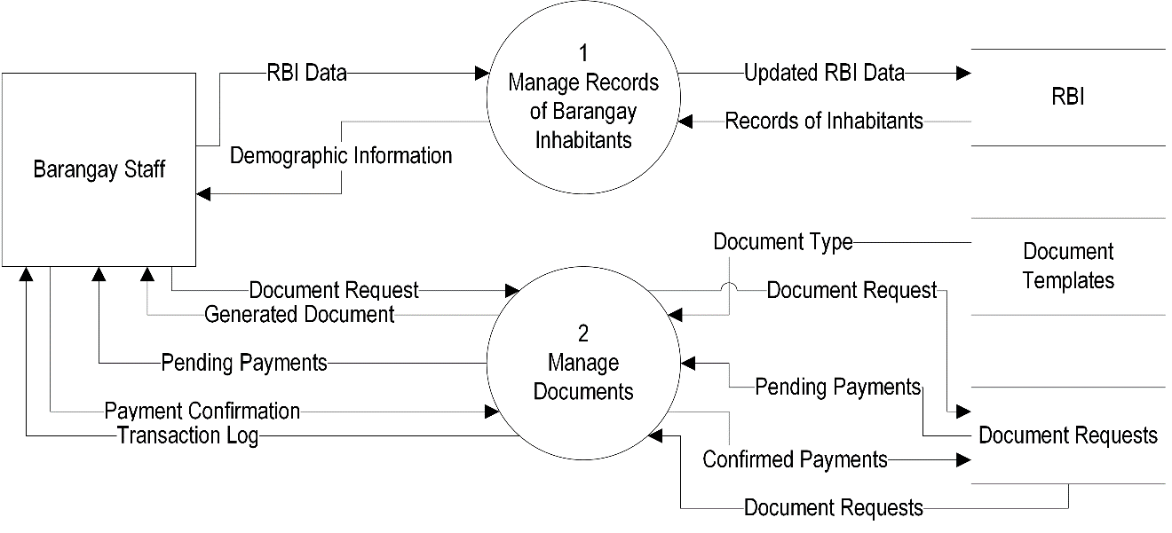

Figure ‑. Data Flow Diagram

The data flow diagram illustrates the flow of data between external entities, processes, and data stores. The barangay secretary/staff interacts with two major processes in the system: the management of RBI and the management of document requests.

### Design

In this phase, the system is designed. The goal of the design phase is to create a blueprint for the system, which includes the system architecture, the user interface, and the database design.

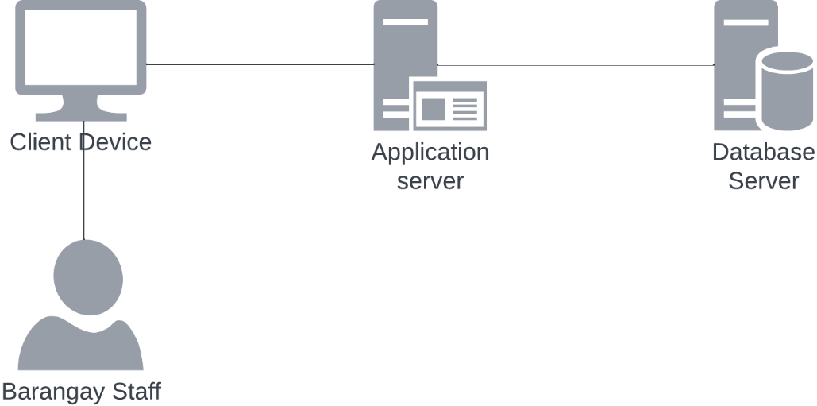

Figure ‑. System Architecture

The architecture of the system is based on a client-server model. A client is a software that sends requests for interacting with the system, whereas the server hosts the system and responds to requests.

### Implementation

In this phase, the system is built. The goal of the implementation phase is to create a working system that meets the requirements that were defined in the analysis phase. For the implementation of the system, the front-end tools used include Figma, Google Chrome, and Visual Studio Code. The back-end tool used is Visual Studio Code which serves as the primary source-code editor.

### Deployment

In this phase, the system is deployed to production. The goal of the deployment phase is to make the system available to the users.

### Evaluation

The project will use ISO 25010 as the standard for evaluating the system. It is a standard that provides a comprehensive framework for evaluating the quality characteristics of software products.

# Chapter IV

RESULTS AND DISCUSSIONS

## [Results by phase of study]

Name the phases of your study and give the results. Have as many headings as necessary depending on the number of experiments you did to attain your specific objectives. Provide the discussions. Present using Tables/ Graphs/ Screenshots/ Statistical tools or anything that will prove your claim.

## [Verification studies]

Lorem ipsum dolor sit amet, consectetur adipiscing elit, sed do eiusmod tempor incididunt ut labore et dolore magna aliqua. Ut enim ad minim veniam, quis nostrud exercitation ullamco laboris nisi ut aliquip ex ea commodo consequat. Duis aute irure dolor in reprehenderit in voluptate velit esse cillum dolore eu fugiat nulla pariatur. The headings above are only suggestive. Follow what is appropriate for your research work.

# Chapter V

SUMMARY, CONCLUSIONS, AND RECOMMENDATIONS

## Summary

Lorem ipsum dolor sit amet, consectetur adipiscing elit, sed do eiusmod tempor incididunt ut labore et dolore magna aliqua. Ut enim ad minim veniam, quis nostrud exercitation ullamco laboris nisi ut aliquip ex ea commodo consequat. Duis aute irure dolor in reprehenderit in voluptate velit esse cillum dolore eu fugiat nulla pariatur.

## Conclusions

The conclusions are direct statements that would prove the achievement of the specific objectives. The conclusions should have one-to-one correspondence to the specific objectives, i.e. if you have 4 specific objectives (a to d) then you should have 4 conclusions (1 to 4).

## Recommendations

Lorem ipsum dolor sit amet, consectetur adipiscing elit, sed do eiusmod tempor incididunt ut labore et dolore magna aliqua. Ut enim ad minim veniam, quis nostrud exercitation ullamco laboris nisi ut aliquip ex ea commodo consequat. Duis aute irure dolor in reprehenderit in voluptate velit esse cillum dolore eu fugiat nulla pariatur.

Lorem ipsum dolor sit amet, consectetur adipiscing elit, sed do eiusmod tempor incididunt ut labore et dolore magna aliqua. Ut enim ad minim veniam, quis nostrud exercitation ullamco laboris nisi ut aliquip ex ea commodo consequat. Duis aute irure dolor in reprehenderit in voluptate velit esse cillum dolore eu fugiat nulla pariatur.

REFERENCES

1. Books
2. Journals
3. Unpublished Materials
4. Online Sources

APPENDICES

Letter Request to Client

Relevant Source Codes

Evaluation Tool

Sample Input/Output/Reports

User’s Guide/Manual

[Other Relevant Documents]

Acceptance Sheet

20% Plagiarism in Grammarly

CURRICULUM VITAE

Lorem ipsum dolor sit amet, consectetur adipiscing elit, sed do eiusmod tempor incididunt ut labore et dolore magna aliqua. Ut enim ad minim veniam, quis nostrud exercitation ullamco laboris nisi ut aliquip ex ea commodo consequat. Duis aute irure dolor in reprehenderit in voluptate velit esse cillum dolore eu fugiat nulla pariatur.