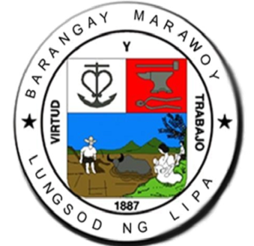

PAMAHALAAN NG BARANGAY MARAWOY

Marawoy, Lungsod ng Lipa

Tel. No. (043) 774 – 0571

OFFICE OF THE PUNONG BARANGAY

**HON. ERIC B. AFRICA**

**CITY MAYOR**

**LIPA CITY**

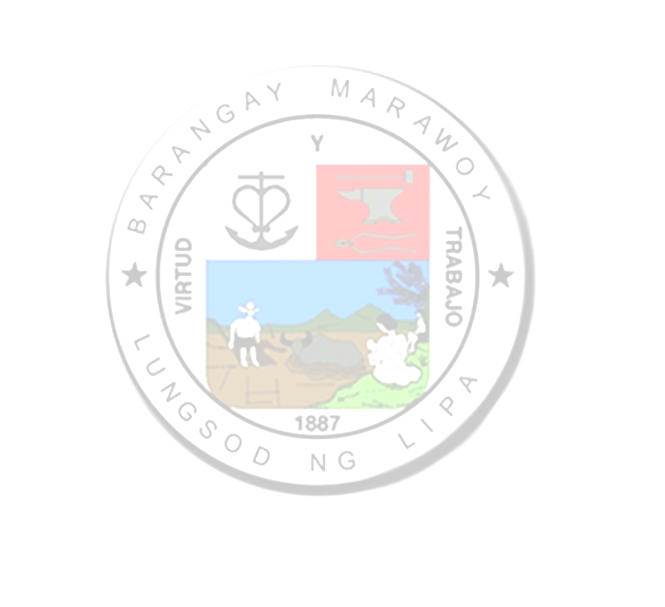

**C E R T I F I C A T I O N**

This is to certify that +++INS fullName+++**,** +++INS age+++years of age, presently residing at +++INS completeAddress+++, has no permanent source of income and belongs to the indigent families in our barangay.

Issued this +++INS currentDate+++, upon request of+++INS fullName+++**,** for +++INS purpose+++

**ROLANDO R. OLAN**

*Punong Barangay*

NOT VALID

WITHOUT DRY SEAL