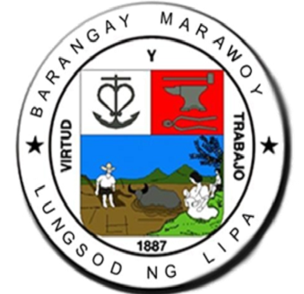

**PAMAHALAAN NG BARANGAY MARAWOY**

Marawoy, Lipa City

Tel. No. (043) 774-0571

OFFICE OF THE PUNONG BARANGAY 

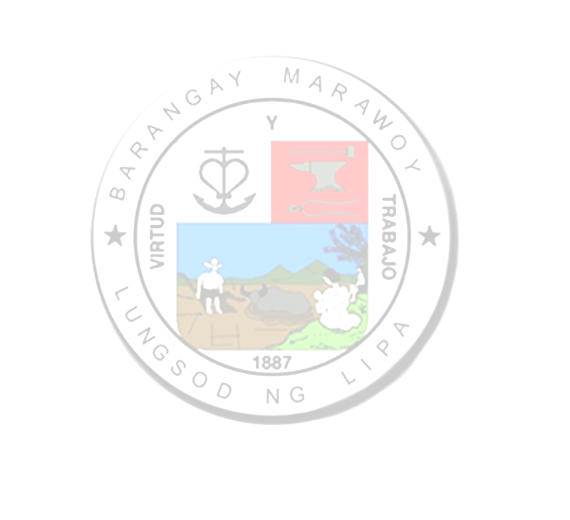

**RESIDENCE CERTIFICATE**

TO WHOM IT MAY CONCERN:

This is to certify that +++INS fullName+++**,** +++INS age+++ years of age, born on +++INS birthDate+++ in +++INS birthPlace+++, presently residing at +++INS completeAddress+++ since +++INS yearsOfResidence+++

Issued this +++INS currentDate+++, upon request of +++INS fullName+++**,** for whatever purpose it may legally serve.

**ROLANDO R. OLAN**

*Punong Barangay*

*Valid for 6 months only.*

