String Project Documentation

1. Us and our project:

1.1 Our project: String Project

1.2 Our team:

Boris Milev -10A - Scrum trainer - [BSMilev18@codingburgas.bg](mailto:BSMilev18@codingburgas.bg)

Martin Bakalov - 10A - Code checker - [MTBakalov18@codingburgas.bg](mailto:MTBakalov18@codingburgas.bg)

Stoicho Dimitrov - 10B - Developer front end - [SDDimitrov18@codingburgas.bg](mailto:SDDimitrov18@codingburgas.bg)

Zhelyazko Ivanov - 10B - Developer back end - [ZAIvanov18@codingburgas.bg](mailto:ZAIvanov18@codingburgas.bg)

1. Documentation content
2. Used Technologies
3. Diagram
4. Future plans
5. Used Technologies:

Visual Studio 

C++ 

1. Diagram:

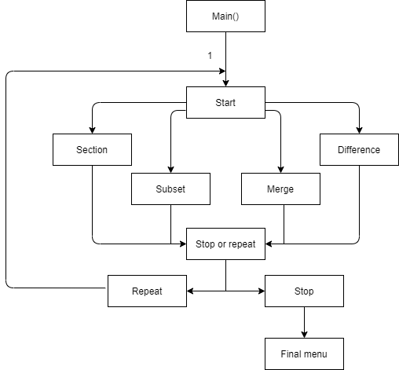

1. Future plans:
2. To add interface
3. More functionality
4. Expand the team