SIMATS ENGINEERING
ASSESSMENT TOOL 3
COURSE NAME::Data Warehousing and Data Mining

COURSE CODE: CSA16

COURSE OUTCOME COVERED

CO2: Apply suitable Data Pre processing techniques like Data cleaning,Data intergration,Data transformation and data Reduction ,for effective data preparation (BL3,BL4)
Assessment Tool Weightage: 20%

QUESTIONS: 10 Total Marks:20

Annexure A

CLASS TEST

Criteria | Understanding of Task (2) | Procedure & Execution (2.5) | Observation & Result (2) | Viva Voce / Conceptual Response (2) | Time Management & Presentation (1.5) | Total(10)
Weightage | 20% | 25% | 20% | 20% | 15% | 100%
Q1
Q2
Q3
Q4
Q5
Q6
Q7
Q8
Q9
Q10

Code of Conduct:

I B Bhavani Sankar (192411238)certify that this submission is my original work and that I have adhered to the guidelines specified for this assessment.
I understand that any violation of academic integrity rules will result in disciplinary action.

BSPNAIDU.//
Signature of the student:
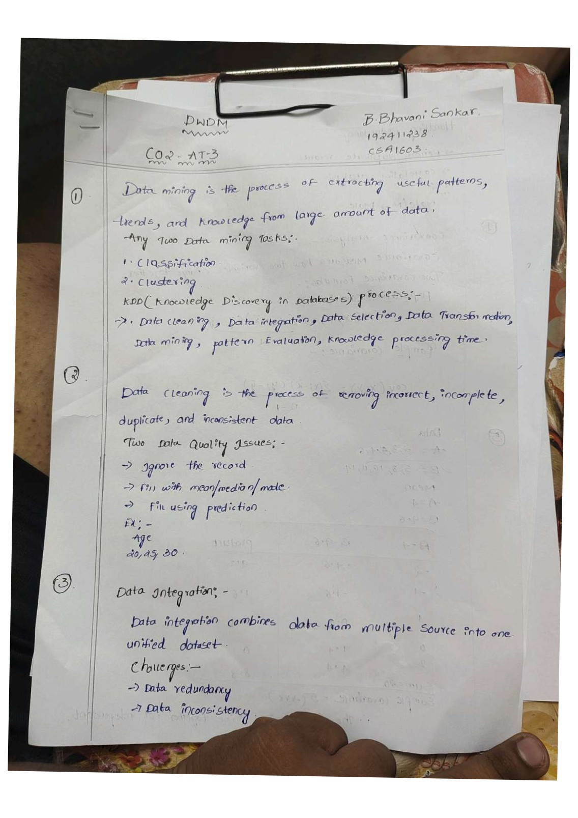
.
•
one-
