SIMATS ENGINEERING
ASSESSMENT TOOL 1
COURSE NAME: CSA16 COURSE CODE: Data Warehousing and Data Mining
COURSE OUTCOME COVERED
C03: Evaluate the effectiveness of classification techniques on real-time data for accurate prediction, enabling informed decision-making. (BL3,BL4,BL5) Assessment Tool Weightage: 50%
QUESTIONS: 5 Total Marks:50
Annexure A
Experiments
Criteria | Understanding  Of Concepts (2.5) | Experimental Design (3) | Use Of  Tools (2) | Analysis Of  Results (1.5) | Documentation  (1) | Total(10)
Wei hta e | 25% |  | 20% | 15% | 10% | 100%
1
Q2
3
(24
5
Code of Conduct:
I B Bhavani Sankar(192411238) certify that this submission is my original work and that I have adhered to the guidelines specified for this assessment.
I understand that any violation of academic integrity rules will result in disciplinary action.
Signature of the student:
BSP NAIDU.//
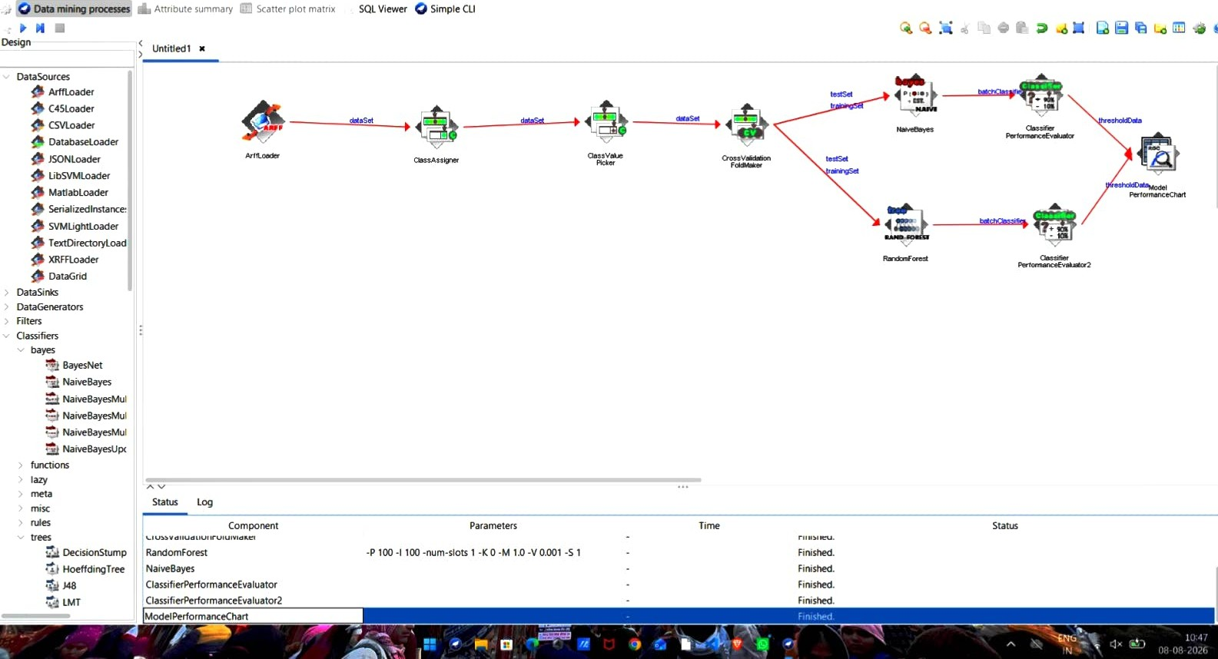
Program File Edit Insert View Wee KnowledgeFlow Environment o x
We,o Experiment Environment o x
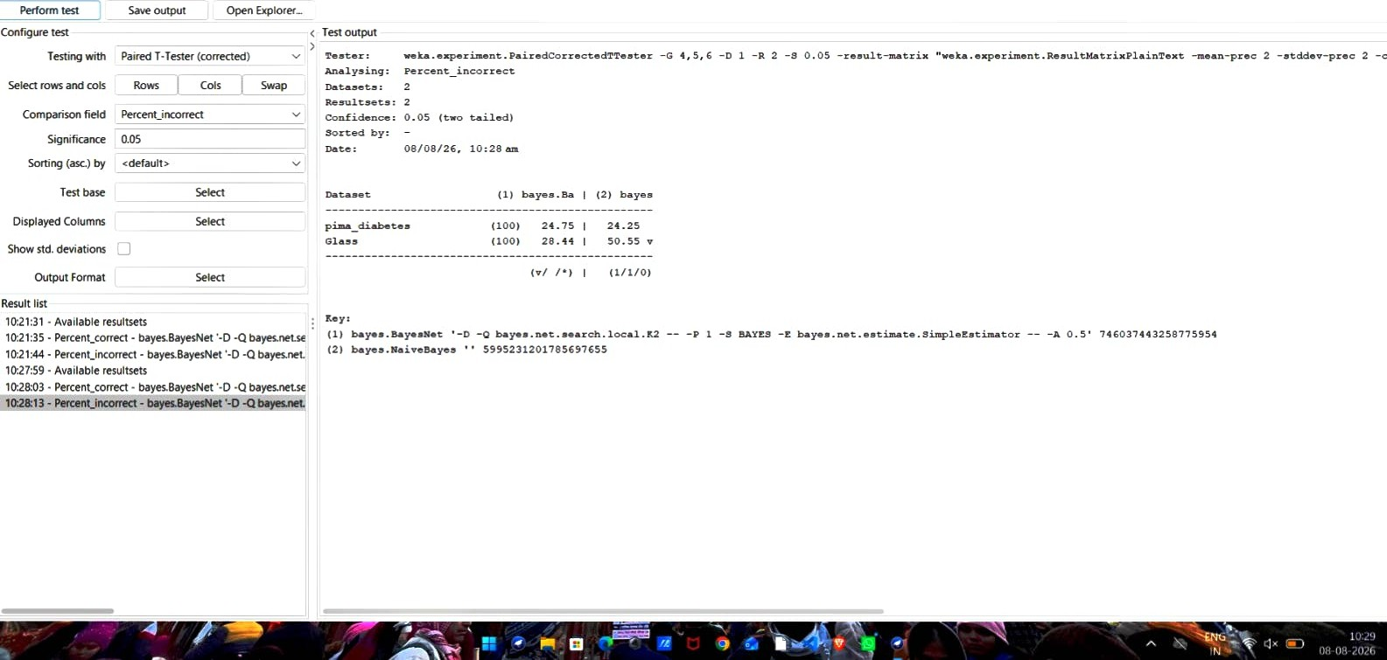
Setup
400 results Database.„ Experiment
Weka Experiment Environment
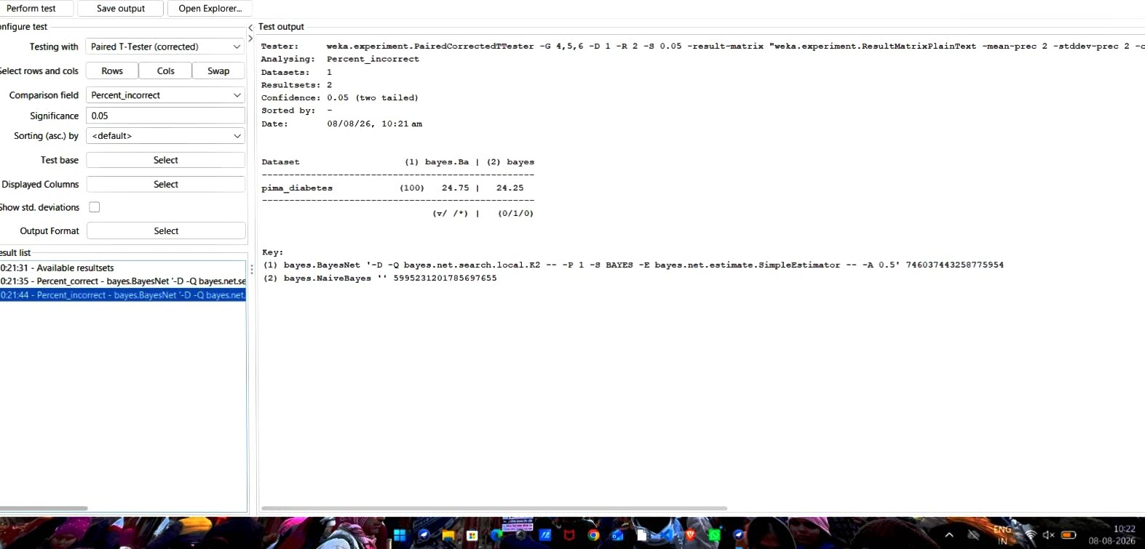
nup Run Analyse
t 2m results Database.„ Experiment
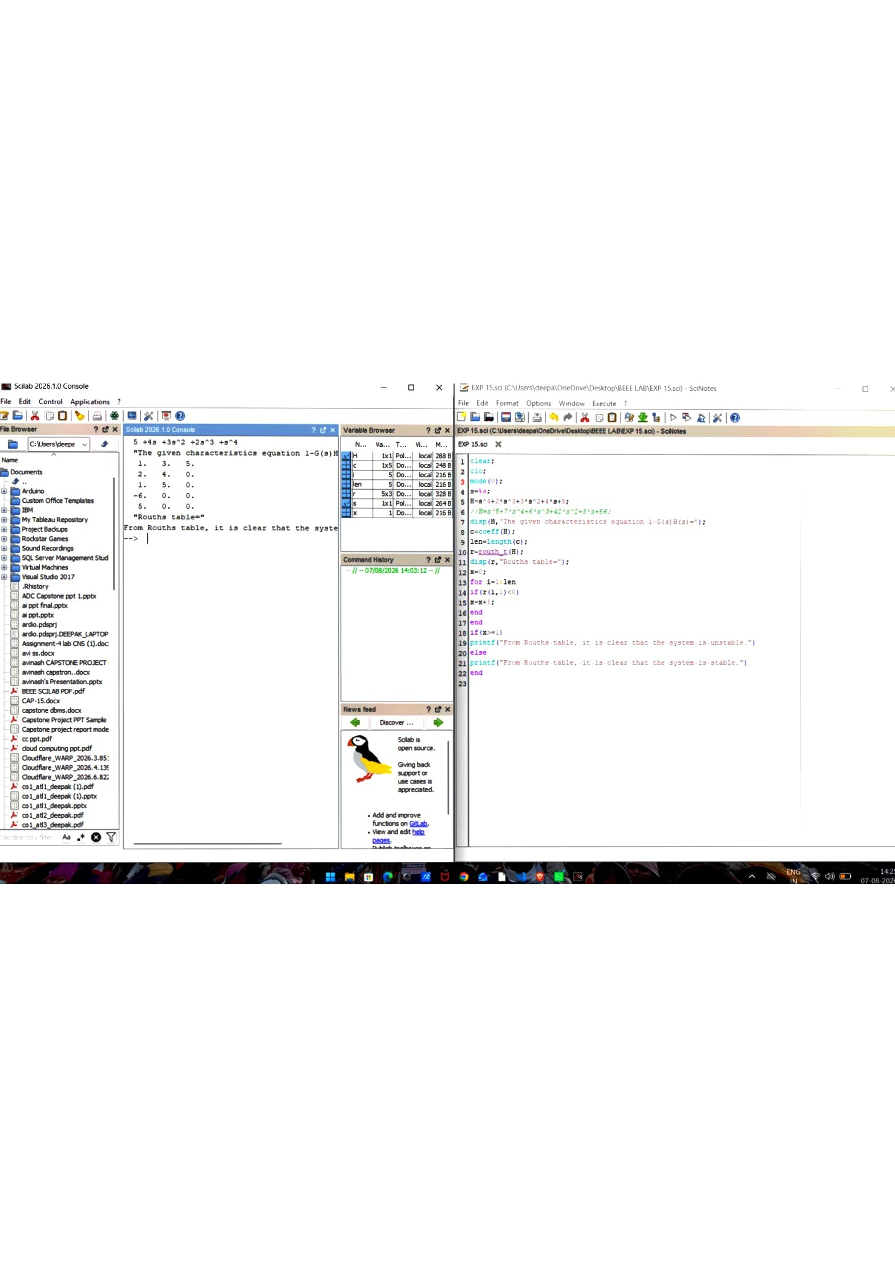
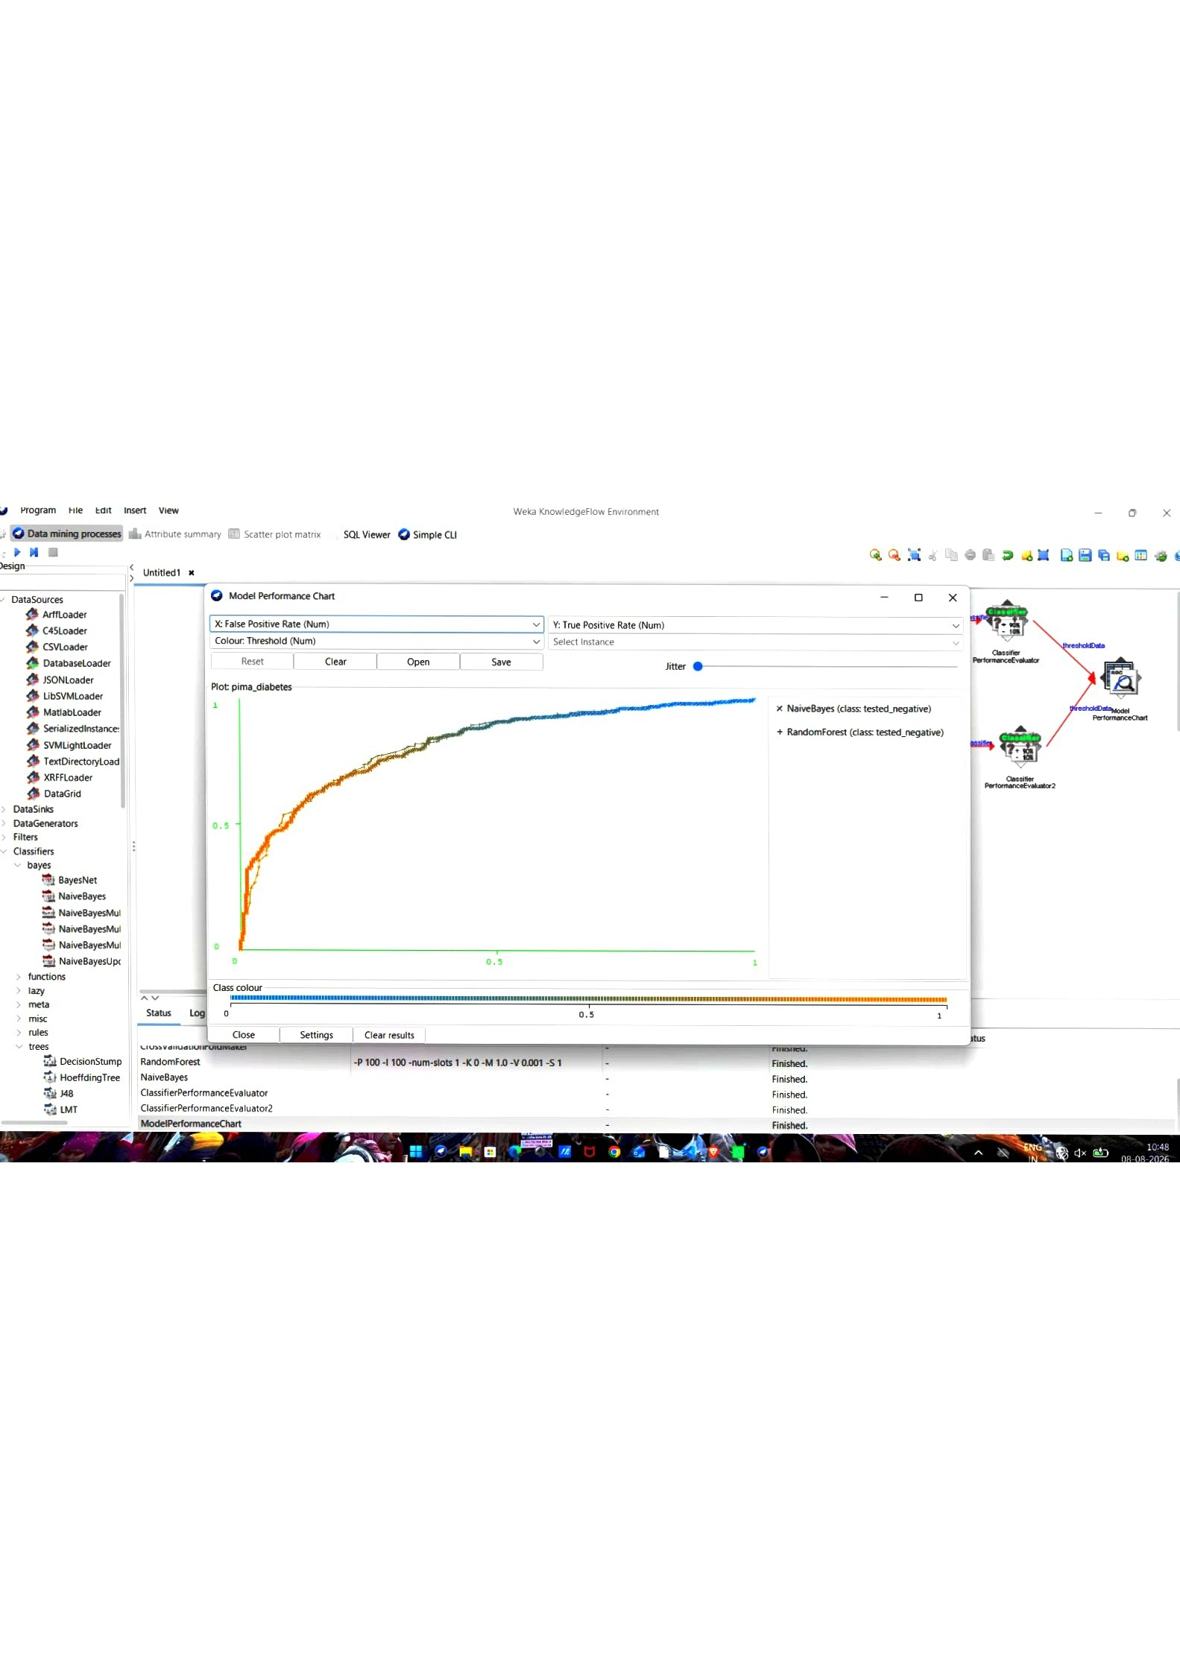
program
File
Edit
Ins«t
View
Weka
KnowledgeFlow
Environment

