Name: Ibrahim Sattar Roll No: BSSE23004
Course: Machine Learning Section B

Task1:
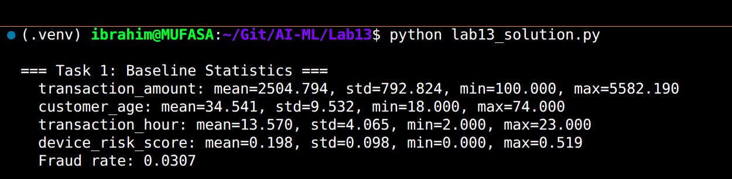
Task2:
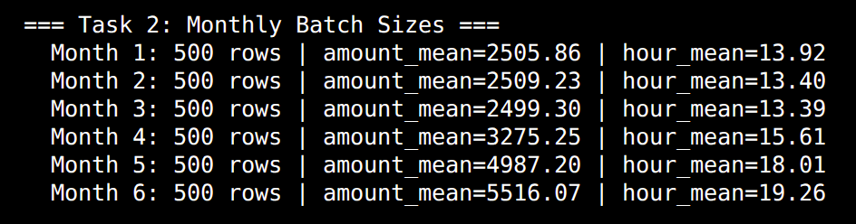
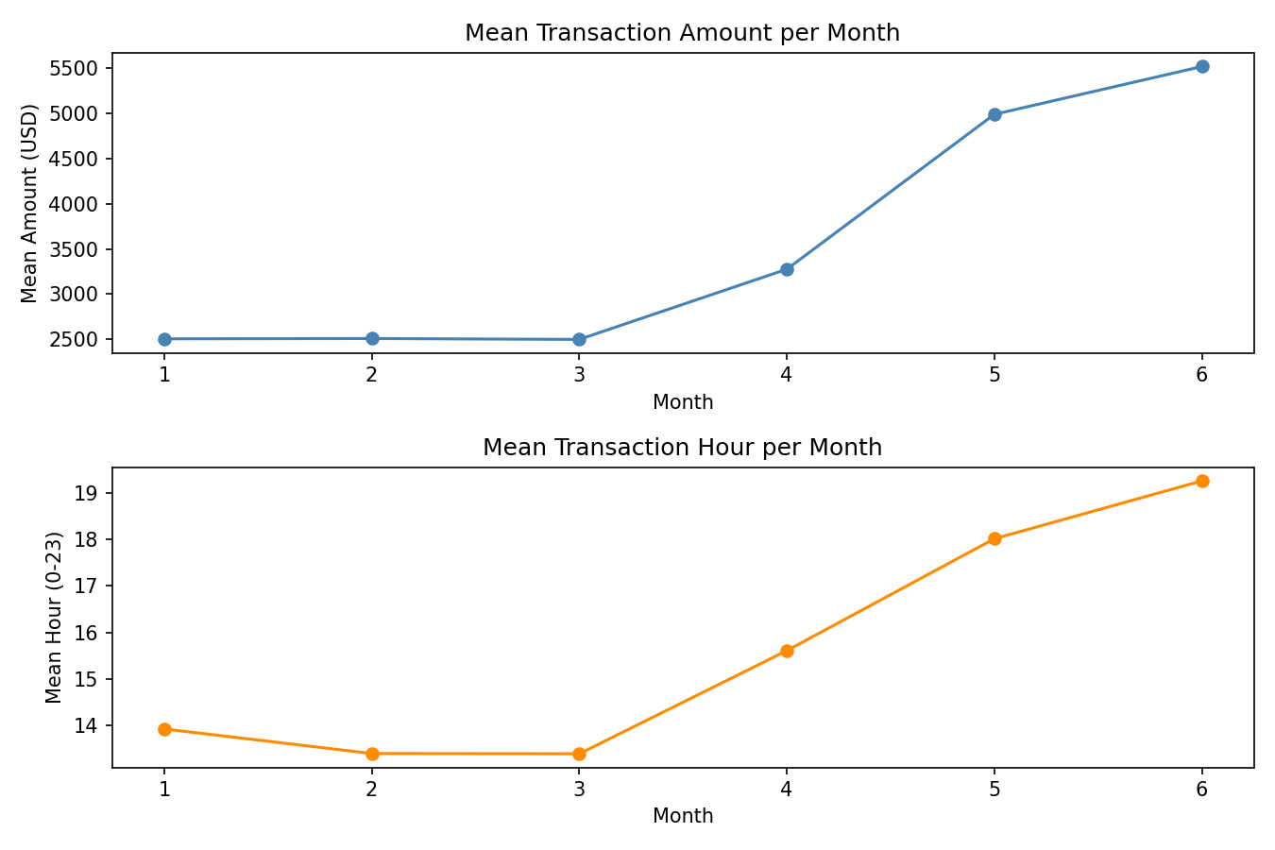

Task3:

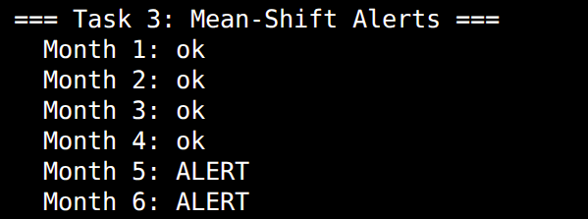

Task4:
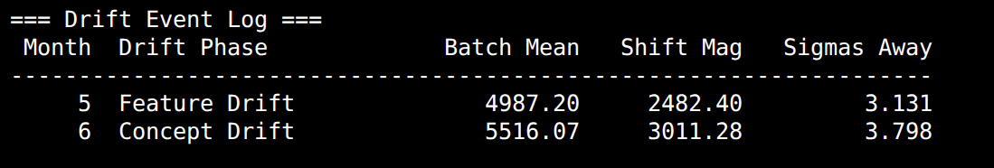
Task5:
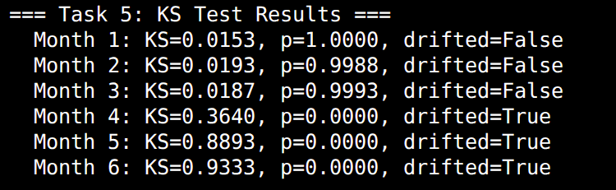
Task6:
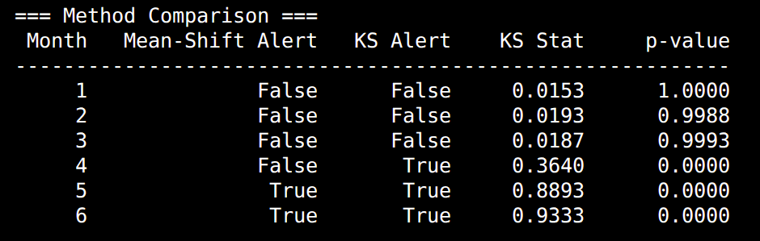
Task7:
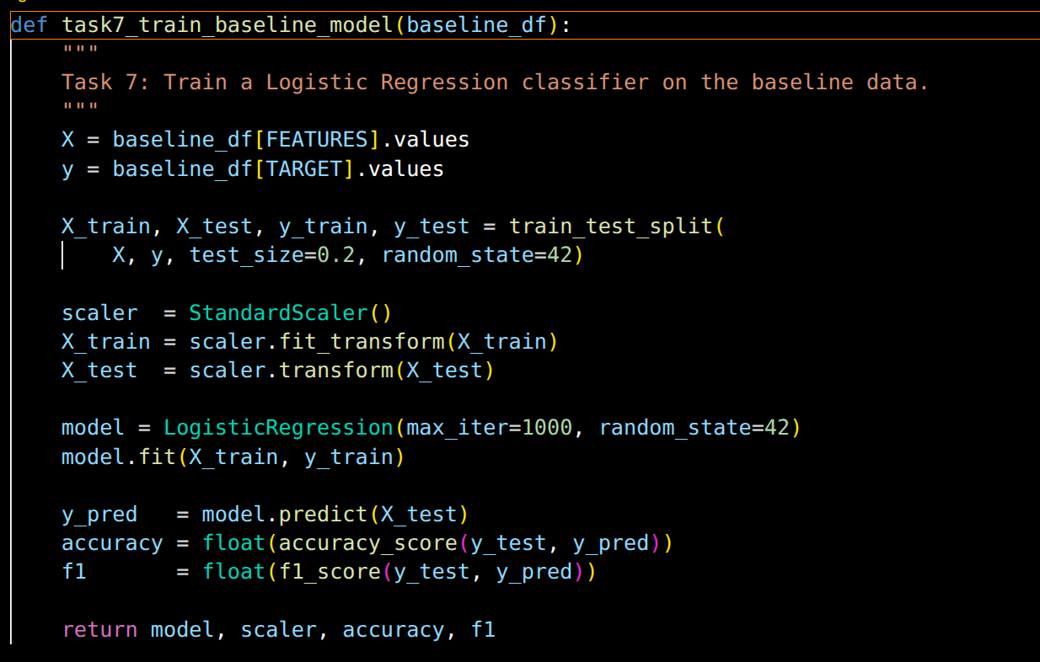

Task8:
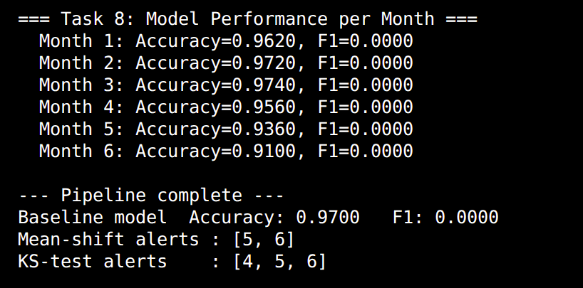

Task9:
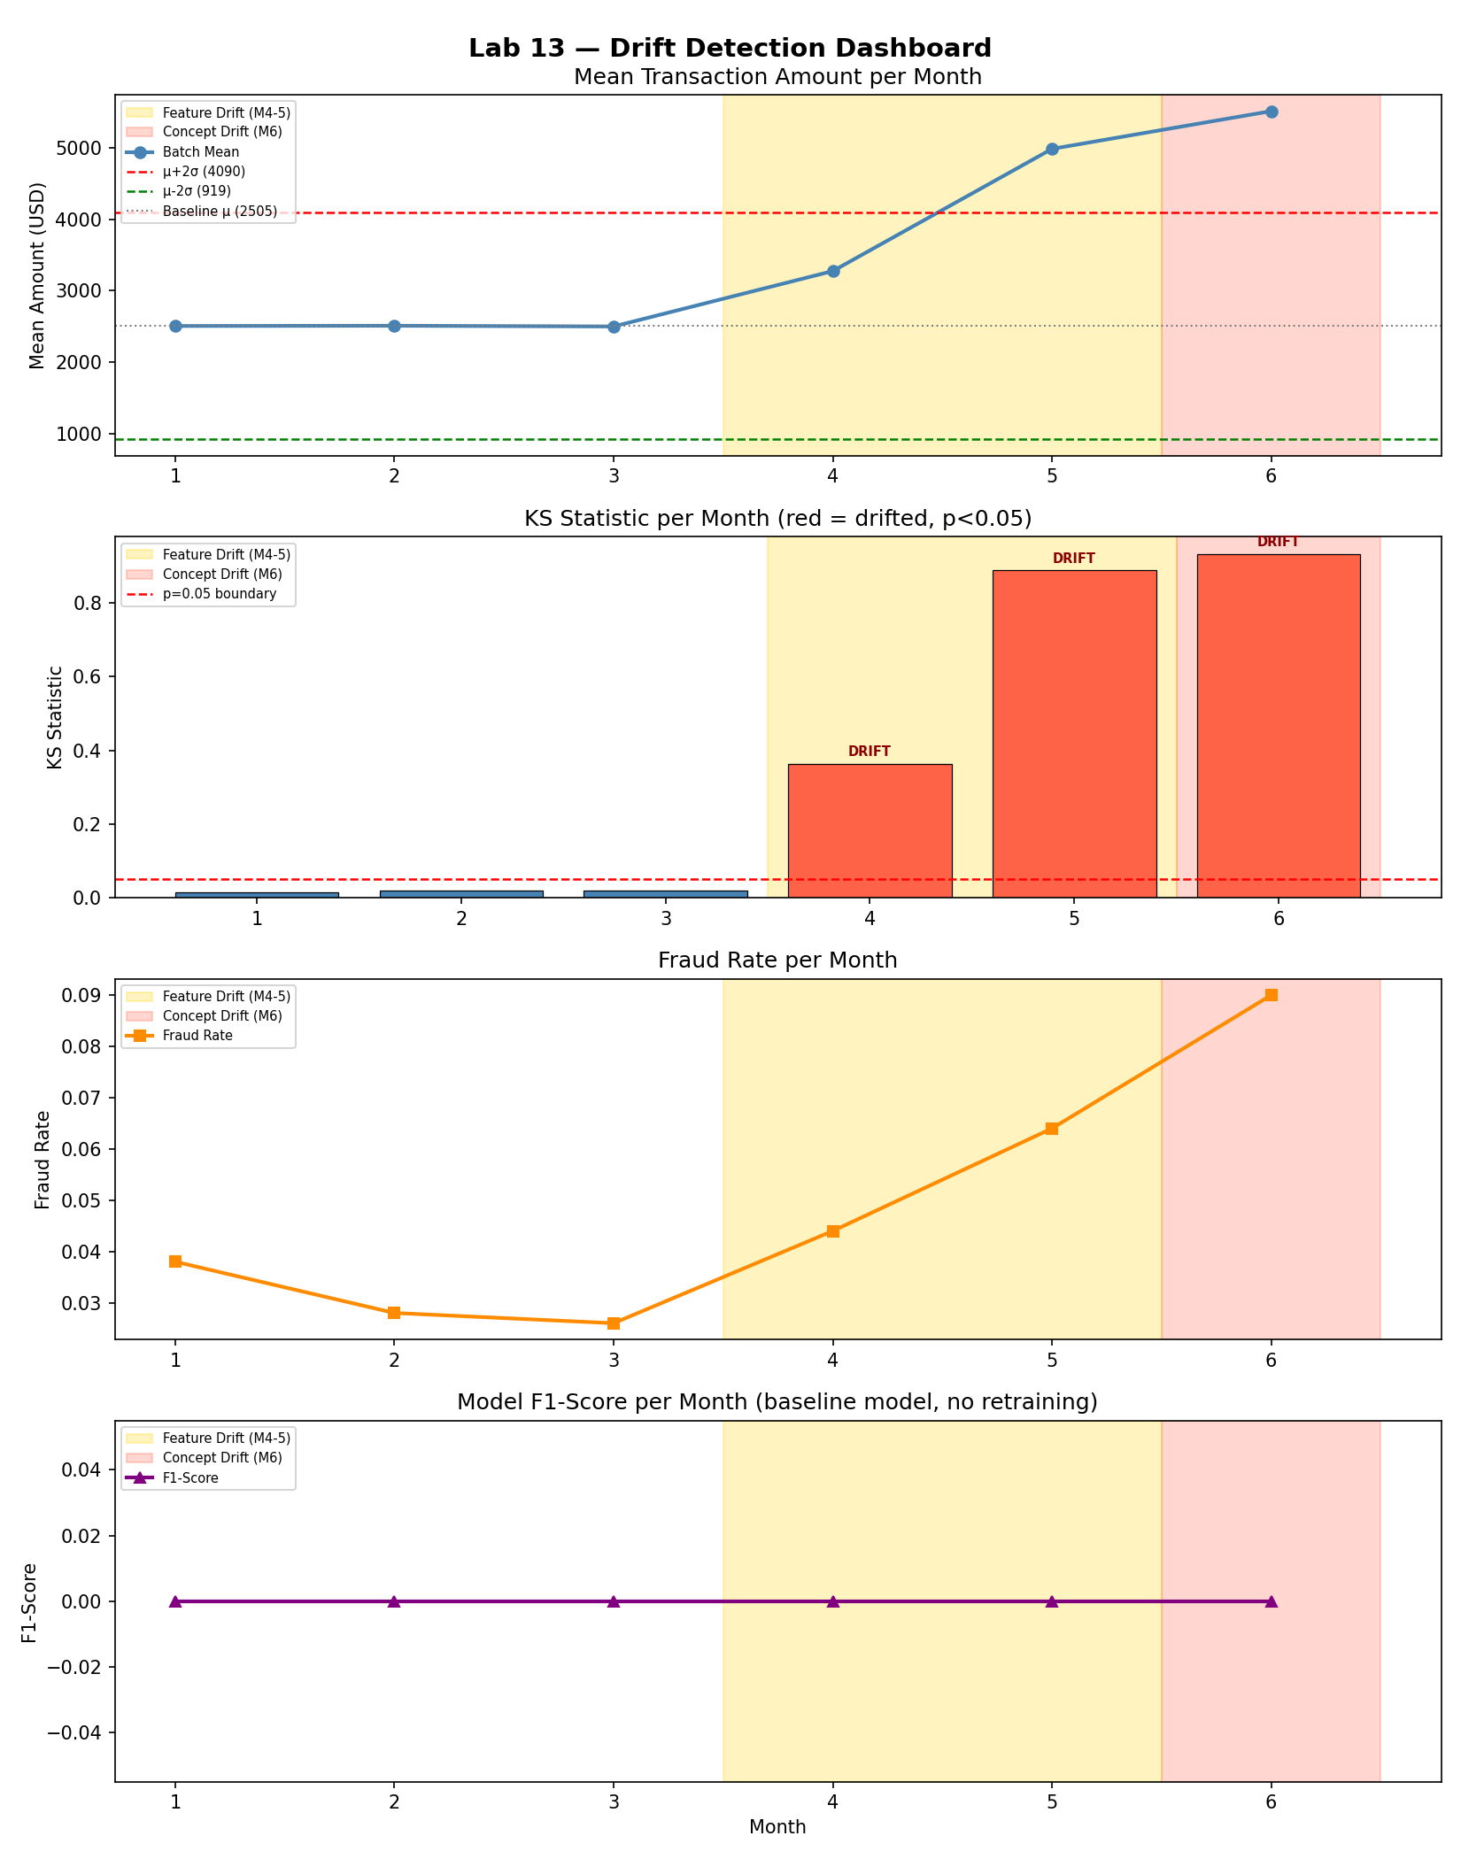

DISCUSSION ANSWERS

Q1. Feature drift vs. Concept drift (with dataset examples)?

Feature drift occurs when the INPUT distribution P(X) changes while
the relationship P(Y|X) remains stable. In this dataset Months 4-5
show feature drift: transaction_amount and transaction_hour increased
noticeably but the fraud detection rules that map these features to
fraud labels did not fundamentally change, so a well-calibrated model
may still perform reasonably.

Concept drift occurs when the relationship P(Y|X) itself changes, i.e.
the same input patterns now map to different labels. Month 6 is the
clearest example: the fraud rate tripled relative to baseline (new
fraud patterns emerged), so the model's learned decision boundary is
no longer valid even for similar feature values.

Q2. Month 4 type of drift and model impact?

Month 4 is purely feature drift (covariate shift). Transaction amounts
rose but the fraud rate barely changed, meaning the learned mapping
P(is_fraud | features) is still approximately correct. Logistic
Regression generalises reasonably well to shifted inputs provided the
class boundary has not moved, so accuracy and F1 should not drop
dramatically in Month 4.

Q3. Why Month 6 causes a sharp F1 drop but not necessarily accuracy?

Accuracy is dominated by the majority class (legitimate transactions,
~97 % of baseline). If the model predicts "not fraud" for everything
it still gets ~97 % accuracy. F1 specifically measures performance on
the positive (fraud) class. When the fraud rate triples in Month 6, a
new category of fraud patterns appears that the model was never trained
on. The model misses many of these new frauds (high false negatives),
causing precision and recall on the positive class and therefore F1
to collapse, even if overall accuracy stays deceptively high.

Q4. Why mean-shift misses drift that KS catches?

The mean-shift detector uses only the first moment (mean). If a
distribution becomes bimodal or heavy-tailed while its mean stays
close to baseline, the rule is blind to the shift. Example: suppose
transaction amounts split into two groups many small amounts and a
few very large ones such that the average is unchanged. The mean-
shift detector fires no alert, yet the distributional shape has changed
fundamentally. The KS test is sensitive to ANY difference in the full
cumulative distribution, including changes in variance, skewness, or
modality, so it catches such cases where the mean-shift rule fails.

Q5. Production ML response to detected drift?

Scheduled retraining with a sliding window: the system maintains a
rolling window of recent labelled data (e.g. last 4-6 weeks). When the
drift monitor fires (KS p < 0.05 or mean-shift alert), it triggers an
automated retraining job that fits a fresh model on the most recent
window, validates it on a held-out slice, and promotes it to production
if it beats the incumbent on key metrics (accuracy, F1, AUC). This
keeps the model aligned with the current data distribution without
requiring manual intervention. Optionally, the system can weight recent
samples more heavily (importance weighting) during retraining to
further adapt to the new regime.

