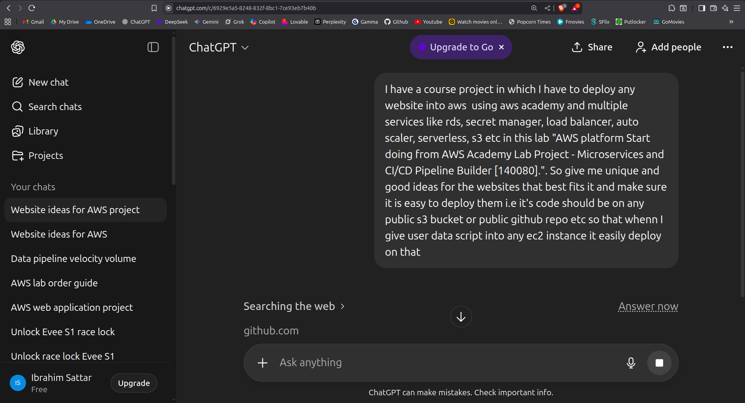

Prompt:

init.sh
File
docker-compose.yml
File
I have open source frappe lms "https://github.com/frappe/lms" that is made on Vue 58.8% Python 25.0% JavaScript 7.0% HTML 4.2% CSS 3.5% TypeScript 1.4% Other 0.1% its readme files says

"Frappe Learning logo Frappe Learning Easy to use, open source, Learning Management System Tests Hero Image Website - Documentation Frappe Learning Frappe Learning is an easy-to-use learning system that helps you bring structure to your content. Motivation In 2021, we were looking for a Learning Management System to launch Mon.School for FOSS United. We checked out Moodle, but it didn’t feel right. The forms were unnecessarily lengthy and the UI was confusing. It shouldn't be this hard to create a course right? So I started making a learning system for Mon.School which soon became a product in itself. The aim is to have a simple platform that anyone can use to launch a course of their own and make knowledge sharing easier. Key Features Structured Learning: Design a course with a 3-level hierarchy, where your courses have chapters and you can group your lessons within these chapters. This ensures that the context of the lesson is set by the chapter. Live Classes: Group learners into batches based on courses and duration. You can then create Zoom live class for these batches right from the app. Learners get to see the list of live classes they have to take as a part of this batch. Quizzes and Assignments: Create quizzes where questions can have single-choice, multiple-choice options, or can be open ended. Instructors can also add assignments which learners can submit as PDF's or Documents. Getting Certified: Once a learner has completed the course or batch, you can grant them a certificate. The app provides an inbuilt certificate template. You can use this or else create a template of your own and use that instead. View Screenshots Batch Create batches to group your learners Quiz Evaluate their knowledge by quizzes Cerficicate Autenticate their work with certification Under the Hood Frappe Framework: A full-stack web application framework. Frappe UI: A Vue-based UI library, to provide a modern user interface. Production Setup Managed Hosting You can try Frappe Cloud, a simple, user-friendly and sophisticated open-source platform to host Frappe applications with peace of mind. It takes care of installation, setup, upgrades, monitoring, maintenance and support of your Frappe deployments. It is a fully featured developer platform with an ability to manage and control multiple Frappe deployments. Try on Frappe Cloud Self Hosting Follow these steps to set up Frappe Learning in production: Step 1: Download the easy install script wget https://frappe.io/easy-install.py Step 2: Run the deployment command python3 ./easy-install.py deploy \ --project=learning_prod_setup \ --email=your_email.example.com \ --image=ghcr.io/frappe/lms \ --version=stable \ --app=lms \ --sitename subdomain.domain.tld Replace the following parameters with your values: your_email.example.com: Your email address subdomain.domain.tld: Your domain name where Learning will be hosted The script will set up a production-ready instance of Frappe Learning with all the necessary configurations in about 5 minutes. Note: To avoid a 404 Page Not Found error: If hosting on a public server, make sure your DNS A record points to your server's IP. If hosting locally, map your domain to 127.0.0.1 in your /etc/hosts file: Development Setup Docker You need Docker, docker-compose and git setup on your machine. Refer Docker documentation. After that, follow below steps: Step 1: Setup folder and download the required files mkdir frappe-learning cd frappe-learning # Download the docker-compose file wget -O docker-compose.yml https://raw.githubusercontent.com/frappe/lms/develop/docker/docker-compose.yml # Download the setup script wget -O init.sh https://raw.githubusercontent.com/frappe/lms/develop/docker/init.sh Step 2: Run the container and daemonize it docker compose up -d Step 3: The site http://lms.localhost:8000/lms should now be available. The default credentials are: Username: Administrator Password: admin Local To setup the repository locally follow the steps mentioned below: Install bench and setup a frappe-bench directory by following the Installation Steps Start the server by running bench start In a separate terminal window, create a new site by running bench new-site learning.test Map your site to localhost with the command bench --site learning.test add-to-hosts Get the Learning app. Run bench get-app https://github.com/frappe/lms Run bench --site learning.test install-app lms. Now open the URL http://learning.test:8000/lms in your browser, you should see the app running Learn and connect Telegram Public Group Discuss Forum Documentation YouTube Frappe Technologies"

its docker-compose.yml and init.sh are given and I have access to this learner lab "ALLv2EN-US-LTI13-141571 Modules AWS Academy Learner Lab Launch AWS Academy Learner Lab" in which I am limited to 50$ budget now tell me which service should I use so that I can easily host web with loadbalancer and auto scaling so that web highly available and scalable and stable and the process to do it is not complex. And also tell me step by step process I already have setup VPC, IGW with 4 subnet 2,2 each in 2 AZ and each AZ has 1 private and 1 public subnet . More info frappe lms use mariadb container, redis container, frappe container

