|  |
| --- |
| **Department of Computer and Software Engineering – ITU** |
| **SE200T: Data Structures & Algorithms** |

|  |  |
| --- | --- |
| **Course Instructor: Usama Bin Shakeel** | **Dated: 5th Sep 2024** |
| **Teaching Assistant: Zainab, Sadia & Ryan** | **Semester: Fall 2024** |
| **Session: 2023-2027** | **Batch: BSSE2023B** |

# **Assignment 3. Complex operations on 3D Arrays**

|  |  |  |
| --- | --- | --- |
| **Name** | **Roll number** | **Obtained Marks/35** |
| Muhammad Mukarram Raza | BSSE-23029-B |  |

Checked on: ____________________________

Signature: ___________________________

**Submission:**

• Email instructor or TA if there are any questions. You cannot look at others’ solutions or use others’ solutions, however, you can discuss it with each other. Plagiarism will be dealt with according to the course policy.

• Submission after due time will not be accepted.

**In this assignment you have to do following tasks:**

**Task 1:** Ensure that you have installed all three softwares in your personal computer (Github, Cygwin & CLion). Now, accept the assignment posted in the classroom (e.g Google, LMS etc) and after accepting, clone the repository to your computer. Make sure you have logged into the github app with your account.

**Task 2:** Open Cygwin app, Move to your code directory with following command “cd <path_of_folder>”, <path_of_folder> can be automatically populated by dragging the folder and dropping it to the cygwin window.

Run the code through Cygwin, use command “make run”, to get the output of the code

**Task 3:** Solve the given problems, write code using **CLion** or any other IDE.

**Task 4:** Keep your code in the respective git cloned folder.

**Task 5:** Commit and Push the changes through the Github App

**Task 5**: Write the code in separate files **(as instructed**). Ensure that file names are in lowercase (e,g **main.cpp**).

**Task 6:** Run ‘**make run**’ to run C++ code

**Task 7:** Run ‘**make test**’ to test the C++ code

Write code in functions, after completing each part, verify through running code using **“make run”** on Cygwin. Make sure to test the code using **“make test”.**

**3D Array**

* **A Three Dimensional Array or 3D array is a collection of two-dimensional arrays.**
* It can be thought of as a **collection of 2D arrays stacked one after another**.

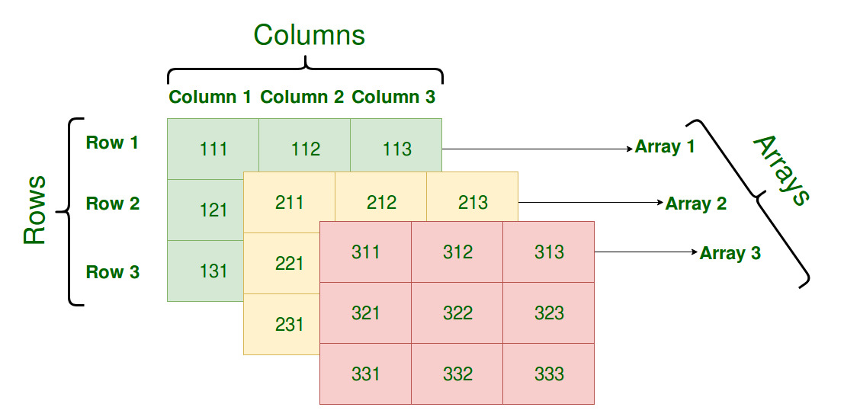

* A 3D array is useful when you need to **store data in three dimensions**, such as in 3D modeling, image processing, or data representation with more than two varying parameters.

**Declaration in C++:**

***int arr[x][y][z]; (****static****)***

***int *** arr = new int **[x]; (****heap****)***

***Visualization of a 3D Array***

*Imagine a 3D array as a cube made up of several 2D matrices stacked on top of each other.*

* *x: Number of 2D arrays.*
* *y: Number of rows in each 2D array.*
* *z: Number of columns in each 2D array.*

***Problem Statement:****In this assignment, you will need to extend the code from your previous assignment by adding complex functionality. Also you were supposed to handle 3D arrays for all functions in the last assignment, but didn’t have time to do it. Now, you'll need to update your previous functions to work with 3D arrays.*

***Additional Methods:***

* + *T* getDeterminant() – Computes Determinant. In case of 1D array nullptr will be returned.*
  + *MyArray* getInverse() – Returns matrix inverse calculated using Adjoint and Cofactor method*
  + *void quickSort(char axis) – Sorts the array along the axis passed as parameter. In case of 1D array parameter will be ignored.*

***Bonus Marks:***

*In the assignment's test cases, there is an issue. Extra marks will be awarded to those who identify this issue, but it can only be found if you have completed the assignment on your own.*

***Important Notice for Your Assignment***

*Please read the following instructions carefully:*

1. ***Do Not Modify test.cpp:*** *You are strictly prohibited from making any changes to the test.cpp file. This file is designed to test your implementation and any modifications will lead to the assignment being graded as zero.*
2. ***Class Definitions:*** *All class definitions and implementations must be provided solely within the files functions.h and functions.cpp. You are not allowed to create any additional files for your class definitions or implementations.*

*Any deviation from these rules, including creating additional files or modifying the test.cpp file, will result in your assignment receiving a grade of zero.*

**Assessment Rubric for Assignment**

|  |  |  |  |  |  |
| --- | --- | --- | --- | --- | --- |
| **Performance metric** | **CLO** | **Able to complete the task over 80% (4-5)** | **Able to complete the task 50-80% (2-3)** | **Able to complete the task below 50% (0-1)** | **Marks** |
| 1. Realization of experiment | 3 | Executes without errors excellent user prompts, good use of symbols, spacing in output. The testing has been completed. | Executes without errors, user prompts are understandable, minimum use of symbols or spacing in output. Some testing has been completed. | Does not execute due to syntax errors, runtime errors, user prompts are misleading or non- existent. No testing has been completed. |  |
| 1. Conducting experiment | 2 | Able to make changes and answer all questions. | Partially able to make changes and few incorrect answers. | Unable to make changes and answer all questions. |  |
| 1. Computer use | 4 | Document submission timely. | Document submission late. | Document submission not done. |  |
| 1. Teamwork | 4 | Actively engages and cooperates with other group member(s) in an effective manner. | Cooperates with other group member(s) in a reasonable manner but conduct can be improved. | Distracts or discourages other group members from conducting the experiment |  |
| 1. Laboratory safety and disciplinary rules | 2 | Code comments are added and do help the reader to understand the code. | Code comments are added and do not help the reader to understand the code. | Code comments are not added. |  |
| 1. Data collection | 2 | Excellent use of white space, creatively organized work, excellent use of variables and constants, correct identifiers for constants, No line-wrap. | Includes name, and assignment, white space makes the program fairly easy to read. Title, organized work, good use of variables. | Poor use of white space (indentation, blank lines) making code hard to read, disorganized and messy. |  |
| 1. Data analysis | 3 | Solution is efficient, easy to understand, and maintain. | A logical solution that is easy to follow but it is not the most efficient. | A difficult and inefficient solution. |  |
| **Total (out of 35):** | | | | |  |