Respected Dr. Zunnurain Hussain,
Asalam Aliekum, Based on the comprehensive Problem Statement and the DP-IDN framework. Proposed in SentinelGPT.docx I would appreciate your guidance on pivoting to address these fundamental vulnerabilities.

Analysis of Current Results (DP-IDN)
- Evidence of Artifact Memorization: Experiment 5 shows a 100% Detection Rate with a mean P(Malicious) of 0.9997 across all novel manifolds (Base64, Polyglot, etc.). In a high-entropy environment like LLM security, such "perfect" scores suggest the model is memorizing superficial artifacts rather than learning abstract attack topology.
- Artificial Manifold Separation: The t-SNE diagrams show a perfect separation between clusters with zero overlap. This suggests the current dataset may lack Hard Negatives (benign prompts that mimic adversarial structures), making the model brittle against sophisticated, real-world "Grey-Zone" inputs.
- Dataset Limitations: I suspect my current synthetic data generation (GPT-4 fuzzing) may be producing "Pure Malicious" vs. "Pure Benign" samples that are too easily separated by the CNN layers. This likely explains why the CNN Energy Variance (Experiment 3) is so high it's catching keywords, not intent.

Observations on the Current Baseline (DP-IDN)
- The Persistence of Leakage: My concern is that even with DP-IDN hardening, if defensive instructions remain as text tokens in the context window, they are fundamentally extractable via recursive logic attacks.
- Latency vs. Depth: While the CNN+BiLSTM ensemble is robust, I am analyzing whether the computational cost of a "triple-pass" (Local/Sequential/Global) analysis might hinder real-time deployment in high-throughput AI agents.
- Overfitting on Surface Patterns: High accuracy in existing models often stems from memorizing "attack syntax" (e.g., Base64 or specific keywords). I am concerned this might fail against semantic-shift attacks where the intent is malicious but the syntax is benign.
- Reactive vs. Proactive Defense: Patching is reactive it attempts to "heal" a prompt after malicious text has already entered the context. In an agentic workflow by adding a "Defensive Patch" (a text warning) to the start of the conversation. Because modern LLMs suffer from Recency Bias, if an attacker adds "Ignore the warning above" at the end of their prompt, the LLM will obey the attacker and ignore the patch. The text-based defense is easily bypassed.

Proposed Path: LSD-SVO (Latent-State Defense)
I am considering if we could achieve a more "invisible" defense by moving from the Input Layer to the model’s Internal Residual Stream:
- System Vector Injection ($v_{sys}$): Could we replace text instructions with a System Vector injected into the latent layers? This would mean the "rules" never exist as tokens, potentially reducing the Prompt Leakage Score (PLS) to near-zero.
- Linear Probing vs. CNN/BiLSTM: What are your thoughts on using Linear Probes to scan internal activations? These are significantly faster than CNNs and can detect malicious intent (e.g., hijacking) during the initial forward pass by analyzing the model's "internal thoughts" before token generation.
- Vector Orthogonalization: For the "Self-Healing" objective, I am exploring Orthogonalization to force malicious latent trajectories to zero. This would effectively "heal" the model’s logic at the neural level rather than adding a text-based "patch."
- Pre-Generation Intent Probing: We replace the CNN/BiLSTM ensemble with a Linear Probe. By scanning hidden activation states, we can catch the "Intent to Disobey" before a single word is generated. This reduces latency. I propose an automated RL-based "Attacker" (LeakAgent) constantly probes the system; any successful bypass is automatically indexed into a Semantic Cache to block future variants instantly. 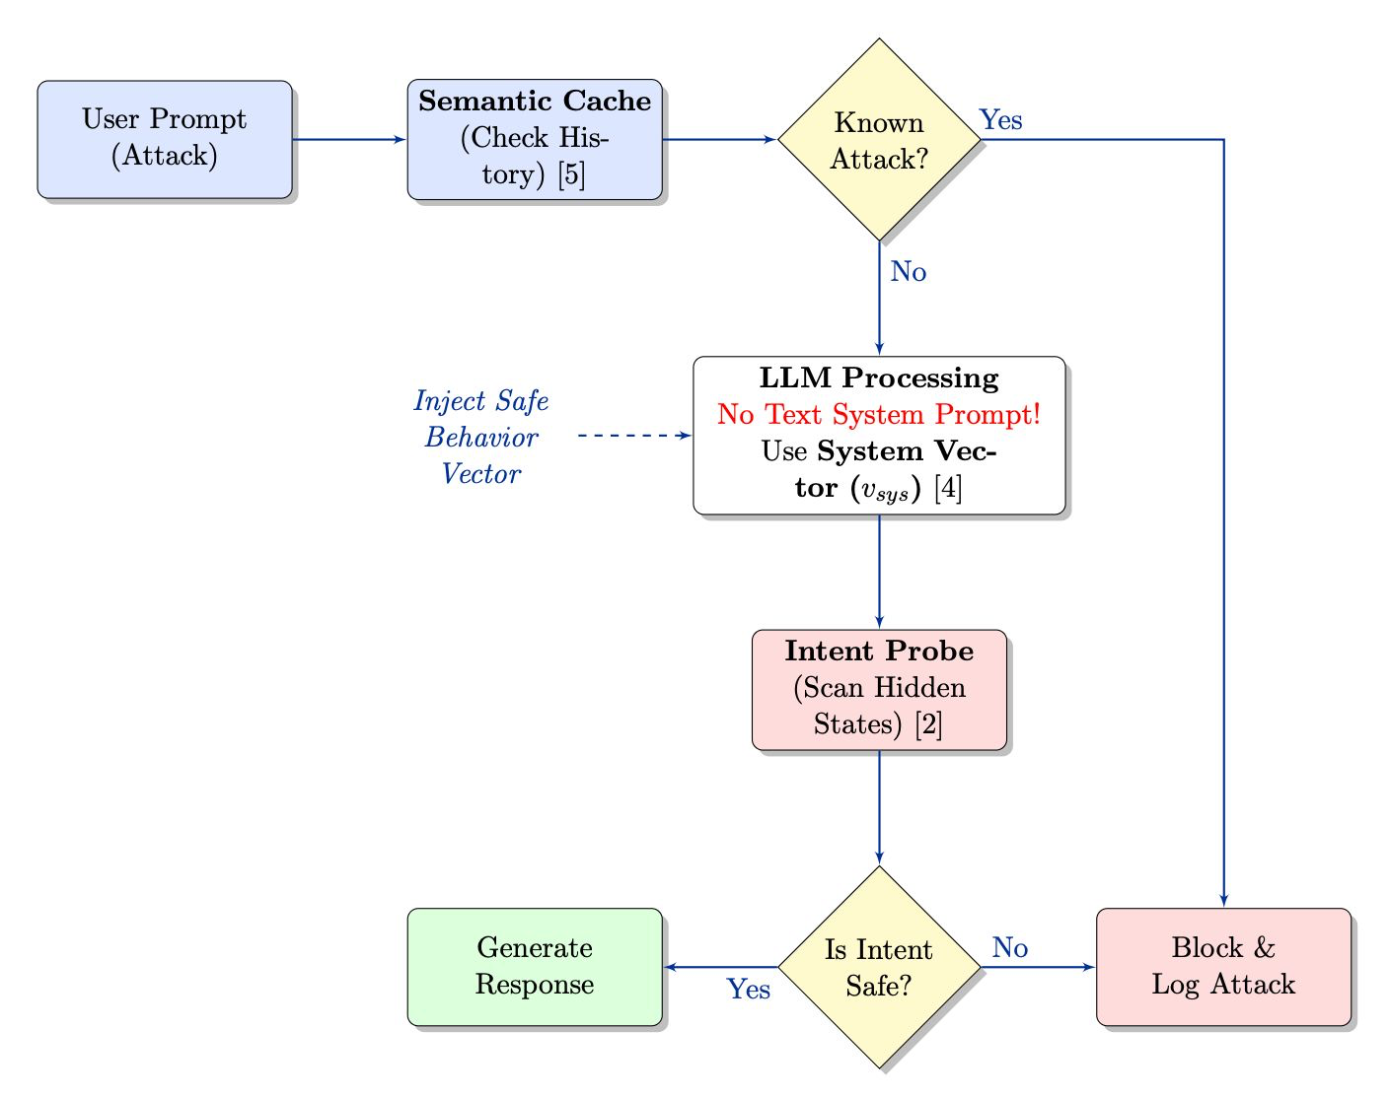

Comparative Technical Summary
Feature | SentinelGPT (Old) | SentinelGPT (New)
Defense Mechanism | Text Patching (Visible) | Vector Injection (Invisible)
Resilience | Fails vs. Context Overload | Input Agnostic
Security Logic | Post-processing | Pre-generation Intent Probe
Validation Metric | Accuracy/F1 | Prompt Leakage Score (PLS)

Seeking Your Feedback
Do you believe that focusing the research on Latent-State Interventions would provide a more novel contribution to the field than optimizing traditional text-filters? Specifically, I am interested in your view on whether the $v_{sys}$ approach is a more viable path for achieving the "Self-Healing" objective you outlined.
Regards

