
Game development
LAB 03

September 27, 2026
Fasiha rohail
BSSE23041

Screen Shots Of My BlockOut:
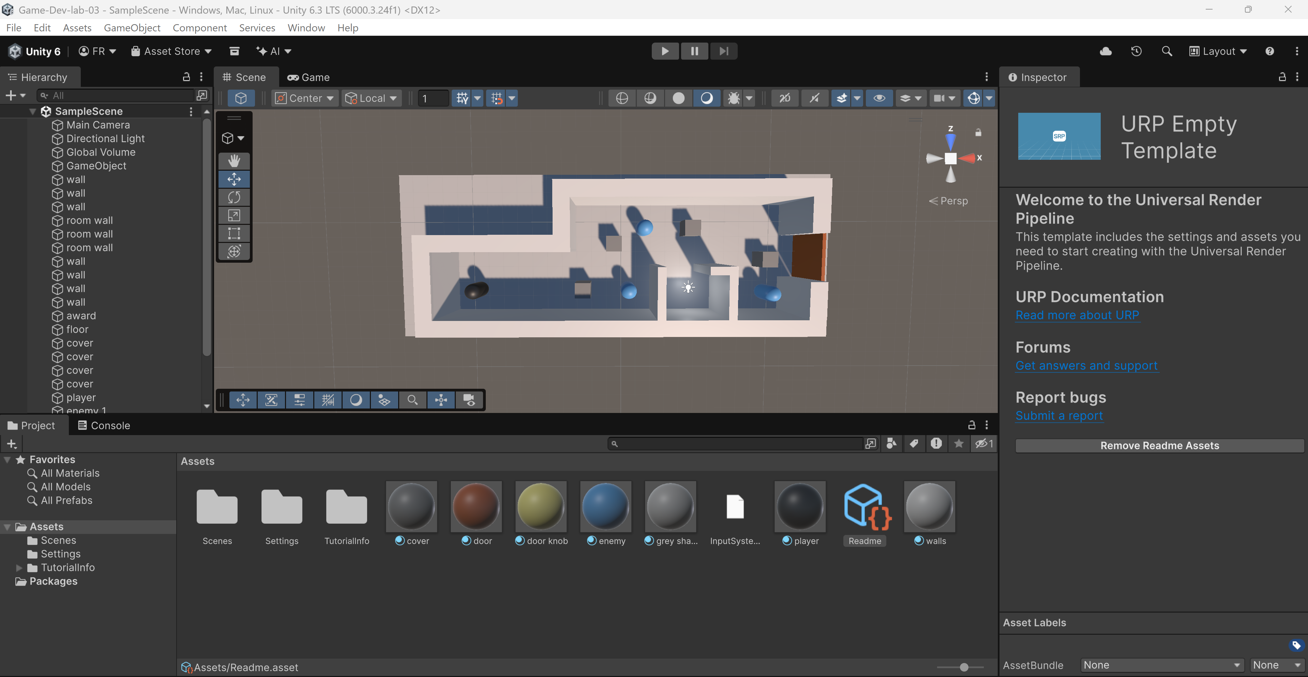
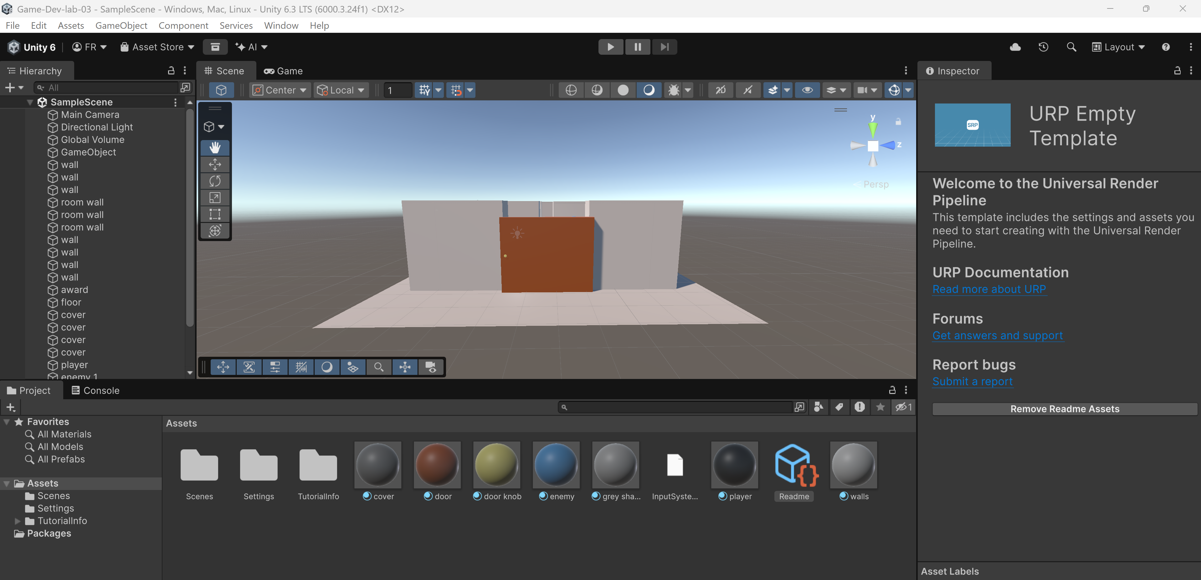

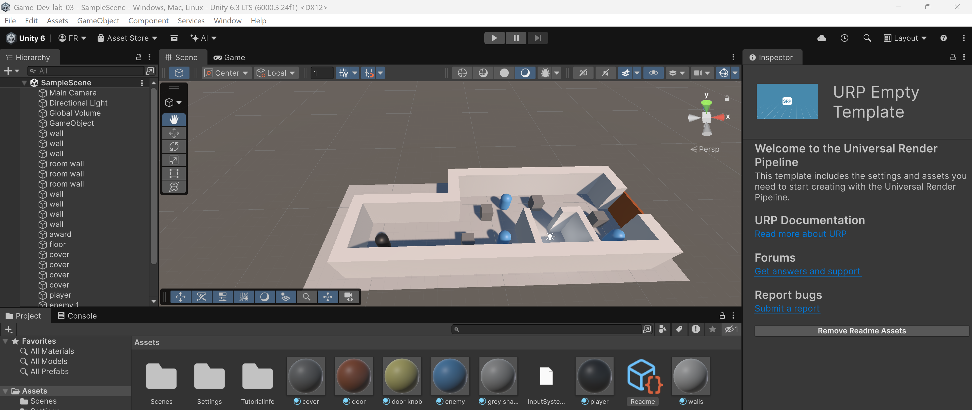
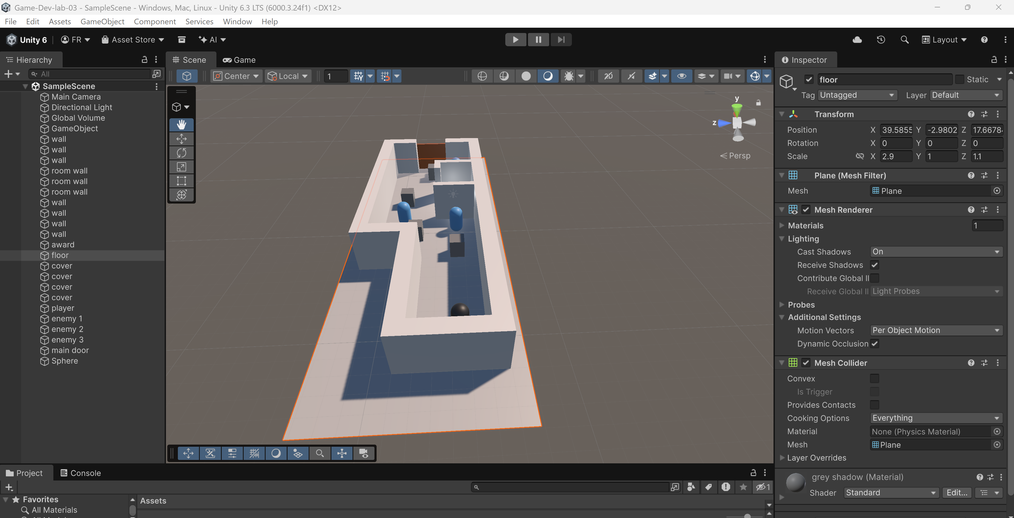

Explanation of Level Design and Obstacles
My level is designed around a simple main idea: hiding, exploring, and getting to the exit.
- The Player & Movement Area: The player is represented by the black capsule that moves inside the main play area.
- Cover Mechanics & Environment: Placed around the main area are block shaped covers. These blocks the enemies' view, allowing the player to hide, plan their path, and stay safe from enemy search paths.
- Obstacles (Enemies): The main challenge comes from multiple blue capsules acting as moving enemies. The player must avoid being seen by timing their movement and using the cover blocks.
- Exit Door: The level has one main door: A locked main exit door that serves as the final goal to win.
- Reward Room & Win Condition: Off to the side is a special reward room lit by a central light. The player must sneak past the moving blue capsules to reach this room and pick up the reward. Once collected, the main exit door opens, allowing the player to escape the level and win the game.

Reason for Choice of Level Design
I chose a hide and escape style because it creates quick excitement without needing complicated fighting systems, making it great for a clear and easy to understand player experience.
- Clear Goal Order: By forcing the player to visit the lit reward room before reaching the exit door, the layout makes the player walk across the whole map instead of just running straight to the end.
- Risk vs. Reward Mechanics: The bright light in the reward room acts as a clear sign, showing the player where to go. However moving into open or bright areas makes it easier for the blue capsule enemies to spot the player, making the moment more exciting.
- Strategic Cover Placement: Putting blocks throughout the main pathway gives safe stopping points that encourage careful movement. Players must watch how enemies move, run from cover to cover, and make smart choices to win.

