SRE Documentation

- Service Overview
System Summary
ContentShield is an adaptive content safety analysis pipeline built with:
- Frontend: React (content submission + moderation dashboard)
- Backend: FastAPI (analysis pipeline)
- Signals:
  - Contextual heuristics
  - Semantic model
  - Deep analysis model (costly)
  - Adaptive decay engine
- Constraints:
  - 20 human reviews/hour
  - PKR 50,000 monthly compute budget
  - Partial observability (3 stages)
  - Adversarial signal decay

- High-Level Architecture
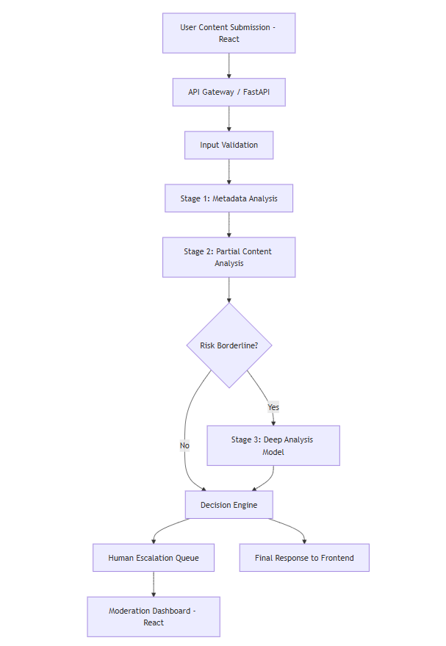
- Service Level Objectives (SLOs)
Availability SLO
Tier | Target
API Availability | 99.5% monthly
Human Queue UI | 99.0%

Latency SLO
Path | Target
Fast Path | < 150ms
Deep Analysis Path | < 800ms
Escalation Queue Insert | < 100ms

Accuracy Targets (Internal)
Metric | Target
False Positive Rate | < 6%
False Negative Rate | < 8%
Ambiguous Misclassification | < 3%

- Monitoring & Observability
Key Metrics
Infrastructure Metrics
- CPU usage
- Memory usage
- Request throughput
- P95 latency
- Error rate
Safety Metrics
- Signal decay level per signal
- Human queue size
- Escalation rate %
- Model disagreement rate
- Ambiguous content detection %
Budget Metrics
- API calls count
- Deep model invocations
- Monthly spend projection

Monitoring Architecture
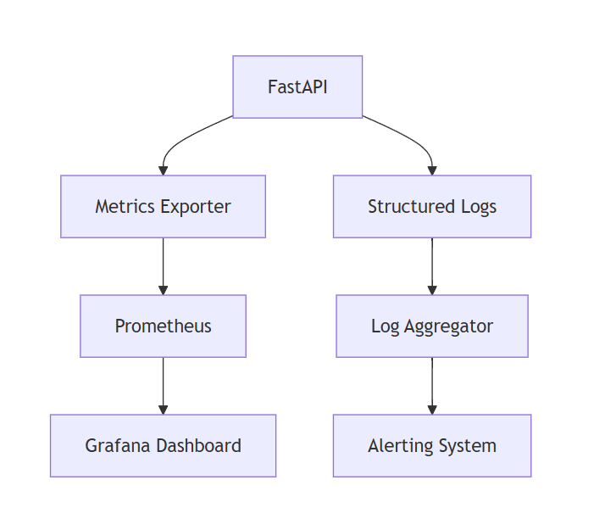
- Alerting Strategy
Condition | Severity | Action
API down > 2 min | P1 | Immediate page
Human queue > 40 items | P2 | Escalate staffing
Deep model cost spike | P2 | Activate cost throttle
Signal decay < 0.4 | P2 | Rotate signal weighting
False positive spike | P1 | Disable aggressive auto-flag

- Incident Response Playbook
P1: API Outage
Steps:
- Check health endpoint
- Roll back last deployment
- Enable degraded mode
- Disable deep analysis
- Notify moderation team

P2: Human Queue Overload
Steps:
- Reduce auto-escalation threshold
- Activate delay decision mode
- Batch low-risk cases
- Increase confidence requirement for escalation

P3: Signal Collapse
Steps:
- Reduce weight of overused signal
- Activate alternate detection signals
- Randomize routing
- Run shadow evaluation

- Degraded Mode Strategy
When:
- Budget exceeded
- High load
- Model API down
System automatically:
- Disable deep model
- Increase ambiguity detection
- Increase delay decisions
- Reduce auto-flag aggressiveness
Degraded Mode Flow
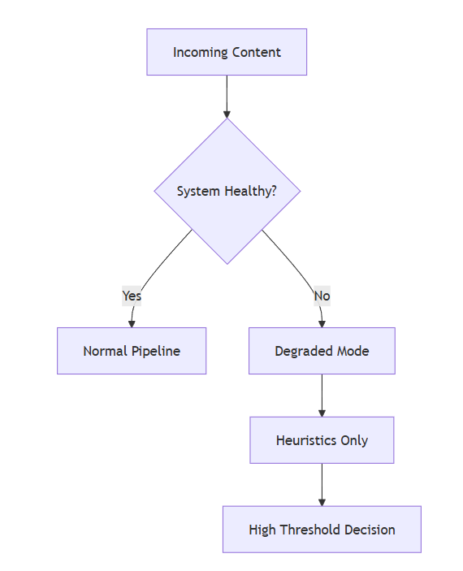

- Cost Management Strategy (PKR 50,000/month)
Assumptions:
- ML API cost: PKR 0.5 per call
- 100,000 requests/month
- 20% deep analysis routing
Estimated Monthly Cost:
Component | Estimated Cost
Semantic model calls | PKR 20,000
Deep model calls | PKR 15,000
Infrastructure | PKR 10,000
Logging/Monitoring | PKR 5,000
Total | PKR 50,000

Cost Control Mechanisms
- Borderline-only deep routing
- Monthly usage projection alerts
- Automatic deep-model throttle at 80% budget
- Fallback to cached embeddings

- Capacity Planning
Load Projection
Scenario | RPS
Normal | 5
Peak | 25
Adversarial Spam | 100

Scaling Plan
- Horizontal scaling via container replicas
- Read-only mode during attacks
- Rate limiting per IP
- Burst control queue

- Human Review Queue Strategy
- Max 20 reviews/hour
- Escalation threshold dynamically adjusted
- Ambiguity-first prioritization
- Random sampling for audit
Human Queue Flow
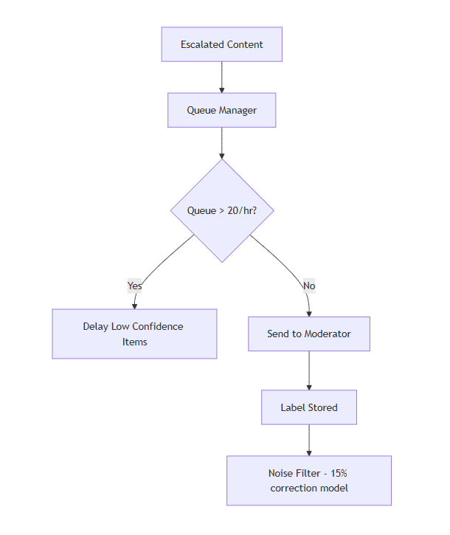

- Handling Noisy Human Labels (15% Bias)
Mitigation:
- Confidence-weighted labels
- Disagreement tracking
- Periodic relabel sampling
- Blind review rotation
- Majority voting for high-risk content

- Adaptive Strategy Against Adversaries
Signal Rotation
- Randomized weighting
- Rotating feature importance
- Hidden ensemble models
- Decay reset window

Anti-Predictability Strategy
- Random deep model sampling (even for low risk)
- Noise injection into thresholds
- Shadow evaluation pipeline

Adaptive Loop Diagram
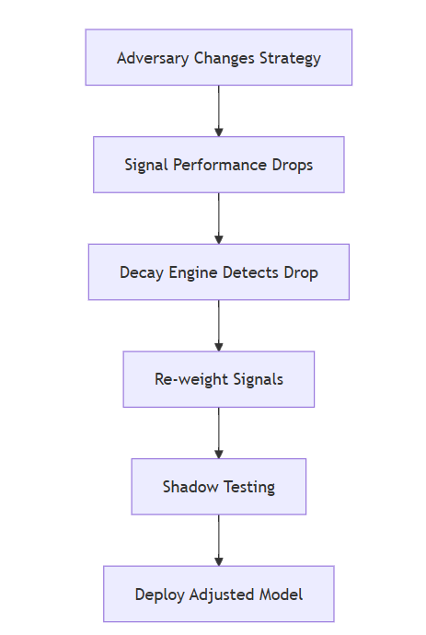

- Security Posture
Threats
- Adversarial prompt injection
- Coordinated label poisoning
- API abuse
- Model inversion attempts
Controls
- Strict input validation
- Rate limiting
- No stack traces in errors
- Model response clipping
- No confidence exposure publicly

- Failure Mode Declaration
Failure 1: Contextual Ambiguity Misclassified
Example:
“yeh fire hai”
Impact:
- False flag
- User trust drop
Containment:
- Ambiguity detector
- Force human escalation
- Low-confidence auto-action block
Failure 2: Coordinated Label Poisoning
Impact:
- Bias reinforcement
- System drift
Containment:
- Random re-review
- Confidence weighting
- Disagreement alarms

Failure 3: Budget Exhaustion Mid-Month
Impact:
- Deep model disabled
- Accuracy drop
Containment:
- Budget throttle at 80%
- Graceful degraded mode
- Increased ambiguity routing

- Release Strategy
- Canary deployment (10%)
- Shadow evaluation
- Auto rollback on:
  - Error spike
  - Latency spike
  - False positive spike

Deployment Flow
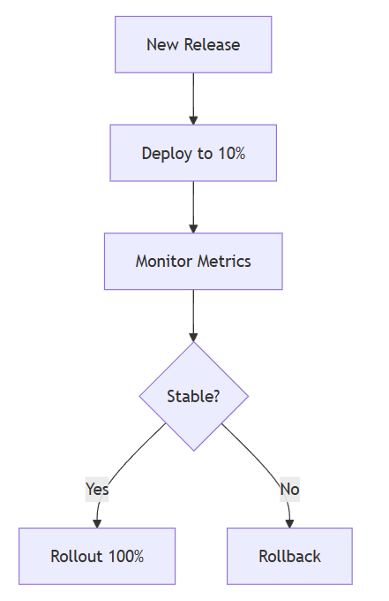

- Chaos Testing Plan
Simulate:
- 10x traffic spike
- ML API outage
- Human queue overload
- Signal decay collapse
- 15% label poisoning spike
Measure:
- Stability
- Recovery time
- Error containment

- On-Call Model
- 1 Backend engineer
- 1 Safety engineer
- Escalation tree defined
- Pager rotation weekly
- Postmortem required for P1

- Postmortem Template
- Timeline
- Detection
- Root cause
- Why safeguards failed
- Permanent mitigation
- Trust impact analysis

- Final Operational Philosophy
ContentShield is:
- Not perfectly accurate
- Not fully automated
- Not infinite budget
It is:
- Adaptive
- Cost-aware
- Human-aligned
- Failure-conscious

