SE: Machine Learning
Department of Computer and Software Engineering

Course Instructor: Dr. Ahmed Raza | Date:
Day: | Semester:

Lab 5: Decision Tree Split using Gini and Information Gain

Lab Title | CLO | BT | PLO | Weightage
Decision Tree Split
using Gini and Information Gain

Name | Roll Number | Report /10 | Viva /5 | Total /15
Muhammad Abdul Qadir | BSSE23105

Checked on:
Signature:

- Learning Outcomes
After completing this lab, the student will be able to:

  - Compute Gini impurity for binary classification.
  - Calculate Information Gain from candidate splits.
  - Implement the split selection procedure used by decision trees.
  - Observe bias toward high-cardinality features.

- Dataset
We will use the Iris dataset from sklearn. To simplify the problem we restrict the dataset to two classes.
Properties:

  - Samples: 100
  - Features: 4
  - Classes: Binary Dataset loading:
from sklearn.datasets import load_iris

- Gini Impurity
For binary classification:

Gini = 1 − (p² + p²)
0 1
A perfectly pure node has Gini impurity equal to 0.

- Information Gain
The reduction in impurity after a split is:
Gain = Gini(parent) − nL Gini(L) + nR Gini(R)
n n
The split with the highest information gain is selected.

- Part A: Implement Gini Impurity (3 Marks)
Implement the function:
gini(y)
The function should:
- compute class probabilities
- apply the Gini formula
- return impurity Verify using:
y = [0,0,0,1]
Compute impurity manually and compare.

Code:
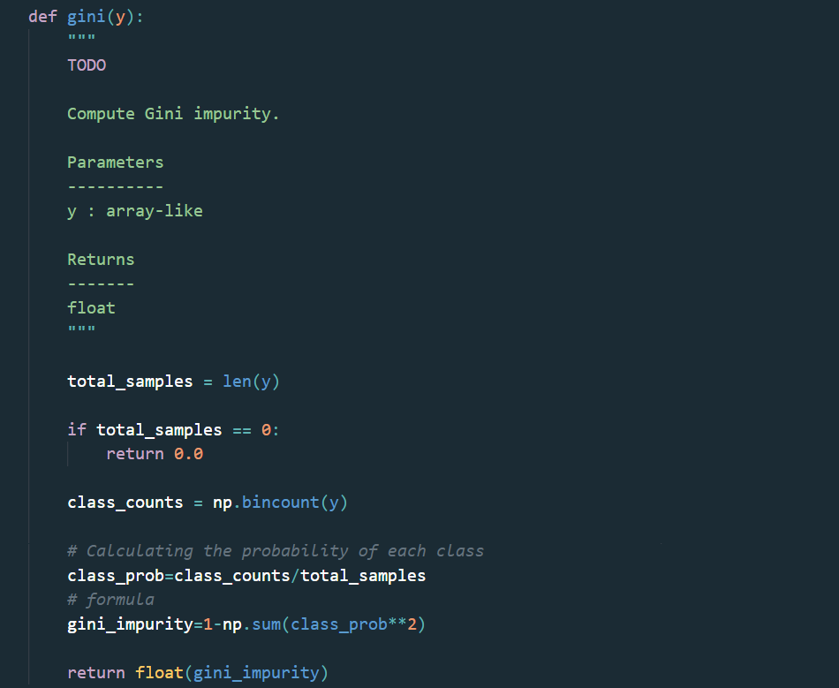

Verification using y=[0,0,0,1]

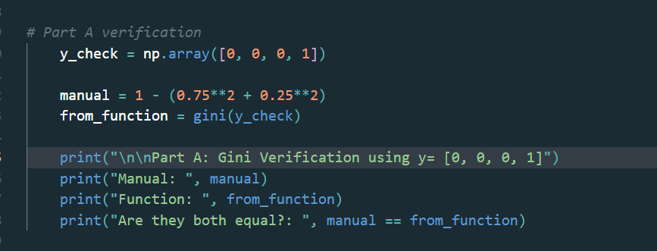

Comparison Output:
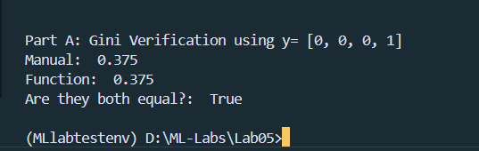

- Part B: Implement Information Gain (4 Marks)
Implement:
information_gain(parent, left, right)
Steps:
- compute parent impurity
- compute child impurities
- compute weighted average
- subtract from parent impurity

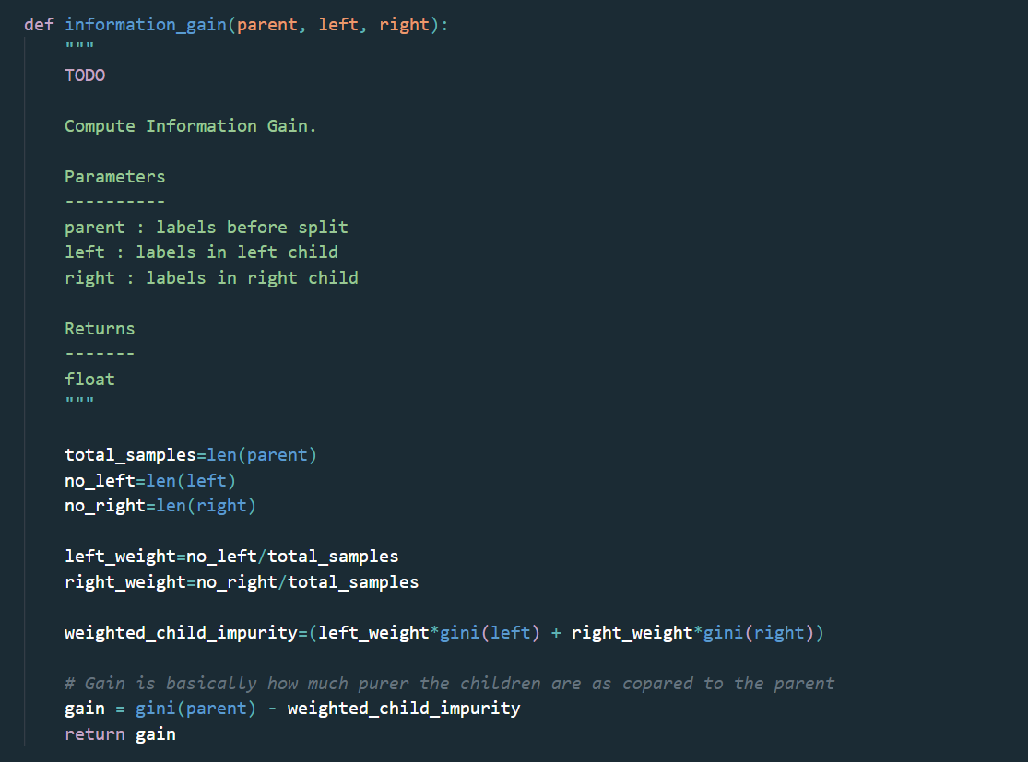

- Part C: Implement Tree Split Logic (4 Marks)
Implement the function: find_best_split(X, y) The function should:
- iterate over features
- compute candidate thresholds
- evaluate information gain
- return the best feature and threshold Use NumPy operations where possible.

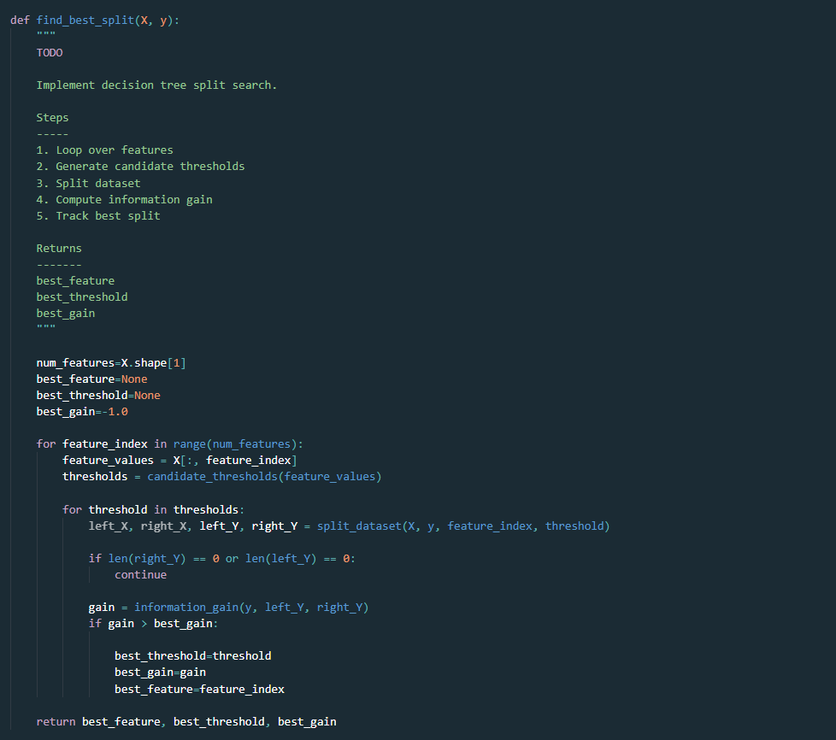

- Part D: Cardinality Bias Experiment (4 Marks)
A new feature will be added:
index_feature = sample_index / N
This feature contains many unique values. Run the split algorithm again and observe:
- which feature is selected
- whether the high-cardinality feature is preferred Explain why this occurs.

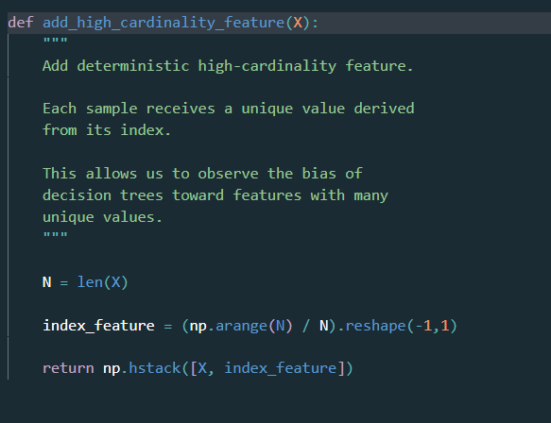

Output:
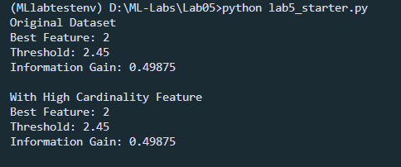
Reason:
- After adding the high-cardinality index feature, the best split remained Feature 2 (petal length) and the index feature was not selected (Not preferred) because Feature 2 already provides the maximum impurity reduction, while The index feature is basically just the row position, and it doesn’t have a real relationship with the class labels here, so it doesn’t beat Feature 2.

Plot For Understanding:

Plots comparison
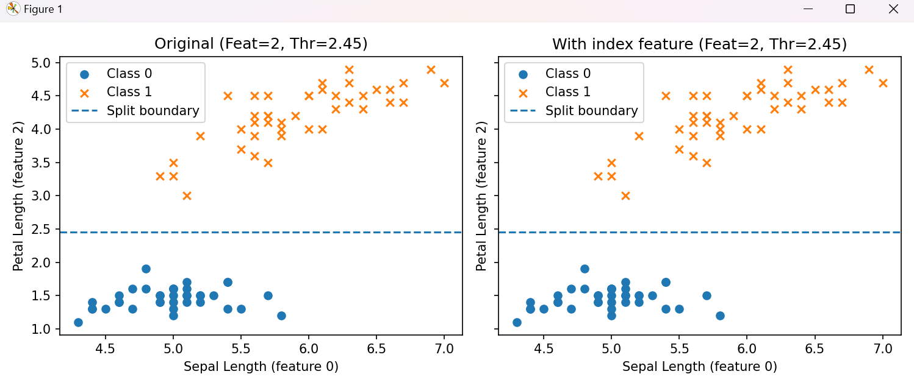

- Expected Output
Your program should print:

  - Best split feature
  - Threshold
  - Information gain
  - Result of cardinality bias experiment

Assessment Rubrics
Method: Lab reports and instructor observation during lab sessions

Outcome Assessed:

- Ability to conduct experiments, as well as to analyze and interpret data (P).
- Ability to use the techniques, skills, and modern engineering tools necessary for engineering practice (P).

Performance | Exceeds expectation (4-5) | Meets expectation (3-2) | Does not meet expectation (1) | Marks
1. Realization of Experiment [a, b] | Selects relevant equipment to the experiment, develops setup diagrams of equipment connections or wiring. | Needs guidance to select relevant equipment and to develop equipment connection or wiring diagrams. | Incapable of selecting relevant equipment to conduct the experiment.
2. Conducting Experiment [a, b] | Does proper calibration of equipment, carefully examines equipment moving parts, and ensures smooth operation. | Calibrates equipment, examines equipment moving parts, and operates the equipment with minor error. | Unable to calibrate appropriate equipment, and equipment operation is substantially wrong.
3. Laboratory Safety Rules [a] | Respectfully and carefully observes safety rules and procedures. | Observes safety rules and procedures with minor deviation. | Disregards safety rules and procedures.
6. Data Collection [a] | Plans data collection to achieve experimental objectives, and conducts an orderly and complete data collection. | Plans data collection to achieve experimental objectives, and collects complete data with minor error. | Does not know how to plan data collection; data collected is incomplete and contain errors.
7. Data Analysis [a] | Accurately conducts simple computations and statistical analysis; correlates results to known theoretical values; accounts for measurement errors. | Conducts simple computations with minor error; reasonably correlates results to known theoretical values; attempts to account for errors. | Unable to conduct simple statistical analysis; no attempt to correlate or explain errors.
8. Computer Use [a] | Uses computer to collect and analyze data effectively. | Uses computer to collect and analyze data with minor error. | Does not know how to use computer to collect and analyze data.
Total

Faculty:
Name: Signature: Date:

