SE: Machine Learning
Department of Computer and Software Engineering

Course Instructor: Dr. Ahmed Raza | Date:
Day: | Semester:

Lab 6: K-Means Clustering from Scratch

Lab Title | CLO | BT | PLO | Weightage
K-Means Clustering
From Scratch

Name | Roll Number | Report /10 | Viva /5 | Total /15
Muhammad Abdul Qadir | BSSE23105

Checked on:
Signature:

- Learning Outcomes
After completing this lab students will be able to:

- Implement the K-Means clustering algorithm from scratch.
- Understand how different distance metrics affect clustering.
- Compare clustering results on separable vs overlapping datasets.
- Visualize cluster decision boundaries.

- Datasets
In this lab we will experiment with two datasets.

Dataset 1: Iris Dataset
The Iris dataset contains 150 samples.
For visualization purposes we only use two features:

    - Sepal Length
    - Petal Length

Dataset 2: Synthetic Dataset
We will also generate a synthetic dataset using:

sklearn.datasets.make_blobs

Two versions will be created:

    - Well-separated clusters
    - Overlapping clusters

This allows us to observe how K-Means behaves when clusters are not clearly separable.

- Distance Metrics
In this lab you will experiment with three distance metrics.

Euclidean Distance
d(x, y) = qΣ(x_{i} − y_{i})2
Produces circular cluster boundaries.

Manhattan Distance
d(x, y) = Σ |x_{i} − y_{i}|
Produces diamond-shaped cluster boundaries.

Cosine Distance
Cosine similarity measures the angle between two vectors.

Cosine distance:
similarity =
x · y

||x|| ||y||

d(x, y) = 1 − similarity
This metric is commonly used in:
- Text clustering
- Document similarity
- Embedding spaces

- Part A: Distance Function (3 Marks)
Implement the function:
_distance(x1, x2)
The function must support the following metrics:
- Euclidean
- Manhattan
- Cosine
Use NumPy operations only.

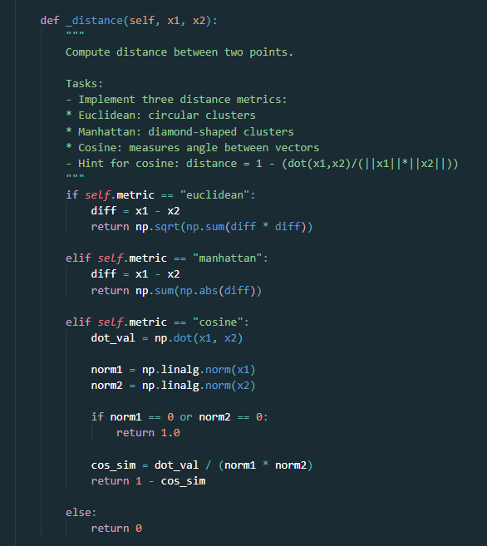

- Part B: Cluster Assignment (4 Marks)
Implement:
assign_clusters(X, centroids)
Steps:
- Compute the distance from each point to every centroid
- Assign the point to the closest centroid
- Return cluster labels

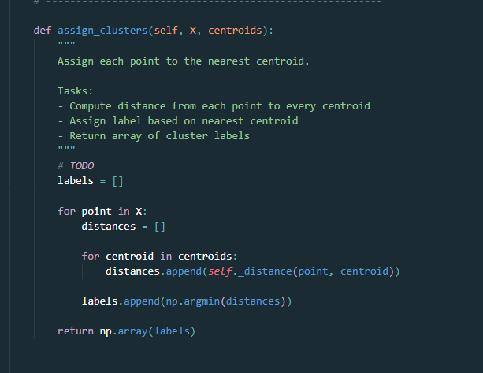

- Part C: Update Centroids (4 Marks)
Implement:
update_centroids(X, labels)
Steps:
- For each cluster compute the mean of all assigned points
- Return updated centroid coordinates

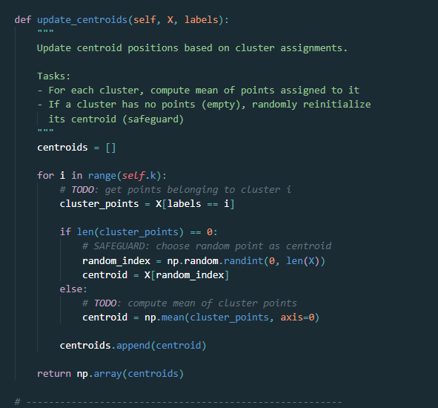

- Part D: Full K-Means Algorithm (4 Marks)
Implement:
fit(X) predict(X)
Algorithm:
- Initialize K centroids randomly
- Assign points to nearest centroid
- Update centroid locations
- Repeat until centroids converge or max iterations reached

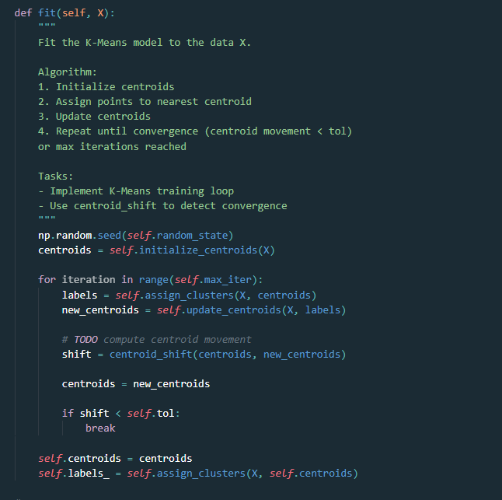

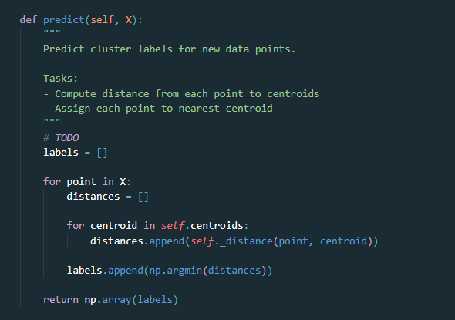

- Part E: Boundary Visualization (Bonus)
Create a function: plot_decision_boundaries(model, X) Steps:
- Create a mesh grid over the feature space
- Predict cluster label for each grid point
- Plot colored decision regions Run the visualization for:
- Euclidean distance
- Manhattan distance
- Cosine distance

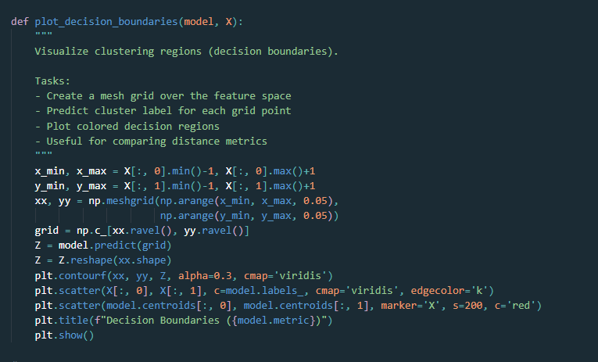

Outputs

- Visualization for Euclidean distance decision boundries
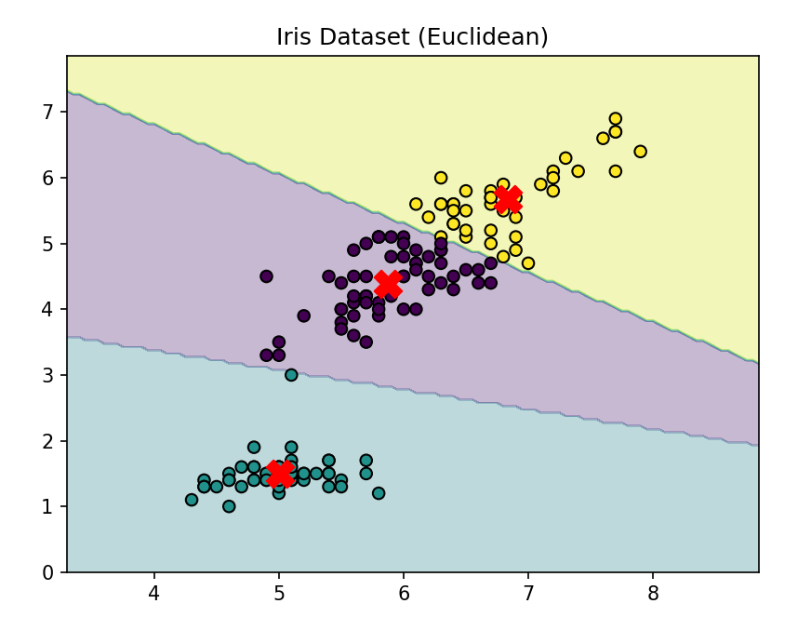

- Visualization for Manhattan distance decision boundaries
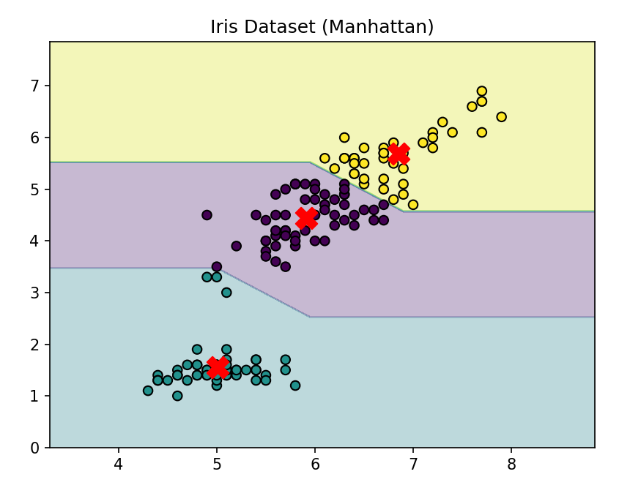

- Visualization for Cosine distance decision boundaries
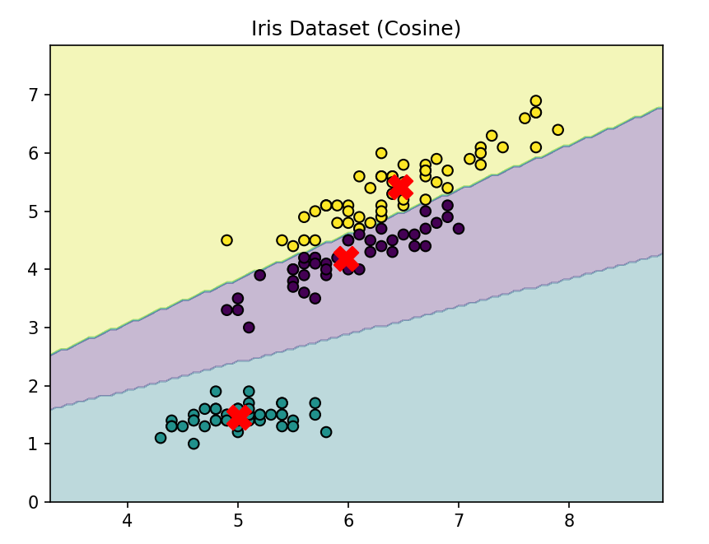

- Part F: Experimental Comparison
Run K-Means on both datasets.

Dataset | Distance Metric | Observations
Iris | Euclidean | It creates smooth and curved decision boundaries, making clusters appear more circular in shape. Because of this, it works really well as a general-purpose method for clustering
Iris | Manhattan | It creates more angular and diagonal decision boundaries, so the clusters tend to look rectangular or diamond-shaped. It’s also less affected by outliers, making it a bit more robust in noisy data.
Iris | Cosine | It creates boundaries that spread out radially from the origin, making it especially useful when the direction of the data matters more than its magnitude. For datasets with only positive values, it often gives results similar to Euclidean distance.
Separable Blobs | Euclidean | It clearly separates the clusters with well-defined boundaries, and the low inertia indicates that the data points are tightly grouped within their clusters.
Overlapping Blobs | Euclidean | It has trouble dealing with overlapping regions, so some points end up being misclassified. The higher inertia also suggests that the clusters are less compact and not as well defined.

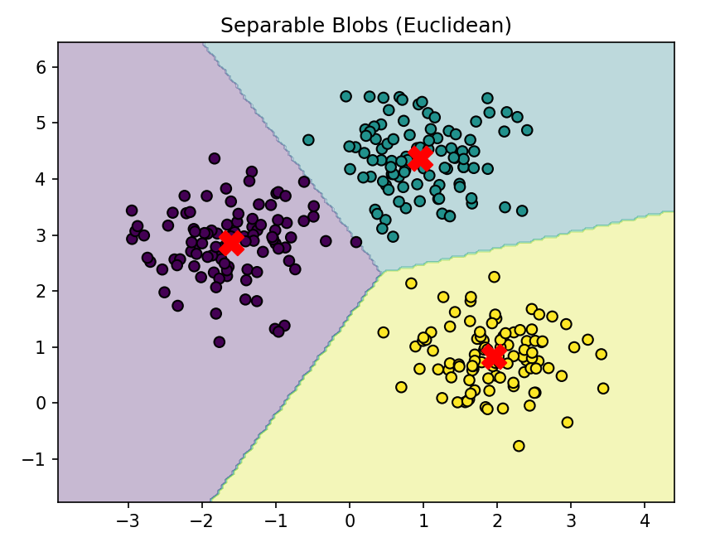

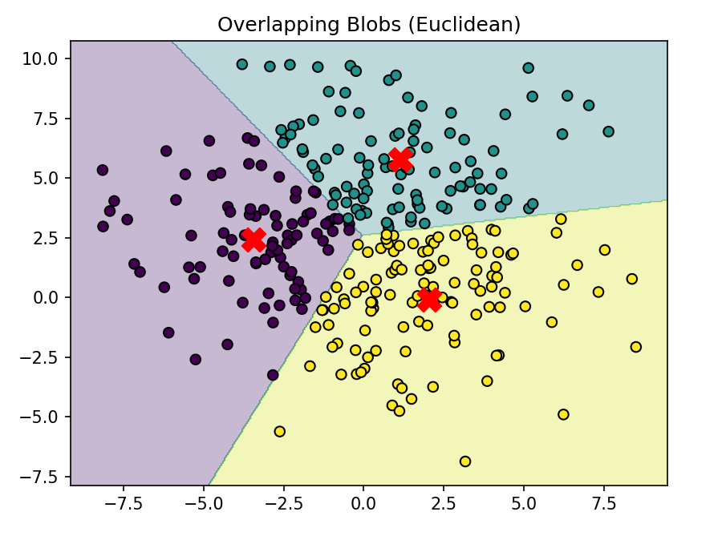

Discuss:

Question1
How do distance metrics change cluster shapes?

Answer:
Euclidean distance forms circular or spherical clusters because it measures straight-line distance the same in every direction. Manhattan distance, on the other hand, produces diamond-shaped clusters since it adds up the absolute differences along each axis. Cosine distance behaves differently,as it creates radial or angular boundaries from the origin because it focuses on the angle between vectors rather than how large they are.

Question2
Which metric performs best for overlapping clusters?

Answer:
When clusters overlap, all distance metrics tend to struggle because K-Means assumes that clusters are well-separated and have a clear, convex shape. That said, Manhattan distance can be a bit more resistant to outliers compared to others. Overall, K-Means isn’t the best choice for overlapping data.

Question3
Does K-Means always converge to the same solution?

Answer
No, K-Means doesn’t guarantee a global minimum; it usually settles for a local minimum. The final result depends heavily on where the initial centroids are placed, so different random starting points can lead to different clusterings. That’s why techniques like multiple restarts or K-Means++ initialization are used to improve the chances of finding a better solution.

- Cluster Quality: Within Cluster Sum of Squares
K-Means attempts to minimize the following objective function:

n
J = Σ ||x_{i} − µ_{c} ||
2
i
i=1
Where
- x_{i} is a data point
- µ_{c}i is the centroid of the cluster assigned to x_{i}

This value is often called:

- Within Cluster Sum of Squares (WCSS) or Sum of Squared Errors (SSE)
- Inertia

Lower values indicate tighter clusters.

- Choosing the Number of Clusters: Elbow Method
The number of clusters K is usually unknown in real applications. The Elbow Method helps estimate a reasonable value for K. Procedure:
- Run K-Means for different values of K
- Compute the inertia for each K
- Plot inertia vs K

Typically the curve looks like:

High decrease → elbow → slow decrease The “elbow” point suggests the optimal number of cluster

- Part F: Compute Inertia (3 Marks
Implement the function: compute_inertia(X, labels, centroids) Steps:
- For every point compute the squared distance to its centroid
- Sum the squared distances
- Return the total inertia

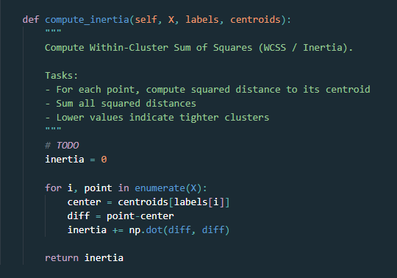

- Part G: Elbow Method (Bonus)
Create a function: plot_elbow_curve(X, k_values) Steps:
- Train K-Means for multiple values of K
- Compute inertia for each value
- Plot inertia vs K
Test with:
k_values = range(1,10)
Which value of K appears optimal for the dataset?

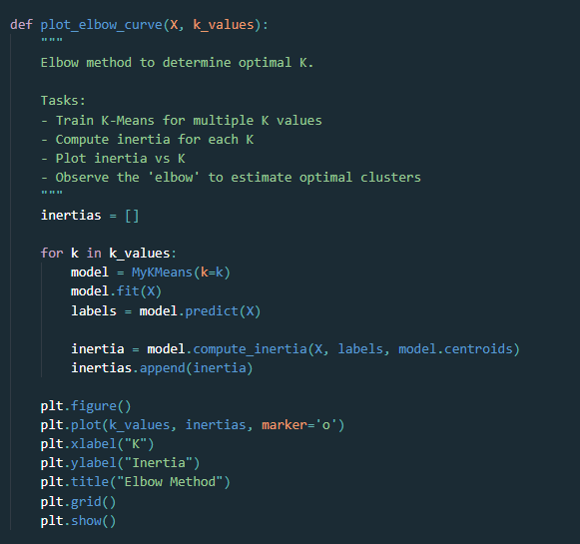

Plot

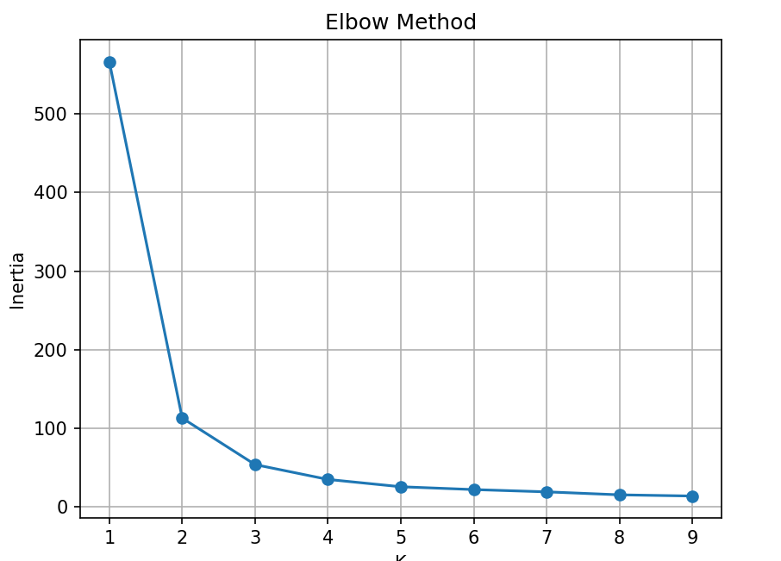

Q: Which value of K appears optimal?

Ans: K = 3 seems to be the best choice for the Iris dataset. The elbow shows up at K = 3, where the drop in inertia is quite noticeable compared to K = 1 and K = 2, and after that, the improvement starts to level off. This also makes sense since the dataset naturally contains three species

Test Cases:
