* **rails new blog_project (Create a new project Blog)**
* **rails s (Run the project)**
* **rails generate controller blog (Create a blog controller)**
* **Create a blog.rb file under model.**
* **Create a class Blog which extends ApplicationRecord**
* **rails generate migration create_blog (create table blogs)**
* **Create neccesary columns under db>migrate> create_blogs.rb file**
* **rails db:migrate**
* **rails generate migration blog_links (run to add new columns to table)**
* **Add a new column author**
* **rails db:migrate(update db)**
* **rails c (shows ruby interpreter)**
* **Add validations blogs.rb file and reload the interpreter.**

**Rails Interpreter:**

1. **SELECT :**

*Blog.all* ***-* select statements which shows details of blog table**

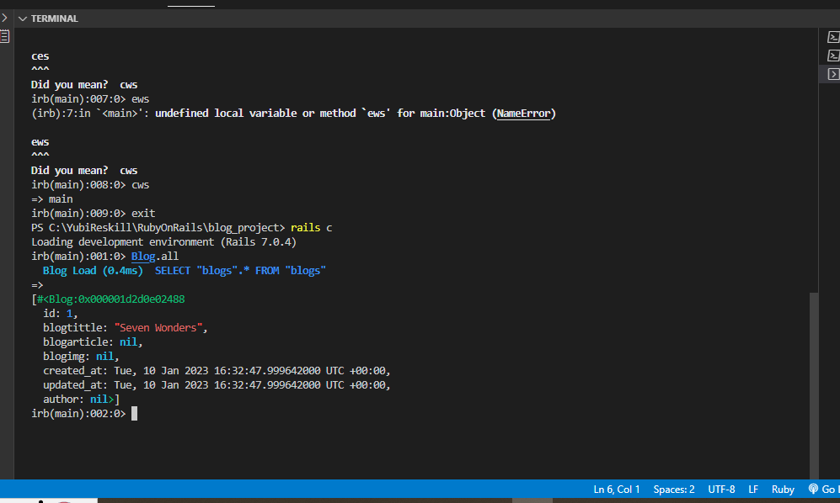

1. **CREATE:**

*b =Blog.new***– This command creates a new row in the blog table.**

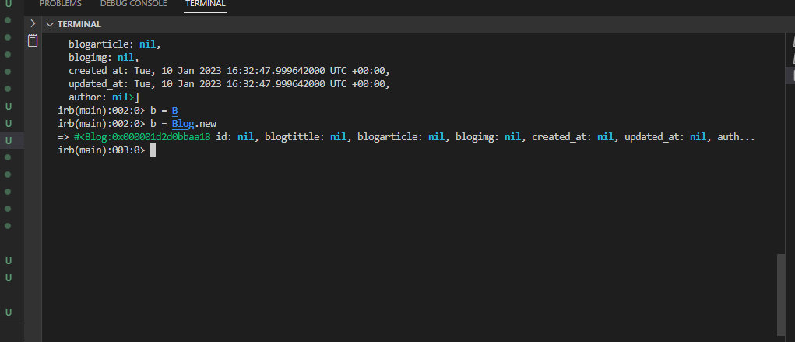

1. **UPDATE:**

*b =Blog.new*

*b.blogtittle =”Seven Wonders”*

*b.blogarticle =” There are many lists of wonders in the world, but none is as awe-inspiring as the Seven Wonders of the World. These ancient sites have been standing for centuries and attract travelers from all over the globe. Whether you're a history buff or just looking for an amazing vacation spot, these destinations should be at the top of your list!”*

*b.blogimg =”*[*https://tse3.mm.bing.net/th?id=OIP.RxYWhmnTI3f8yn1ur1XGvQHaFj&pid=Api&P=0*](https://tse3.mm.bing.net/th?id=OIP.RxYWhmnTI3f8yn1ur1XGvQHaFj&pid=Api&P=0)*”*

*b.save*

**In the above commands, we are updating the blog table**

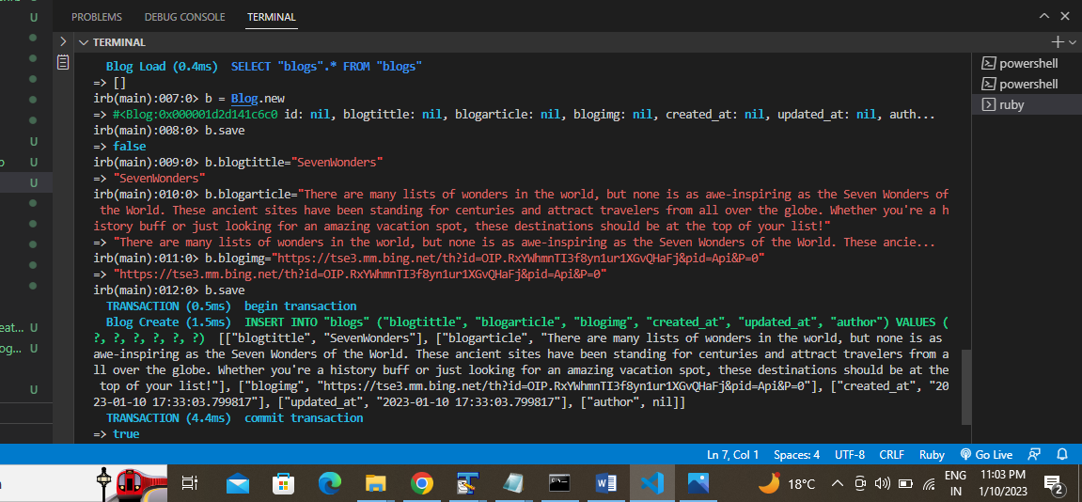

1. **DELETE:**

*b= Blog.find(1)*

*b.destroy*

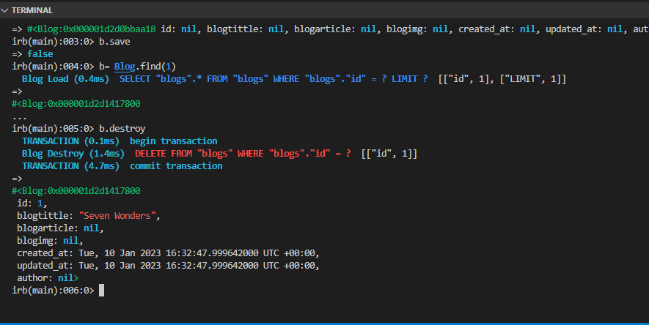

**In the below screenshot you can see command** *Blog.all* **fetches the data in json format**

