**Different Modules of Mautic**

Mautic can be divided into five modules.

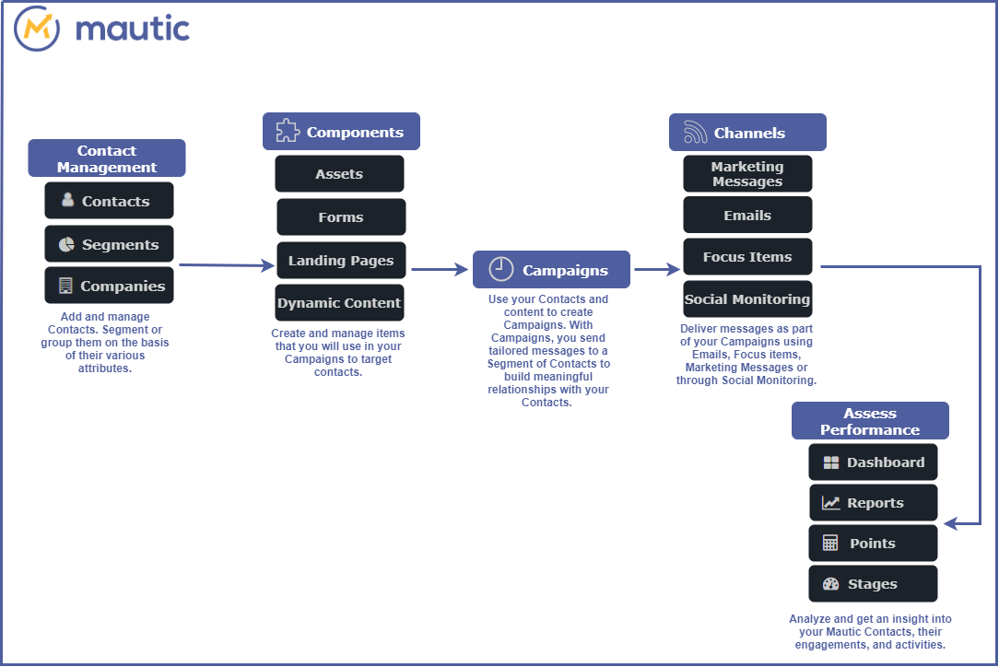

**Contact Management**

Contact Management helps you to build a functional database of Contacts for your business, group them together based on your business needs or based on shared attributes.

**Contacts**

Contacts are the central factor of a marketing automation platform. These are all the individuals who have visited your websites or interacted with you in some way.

There are two ways we can store the contacts in a mautic database.

1. **Visitor** : Visitors to your site who have not yet been identified by a form or other interaction. These contacts are tracked by Mautic but typically remain hidden.
2. **Standard contacts** — Contacts which have identified themselves via a form or some other source. As a result, these contacts typically have a name, email, and other identifying fields.

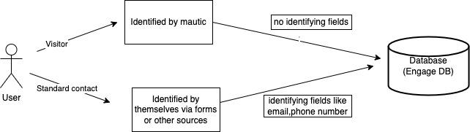

Since contacts are the primary requirement for marketing/campaigning, these details cannot be empty or null.

Use case #1 : If contact is a visitor, basic details required for campaigning like Name , email and phone number will be tracked by mautic and stored.

Use case #2 : If contact is a standard contact, we can get all other details of contact like address, DOB etc via form or any website the contact has visited.

Use case #3: Contacts can also be imported via file. It is mandated that this spreadsheet column name should be as per the mautic customer field.

For eg ; Contact name should be First Name and Last Name and type should be text or String type.

Once the contacts are stored, they can be divided based on the segments and companies which the contact belongs to. This helps for better campaigning.

**Segments**

A group of Contacts that share certain attributes. For example, you may segment Contacts based on a contact’s location. This may help you easily send out location-based offers or promotions to this specific group of Contacts.

Public and private segments: It is possible to create a segment which is accessible to everybody who uses your Mautic instance called a public segment - or just for your own use called a private segment.

Segment Filters: Filters in segmentation refer to the criteria or conditions used to group contacts or leads into specific segments. These filters can be based on a variety of factors: age, gender, location,date. Using filters in segmentation allows businesses to create targeted and personalized marketing campaigns based on the unique characteristics and behaviors of each segment.

* Once you have created your segment, any applicable contact will be automatically added through the execution of a cron job. This is the essence of segments. To keep the segments current, create a cron job that executes the following command at the desired interval: php /path/to/mautic/bin/console mautic:segments:update
* Through the execution of that command, contacts that match the filters will be added and contacts that no longer match will be removed. Any contacts that were manually added will remain part of the list regardless of filters.
* It is also possible to batch delete the unwanted contacts using the batch delete action in the contact table allowing deletion of up to 100 contacts at one time.

**Company**

Companies are a way to group contacts based on the company(ies) the contact is assigned to. Each company has a detailed page where you can see what Mautic knows about them.

The Company name field is marked as a unique identifier by default. You can choose any other company field as a unique identifier in custom fields (Forms).

We can merge a company into another existing company. This makes the migration of contacts easier.

**Components**

These are the items that are used during the campaign. They have to be created before the campaign.

Components can be any of the following:

* Assets
* Dynamic Web Content
* Forms
* Landing Pages

**Assets**

Assets are the items that are given to the contact upon the completion of form.

A few common examples of assets include:

* a white paper provided in regards a particular product or service.
* a downloadable demo application or other digital product;
* any file of interest to the contact such as video, mp3, presentation, etc.

**Dynamic Web Content**

Mautic introduced the ability to embed content on a web page dynamically for both visitor and Standard contacts.

There are 2 types of Dynamic Web Content items (or DWC):

## Filter based

This feature allows you to configure filters (like in segments) so a Landing Page with a DWC token or slot can show content based on specific conditions.

## Campaign based

The default content will be delivered to all contacts. If you want to push something different based on a set of criteria, you create those here and deliver them.

If you want to serve up different information based on certain criteria, you can use a push request.

1. If the person is known, they receive the content from the pull request(default content).
2. If they meet the criteria (in the example below - if they are from Canada), a different set of content can be delivered to the browser.
3. If they are unknown, they will see the information embedded in the dynamic web content div from the page.

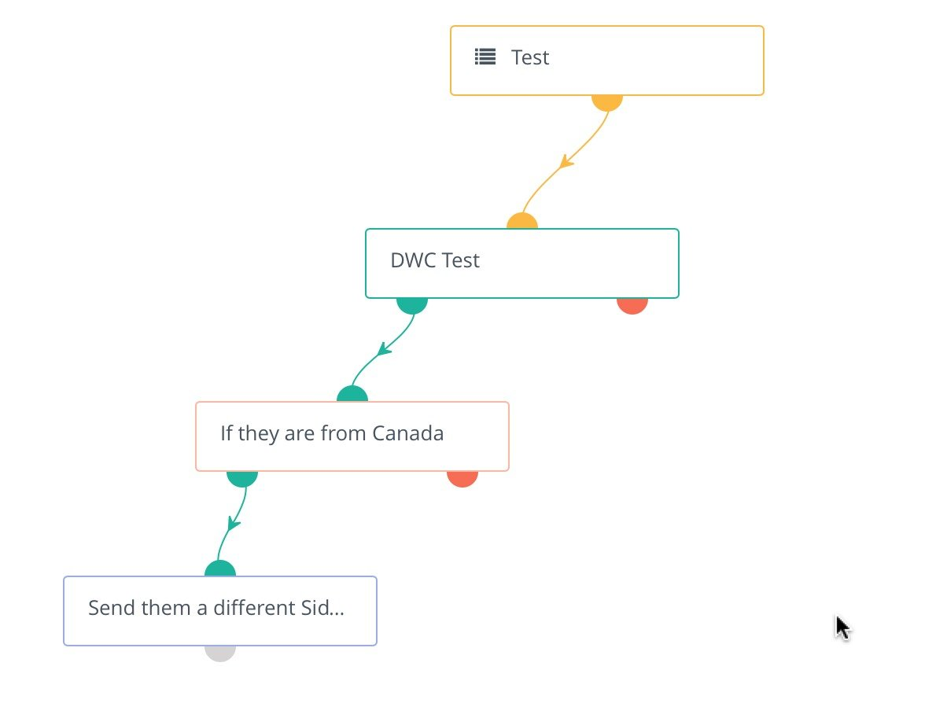

**Translations**

Dynamic web content supports translated content. When creating/editing a dynamic web content item, there are the options to set a language and select a translation parent. By selecting a translation parent, the current item is then considered to be a translation in the selected language of that parent item.

## **Tokens**

Dynamic web content supports these tokens:

1. Contact Fields - example {contactfield=firstname}
2. Page Link - example {pagelink=1}
3. Asset Link - example {assetlink=1}
4. Form - example {form=1}
5. Focus Item - example {focus=1}

**Forms**

A form is used to collect user information often in exchange for providing access to a download, an event registration, or an email newsletter(Assets). Forms allow you to collect contact data and add additional information to their profile.

There are two types of form:

A. **Campaign Form** can push a contact directly into a campaign but all actions are performed in the Campaign Builder.

B. **Standalone Form** can push a contact into a segment, but not into a campaign directly. The advantage to this form type is that you can perform actions at the time of submission.

An example of this would be sending an email to an administrator with the form values included.

## **Managing Forms**

## Form Fields

A form can contain as many fields as needed. These fields can be laid out dynamically by the system or handled via HTML if you want more control.

### Page Breaks

Page breaks allow multi-paged forms. The submission does not happen till the final page and the submit button is pressed.

Form Actions

Form actions are items to be handled on the submission of the form. You can define multiple actions to be performed on each submission.

**Landing Pages**

Landing pages are used for directing contacts through a form or providing a way to download an asset, or merely tracking interest in a particular subject.

#### **Campaign**

#### A Campaign is a marketing effort that uses different Components and Channels to promote content in a coordinated and strategic way to achieve specific business goals like Contact management, marketing operation and sales enablement.It can send customized messages to all contacts in the segments or its subset contacts that you specify.

#### **Campaign types**

#### Campaign Builder: The Campaign Builder is an intuitive visual interface that allows users to create marketing campaigns using a drag-and-drop interface. Users can create custom workflows with multiple steps, such as sending email messages, adding contacts to a segment, or creating tasks for team members.

#### Email Campaigns: Mautic allows users to create and send targeted email campaigns to their contacts. Users can create email templates, personalize messages with merge tags, and schedule emails to be sent at specific times.

#### Social Media Campaigns: Users can create and schedule social media posts on platforms like Twitter, LinkedIn, and Facebook, and track the performance of their social media campaigns.

#### Landing Page Campaigns: The Campaigns module in Mautic allows users to create custom landing pages to capture leads and track conversions. Users can create landing page templates, add forms to collect data, and track the performance of their landing pages.

#### Analytics and Reporting: The Campaigns module in Mautic provides detailed analytics and reporting on campaign performance, including data on email opens, click-through rates, social media engagement, and lead conversions.

#### Automation: Mautic's Campaigns module supports marketing automation, enabling users to create complex workflows that automate marketing activities based on specific triggers, such as email opens, link clicks, or form submissions.

#### 

#### 

#### 

#### **Channels**

Channels are the various methods or platforms through which businesses can reach their target audience with their marketing message. By leveraging these Channels, businesses can create effective marketing campaigns that reach their target audience with the right message, at the right time, on the right platform.

Mautic provides several built-in Channels that businesses can use to engage with their audience, including:

1. Email: Email is one of the most effective Channels for marketing communication. With Mautic, businesses can create and send targeted email messages to their subscribers, track email opens and clicks, and automate email campaigns.
2. Social Media: As people are engaged in using Social media ,reaching out on spaces where people are enables businesses to connect with their target audience like on Facebook, Twitter, LinkedIn, and Instagram. Users can schedule social media posts, track engagement metrics, and respond to comments and messages from their audience.
3. Landing Pages: Landing pages are standalone web pages that are designed to capture leads and encourage conversions. With Mautic, businesses can create custom landing pages, track conversions, and analyze user behavior.
4. SMS: SMS (short message service) is a text messaging service that businesses can use to reach their audience on their mobile devices. With Mautic, users can send SMS messages to their subscribers, track delivery and response rates, and automate SMS campaigns.
5. Web Notifications: Web notifications are pop-up messages that appear on a website, encouraging visitors to take action. With Mautic, businesses can create custom web notifications, track user behavior, and analyze the performance of their notifications.
6. Push Notifications: Push notifications are messages that are sent to users' mobile devices or desktops, encouraging them to take action. Mautic enables businesses to send push notifications to their subscribers, track delivery and response rates, and automate push notification campaigns.

#### 

#### **Assess Performance**

#### Helps you to analyze trends and progress of your marketing strategy using various tools.

**Dashboard**

Dashboards are customizable where each user can compose widgets with the information they want to track.

## Date range filter

All the widgets will display data in the selected global date range filter at the top of the widget list. The default date range is set from 30 days ago to today.

**Reports**

Highly customizable reports can be generated through Mautic's Report.

## Data Sources

Choose the data source appropriate to the report you want. Each data source has a different set of available columns, filters and graphs.

## Configuration

Each report can be customized to include the columns of choice. Filter data based on set criteria and/or set a specific order for the data.

Scheduling Reports

It is possible to schedule emails which will send reports to one or more email addresses.

### Cron job to schedule reports

To be able to send scheduled reports, the following cron command is required:

php /path/to/mautic/bin/console mautic:reports:scheduler [--report=ID]

The --report=ID argument allows you to specify a report by ID if required.

**Points**

Points provide a way for contacts to be properly weighted. These points have both triggers and actions.

## **Stages**

Stages is a way to define the lifecycle of a contact. Create stages based on your marketing stages, and move your contacts from stage to stage.