**Commands to create the project**

* rails new bookstockapp -d postgresql
* Once the project is created, change the dbname , username , password, and uncomment the

port number and local host.

* rails generate migration create_book. This command creates the migration file and table ‘books’
* In the migration file, create all the columns required.
* rails db: migrate. This command creates the columns.
* rails generate controller book. This command creates the book_controller file.
* Then create book.rb under models. Create class Book which inherits ApplicationRecord.

**Creating API for CRUD operations under Book_controller**

* **index API:**

In this API, we show all the book details. This is a ‘GET” request. Below is screenshot of output when the url ‘*http://127.0.0.1:3000/book’*  is send in postman.

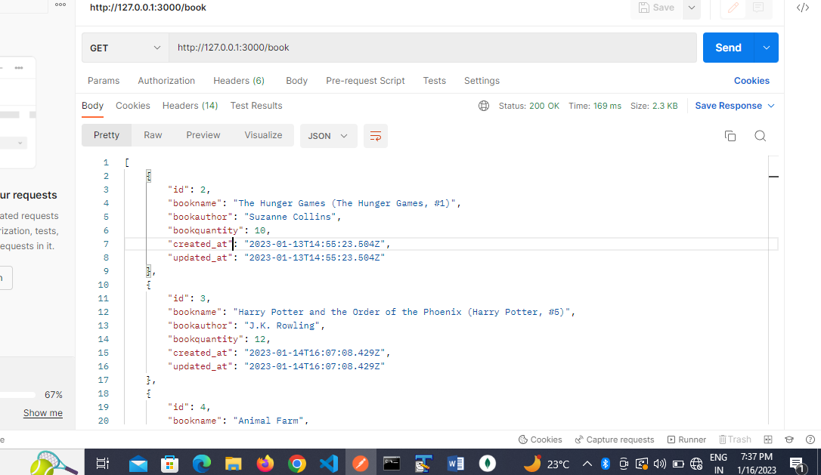

* **show API:**

In this API, we show the book details by id as shown below. This is a ‘GET” request. Here we see details of each book by giving id in the url . Below is screenshot of output when the url ‘*http://127.0.0.1:3000/book/2’*  is send in postman.

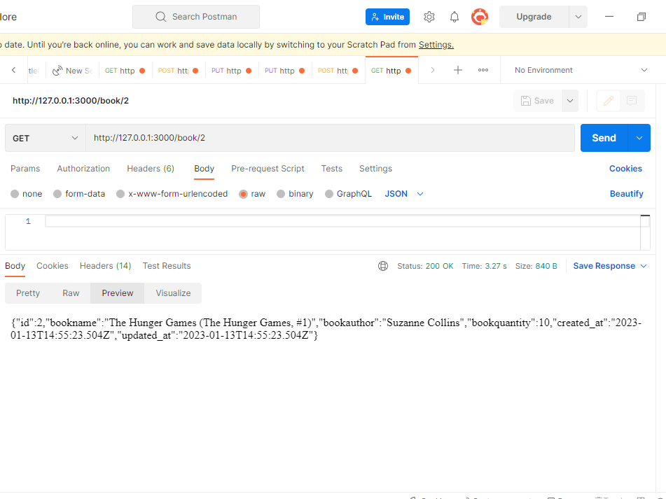

* **create API:**

This API is used to create the data. This is a ‘POST’ request. The data is send in the json format as

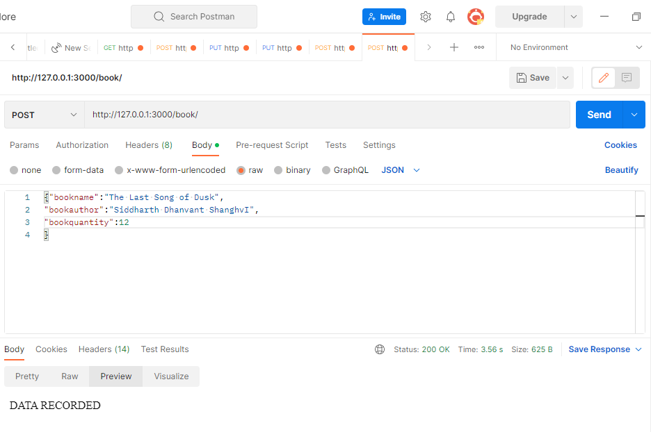shown in the screenshot. The url is ‘*http://127.0.0.1:3000/book.*

* **update API:**

This API updates the data fetched by the id given in the url. This is a ‘PUT’ request. Below is screenshot of output when the url ‘*http://127.0.0.1:3000/book/2’*  is send in postman.

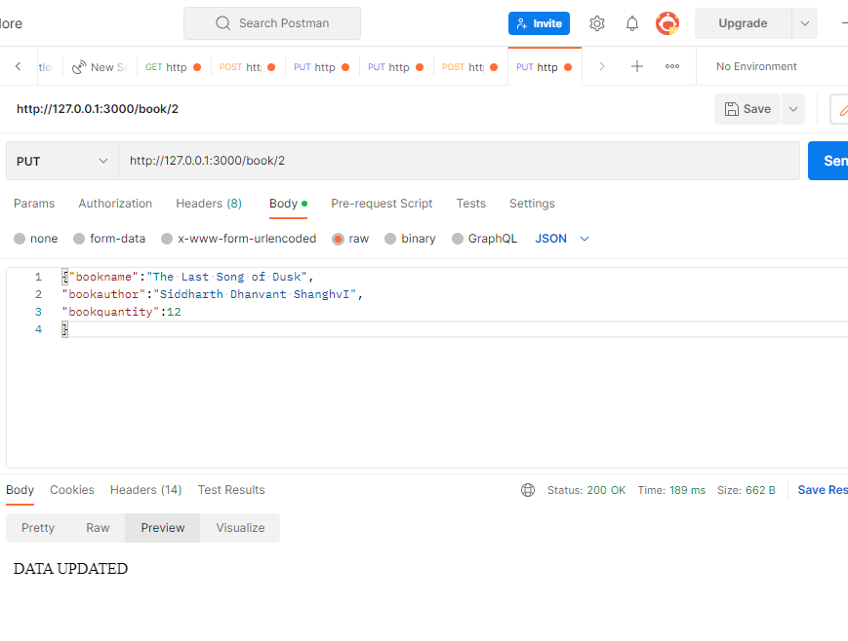

* **destroy API:**

This API deletes the data fetched by the id given. . This is a ‘DELETE’ request. Below is screenshot of output when the url ‘*http://127.0.0.1:3000/book/2’*  is send in postman.

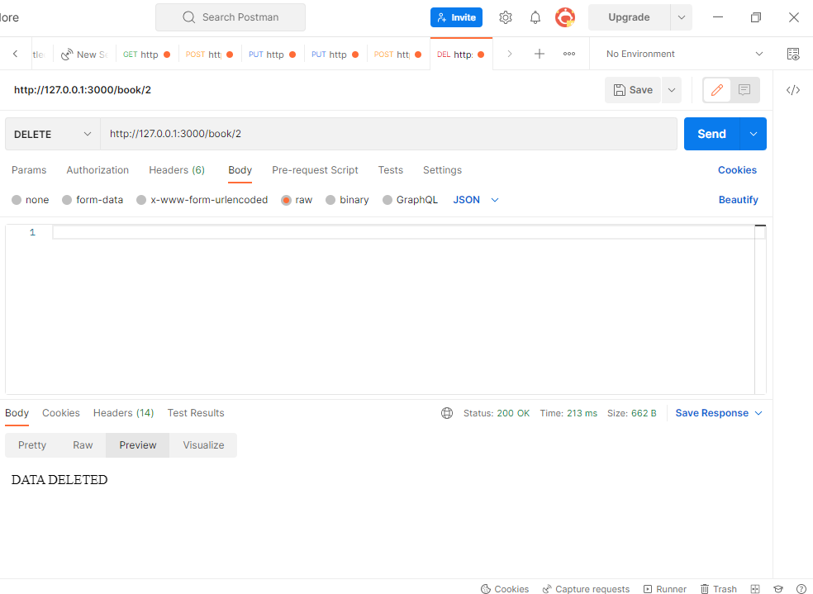

**Creating APIs for search by book name and book author**

* Create new controller “searchbookname” by using the below command

rails generate controller searchbookname

* Record in routes.rb as searchbookname.
* In SearchbooknameController, write **index function** where the details are fetched by bookname using ‘find_by’ function. This is a ‘GET’ request. Below is the screenshoot when the url ‘*http://127.0.0.1:3000/searchbookname’* is send in postman and parameter “bookname” is sent as json data.

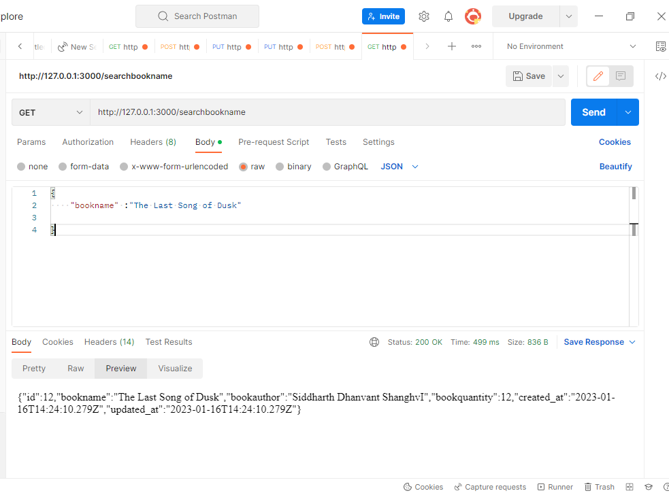

* Create new controller “searchbookauth” by using the below command

rails generate controller searchbookauth

* Record in routes.rb as searchbookauth.
* In SearchbookauthController, write **index function** where the details are fetched by bookauthor using ‘where’ function. This is a ‘GET’ request. Below is the screenshoot when the url ‘*http://127.0.0.1:3000/searchbookauth’* is send in postman. parameter “bookauthor” is sent as json data.

