**ABSTRACT**

Software testing is one of the most critical steps in the stages of software development. It is the process of cross-validating whether a software is free from bugs and satisfies the technical requirements and user requirements by meeting all the conditions. As the current era focuses on developing the software applications through web, the demand for quality increases. This is where automation testing comes in to ensure high quality products are delivered at a reasonable testing cost. Selenium is one of the most popular open source automation tool used for web applications across many browsers.

**INTRODUCTION**

Selenium Framework is one of the most popular open source automation testing tool which is a collection of multiple software tools. Selenium is known for it's flexibility to manage wide variety of browsers with a good support for various programming languages such as Java, C, PHP, Ruby, Perl etc. Even though there exists many components only three major tools constitute of what is selenium.

* Selenium IDE: Selenium IDE (Integrated Development Environment) is a part of the selenium suite which was developed to fastrack the creation of automation scripts.It has support for both Chrome and Firefox which allows testers to track the workflow whenever they need to test. One of the easiest tool to work for script testing.
* Selenium RC: A Client-Server Architecture which retrieves the commands from the IDE followed by the tests executed on the browser. A Critical component in the test suite which has support for programming languages like Java, C#, Perl, python and PHP. It helps a tester to easily write test vases to automate testing for web applications.
* Selenium Web Driver: A Web framework that allows one to execute cross browser tests and allows for testing the application to check whether it performs according to the expectations or not.However, it is not capable of handling window components but it can be overriden by various other tools.
* Selenium Grid: A Part of the selenium suite which allows one to run multiple tests across various browsers and operating systems. Selenium grid provides a good flexibility to distribute the test cases for multiple executions hence reduced processing time. A Central Point known as the Hub recieves all requests which distributes the test cases to each nodes. Only one Hub is present in the selenium grid. However there can be multiple nodes in a Grid. Each node carries out communication with the hub hence performing tests assigned to each one of them.

**TYPES OF TESTING WITH SELENIUM**

* Unit Testing: These type of testing is mainly done by developers in order to fix a bug to a website application.Unit testing is challenging as it requires to perform on various application modules.
* Black-Box Testing or System Testing: In these, testers are responsible for making sure that the system’s compliance is based on particular requirements.The Functionality of the module should be tested from end-to-end perspective.
* ·Integration Testing: In Integration Testing certain set of actions are performed by the QA to ensure that all the units of the application work effectively. Here,testers are able to easily perform through integration testing after the release of every application which helps in evaluating the functionality and the behaviour of various modules
* End-to-End Testing: These type of testing are done on the web applications by the QA engineers from the perspective of the end-users. A set of test cases are made to ensure that web applications run smoothly at various points.
* Regression Testing: Allows the developers to gauge the functionality of a particular web application to make sure that the new code does not override the current functionality of the web application.It is also used to ensure that the current application works well after the feature integration
* Performance and Load Testing: QA Engineers perform various tests to check if the applications is working as per the requirements and expectations of the end-users.The Performance of the web application is the only concern for the end users and nothing more.

**III. WORKING:**

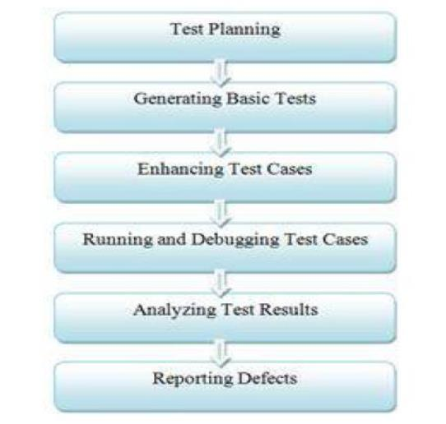Selenium itself isn’t necessary for the performing automations but however some of it’s components are essential to run tests on browsers.The First step is the installation of IDE through a browser where add-ons can be integrated into the browser.Once installed it will be available for recording a test. A Name should provided for the project with a valid URL. The Recording starts once the browser redirects to this URL. Tests can be played back in the selenium automation testing IDE by selecting the required tests and by clicking the play. Command-iine-runner can also be used for the cross-browser playback.

WebDriver:

Selenium WebDriver is an open source API Collections used for testing web applications.The WebDriver controls the web browser from the OS Level.The Simple Architecture of the WebDriver makes it easy to use.WebDriver makes use of the Browser’s engine to control it when directly interacting with the browser.It has the simplest architecture than the Selenium RC.

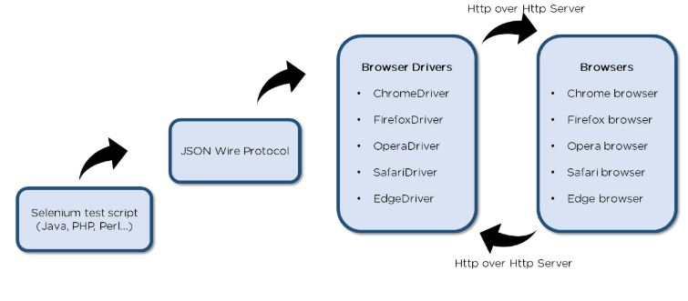

The Above diagrams depicts the SeleniumWebDriver Architecture.Downloading and the installation of Java 8 is the first step followed by the installation and configuration of Eclipse IDE. The Browser driver should then be downloaded and configured which comes with its own driver files as they are essential to run the scripts . The WebDriver can be configured easily through the Eclipse IDE which is the final step and hence a new java project is created to build our test script.The next stage is where a name for the project is given and the selection of JRE is done for use. The Most crucial step is adding the java executable files and adding libraries and External JARs.

After the WebDriver has been successfully configured the first test script can be built. Navigating to Src folder > New > Class can be used for building the first one.

**CONCLUSION:**

Selenium is one of the most flexible and cost-effective tool developers use for testing web applications and it’s popularity is still rising. What makes selenium the best from other tools is it’s support across various web browser which makes it the primary choice for companies that support heavy traffic like social platforms and e-commerce websites

**REFERENCES**

[1] Ms.RigzinAngmo,Mrs.MonikaSharma,”Selenium Tool: A Web based Automation Testing Framework”, (IJETCAS),2014.

[2] C. Kulkarni, Y.C. Kulkarni,”Automating the web applications using the selenium RC”,ASM's International Journal of Ongoing Research in Management and IT e-ISSN-2320-0065, 2011.

[3] Rafi, “Benefits and limitations of automated software testing:Systematic literature review and practitioner survey”, Automation of Software Test, IEEE, pp. 36-42, 2012.

[4] Niranjanamurthy M, Arun Kumar R , Sahana Srinivas, Manoj RK, Research Study on Web ApplicationTesting using Selenium Testing Framework, IJCSMC, Vol. 3,Issue. 10, October 2014.