Ode to the Data Warehouse Load
by Beth S. Wolfset

Ode to the Data Warehouse
It took so long to build
But that was really the easy part
It is much tougher to fill
The data must be scrubbed and cleaned
Bad records weeded out
Finally data is moved from there to here
In time for the next go round
A word of caution to data gurus
The warehouse struggles as you feed it
Those who do not study history
Are always doomed to repeat it

This paper describes the methodology used in loading a data warehouse that reads both legacy, PeopleSoft and Oracle Financials data. The discussion includes the data loading architecture, the construction of the data load programs, data conversion and interface issues, managing bad data, keeping current and history records synchronized, and distributed query optimization. Special focus is placed on the use of database views to provide data location transparency, access security, performance enhancements and insulate applications from schema changes. This implementation is currently in use.

Background

A warehouse is being implemented to allow ad hoc queries, provide consistent answers for decision support, facilitate data sharing and application inter-operability, and treat data as a corporate resource. The development and implementation of the warehouse involved the following iterative steps: analysis and design of an enterprise data model, validating the design against user requirements or Commercial Off The Shelf (COTS) models, enforcing standards for readability, developing the data model with reusability in mind, generating a schema, and implementing the database. The Oracle CASE tool is being used to support this effort.

The classical definition of “Warehouse” as defined by Inmon is “a collection of integrated, subject-oriented databases designed to support the DSS [decision support] function, where each unit of data is relevant to some moment in time. The data warehouse contains atomic data and lightly summarized data.”[INM92] However, ‘warehouse’ was interpreted in a broader sense. The warehouse includes internal and external documents, as well as financial, human resource and client data. Given this all encompassing definition, it is important to recognize that the conceptual warehouse will include two different categories of data: operational and decision support. The inherent structure and characteristics of each necessitate that the implementation spans multiple databases and servers.

Operational data. The operational data portion of the warehouse serves as the integration point for OLTP applications. It typically experiences higher update and transaction volumes than the decision support data portion. The queries are usually predictable and application driven and require a faster response time. The implementation of operational data in the warehouse substantially reduces the number of data interfaces between applications.

Decision Support (DS) Data. DS data acts as a window to the operational data. It forms a semantically consistent, cached, read-only database. DS data is usually summarized, tuned for large queries and refreshed with some periodicity.

The two types of data are both logically and physically separate. The data stored in each is consistent and integrated within its respective database [KEL94]. Different querying and indexing requirements are two major reasons that these are physically separate databases. An operational warehouse is optimized for immediate response times to queries and data refresh. A DS warehouse is optimized for informational searches and data extraction. Different indexing algorithms or strategies are often employed to achieve these two purposes.

Data Warehouse Architecture

A diverse set of hardware platforms, operating systems, database management systems, development methodologies, and communication networks characterized both the development and production environments before modernization. These environments evolved as a result of growth, dynamic requirements, and government regulations. Production systems were deployed across both mainframe and PC platforms.

Currently, COTS applications are being rolled out and integrated with custom developed applications. The development environments and approaches are still diverse to allow the flexibility to choose the proper approach for a given functional application. Development is currently being done following either an Information Engineering or Object Oriented life cycle. Two database management systems are being used, Oracle and Informix. The query tool, graphical user interface, and spreadsheet package are being standardized. These will be used regardless of whether the application is a transaction processing application or a decision support application.

The system consists of three UNIX servers (figure 1). One server is a Sequent running Dynix and two versions of Oracle. The second server is a Sun running Solaris and one version of Oracle. This server will eventually be backed up by a second Sun server to provide processing load distribution and fault tolerance. The third server is an IBM RS6000 running Informix. The data warehouse is in its own instance of Oracle on the Sun server. The legacy systems execute on an IBM mainframe running MVS.

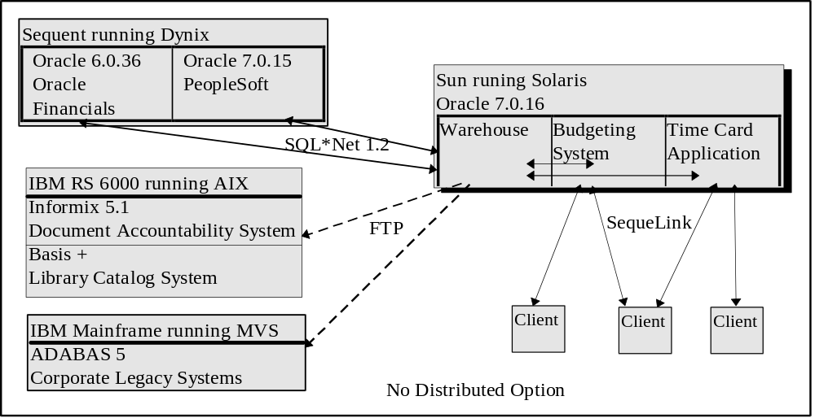
figure 1

Inter-database communication among Oracle databases is done using SQL*Net 1.2. A database link exists for every type of user of the data warehouse as well as each system the data warehouse has to access. The database links use a from-to naming convention so that it is apparent what is being connected. A special read-only user id is created on the remote machine to allow the database link to connect. In addition, there is no access to the base tables across the link. At a minimum, there is a view on the remote database giving that read-only user id access only to what it needs. There may also be a view on the local database. The views have insulated the applications from schema and data location changes as well as providing data access security.

Inter-database communication with a non-Oracle database is done using file transfer. The source system will unload the data to an ASCII file. The file is then transferred to the appropriate server using FTP. Finally, a data load is done at the receiving database.

Internally developed client-server applications use SequeLink to communicate between Oracle and the client. Several of these applications were initially written against Informix. A third-party middleware was chosen to provide a more open system.

One of the advantages of this architecture is that it minimizes the number of interfaces that need to be written for different applications to share information. If the warehouse was not used, there would potentially have to be an interface in each direction between any two applications. With the warehouse in place, there is as little as one interface in each direction between the warehouse and each of the other applications. In addition, some of those interfaces merely consist of views, with a presumably shorter development effort than a programmed interface.

Data Load Programs

The data to be loaded into the warehouse comes from many different sources. These can be divided into Oracle sources and non-Oracle sources. In order to get data from an Oracle source, a view was created on the source database for the load programs to read. The load programs are lumped together in figure 2 and represented by the “converter” black box (usually at least one PL/SQL program per table to be loaded.) In order to get data from a non-Oracle database no bridges are used. A data extract, to an ASCII file, is done on the source database. These files are transmitted to the warehouse server using FTP. The flat files are loaded into temporary tables, which are read by the load programs, using Oracle’s SQL Loader utility.

The temporary or load tables include the source information needed to load the warehouse. They frequently include additional information including a field indicating the source of the data. This is needed where data from multiple sources is destined for a single warehouse table. The load tables also include information to allow the foreign keys from the legacy systems to be converted to the appropriate references in the warehouse.

Once all of the data is in an Oracle database, it can be read by the load routines which are written in PL/SQL. All of the data conversion is done within the load routines. At least one table will be fully loaded in each routine. If the table has a corresponding history table, they are both loaded in the same routine. All of the routines had to join many different tables including: temporary tables containing information pulled from non-Oracle databases; tables from other instances of Oracle; and warehouse tables (i.e. “types” table, base tables for foreign keys, and the tables to be loaded.)

The routines were built using two different starting points. The majority of the routines create a single query that includes several outer joins. The data is brought into a cursor that is then checked row by row. Valid rows are inserted into the table. Rows with null data in one or more mandatory columns are not loaded. An error message and identifying information is written to a “bad_records” table. In some cases, the missing or incorrect data is in non-mandatory columns. This record is inserted into the table to be loaded but is also inserted into the “bad_records” table. SQL errors are trapped and written to the “errors” table. If the table is loaded successfully, meaning every record in the cursor has been checked, a record is written to the “transfer_log” table.

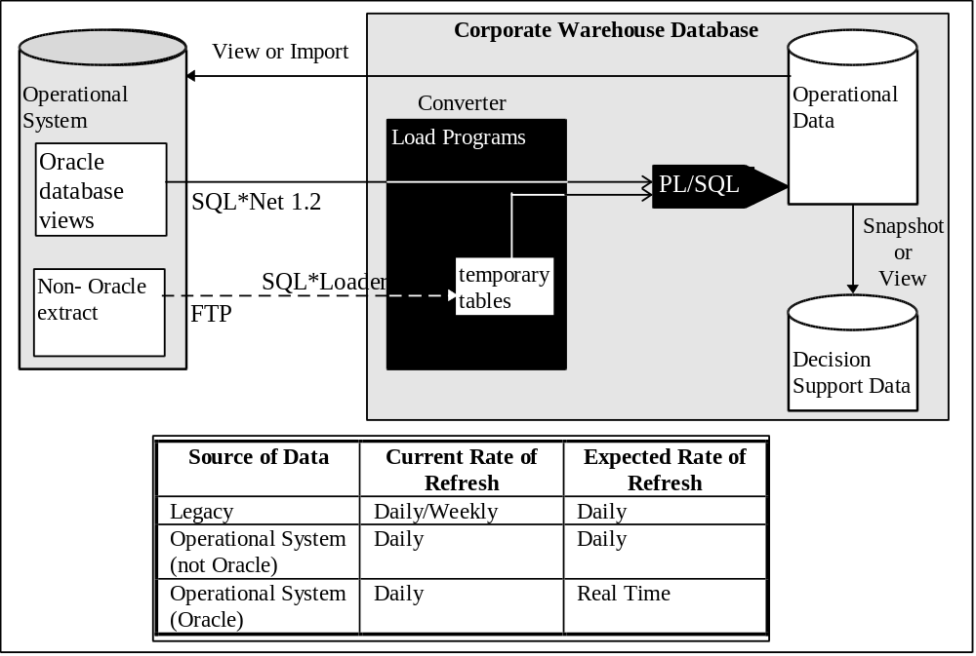
figure 2

Other routines are written to do the initial query with a union, rather than outer joins. In the initial query, only a list of records, using employer number, needing to be checked is returned in one cursor. As each row is checked in the cursor, an insert cursor is built up by querying each table needed. In this method, no outer joins are done. A single row that represents the most recent record corresponding to the employee number is inserted into the table. The remainder of the processing is done the same way as previously discussed, with rows being inserted into the “bad_records” and “errors” tables as needed. Finally, a successful run is completed with a record inserted into the “transfer_log” table.

The use of the “bad_records", “errors”, and “transfer_log” tables are very important. The “transfer_log” table can be used to get the exact date and time an update to a table was last completed. It also yields the order the tables were updated. The load routines are written to read the “transfer_log” and start processing with records created after the last update date. If a record is posted to the warehouse after the last transfer date, it will be deleted prior to the next run. This situation occurs if a run does not finish completely. The “bad_records” and “errors” tables should be checked daily. “Bad_records” shows problems in the data that should be fixed. The load routines were written to re-process the records in the “bad_records” table on the assumption that the source data will be fixed between runs. Since all errors are written to the “errors” table, it is also important to check it daily. By using “on sqlerror exit failure," processing will halt after a SQL error. This is not the case for an ORA error. The ORA error is written to the “errors” table but there is no mechanism to halt processing. A table load can be listed as completed successfully in the “transfer_log” even when serious ORA errors have occurred.

Since there are inherent dependencies between the tables, based on foreign key relationships, there is an order in which they can be loaded. A dependency diagram was created. The tables that are not dependent on any others can be loaded first. Also, if several tables are dependent upon one table, that table needs to be loaded early. A sequential order of loading was determined and a job scheduler was programmed to run the load routines in a single chain. After several full load runs that took over 5 hours, some tuning was done strictly using the job scheduler. After looking at the runs, 2 1/2 hours were used just loading two tables. These scripts were run in parallel. Later, a third parallel thread was added to speed up the entire load chain to about 3 hours. Any further tuning has to be done within the load routines.

The operational data is loaded first. The decision support data, which is not yet implemented, will be periodically loaded from the operational data.

Distributed Query Optimization

As indicated in the architecture section, the warehouse database is central to the operation of the OLTP systems. This resulted in many distributed queries. This is also the case for the load routines, which read other Oracle databases for source data.

Although the advantages and disadvantages of the rule-based and cost-based optimizers are well known, there is little known about the distributed query optimizer. The information presented was derived by trial and error.

Keep in mind, there is a threshold that Oracle uses to determine whether a table is large or small. In a local query, the SMALL_TABLE_THRESHOLD is a settable parameter and the default is usually 4 database blocks. In the distributed case, the threshold in not published and is unknown to the average user, but is apparently much larger than the SMALL_TABLE_THRESHOLD. If a remote table is below the threshold, the full table is copied to the local database over SQL*Net at execution time. If it turns out that this table is really not so small, or is used many times, this can be quite costly in network traffic, execution time and rollback space.

The approach for dealing with distributed queries using “small” tables is to use views. As indicated earlier, when an application intends to access a remote table, it performs the access through a view on the local database. This is not necessary for the solution. It is necessary to have a view located on the remote database that minimizes the data that will be transmitted across the network by restricting it to only what is needed for the query or application. In this way, any joins or processing that must be done to the remote data is done on the remote database and only the result is passed across the network.

This approach works in most cases. In one instance, it was still necessary to replicate a small table on the warehouse database. This was done as part of the warehouse load chain. Without this replication, the rollback segments were being exhausted. With the replication, the query was completing with 21 rollback extents. The table itself was small but was used many times in the same query.

Another frustration is how to put an application into production when a view has to be created on a remote database. A SQL create script was developed that prompts for the owner and password of the object on the local and remote databases. The script then creates any database links needed and uses the “connect” command to switch between local and remote databases. In this way, all of the code for an application can be stored together regardless of where it will be executed.

In distributed queries dealing with “large” remote tables, the table is not copied across the network. This itself is good but does not solve the problem. It turns out that it may be difficult to get the optimizer to recognize the right index to use on the remote database. Sometimes a hint or series of hints will help. In other cases, it is still necessary to create a view located on the remote database. The view will usually use the right indexes because it is optimized on the database on which it resides. Working in this arena, it was discovered that the “where clause” is not distributed in a distributed query. This is probably because the optimizer does not know how to determine which part of the “where clause” pertains to the remote database. If the rows of the remote table are restricted by the “where clause," none of the previous approaches will help. In one case, the rows to be returned were to be limited to those that fell in a specific date range to be passed to the routine at run time. The solution chosen was to combine the routine with a “dynamically” created view. At run time, the dates are input, the view is created on the remote database with the dates incorporated as constants, and then the query is executed.

Although views have provided location transparency, enhanced performance, insulated applications from schema changes, and restricted data access, they can also be detrimental to performance. A view definition must be scanned, merged with the actual query, and parsed at execution time. Usually, this is of trivial consequence. What is more important to recognize is that the joining of several views can force self-joins on tables that would not normally be self-joined. This will happen if there are two or more views that use the same table as part of their queries and then the views are joined in a query, effectively joining the table to itself. This can be overcome by evaluating whether the original views are logically correct, and either correcting them or creating another view that supports the query and eliminates the self-join.

Keeping the Current and History Records Synchronized

One of the problem areas was in keeping current and history records synchronized. The original database design called for storing current data and history data in the same table. This table used a sequential identifier as the primary key since the traditional primary key could be in the table several times as history records were added. For example, a single salary table would contain both a current salary record and several expired salary records indicating the employee’s salary history (see HIST_SALARIES table in figure 3). Every table containing history has a date triple:
post_date ------ the date the record was written to the warehouse database.
valid_date ----- the date for which the data in the record becomes valid. This allows for pre-dating and post-dating records.
invalid_date -- the date for which the data in the record is no longer valid or the record has expired.

The “post_date” and “valid_date” are not null. When a record is added, the “post_date” is always equal to the sysdate. If the “valid_date” is unknown, it is also set equal to sysdate. The invalid date will be null until one of two things happens: a new record is added for the same individual, or the record is no longer valid (see figure 3). In the salary table example, a new record will be added when the individual gets a salary increase. The previous salary record will have the “invalid_date” field set with the “valid_date” of the new record minus one ( figure 3 record ids 51 and 52). The new salary record will have a “post_date”, “valid_date” and the “invalid_date” will be null. If an employee terminates his/her employment, no new record is added to the salary table but the “invalid_date” of the current salary record is set equal to the termination date. The user must be careful not to assume that the current record is the one in which the “invalid_date” is null. Although this will be true most of the time, if a pre-dated record is added, the current record will have an “invalid_date” that is future dated. To check for the current record, today’s date or the date in question must be in the range of the “valid_date” and the “invalid_date."

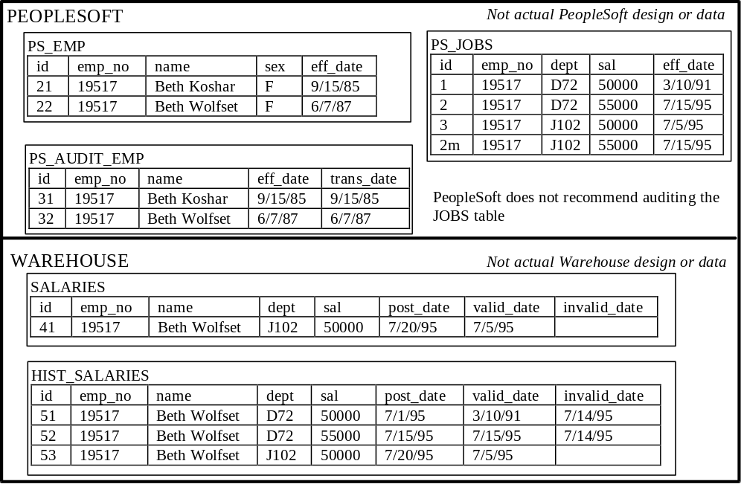figure 3

When it was time to implement this scenario, it was purported that having all of the history in one table would slow down queries on current data. In one case, a current flag was on the data. Queries were executed where “current_flag” = ‘Y’. The performance was dismal. It was decided to create a current records table, rather than just have one table. Both tables still contain the date triple. The current table still uses a sequential identifier as the primary key, although in most cases it is no longer needed. For example, there is only one record per employee in the salary table and the employee number can be used as the primary key. The history table uses the sequential identifier from the current table combined with the “valid_date” as the primary key. Again, it can be argued that the sequential identifier is not necessary. There is a copy of the current record in both tables so that a query that needs both history and current records does not have to perform a join.

This is where the problems started. In rare cases, a record is added and then another record is added to correct a mistake or make a change to the first. The second record has the same “valid_date”, causing a “duplicate index” error. This problem was exacerbated by the fact that a programming error caused the “valid_date” to be the same more often than actual. In this situation, the current table is up to date but the history table remains behind. This problem is documented in the “errors” table.

Finding the error was much easier that fixing it. The index scheme on the history table had to be altered to use a true sequential identifier, not one derived from the current table. All of the history load routines had to be changed to use the new sequence correctly. The history data had to be brought back up to date. Although the problem records were easy to find, fixing the history was not. In some cases there had been many changes to the same record. The history table may have been out of synchronization for several changes, then re-synchronized by several changes, and the back out of synchronization. The resolution had to be done manually, or the history tables needed to be re-loaded from scratch. Neither was an attractive solution.

Handling Pre and Post-dated Updates to the Source Data

In the previous section there was a discussion of handling pre and post-dated changes to the warehouse. Although this approach works very well on the warehouse side, it is difficult to have the load programs handle pre and post-dated changes to the source data.

If there is no “valid_date” or effective date on the source data, it is assumed that the new record is valid when it is entered (see figure 3). In this case, there are no pre-dated or post-dated changes made to the data since everything is immediately effective. If there is an effective date, then the date can be the same as the load run date (the date the warehouse load is being run), prior to the load run date, or after the load run date. If the effective date is the same as the load run date, then it is the same as the prior case. This is the first time that the record is seen by the warehouse and it will be immediately effective. If the effective date is prior to the load run date, it must be determined if it is prior to the last transfer date or not. If it was prior to the last transfer date, then the load routines have presumably already picked up the change. If the effective date is after the last transfer date, and prior to the load run date, it will be processed in the current run and a post-dated record will be added to the warehouse. If the effective date is after the load run date, the record can be processed in the current load run and a pre-dated record added to the warehouse. Alternatively, the record can be ignored until the effective date on the record is equal to a load run date, at which time it will be processed.

All of this is predicated on knowing which are the new records. This is not always easy. In PeopleSoft, the audit table capability was used (a separate table is created which duplicates indicated columns from a given table, and adds timestamp columns.) In this scenario, whenever a record is inserted in the base table, a copy of that record is written to the audit table with the date the change was made (see figure 3 PS_EMP and PS_AUDIT_EMP tables). In this case, it is easy to determine which records have been added since the last transfer date and process them. Oracle Financials included the equivalent of a post-date on most of its tables. This made it fairly easy to determine which are the new records and no separate audit tables are necessary. On the legacy systems, frequently there is no post-date. In some cases there is a transaction table that can be used similarly to the audit table in PeopleSoft. In other cases, there is no way to determine which records are new and a full refresh of the tables loaded from legacy is done on each load run. It was considered too cumbersome to try to keep a previous copy of a table, and do a record-by-record compare of the current version of the table, in order to determine which records had changed. This had been tried on an unrelated system and required enormous amounts of space and time, both elapsed and CPU, in order to do the difference operation.

Where there is a post-date on the record, it is important that the date is always maintained. In any scenario, if a user by-passes the application and updates the database directly, the post-date will probably not be updated. In the PeopleSoft scenario, the audit tables only record changes when a record is created through a PeopleSoft screen. If records are updated in the database directly, either manually or through a batch process, these changes are not recorded in the audit tables. Moreover, if the user modifies a record using a PeopleSoft screen, the change is also not recorded in the audit table.

This fact about the audit tables was not known immediately. The warehouse was in production about six weeks before the problem was discovered. An individual using Oracle Financials Project Accounting had gotten a promotion and raise after the warehouse and PeopleSoft databases had gone into production (the two went production at the same time). She noticed that although her paycheck was correct (payroll was being done in PeopleSoft), the postings for her time charges were incorrect in the Oracle Financials database. The investigation into the problem revealed that Oracle Financials and the warehouse were synchronized, but that the warehouse was not synchronized with the PeopleSoft database. It was determined that the following set of events occurred which resulted in the data in figure 3 (note tables PS_JOBS and HIST_SALARIES):
1. PeopleSoft and the warehouse went production (presumably synchronized as in figure 3 record ids 1 and 51).
2. There was a reorganization of two departments
3. An employee was given a promotion and salary increase. This data was immediately entered into the PeopleSoft database and consequently picked up by the warehouse database (figure 3 record id 2).
4. The reorganization data was retroactively entered into the PeopleSoft database by creating a new, post-dated record indicating when the re-organization was effective (figure 3 record id 3). In addition, if there were intervening records for an individual getting a retroactive change (which included the employee in question), the intervening records were modified to correct the data that was being retroactively changed (in figure 3, this is represented by record id 2m which replaced record 2).
5. The warehouse load picked up the retroactive change to the PeopleSoft database but did not see the change to the intervening records since they were not recorded in the audit tables (the SALARIES table in figure 3 loaded record id 53 from record 3 but record id 2m does not get loaded). The warehouse database posted a retroactive change to the department with a side effect of returning the employee back to the previous salary.

Similar problems happened four times before the error was caught. The users assumed that it would take time for a change to show up in the warehouse and subsequently the Oracle Financials database and did not report the problem for several weeks. Another problem with the audit tables resulted in the same effect. The developer must specify the columns to be audited in the PeopleSoft audit table. In one case, a column needed by the warehouse load had accidentally been left off the audit table. The load routines had no way of determining when a change to that column had occurred (note “sex” column of PS_EMP table in figure 3).

One way to fix this problem would be to use database triggers to update the post-date whenever a change was made to one of the other fields in a record. Another method would include removing any update privileges to the base tables and creating views that would keep the post-date synchronized with any changes. To implement this approach without changing the application, rename the tables and create the views named with the old table names and referencing the new table names. If there are application views on the original tables, they may have to be rebuilt using the new table names. Neither of these approaches may seem acceptable if it requires modifying a database or views that came with a COTS product.

Additional Uses of the “bad_records” Table

Recall that the “bad_records” table is used to record any errors in processing data during the warehouse load. If the error is in a non-mandatory field, it is still inserted into the warehouse database as well as the “bad_records” table. In addition, the load routines have been written to re-process any of the records in the “bad_records” table on each run. In the previous situation, the warehouse data managed to get out of synchronization with the source database. This lead to an interesting use of the “bad_records” table. The data in the source database was correct but was not correct in the warehouse database. It was decided to insert the offending records into the “bad_records” table. In this way, none of the data in the source database had to be modified. The incorrect records were automatically processed on the next data load run and manually checked after its completion. Once a “bad record” is processed correctly, it is automatically deleted from the “bad_records” table.

There was one unfortunate side effect of reprocessing the “bad_records” table every day. Each time a record is processed, the date of the run (sysdate) is used as the “post_date." If the record is still bad on a subsequent load, it remains in the “bad_records” table. If a record continues to be bad for any period of time, it looks as if it is being re-added to the warehouse database with each load. Any applications using the warehouse “post_date” as a basis for bringing new records into that application’s database will continue to get this record as new on a daily basis. The application may not be interested in the piece of data that is bad. In that case, the record may not even be considered bad in the application. If the application did need the piece of data that is bad, processing still has to take into account that it might get a bad record. Finally, the fact that the record keeps showing up as new can create havoc in the application.

It is important to check the “bad_records” and “errors” after each load. An attempt should be made to correct the records listed in the “bad_records” table at the source, and prior to the next load. Unfortunately, this is not always possible. In one case, it was felt that the problem would never be corrected because the data was simply not available in the legacy system that was its source, and these records pertained to “ancient” history. In this case, the offending records were noted and deleted from the “bad_records” table so that there were no longer being processed.

The “bad_records” table can also highlight a domain mismatch between the source and warehouse databases. Domains are usually fairly static. It may not be necessary to worry about updating domains with each data load run. A formal procedure is still required to know when a domain modification has been made at the source data and to capture this at the warehouse database prior to the next data load run. If the domain change is not caught, records using any new values added to the domain will be recorded in the “bad_records” table even though they are really not bad. If valid values were removed from the domain at the source, records using the invalid values will still look valid at the warehouse. Presumably no records would use the invalid values since this should be prevented by the source application.

Conclusions

When the enterprise data modeling effort was started, that seemed like the biggest part of the puzzle. Then the database design was determined and the implementation done. Next came developing the load routines, which was no small feat. Finally, the mistakes became known. Usually the errors are found fairly readily. In a warehouse situation there are always at least two pieces to fix. The error in the load routine must be fixed. Then the data that is incorrect must be fixed. These two pieces frequently need to be done concurrently or the fix to the load may make it more difficult to fix the data. Finally, any applications and data in them, affected by the error, must also be fixed.

No amount of lessons learned can substitute for adequately testing new data load modules and modifications to existing modules. Testing is very complicated in this scenario. There are many conditions on the source data and many ways of handling these situations in the warehouse database. It is hoped that the lessons presented here will allow for more thorough testing of other warehouse load programs. They also highlight the need for excellent communication between the application developers and implementers of all of the systems working together, including the warehouse. When an error is found at one location, it must be communicated to all applications. Another application may be affected by the error, or may be experiencing the same error and not even recognize it. Unfortunately, all possible situations can not be anticipated because the applications involved and the use of them changes over time. What is important is to quickly recognize the problem and fix it. Teamwork, flexibility, ingenuity and insight are the key.

References

[INM92] Inmon, W. H. Building the Data Warehouse. Boston, MA.: QED Technical Publishing Group, 1992.
[KEL94] Kelley, Chuck. “Defining the Data Warehouse," Data Warehousing Conference Proceedings, February 1994. p. D3-12.
[BAS95] Basel, Christine and Wolfset, Beth. “Implementing a Corporate Warehouse Through Oracle CASE," ECO ‘95 Conference Proceedings, April 1995. p. I-15-23.

Acknowledgments

I wish to acknowledge the efforts of Vincent Ventrone and Christine Basel in assisting with the database design. I want to recognize Barbara Quinn, Andrew Sohn and Thomas Famiglietti for the efforts in creating the warehouse load programs. I would also like to thank Barbara Quinn and Edith Sandy for helping find errors in the warehouse data and diagnosing the load problems. Finally, I would like to thank Walter Braunschweiger and Christine Georgilas for their findings in tuning distributed queries that used large remote tables.

A decision had been made at the time of moving from the logical to physical design of the warehouse to implement the many domain tables as a single "types" table. [BAS95]
To combat the problem of the ORA errors not halting execution, modules were added to the load chain to check the “errors” table after the execution of each load module. If these additional modules find an ORA error in the “errors” table, they signal the job scheduler that the chain has failed and the job scheduler halts execution. When the job status is checked the next day and the problem determined, the job can be restarted at the offending point. If a table is listed as completing successfully and the “errors” table shows that it has not, the table is reloaded from the start by deleting the last “transfer_log” record for it. This makes it look as if the faulty load had never occurred for the next data load run.
If the physical data model has been developed in a CASE tool, a dependency diagram should be a natural result. In Designer 2000, the dependency diagram should be in the Data Diagrammer tool. The diagram may need to be reorganized in a way to better show the dependencies.
Note that this is pertinent to Oracle versions 7.0.15 and 7.0.16. The 7.0 versions were the first time that Oracle had introduced distributed queries. It is expected that higher versions of Oracle have improved distributed query optimization. Moreover, these findings have nothing to do with the “distributed option” which facilitates distributed updates.
The default for SMALL_TABLE_THRESHOLD is 4 database blocks. If the database blocksize is 2k, the SMALL_TABLE_THRESHOLD is equal to 8k. The SMALL_TABLE_THRESHOLD affects the use of memory. If a local table falls below the threshold, the query is optimized and executed exactly as one would expect. If the local table is larger than the threshold and there is an appropriate index on the table, the index is used as expected. If the local table is above the threshold and there is no appropriate index for the query, a full table scan will be required. The table is swapped into the "oldest" end of the least recently used queue so that it will be swapped back out quickly. The assumption is that full table scans of large tables will be done infrequently. Even if the table is needed frequently, it will be constantly swapped in and out of memory because it is essentially at the wrong end of the queue. Adding an index to the table will fix the problem, even if was previously felt that an index is unnecessary.
The cost based optimizer will assume a uniform distribution of the values in a column. In this case, “current_flag” has two values: Y or N. Although the bulk of the records have “current_flag”=‘N’, the optimizer assumes they are in a 50/50 ratio and that a full table scan will be more efficient that an index search. One way to avoid this is to use a rule-based hint on this type of query. The rule-based optimizer will always choose to use the index.
The program has to join six tables on the remote database to load the table on the warehouse. Any of the six tables, each having their own “valid_date," can contribute to a change in the record, but the load routine was only picking the date from one table, which may not have changed. The load program was corrected to pick the maximum value of the “valid_date” from all six tables.
When loading the data warehouse, it must be determined how many years of history should be stored. In one case, no history was stored. In another case, history was stored from the day of the Corporation’s creation. In this case, the data had been available in more recent years but was not available for the older records.

