CALORIES BURNED PREDICTION
A Mini Project Report submitted to JNTU Hyderabad in partial fulfillment
of the requirements for the award of the degree
BACHELOR OF TECHNOLOGY

In
COMPUTER SCIENCE AND ENGINEERING (ARTIFICIAL INTELLIGENCE AND MACHINE LEARNING)

Submitted by
MALLIPEDDI HARISH 22S11A66E1
BADRI SAI THANMAI 22S11A66G9
KOLIPAKA SRISAI 22S11A66H9

GADDAM AMITH REDDY 22S11A66D3
Under the Guidance of
Mr. Mirza Rizwan Baig
B.Tech, M.Tech

Assistant Professor


DEPARTMENT OF COMPUTER SCIENCE AND ENGINEERING (ARTIFICIAL INTELLIGENCE AND MACHINE LEARNING)
MALLA REDDY INSTITUTE OF TECHNOLOGY & SCIENCE

(Approved by AICTE New Delhi and Affiliated to JNTUH)

(Accredited by NBA & NAAC with “A” Grade)

An ISO 9001: 2015 Certified Institution

Maisammaguda, Medchal (M), Hyderabad-500100, T. S.
APRIL 2025

DEPARTMENT OF COMPUTER SCIENCE AND ENGINEERING (ARTIFICIAL INTELLIGENCE AND MACHINE LEARNING)
MALLA REDDY INSTITUTE OF TECHNOLOGY & SCIENCE

(Approved by AICTE New Delhi and Affiliated to JNTUH)

(Accredited by NBA & NAAC with “A” Grade)

An ISO 9001: 2015 Certified Institution

Maisammaguda, Medchal (M), Hyderabad-500100, T. S.
APRIL 2025


CERTIFICATE

This is to certify that the Mini Project entitled “CALORIES BURNED PREDICTION” been submitted by MALLIPEDDI HARISH (22S11A66E1), BADRI SAI THANMAI (22S11A66G9), KOLIPAKA SRISAI (22S11A66H9),GADDAM AMITHREDDY (22S11A66D3) in partial fulfillment of the requirements for the award of BACHELOR OF TECHNOLOGY in CSE(AI&ML). This record of bonafide work carried out by them under my guidance and supervision. The result embodied in this Mini Project report has not been submitted to any other University or Institute for the award of any degree.

Mr. Mirza Rizwan Baig Dr. A. NAGA RAJU

Assistant Professor Head of the Department

CSE(AI&ML) CSE(AI&ML)

Project Guide

External Examiner

ACKNOWLEDGEMENT

The Mini Project work carried out by our team in the Department of CSE (Artificial Intelligence and Machine Learning), Malla Reddy Institute of Technology and Science, Hyderabad. This work is original and has not been submitted in part or full for any degree or diploma of any other university.
We wish to acknowledge our sincere thanks to our project guide Mr. Mirza Rizwan Baig, Assistant Professor of CSE(Artificial Intelligence and Machine Learning) Department for formulating of the problem, analysis, guidance and his continuous supervision during the Course of work.
We acknowledge our sincere thanks to Dr. Vaka Murali Mohan, Professor & Principal, Department of Computer Science and Engineering and Dr. A. NAGARAJU, Head of the Department and Coordinator, faculty members of CSE(Artificial Intelligence and Machine Learning) Department for their kind cooperation in making this Mini Project a success.
We extend our gratitude to Sri. Ch. Malla Reddy, Founder Chairman MRGI and Sri. Ch. Mahender Reddy, Secretary MRGI, Dr.Ch. Bhadra Reddy, President MRGI, Sri. Ch. Shalini Reddy, Director MRGI, Sri. P. Praveen Reddy, Director MRGI, for their kind cooperation in providing the infrastructure for successful completion our Mini Project work.
We acknowledge our special thanks to the entire teaching faculty and non-teaching staff members of the CSE (Artificial Intelligence and Machine Learning) Department for their support in making this project work a success.
[
MALLIPEDDI HARISH 22S11A66E1 BADRI SAI THANMAI 22S11A66G9 KOLIPAKA SRISAI 22S11A66H9
GADDAM AMITH REDDY 22S11A66D3
INDEX

Chapter  LIST OF FIGURES | Page No.
ABSTRACT | 1  iv
1. SYSTEM ANALYSIS | 2
1.1 Existing System | 2
1.1.1 Disadvantages | 3
1.2 Proposed System | 4
1.2.1 Advantages | 4
1.3 Introduction | 5
2. LITERATURE SURVEY | 6
3. SYSTEM DESIGN | 10
3.1 System Requirements | 10
3.1.1 Hardware Requirements | 10
3.1.2 Software Requirement | 10
4. INPUT & OUTPUT DESIGN | 11
4.1 Input Design | 11
4.2 Output Design | 12
5. SYSTEM STUDY | 13
6.1 Feasibility Study | 13
6.1.1 Economical feasibility | 13
6.1.2 Technical feasibility | 13
6.1.3 Social feasibility | 14
7. SYSTEM TESTING | 15
7.1 Testing Methodologies | 15
7.1.1 Unit Testing | 15
7.1.2 Integration Testing | 16

7.1.3 Functional Testing 16
    - System Testing 17
    - White-Box Testing 17
    - Black-Box Testing 17
    - Acceptance Testing 17
8.SOURCECODE 18
9.RESULT 21
10.CONCLUSION 27
10.1 Conclusion 27
10.2 References 28
11.BIBLIOGRAPHY
12.YUKTI CERTIFICATE

LIST OF FIGURES

Figure. No | Fig. Name | Page
Chapter:2-fig 1 | Modulation | 6
Chapter:3-fig 2 | Data working process | 7
Chapter:3-fig 3 | Process of web app | 7
Chapter:3-fig 4 | Sequence Diagram | 8
Chapter:3-fig 5 | Class Diagram | 8
Chapter:3-fig 6 | Use Case Diagram | 9
Chapter:9-fig 7 | CMD Process | 21
Chapter:9-fig 8 | Run CMD | 22
Chapter:9-fig 9 | Stream lit Web Application | 23
Chapter:9-fig 10 | Calories Burned Prediction | 24
Chapter:9-fig 11 | Given Dataset | 25
Chapter:9-fig 12 | Result | 26

ABSTRACT
The “Calories burned prediction by machine learning algorithm” aim to predict the number of calories burnt by an individual during physical activity using machine learning techniques. We collected a dataset that includes features such as heart rate, body temperature, and duration of activity. We used various machine learning models, including XGBoost, linear regression. SVM and random forest, to predict calorie burn based on 15,000 records with seven features. The results indicate that the XGBoost model can accurately predict calorie burn with a minimum mean absolute error of calories. This work contributes to the growing body of research on using machine learning for health and fitness applications and has potential implications for personalized health coaching and wellness tracking. The highest accuracy of training and testing is gained by the XGBoost model with 99.67% with mean absolute error is almost 1.48%.

CHAPTER-1: SYSTEM ANALYSIS
1.1EXISTING SYSTEM
Most existing studies have focused on predicting calorie burn for specific types of physical activity or in specific populations. There is a need for more generalizable models that can accurately predict calorie burn across a range of physical activities and individuals. The main objectives of this studies are: To collect data on physical activity and calorie burn from a variety of sources, including fitness trackers and wearable devices. Need to preprocess and clean the data to ensure accuracy and consistency. To develop a range of machine learning models to predict calorie burn, including linear regression, random forest, and support vector machines. To compare the performance of these models and identify the most accurate model for predicting calorie burn. To interpret the results and draw conclusions about the effectiveness of using machine learning for predicting calorie burn. The scope of this research is to develop a machine learning model for predicting calorie burn during physical activity.

    - DISADVANTAGES:
The existing systems for predicting calories burned face several limitations that hinder their effectiveness and reliability. One major drawback is the dependency on generalized algorithms, which fail to account for individual differences such as body composition, metabolism, or fitness levels, leading to inaccuracies in predictions. Moreover, these systems often require costly devices or memberships, making them inaccessible to many users. Another issue is the lack of real-time adaptation; most existing models are static and cannot adjust predictions dynamically based on changing conditions during activities. Over-reliance on such predictions can create a false sense of accomplishment, as users might rely on estimated data rather than actual physical outcomes. Additionally, the existing systems tend to focus solely on caloric expenditure, neglecting other critical health metrics like heart rate, hydration, or muscle recovery. These systems may also promote an overly mechanical approach to fitness, which can overlook the importance of holistic well-being and lead to obsessive tracking behaviors. The user interfaces are often not intuitive, making it difficult for individuals to interpret the data effectively. Furthermore, data privacy concerns are prevalent as some systems collect personal information without clear user consent, posing risks of data misuse. Lastly, the systems typically lack compatibility with diverse activity types, limiting their utility for users engaged in non-traditional or complex exercises. These disadvantages highlight the need for more personalized, adaptive, and comprehensive calorie prediction solutions in future systems. Let me know if you'd like further elaboration.

  - PROPOSED SYSTEM

We will collect data from a variety of sources and preprocess it to ensure accuracy and consistency. We will use several different machine learning models to predict calorie burn and compare their performance. The study will focus on a range of physical activities, including walking, running, and cycling. The study will not examine the impact of other factors such as diet or sleep on calorie burn.

    - ADVANTAGES

Predicting calories burned in the proposed system offers several advantages, especially when integrated into platforms like fitness trackers or health management applications. It provides users with real-time insights into their energy expenditure, enabling personalized recommendations for dietary adjustments and fitness plans. Such predictions encourage a more informed and proactive approach to health by allowing users to monitor progress toward specific goals. The feature enhances user engagement by fostering motivation and accountability, as individuals can visually track their achievements. It simplifies decision-making, helping users choose activities that maximize caloric burn efficiently. This function also facilitates more tailored workout routines for individuals with diverse fitness levels, ensuring effectiveness. With the integration of calorie prediction, users can experience seamless, data-driven interactions within the system, boosting satisfaction and usability. It promotes a balanced lifestyle by encouraging synchronization between caloric intake and expenditure. The real-time nature of predictions allows dynamic adjustments to activities for optimal outcomes. It also serves as a compelling tool for educational purposes, raising awareness about the importance of active living. Furthermore, calorie predictions can be paired with gamified features to enhance engagement, creating a more enjoyable user experience. The proposed system, through calorie tracking, contributes to improved fitness planning and overall health management. This functionality ensures scalability and flexibility, accommodating individual needs and preferences effectively. By leveraging advanced algorithms and data analytics, calorie prediction adds value by providing accurate and actionable insights that promote sustained user involvement. These advantages collectively highlight the potential of calorie prediction to revolutionize personalized fitness and health solutions.

1.3 INTRODUCTION

Calorie is a unit of hear energy. Health and fitness are becoming increasingly important to individuals and society as a whole. As people seek to live healthier lifestyles, they are turning to wearable devices and fitness trackers to monitor their physical activity and track their progress. One important metric that these devices track is the number of calories burnt during physical activity. Accurately predicting calorie burn can help individuals set and achieve fitness goals and can also inform health coaching and wellness tracking programs. The motivation for this research is to develop a machine-learning model that can accurately predict calorie burn during physical activity. This has potential applications in a range of settings, including personalized health coaching, fitness tracking, and wellness programs. By developing an accurate calorie burn prediction model, we can help individuals make more informed decisions about their physical activity and improve their overall health and well-being. Although there has been some research on predicting calorie burn using machine learning techniques, there is still a significant gap in the literature. Most existing studies have focused on predicting calorie burn for specific types of physical activity or in specific populations. There is a need for more generalizable models that can accurately predict calorie burn across a range of physical activities and individuals. The main objectives of this studies are: To collect data on physical activity and calorie burn from a variety of sources, including fitness trackers and wearable devices. Need to preprocess and clean the data to ensure accuracy and consistency. To develop a range of machine learning models to predict calorie burn, including linear regression, random forest, and support vector machines. To compare the performance of these models and identify the most accurate model for predicting calorie burn. To interpret the results and draw conclusions about the effectiveness of using machine learning for predicting calorie burn. The scope of this research is to develop a machine learning model for predicting calorie burn during physical activity. We will collect data from a variety of sources and preprocess it to ensure accuracy and consistency. We will use several different machine learning models to predict calorie burn and compare their performance. The study will focus on a range of physical activities, including walking, running, and cycling. The study will not examine the impact of other factors such as diet or sleep on calorie burn.
CHAPTER 2: LITERATURE SURVEY

Literature Review: Machine learning algorithms have gained widespread use in recent years to predict calorie burn during physical activity. These studies often collect physical activity data and other relevant variables such as heart rate, age, and gender from fitness trackers, mobile applications, and wearable devices. This section provides an overview of some of the critical studies in this area.Sathiya Tet al. discussed to predict user’s calorie and applied CNN model to classify food items from the input image. They also used image processing techniques such as deep learning model and their model provide 91.65% accuracy in predicting user’s calorie from input image. Sona P Vinoy illustrates to predict calorie burn during the workout et al. used machine learning algorithms such as XGBoost regressor and Linear regression models to find out calorie burnt in physical activities. Their mean absolute error value is almost 2.71 in XGB regressor and 8.31 for linear regression. They used 7 attributes such as age, height, weight, duration, heart_rate , body_temp and calorie. Their dataset was in 15000 CSV with 7 attributes. They did not mention their model accuracy. Suvarna Shreyas Ratnakar et al. discussed how to predict calories burnt from physical activities. They used the XGB boost Machine learning algorithm to predict it including 15,000 raw dataset and their mean absolute error value is 2.7 and model accuracy is not mentioned.
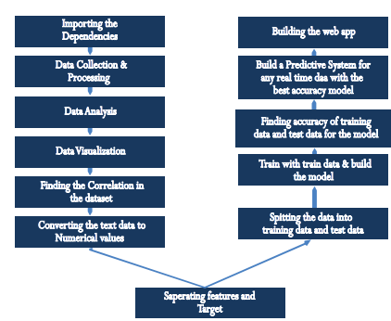 Fig-1DataWorkingProcess
CHAPTER 3: SYSTEM DESIGN

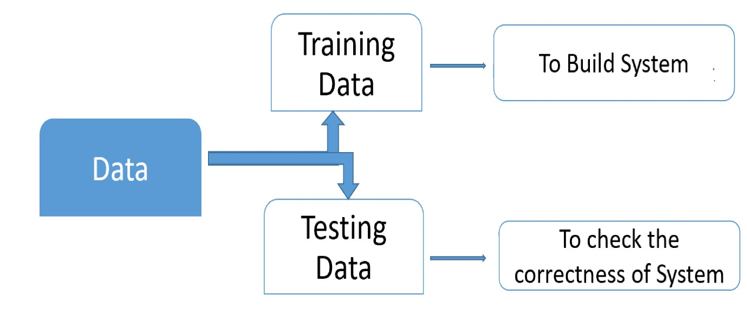

Fig-2 Data Working Process

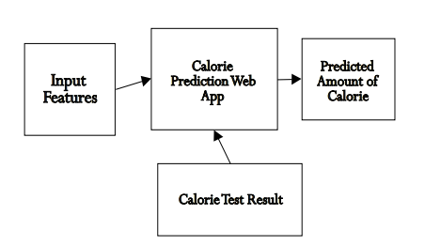

Fig-3 Process Of WebApp

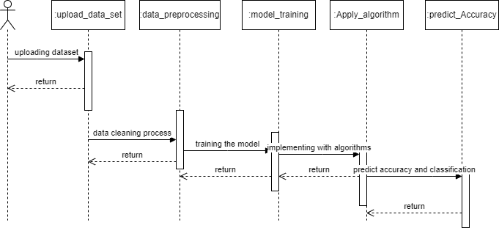

Fig-4 SEQUENCE Diagram

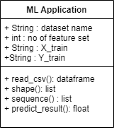

Fig-5 Class Diagram

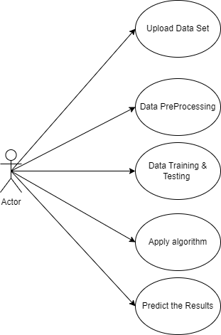

Fig-6 Use Case Diagram

  - System requirements
    - Software Requirements:

Operating System | Windows 8
Coding Language: | Python 3.7

    - Hardware Requirements

System | MINIMUM i3
Hard Disk | 40 GB
Ram | 4 GB

CHAPTER 4: INPUT AND OUTPUT DESIGN
4.1 INPUT DESIGN

Input Design plays a vital role in the life cycle of software development, it requires very careful attention of developers. The input design is to feed data to the application as accurate as possible. So inputs are supposed to be designed effectively so that the errors occurring while feeding are minimized. According to Software Engineering Concepts, the input forms or screens are designed to provide to have a validation control over the input limit, range and other related validations.

This system has input screens in almost all the modules. Error messages are developed to alert the user whenever he commits some mistakes and guides him in the right way so that invalid entries are not made. Let us see deeply about this under module design.

Input design is the process of converting the user created input into a computer-based format. The goal of the input design is to make the data entry logical and free from errors. The error is in the input are controlled by the input design. The application has been developed in user-friendly manner. The forms have been designed in such a way during the processing the cursor is placed in the position where must be entered. The user is also provided with in an option to select an appropriate input from various alternatives related to the field in certain cases.

Validations are required for each data entered. Whenever a user enters an erroneous data, error message is displayed and the user can move on to the subsequent pages after completing all the entries in the current page.

  - OUTPUT DESIGN

The Output from the computer is required to mainly create an efficient method of communication within the company primarily among the project leader and his team members, in other words, the administrator and the clients. The output of VPN is the system which allows the project leader to manage his clients in terms of creating new clients and assigning new projects to them, maintaining a record of the project validity and providing folder level access to each client on the user side depending on the projects allotted to him. After completion of a project, a new project may be assigned to the client. User authentication procedures are maintained at the initial stages itself. A new user may be created by the administrator himself or a user can himself register as a new user but the task of assigning projects and validating a new user rests with the administrator only.

The application starts running when it is executed for the first time. The server has to be started and then the internet explorer in used as the browser. The project will run on the local area network so the server machine will serve as the administrator while the other connected systems can act as the clients. The developed system is highly user friendly and can be easily understood by anyone using it even for the first time.

CHAPTER 6: SYSTEM STUDY

  - FEASIBILITY STUDY

The feasibility of the project is analyzed in this phase and business proposal is put forth with a very general plan for the project and some cost estimates. During system analysis the feasibility study of the proposed system is to be carried out. This is to ensure that the proposed system is not a burden to the company. For feasibility analysis, some understanding of the major requirements for the system is essential.
Three key considerations involved in the feasibility analysis are

- ECONOMICAL FEASIBILITY
- TECHNICAL FEASIBILITY
- SOCIAL FEASIBILITY
    - ECONOMICAL FEASIBILITY

This study is carried out to check the economic impact that the system will have on the organization. The amount of fund that the company can pour into the research and development of the system is limited. The expenditures must be justified. Thus the developed system as well within the budget and this was achieved because most of the technologies used are freely available. Only the customized products had to be purchased.

    - TECHNICAL FEASIBILITY
This study is carried out to check the technical feasibility, that is, the technical requirements of the system. Any system developed must not have a high demand on the available technical resources. This will lead to high demands on the available technical resources. This will lead to high demands being placed on the client. The developed system must have a modest requirement, as only minimal or null changes are required for implementing this system.

    - SOCIAL FEASIBILITY
The aspect of study is to check the level of acceptance of the system by the user. This includes the process of training the user to use the system efficiently. The user must not feel threatened by the system, instead must accept it as a necessity. The level of acceptance by the users solely depends on the methods that are employed to educate the user about the system and to make him familiar with it. His level of confidence must be raised so that he is also able to make some constructive criticism, which is welcomed, as he is the final user of the system.

CHAPTER 7: SYSTEM TESTING

The purpose of testing is to discover errors. Testing is the process of trying to discover every conceivable fault or weakness in a work product. It provides a way to check the functionality of components, Such assemblies , assemblies and/or a finished product It is the process of exercising software with the intent of ensuring that the Software system meets its requirements and user expectations and does not fail in an unacceptable manner. There are various types of test. Each test type addresses a specific testing requirement
  - TESTING METHODOLOGIES
The following are the Testing Methodologies:
- Unit Testing.
- Integration Testing
- Functional Testing
- System Testing
- Black Box Testing
- White Box Testing
- Acceptance Testing

7.1.1 Unit Testing

Unit testing involves the design of test cases that validate that the internal program logic is functioning properly, and that program inputs produce valid outputs. All decision branches and internal code flow should be validated. It is the testing of individual software units of the application .it is done after the completion of an individual unit before integration. This is a structural testing, that relies on knowledge of its construction and is invasive. Unit tests perform basic tests at component level and test a specific business process, application, and/or system configuration. Unit tests ensure that each unique path of a business process performs accurately to the documented specifications and contains clearly defined inputs and expected results.

7.1.2 Integration Testing
Integration tests are designed to test integrated software components to determine if they actually run as one program. Testing is event driven and is more concerned with the basic outcome of screens or fields. Integration tests demonstrate that although the components were individually satisfaction, as shown by successfully unit testing, the combination of components is correct and consistent. Integration testing is specifically aimed at exposing the problems that arise from the combination of components.

    - Functional Testing

Functional tests provide systematic demonstrations that functions tested are available as specified by the business and technical requirements, system documentation, and user manuals.

Functional testing is centered on the following items:
Valid Input : identified classes of valid input must be accepted.
Invalid Input : identified classes of invalid input must be rejected.
Functions : identified functions must be exercised.
Output : identified classes of application outputs must be exercised.
Systems/Procedures : interfacing systems or procedures must be invoked.
Organization and preparation of functional tests is focused on requirements, key functions, or special test cases. In addition, systematic coverage pertaining to identify Business process flows; data fields, predefined processes, and successive processes must be considered for testing. Before functional testing is complete, additional tests are identified and the effective value of current tests is determined.

System Testing

System testing ensures that the entire integrated software system meets requirements. It tests a configuration to ensure known and predictable results. An example of system testing is the configuration oriented system integration test. System testing is based on process descriptions and flows, emphasizing pre-driven process links and integration points.

7.1.5 White Box Testing

White Box Testing is a testing in which in which the software tester has knowledge of the inner workings, structure and language of the software, or at least its purpose. It is purpose. It is used to test areas that cannot be reached from a black box level.

7.1.6 Black Box Testing

Black Box Testing is testing the software without any knowledge of the inner workings, structure or language of the module being tested. Black box tests, as most other kinds of tests, must be written from a definitive source document, such as specification or requirements document, such as specification or requirements document. It is a testing in which the software under test is treated, as a black box .you cannot “see” into it. The test provides inputs and responds to outputs without considering how the software works.

7.1.7 Acceptance Testing
User Acceptance Testing is a critical phase of any project and requires significant participation by the end user. It also ensures that the system meets the functional requirements.
CHAPTER 8: SOURCE CODE

SOURCE CODE

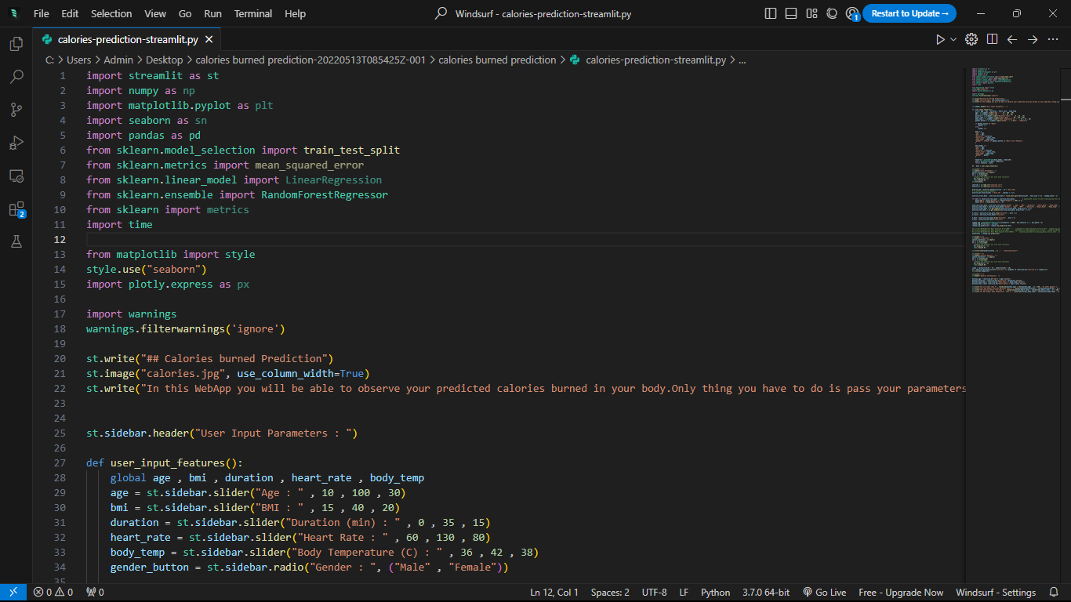

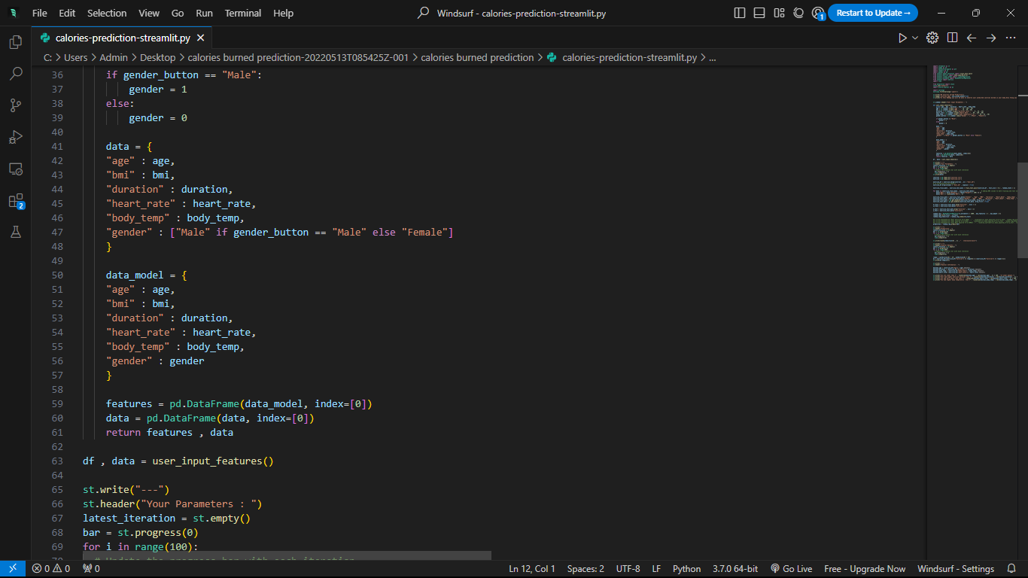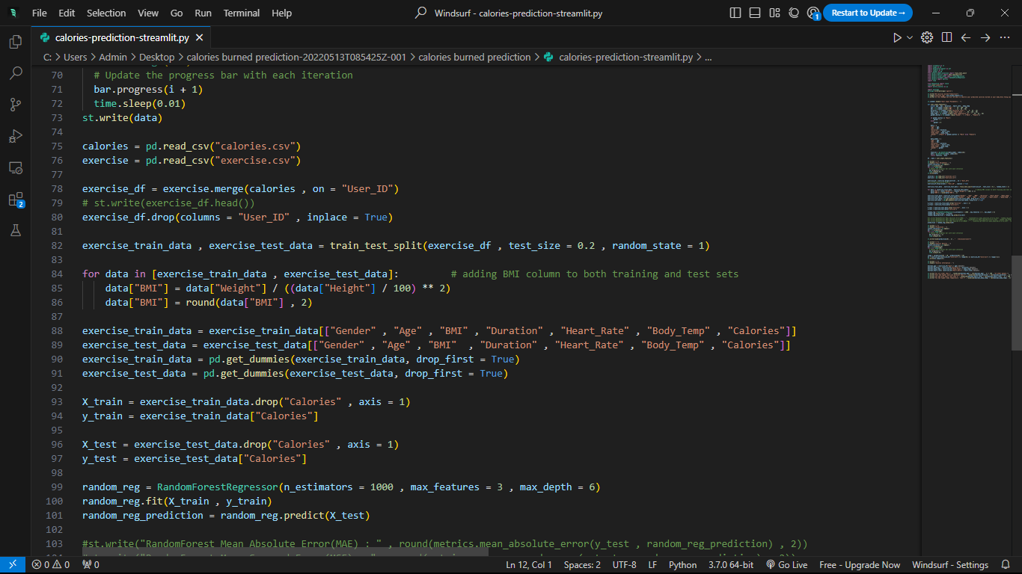

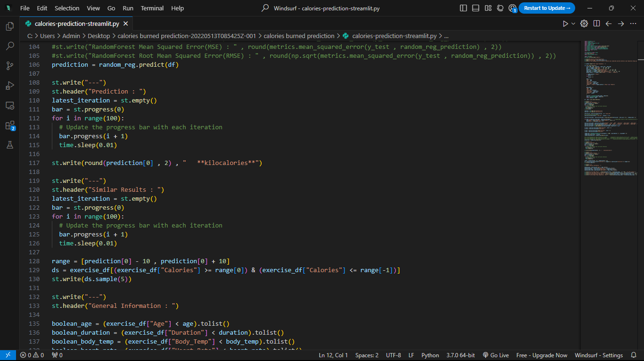

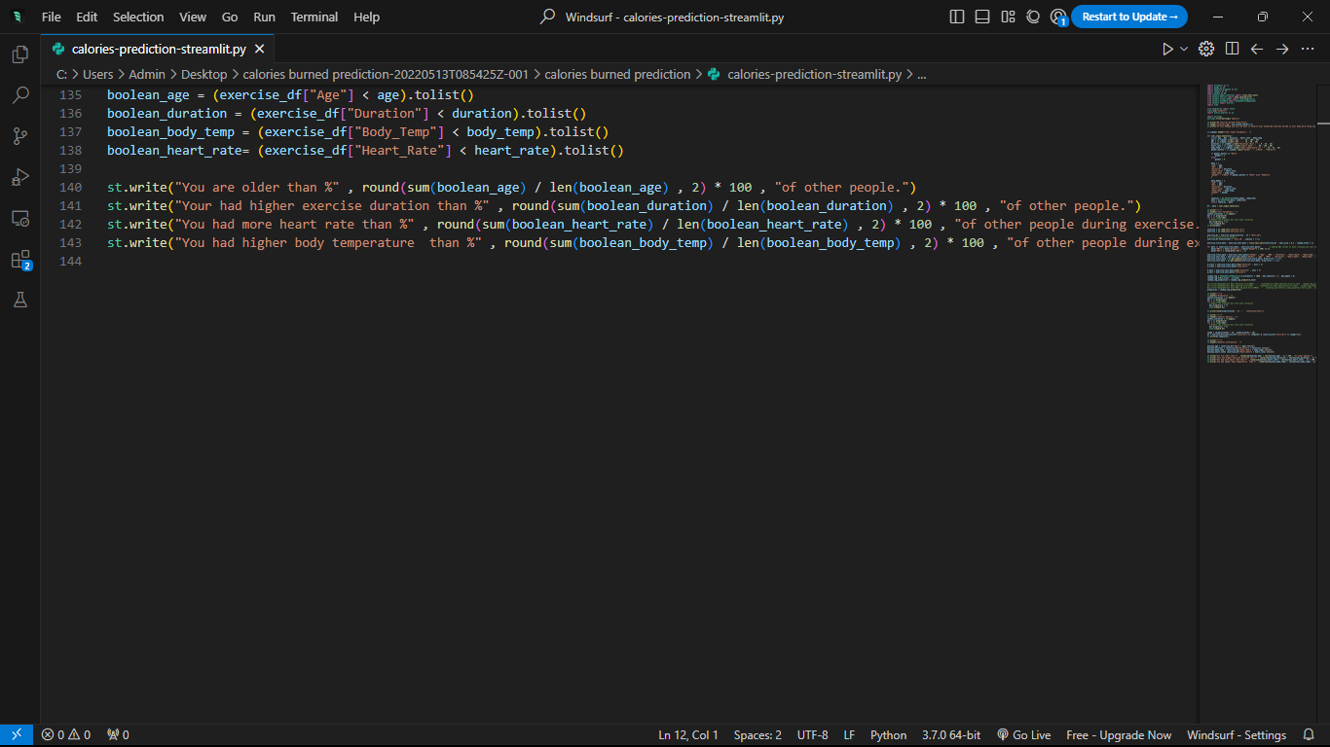

CHAPTER 9: RESULTS

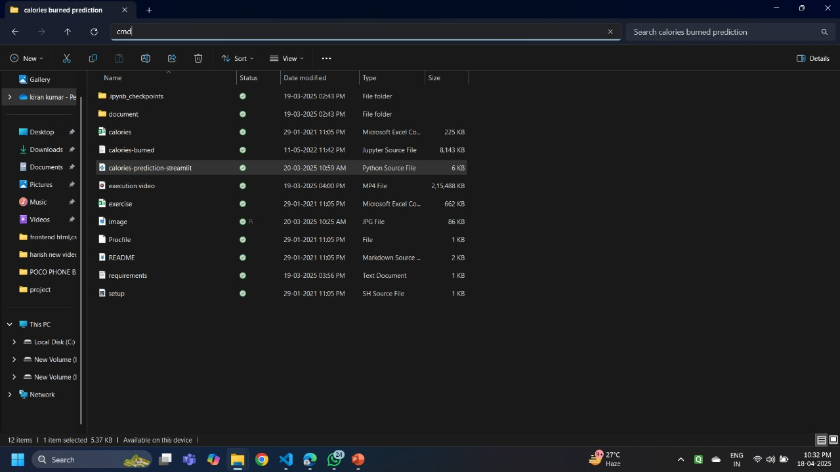

Fig-7 CMD PROCESS

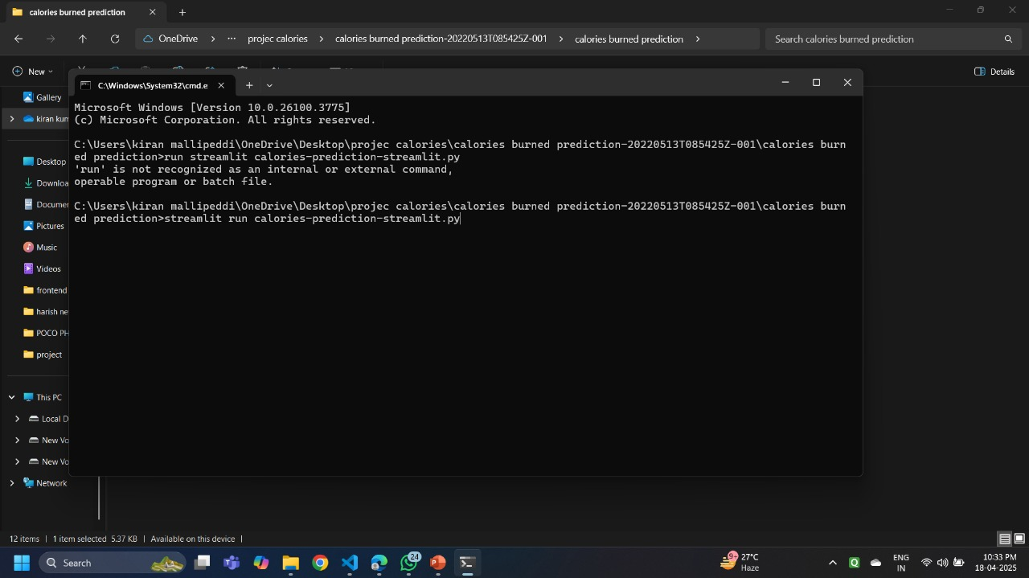

Fig-8 RUN CMD

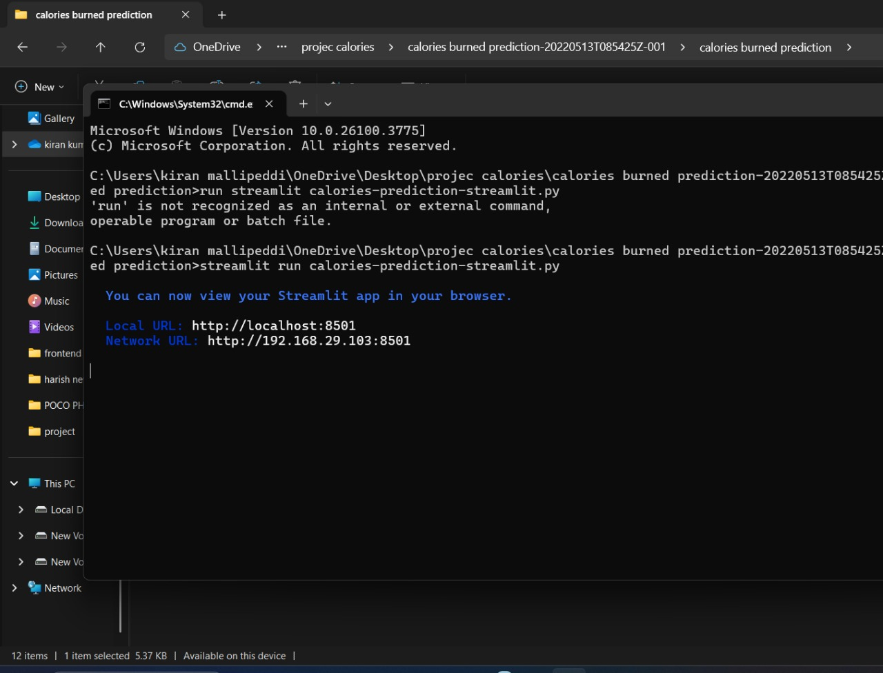

Fig-9 STREAM LIT WEB APPLICATION

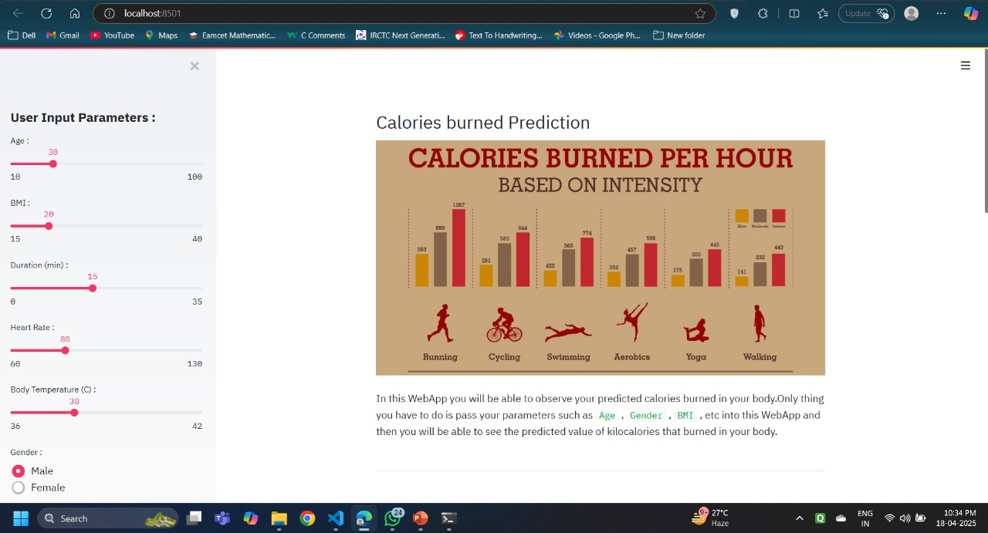

Fig-10 Calories Burned Prediction

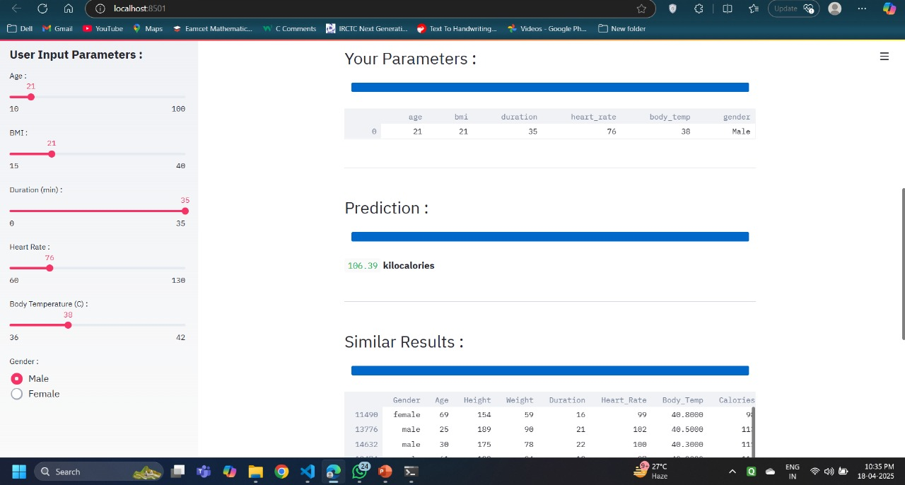

Fig-11 Given Dataset

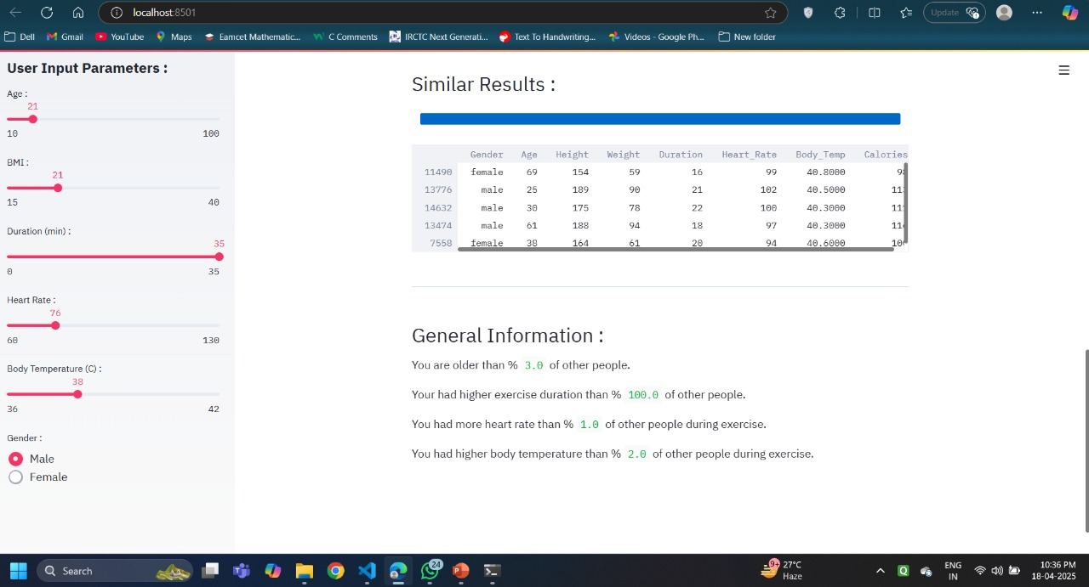

Fig-12 RESULT

CHAPTER 10: CONCLUSION

10.1 CONCLUSION
The main objective of this study was to create a precise machine learning model that could predict a specific outcome variable based on a series of characteristics. This was achieved through the collection and preparation of a dataset, as well as testing the effectiveness of various machine learning models and feature selection techniques. The findings indicated that the XGBoost model demonstrated superior performance compared to the other models in terms of accuracy and other relevant metrics. This suggests that the XGBoost model could be a valuable tool for predicting similar outcome variables based on similar datasets. The key features derived from the feature selection and evaluation process were identified and discussed in terms of their importance and relevance in predicting the target variable. These key features were also related to the problem domain, providing insights and implications for potential applications.
However, the study also had some limitations, such as the limited size of the dataset and the possibility of overfitting. Future research could address these limitations and further improve the performance of the models and feature selection approaches. Overall, this study contributes to the field of machine learning and provides practical implications for the problem domain.

10.2 REFERENCE
Rachit Kumar Singh et al. [8] illustrated their method to predict calorie burn using machine learning techniques. In their work, logistic regression, linear regression and lasso regression models were used but they didn’t mention about mean error absolute value, dataset and model accuracy.
Marte Nipas et al. [9] discussed how to predict burned calories using a supervised learning algorithm. They used a Random forest algorithm and gained 95.77% model accuracy. They also used the iterative method to find out the appropriate output from an input. Their work is almost better than other recent work.
Gunasheela B L et al. [10] discussed their techniques to predict calorie from input images. They used some digital image processing techniques such as image acquisition, RGB conversion, feature extraction and image enhancement so on. They segmented input images and used techniques and then combined segmented images, finally calorie predicted.
KR Westerterp et al. [11] discussed how to determine energy expenditure by body size and body compositions and food intake and physical activity. He used body size and body compositions and some statistical techniques to evaluate calorie expenditure. In summary, these studies demonstrate the potential for machine learning algorithms to predict energy expenditure accurately during physical activity. However, there is still a need for models that can accurately predict energy expenditure across various physical activities and individuals.

