100%

1.Question 1

Which of these terms best describes the type of AI used in today’s email spam filters, speech recognition, and other specific applications?



Artificial General Intelligence (AGI)



Artificial Narrow Intelligence (ANI)

**Correct**

**1 / 1 point**

2.Question 2

What do you call the commonly used AI technology for learning input (A) to output (B) mappings?



Artificial General Intelligence



Reinforcement learning



Supervised learning



Unsupervised learning

**Correct**

**1 / 1 point**

3.Question 3

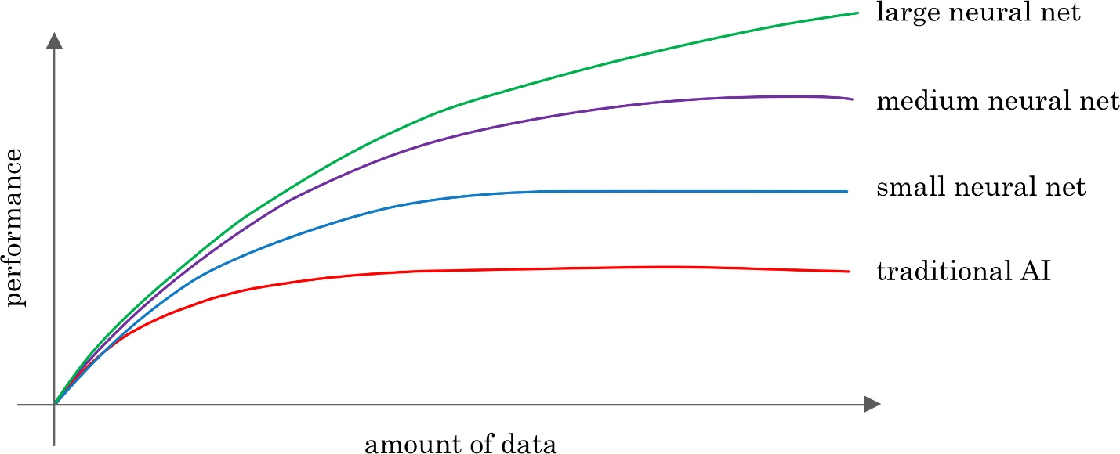

You want to use supervised learning to build a speech recognition system. The figure above suggests that in order for a neural network (deep learning) to achieve the best performance, you would ideally use: (Select all that apply)



A large dataset (of audio files and the corresponding text transcript)

**Correct**



A small dataset (of audio files and the corresponding text transcript)



A large neural network

**Correct**



A small neural network

**1 / 1 point**

4.Question 4

The only way to acquire data for a supervised learning algorithm is to manually label it. I.e., given the input A, to ask a human to provide B.



True



False

**Correct**

**1 / 1 point**

5.Question 5

Which of these statements regarding data acquisition do you agree with?



Some types of data are more valuable than others; working with an AI team can help you figure out what data to acquire.



It doesn’t help to give data to an AI team, because they can always produce whatever they need by themselves.



It doesn’t matter how data is acquired. The more data, the better.



Only structured data is valuable; AI cannot process unstructured data.

**Correct**

**1 / 1 point**

6.Question 6

You run a company that manufactures scooters. Which of the following are examples of unstructured data? (Select all that apply.)



The maximum speed of each of your scooters



The number of scooters sold per week over the past year



Audio files of the engine sound of your scooters

**Correct**



Pictures of your scooters

**Correct**

**1 / 1 point**

7.Question 7

Suppose you run a website that sells cat food. Which of these might be a good result from a Data Science project? (Select all that apply.)



Insights into how to market cat food more effectively, depending on the breed of cat.

**Correct**



A neural network that closely mimics how cats’ brains work.



A slide deck presenting a plan on how to modify pricing in order to improve sales.

**Correct**



A large dataset of images labeled as “Cat” and “Not Cat”

**1 / 1 point**

8.Question 8

Based on the terminology defined in Video 4, which of the following statements do you agree with? (Select all that apply.)



AI is a type of deep learning. (I.e., all AI algorithms are deep learning algorithms.)



Deep learning is a type of machine learning.  (I.e., all deep learning algorithms are machine learning algorithms.)

**Correct**



The terms “Machine learning” and “data science” are used almost interchangeably.



The terms “Deep learning” and “neural network” are used almost interchangeably.

**Correct**

**1 / 1 point**

9.Question 9

Which of these do AI companies do well?



Strategic data acquisition



Invest in unified data warehouses



Spot automation opportunities



All of the above

**Correct**

**1 / 1 point**

10.Question 10

Say you want to input a picture of a person’s face (A), and output whether or not they are smiling (B). Because this is a task that most humans can do in less than 1 second, supervised learning can probably learn this A-to-B mapping.



True



False

**Correct**