

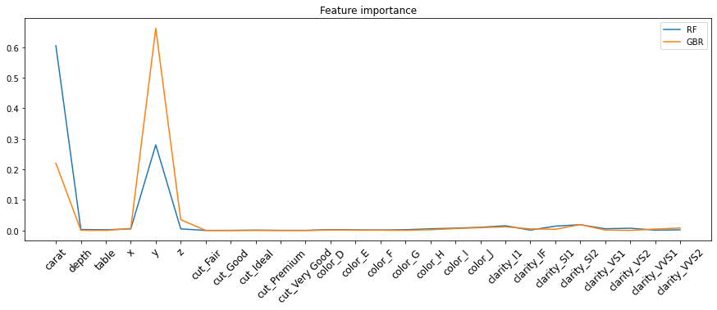
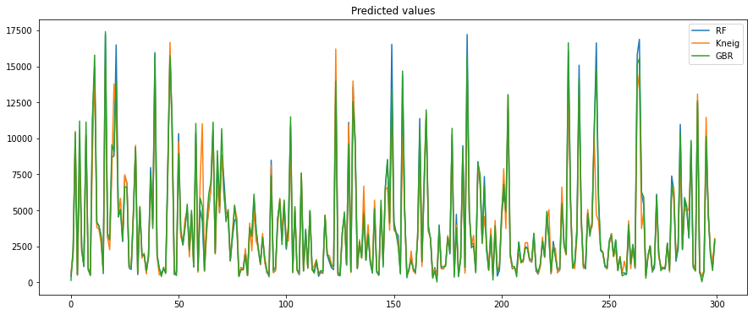
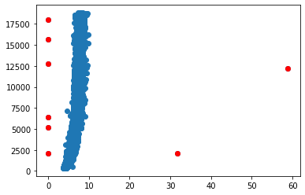
Predicting diamond price
RandomForestRegressor(n_estimators =200) → RMSE = 557
KneighborsRegressor(n_neighbors=5) → RMSE = 965
GradientBoostingRegressor(n_estimators=200) → RMSE = 656
Beatriz Sanaú
Normalize

Categorize the cut:
Instead of ('Fair', "Good", 'Very Good', 'Premium', 'Ideal') → (0, 1, 2, 3, 4)

Eliminate outliers:

