Supplementary Material

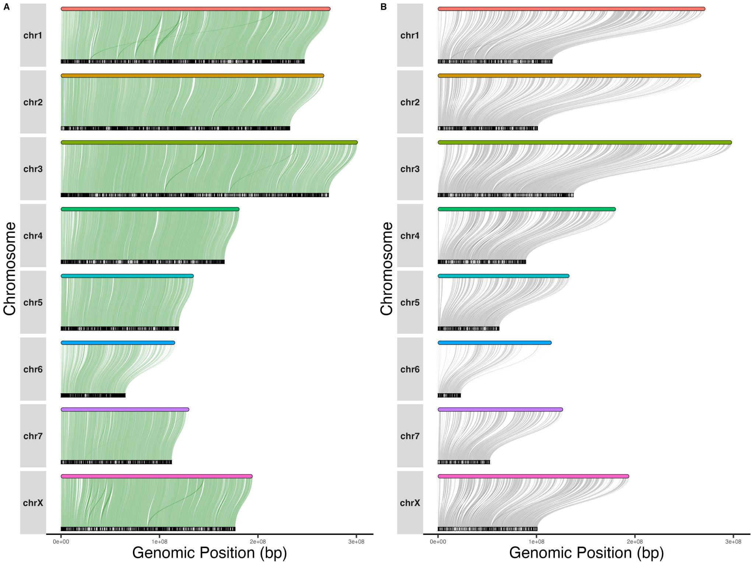
Figure S1. Alignment of all genome scaffolds (top tracks, colored bars) to (A) all scaffolds of the previous genome, as in Figure 1E, or (B) the subset of scaffolds which were placed on pseudochromosomes in the previous genome (bottom tracks, black and grey lines). Note the reduction in the length of each pseudochromosome in (B) compared to (A), indicating the number of unplaced scaffolds in the previous genome. Analysis limited to the scaffolds mapping to the chromosomes from the new assembly and which are 10,000 bp or longer.
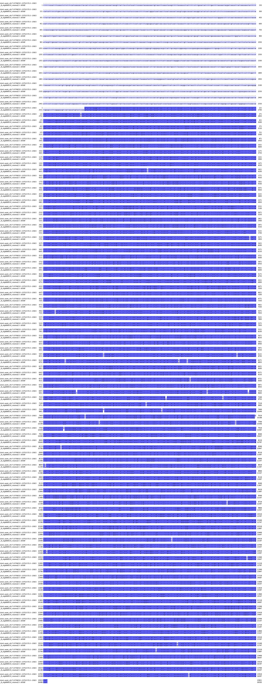
Figure S2. Alignment of the mtDNA against the large NUMT found on chromosome 7. Colored regions are conserved between the two sequences. Sequences have 84.17% similarity, including gaps.

