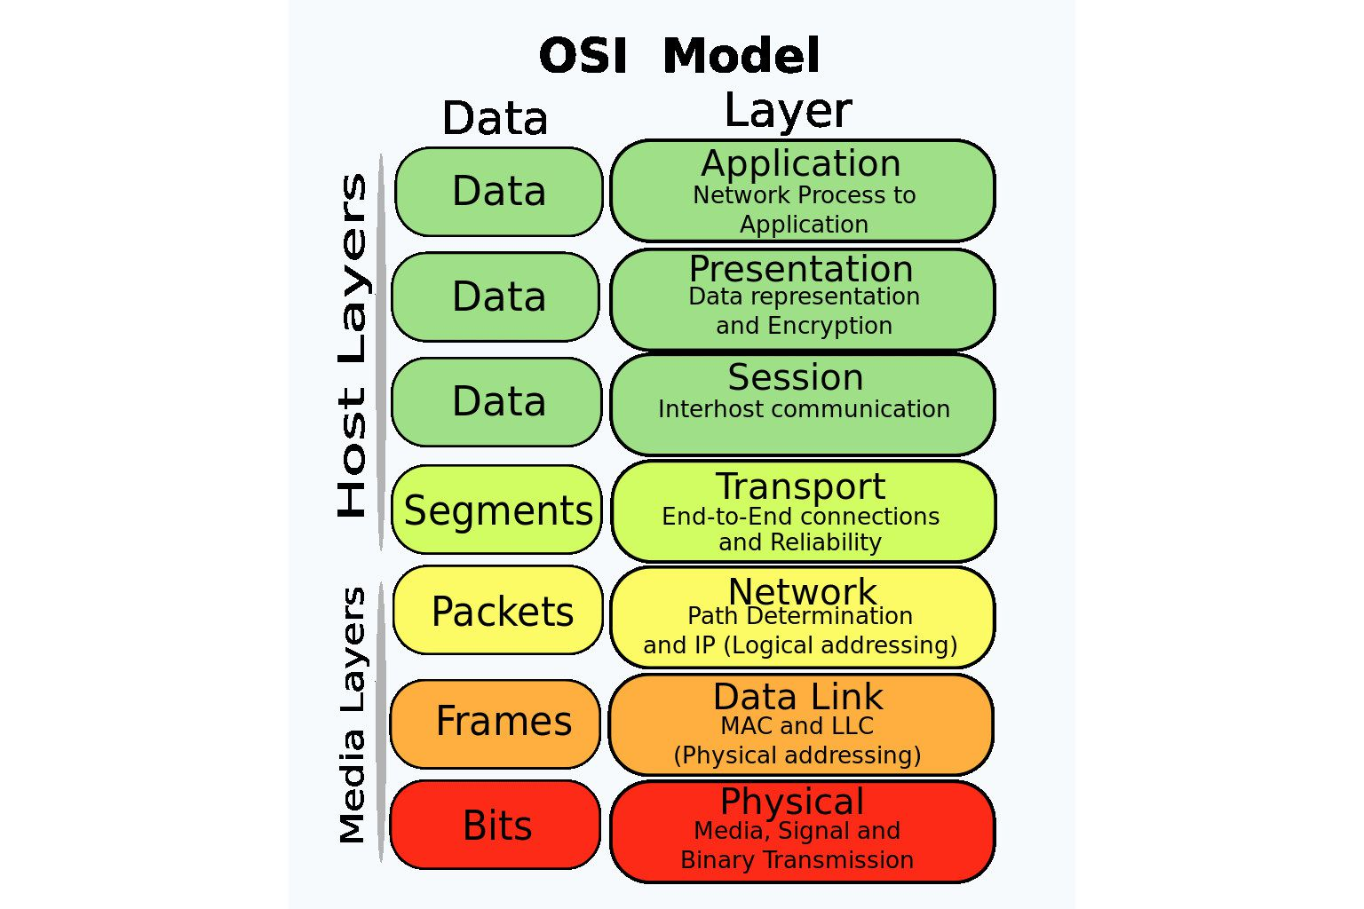

In network a layer can communicate with its immediate up layer or below layer  
The OSI (Open Systems Interconnection) model is a conceptual framework that standardizes network communication into seven layers. Each layer has a specific function and interacts with the layers above and below it.

**1. Physical Layer (Layer 1)**

* **Function:** Deals with the physical connection between devices.
* **Responsibilities:**
  + Transmission and reception of raw bitstreams over a physical medium.
  + Defines hardware specifications like cables, switches, and network adapters.
  + Manages data encoding, signaling, and synchronization.
* **Example:** Ethernet cables, Fiber optics, Wi-Fi, Bluetooth.

**2. Data Link Layer (Layer 2)**

* **Function:** Ensures reliable data transfer between adjacent network nodes.
* **Responsibilities:**
  + Handles MAC (Media Access Control) addressing and LLC (Logical Link Control).
  + Detects and corrects errors in data transmission.
  + Divides data into frames for efficient transmission.
* **Example:** Ethernet, MAC addresses, Switches.

**3. Network Layer (Layer 3)**

* **Function:** Handles logical addressing and routing of data between networks.
* **Responsibilities:**
  + Assigns IP addresses for devices.
  + Determines the best path for data transmission.
  + Uses routers to forward data packets.
* **Example:** IP (Internet Protocol), Routers, IPv4 & IPv6.

**4. Transport Layer (Layer 4)**

* **Function:** Ensures reliable, end-to-end communication.
* **Responsibilities:**
  + Divides data into segments.
  + Ensures data is delivered without errors, loss, or duplication.
  + Manages flow control and retransmissions.
* **Example:** TCP (Transmission Control Protocol), UDP (User Datagram Protocol).

**5. Session Layer (Layer 5)**

* **Function:** Manages and controls communication sessions between applications.
* **Responsibilities:**
  + Establishes, maintains, and terminates connections between applications.
  + Synchronizes data exchange.
* **Example:** Authentication, SQL sessions, Remote Desktop Protocol (RDP).

**6. Presentation Layer (Layer 6)**

* **Function:** Translates data between application and network formats.
* **Responsibilities:**
  + Handles encryption and decryption for security.
  + Compresses data to reduce transmission size.
  + Converts data formats like ASCII to EBCDIC.
* **Example:** SSL/TLS encryption, JPEG, GIF, MP3 formats.

**7. Application Layer (Layer 7)**

* **Function:** Provides network services directly to user applications.
* **Responsibilities:**
  + Manages user interfaces for communication.
  + Supports network applications like email, web browsing, and file transfer.
* **Example:** HTTP (Web browsing), FTP (File Transfer), SMTP (Email).

**Key Takeaways:**

* **Host Layers (Upper layers):** Focus on data handling and application interactions.
* **Media Layers (Lower layers):** Handle data transmission across physical networks.
* **Data encapsulation:** Each layer adds its own headers and trailers for transmission.

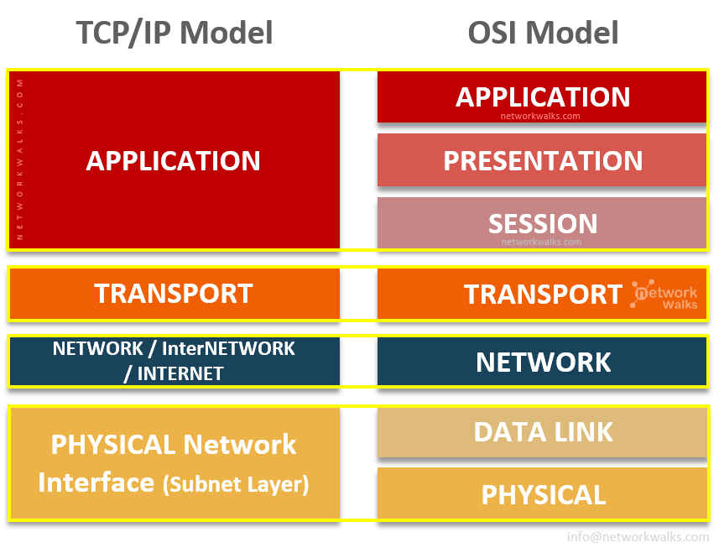

The **TCP/IP (Transmission Control Protocol/Internet Protocol) model** is a simplified framework used for network communication, primarily on the internet. It consists of **four layers**, compared to the seven-layer **OSI model**.

**Layers of the TCP/IP Model:**

1. **Application Layer**
   * Equivalent to the top three layers (Application, Presentation, Session) in the OSI model.
   * Handles user interaction, data formatting, encryption, and session management.
   * **Examples:** HTTP, FTP, SMTP, DNS.
2. **Transport Layer**
   * Manages end-to-end communication, error detection, and data reliability.
   * Uses **TCP** (for reliable, connection-oriented transmission) and **UDP** (for faster, connectionless communication).
   * **Examples:** TCP, UDP.
3. **Internet Layer**
   * Handles logical addressing and routing of data packets across networks.
   * Uses IP addressing and determines the best path for data transmission.
   * **Examples:** IP, ICMP, ARP.
4. **Network Access Layer (Link Layer)**
   * Handles physical data transmission over the network (similar to the OSI's Physical & Data Link layers).
   * Defines how data is formatted into frames and sent over the network medium.
   * **Examples:** Ethernet, Wi-Fi, MAC addresses.

**Key Differences from OSI Model:**

* **Simpler structure:** Only 4 layers instead of 7.
* **More practical:** Directly based on real-world networking protocols.
* **Widely used:** The foundation of the internet and modern networking.

IP ADDRESS🡪Inet address

Port-🡪0-65535

In that 0-1023 are the fixed port numbers

Smtp(simple mail transport protocol):to sent the email to receive there will be another protocol…these protocols are accessible by the port no 25

When we want to use our computer to send any thing that means user services we will use the port no:1024-65535

Set of rules which are used to govern the transmission of data over the network: Protocol

Socket: is the software abstraction. (it is a class)

* + 1. It binds socket to the port
    2. It connects or request to remote system
    3. It accepts the connection
    4. It waits for the incoming connection
    5. It provides the streams (flow of data) to transfer the data
    6. Closes the connection

|  |
| --- |
| IP ADDRESS |
| PORT |
| PROTOCOL |
| SOCKET |

In java there are 2 types of socket which is for the TCP/IP model:

1. Server socket(Java.net.ServerSocket-🡪this is the class)
2. Socket(Java.net.Socket)

For tcp the serversocket steps are :

🡪it binds socket to a port.

🡪It waits for incoming connection

🡪It connects sockets of both ends

🡪Closes the connection

Socket:

🡪it requests for the connections

🡪it provides the stream of the data

🡪closes the connection