The output is stored on: /scratch-shared/edwinhs/test_water_bodies_4LCs_after_indonesia_working

Model scripts can be found on: /scratch-shared/edwinhs/test_water_bodies_4LCs_after_indonesia_working /scripts/

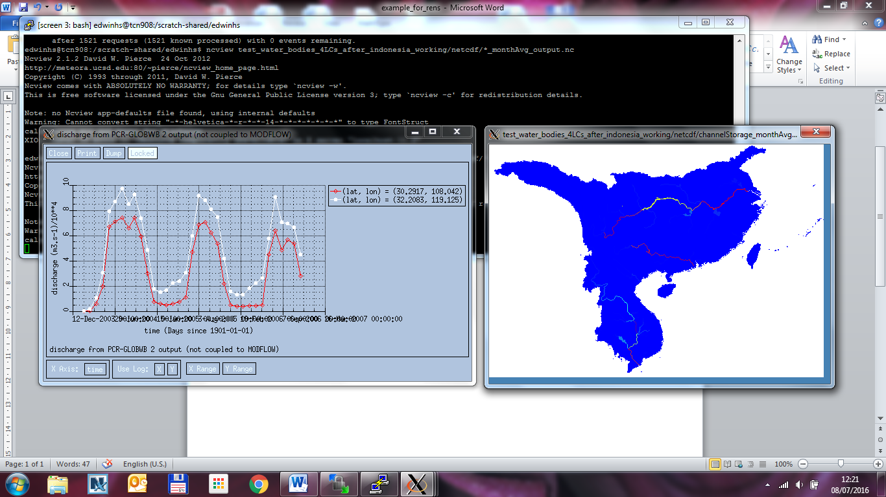

**Figure 1 - Discharge (monthly resolution, m3/s)**

* Red: at Three Gorges Dam
* White: at the outlet

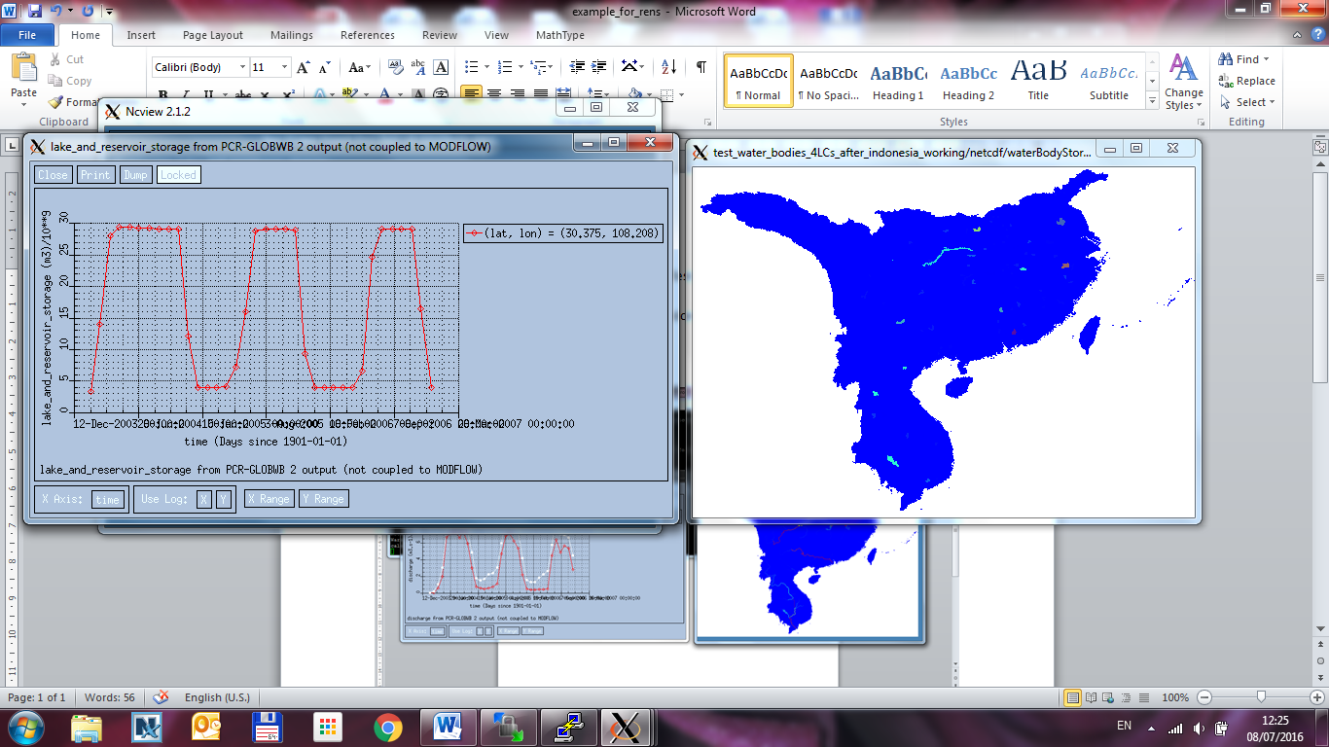

**Figure 2 - Reservoir storage of Three Gorges Dam (monthly resolution, m3). Reservoir capacity: 39.3 km3**

The github for this version can be found on: <https://github.com/edwinkost/PCR-GLOBWB/tree/starting_from_24_june_2016>

* This also includes “maximum reporting” (e.g. reporting maximum values for every month or year).