Milestone 2 – Salable Products and Store Front Application
Benjamin Schoolland
CST-239 – Java Programming II

Design Overview
This milestone implements a console-based arena store front application using a product class hierarchy built on object-oriented principles. The design follows a clear inheritance structure with SalableProduct as the base class, extended by three specialized product types: Weapon, Armor, and Health.
The SalableProduct base class encapsulates common attributes shared by all products: name, description, price, and quantity. Each subclass adds a domain-specific attribute — Weapon adds damage, Armor adds defense, and Health adds healAmount — representing the unique characteristics of each product category in the arena game context.
The StoreFront class manages the store inventory using a List of SalableProduct objects, leveraging polymorphism to handle all product types uniformly. It provides methods for displaying products, purchasing (which decrements quantity), and returning products (which increments quantity). The inventory is initialized with hard-coded products: 2 weapons (Flame Sword, Shadow Dagger), 2 armor pieces (Iron Shield, Dragon Scale Chestplate), and 2 health items (Healing Potion, Elixir of Life).
The application flow begins in Main, which creates a StoreFront and StartingActions. The user chooses between customer and manager roles. The CustomerActions class provides a fully functional menu for viewing products, purchasing items, and returning items, with appropriate input validation and error feedback. The StoreManagerActions class remains a placeholder for future milestone implementation.

UML Class Diagrams

Product Class Hierarchy
The following diagram shows the inheritance hierarchy of the salable product classes. SalableProduct serves as the base class with Weapon, Armor, and Health as derived classes.
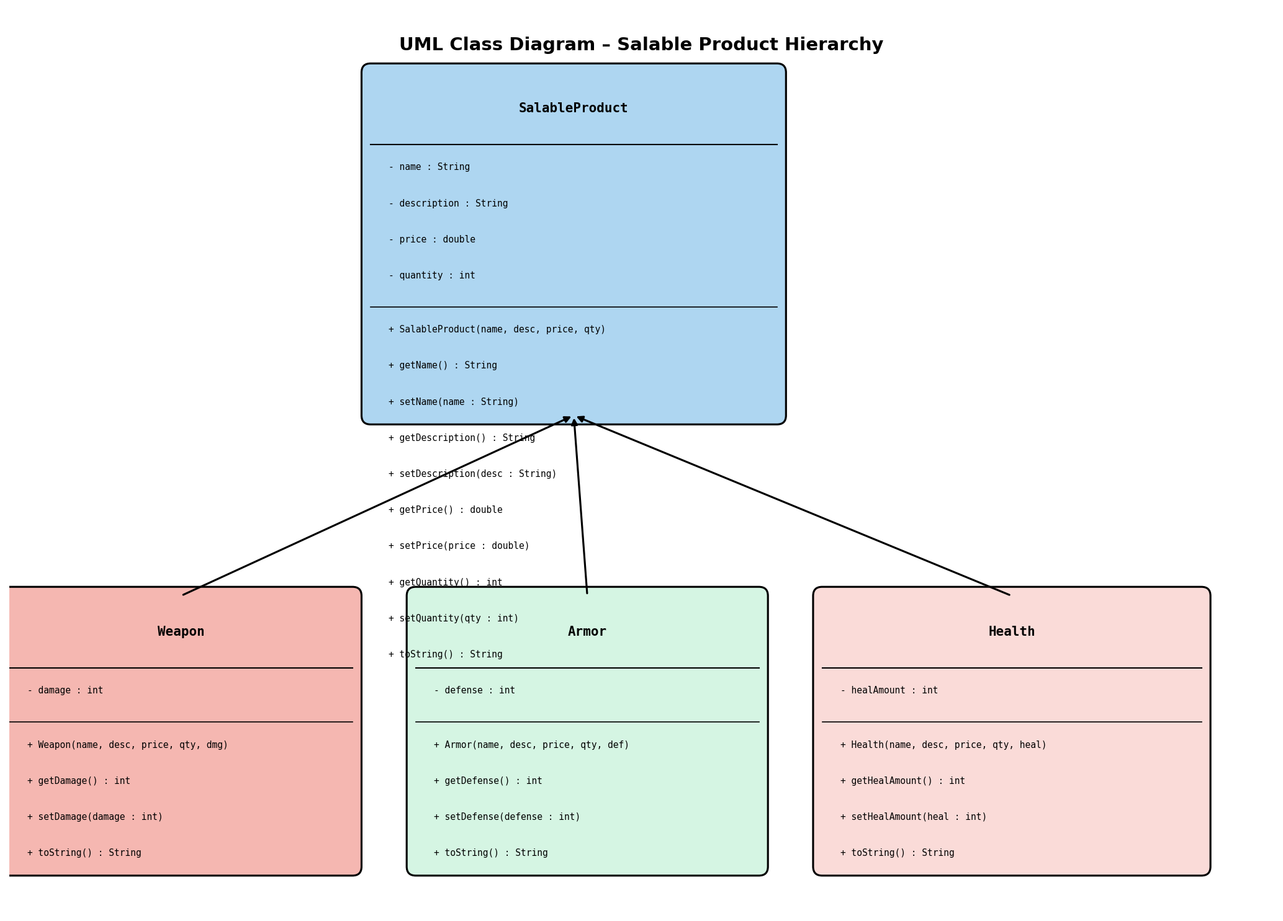

Application Structure
The following diagram shows the overall application structure including the relationships between Main, StartingActions, CustomerActions, StoreManagerActions, StoreFront, and InputUtilities classes.
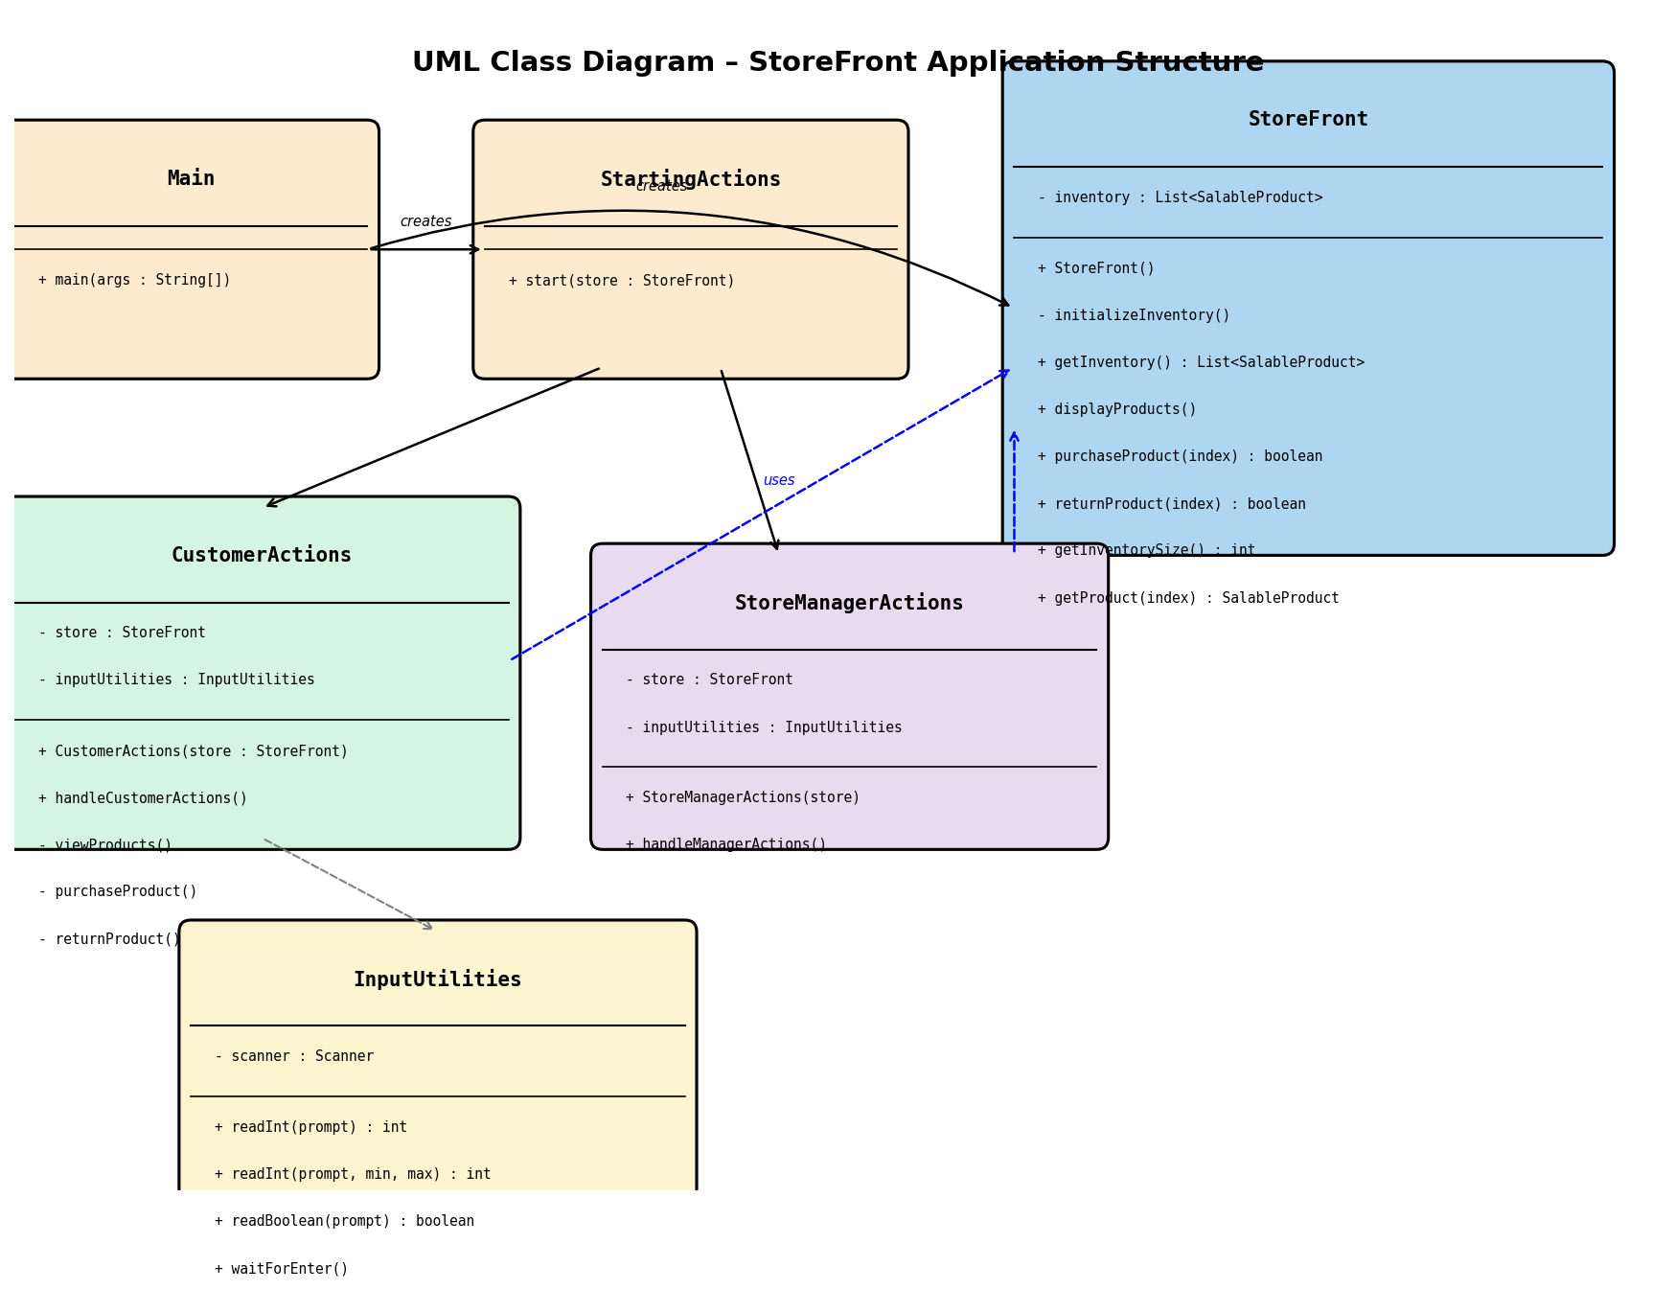

Flowchart – Game User Interaction
The following flowchart illustrates the interaction flow when a game user (customer) interacts with the store front application. It shows the menu loop, product viewing, purchasing with stock validation, returning products, and the exit flow.
