Analysis of Algorithms Project 2

by Brian Sharp

Objective – The second project for analysis of algorithms entails developing an algorithm to find the largest substring between two strings. The strings may be random or part of a language such as free text or a DNA sequence.

Methodology – To solve this problem, we analyze the brute force method. The first step in this method is to find every substrings of both strings. If we have two strings, say string1 and string2, we may say they have length n for string1 and length m for string2. We can then realize that the set of all substrings of string1 will have n! Number of elements. Similarly, string2 will have m! Number of elements. We are then able to compare both sets of substrings and find which elements match. To make our algorithm slightly more efficient we can start with the elements that are the largest. Once we find two elements that are in both sets, we can say that this is the largest, or as long as all the longest, shared substrings.

For this algorithm we analyze the psuedocode to see how efficient this method is.

//find the set of substring1
substrings1 = []
for n = (len(n) to 1):
for substring of string of length n:
substring1 += substring

substrings2 = []
for n = (len(n) to 1):
for substring of string of length n:
substring2 += substring

for s1 in substring1
for s2 in substring2
if s1 == s2 and s1.length > maxlength
maxlength = len(s1)
largest_substring = s1

For this algorithm, we realize that there are n! Different elements in each set. Therefore, we realize that the first loop and second loop both run in n! Time. The third loop compares all the elements in both sets. We can say that this runs in n! * n! Time. That is, it runs in O((n!) ^2) time. For any algorithm that is incredibly inefficient.

Testing our algorithm – To test this algorithm, we run several tests on different size strings and compare the timing. We use an alphabet of digits. For example a random string of size 10 may be 1729439537. We run the algorithm of several different size string and hypothesize that we will see a huge increase in the run time when the size of the strings increases.

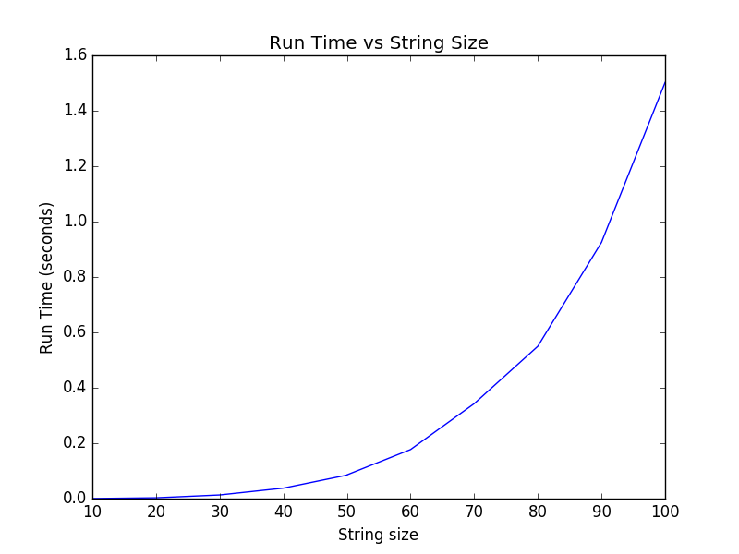

As we can see from the results, as the string sizes increase, the run time greatly increases. This is because this algorithm is incredibly inefficient. At string sizes large than 100 this algorithm is not realistic

Methods to improve – there are a number of realistic ways to improve this algorithm. The first is realize that we only need to find the substrings that are the largest. That is, we hope that by checking only the strings of size n, then n-1, etc, that we may find a string that is smaller and we wont need to check all substrings. In practice, this may be much faster since an early hit will hugely reduce the run time. However, this method still runs in big-o of (n!) ^ 2. With other types of data, such as free text, we could also compare smaller tokens of data. For example, if we were comparing two sentences, we could compare all the words for similarities. We expect that if we find two or three words that are matching, that this will be the largest substring between the two.

