1) Given the instances, where circles represent class +1 and squares represent another class (-1), use the general idea of support vector machines to draw the maximum margin hyperplane.
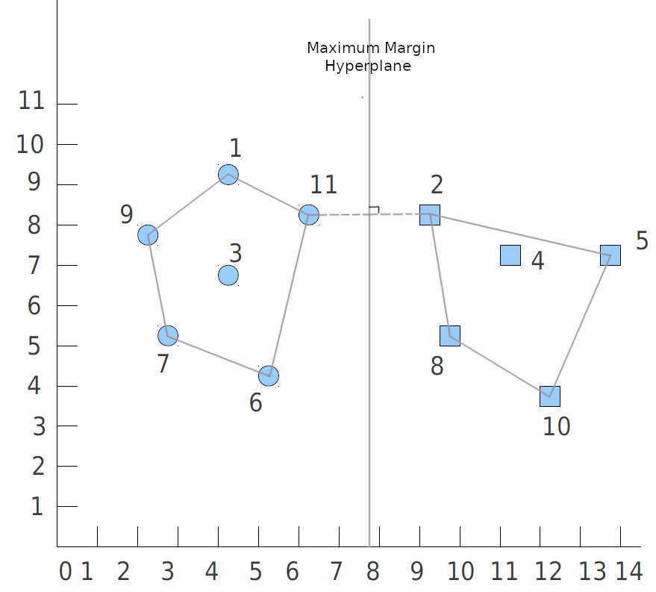

2) Identify the Support Vectors

Instance 2 (9,8) and Instance 11 (6.5,8) are the support vectors.

3) Write the equation that would be used to classify a new instance using the support vectors from (b). Indicate what constants in the equation would be determined by the geometry above.

x = sign( b + SUM_i_is_suppVecs[ Alpha_i * y_i * DOT(a(i), a)] )

b and Alpha_i are parameters learned from the geometry above.
a(i) represents the set of support vectors i
y_i represents the class (+1 or -1) of a given support vector i
a represents the test instance.

Since this is a 2 class problem, we can simply use the sign() function to determine if the test instance belongs to class +1 or -1.

