1) Use the perceptron algorithm to find the hyperplane separating the two classes and then draw the picture in 2D showing the corresponding line separating the instances.
Instance | a1 | a2 | class
1 | 1 | 3 | 1
2 | 1 | 1 | -1
3 | 2 | 4 | 1
4 | 2 | 2 | -1

Instance | Actual Class |  |  | Pred. Class | Correct? | Action
(a0,a1,a2) | y_actual | (w0,w1,w2) | Dot product | y_pred |  | w = w + y_a*a
(1,1,3) | 1 | (0,0,0) | 0 | -1 | No | Add
(1,1,1) | -1 | (1,1,3) | Positive | 1 | No | Subtract
(1,2,4) | 1 | (0,0,2) | Positive | 1 | Yes
(1,2,2) | -1 | (0,0,2) | Positive | 1 | No | Subtract
(1,1,3) | 1 | (-1,-2,0) | Negative | -1 | No | Add
(1,1,1) | -1 | (0,-1,3) | Positive | 1 | No | Subtract
(1,2,4) | 1 | (-1,-2,2) | Positive | 1 | Yes
(1,2,2) | -1 | (-1,-2,2) | Negative | -1 | Yes
(1,1,3) | 1 | (-1,-2,2) | Positive | 1 | Yes
(1,1,1) | -1 | (-1,-2,2) | Negative | -1 | Yes

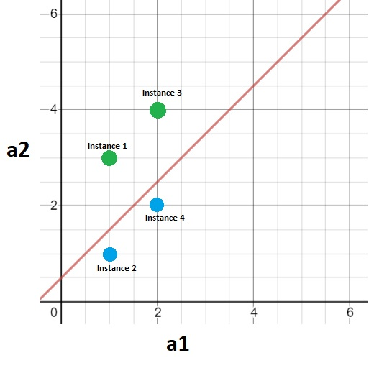
The hyperplane is given by dot(a,w) = 0
dot(a,w) = 0
a_0*-1 + a_1*-2 + a_2*2 = 0
-2*a_1 + 2*a_2 = 1
a_2 = a_1 + 1/2

