- Draw a kD-tree for the following set of training instances. Also show the rectangular regions, and number the points in the drawing and in the tree. The star is the test case. Show the path taken by the star through the tree, and how the nearest neighbour is located. We assume that a1 attribute has higher variance than a2.
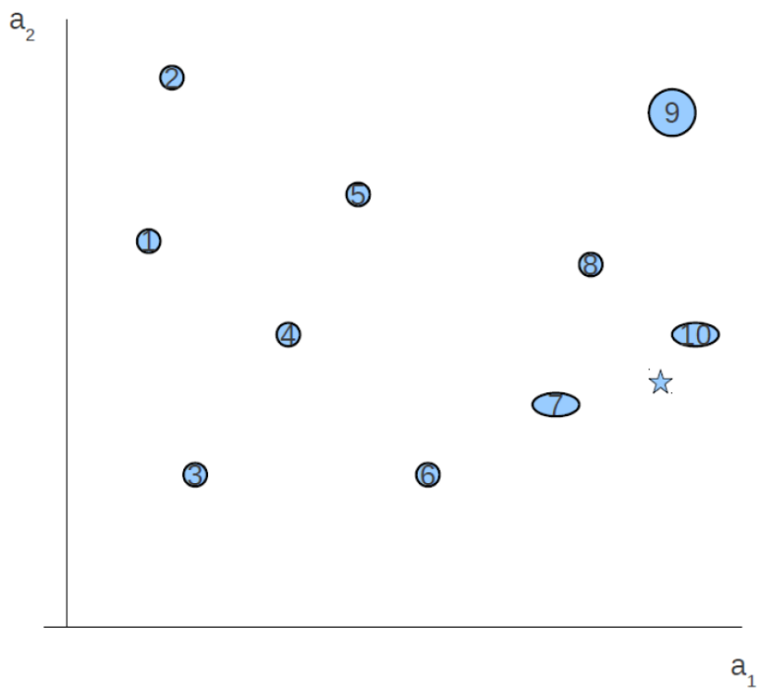
The steps are listed on the following page, but the end result for the test instance is visualized below.
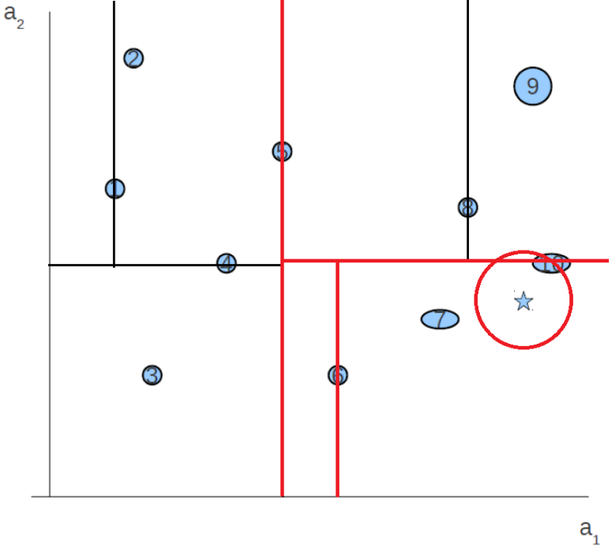

As the a1 axis has a higher variance, we first split using the median of a1. Since there are an even number of items, we'll randomly choose the 5th instance out of [5,6]. Then, we find the median of each subset less than and greater than the 5th instance, alternating attributes.

 | 5
3,4,1,2 |  | 6,7,10,8,9
Median: 4 or 1. We'll choose 4 |  | Median: 10
Note that the current leaf nodes contain all elements not yet added to the tree, in the order as sorted from least to most of the next attribute to split on.

 |  |  | 5
 | 4 |  |  |  | 10
3 |  | 1,2 |  | 6,7 |  | 8,9
 |  | Median: 1 |  | Median: 6 |  | Median: 8
We began splitting on a1, then split on a2, so now we are once again splitting on a1.

 |  |  |  | 5
 | 4 |  |  |  |  |  | 10
3 |  | 1 |  |  | 6 |  |  |  | 8
 |  |  | 2 |  |  | 7 |  |  |  | 9
The final tree structure as the above.
The path that the new instance would take is shown in red below.
 |  |  |  | 5
 | 4 |  |  |  |  |  | 10
3 |  | 1 |  |  | 6 |  |  |  | 8
 |  |  | 2 |  |  | 7 |  |  |  | 9
 |  |  |  |  |  | ★
To find the nearest neighbour, we begin by finding the distance between the new instance and the root node, then each node on the path down to its position in the tree. Then, we go down sibling sub-trees to compare distance against those instances.
Dist(, 5) > Dist(,10) => 10 is the NN
Dist(,10) < Dist(, 6) => 10 is the NN
Dist(,10) < Dist(, 7) => 10 is the NN
Dist(,10) < Dist(, 8) => 10 is the NN
Dist(,10) < Dist(, 9) => 10 is the NN

