1) Show two moves of the centers in k-means clustering, given the initial random positions shown by the stars. Also show the clusters.
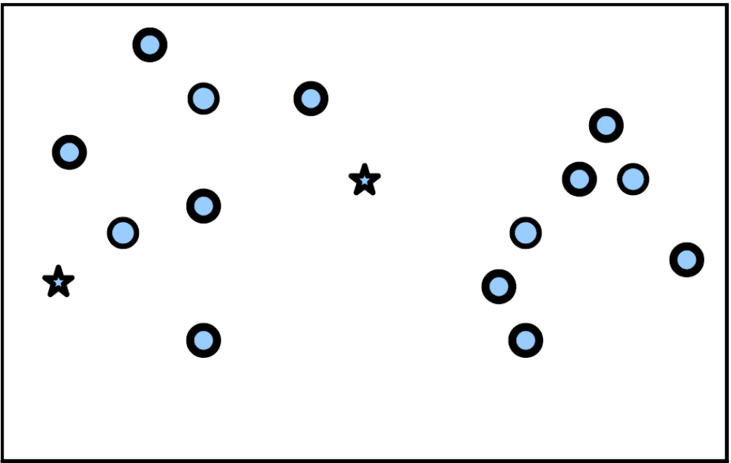
Move 1: Cluster and recenter
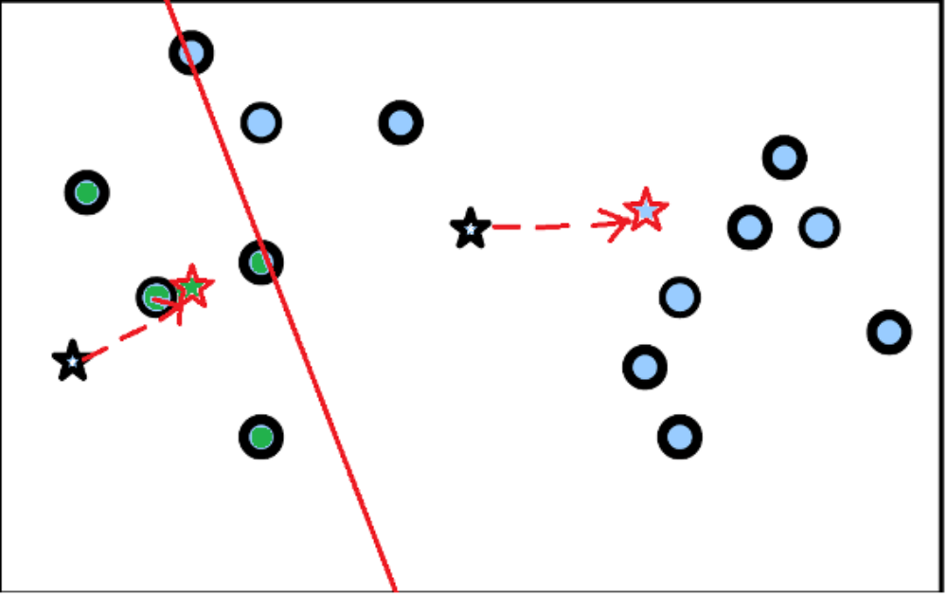
Move 2: Cluster and Recenter
