AI-Driven Bench Management & Candidate Shortlisting Proposal

1. Overview
This proposal outlines an AI-driven solution to replace the current manual Excel-based bench tracking process. The system automates employee data ingestion, skill mapping, project requirement matching, and provides smart recommendations for staffing decisions.

2. Objectives
• Eliminate manual effort and errors in bench tracking.
• Centralize employee data, skills, and availability in a structured database.
• Enable faster, AI-assisted shortlisting of employees for new projects.
• Improve utilization and reduce bench time.

3. Proposed System Architecture
The solution includes:
• Centralized Employee Database.
• Skills & Experience Normalization Layer.
• AI Matching Engine (Skill similarity + Experience fit + Availability).
• Dashboard for HR, Delivery Leads, and Management.
• Automated alerts for upcoming roll-offs.

5. Candidate Shortlisting Process
The AI Matching Engine evaluates employees based on a weighted scoring system:
• Skill match score (60%) — cosine similarity between required and available skills.
• Experience relevance score (20%).
• Availability score (10%).
• Certifications / special skills (10%).
The system returns a ranked list of top candidates for every new project requirement.

6. Workflow
1. Uploads new employees or updates skills.
2. System parses the data and updates normalized tables.
3. Delivery Lead submits a project requirement.
4. AI Matching Engine runs matching logic.
5. Dashboard shows recommended candidates.
6. Lead can view profiles, compare candidates, and shortlist.

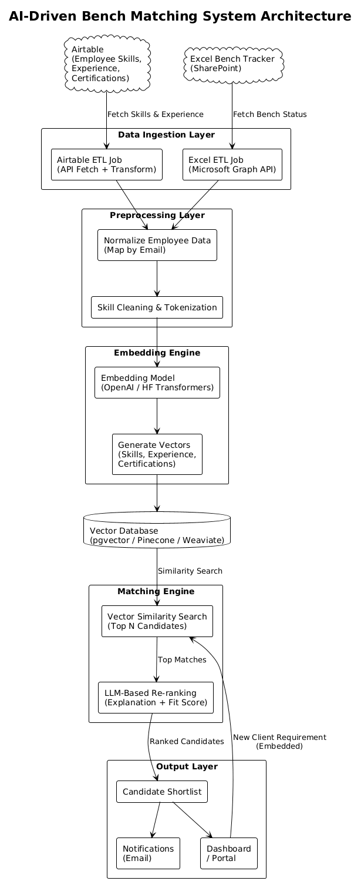

7. Advantages of the Proposed Approach
• Fully eliminates Excel-based tracking.
• Real-time availability view.
• AI-based ranking reduces human errors.
• Faster staffing leads to higher revenue.
• Clean historical data for forecasting and reporting.

8. Conclusion
This system will significantly enhance workforce utilization by automating bench management, maintaining clean employee skill data, and providing AI-driven recommendations for faster and more accurate staffing decisions.

