User Guide for the Meeting Time Calculator Web Application

Group D: Meetings

Brent Silvernagel; Deborah Snyder; Joshua Thomas; Clayton Townley

University of Maryland University College

Revision: 1.1

Date: 03/27/2018

Class #: CMSC 495 7981

**Revision History**

|  |  |  |  |
| --- | --- | --- | --- |
| **Revision** | **Date** | **Author** | **Description** |
| 1.0 | 03/27/2018 | Deborah Snyder | Document Creation |
| 1.1 | 3/30/2018 | Deborah Snyder | Update Intro & Create Steps |
|  |  |  |  |

**User Guide for the Meeting Time Calculator Web Application**

# Introduction

The purpose of the Meeting Time Calculator web application is to provide visibility to the time and cost of meetings. It should be noted that the value meetings bring to a company varies from company to company and meeting to meeting. The purpose is not to discern the value of meetings, but to provide visibility of their opportunity cost. Additionally, it can give insight into the projected costs of recurring meetings throughout the life of a program to provide more accurate program costs estimates.

This application allows the user to input details about reoccurring meetings at their company or establishment and get the estimated cost of the meetings over a period of time (one meeting, one week, one month or one year). Details that the user must input are the estimated duration of the meeting, how many times per week are the meetings occurring, how many people attend the meeting and lastly what the typical salary is for the attendees of the meetings.

# System Specification

Software: Modern web browser on mobile or desktop: Chrome, Safari, Firefox.

Web server running SQL.

# System Requirements

**1:** User should have the following meeting information to enter into the application:

1. Meeting Duration
2. Frequency
3. Attendees
4. Attendee Pay Grade
5. Time Scale (meeting, day, week, month, year, program life)

# Accessing the Web Application

1. Open preferred browser such as Chrome, Safari, or Mozilla Firefox. In the address bar, copy and paste the following URL, <https://frozen-stream-35594.herokuapp.com/> (this link is to the demo), and press enter.

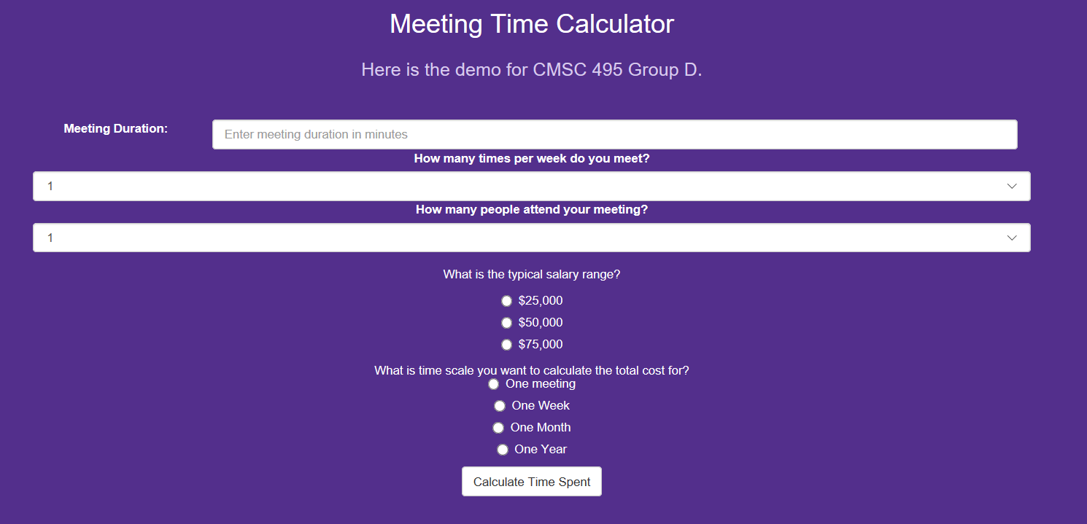

Figure 1: Snapshot of the Web Application when loaded in a browser.

# Inputting Data:

There are five questions that must be answered before calculating the estimate.

1. Start with the first text box labeled “Meeting Duration”. As stated in the text box, enter an integer of the duration of the meeting in minutes. Proper examples of this would be “30” or “60” not thirty or sixty. Do not enter the word minutes or “min” after the integer. 

Figure 2: Example of Meeting duration input.

1. Next, refer to the text box with the label “How many times per week do you meet?”. Click on this box and a dropdown menu will appear. Select the amount of times that the meeting is held from the drop down. 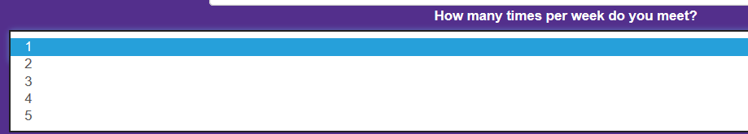

Figure 3: Example of times per week dropdown menu.

1. Move on to the text box with the label “How many people attend your meeting”. Click on the text box and a dropdown menu will appear. Select the amount of individuals who attend the meeting from the dropdown. 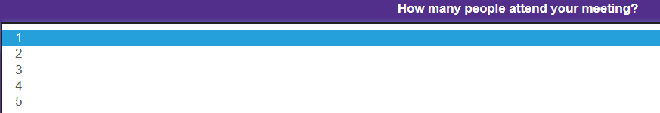

Figure 4: Example of amount of attendees dropdown menu.

1. After selecting from the dropdown text boxes, refer to the fourth question “What is the typical salary range?”. Click the radio button that corresponds to the salary range of attendees. It should look like the following: 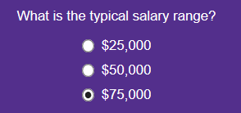

Figure 5: Example of typical salary selection.

1. Refer to the fifth and final question “What is the time scale that you want to calculate the total cost for?”. Click the radio button that corresponds to the time scale that best suits your calculations whether it be one day, one week, one month or one year. This will break down the cost of meetings over that span of time. 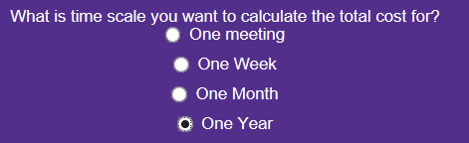

Figure 6: Example of time scale selection.

# Running the Web Application:

1. To run the application, user must select the button at the bottom of the screen that is labeled “Calculate Time Spent”.

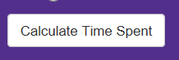

Figure 7: Snapshot of button that runs the web application calculations.

# Results:

1. Estimated dollar amount will appear below the Calculation Button.
2. If unsatisfied with the cost, user can adjust the amounts and click the Calculation button again.