CS 255 System Design Document Template

UML Diagrams

UML Use Case Diagram
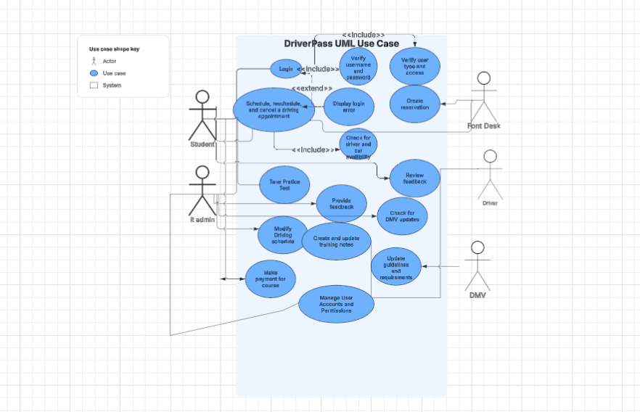

UML Activity Diagrams
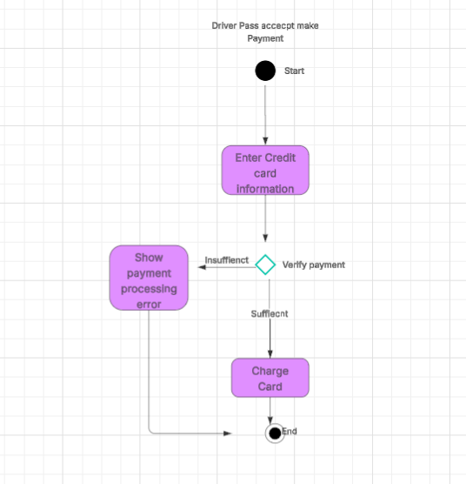
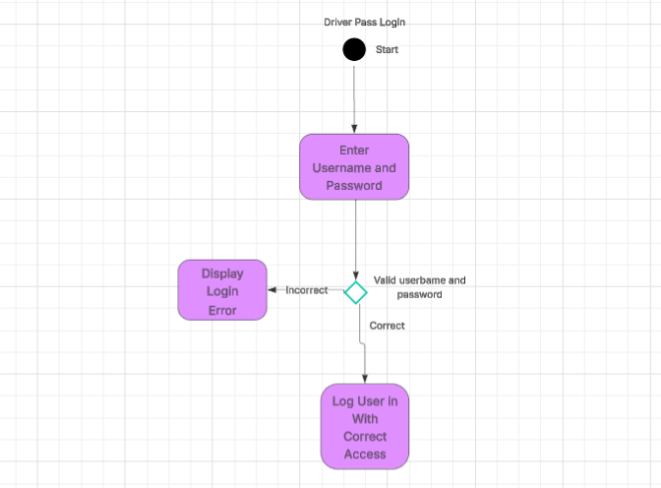

UML Sequence Diagram
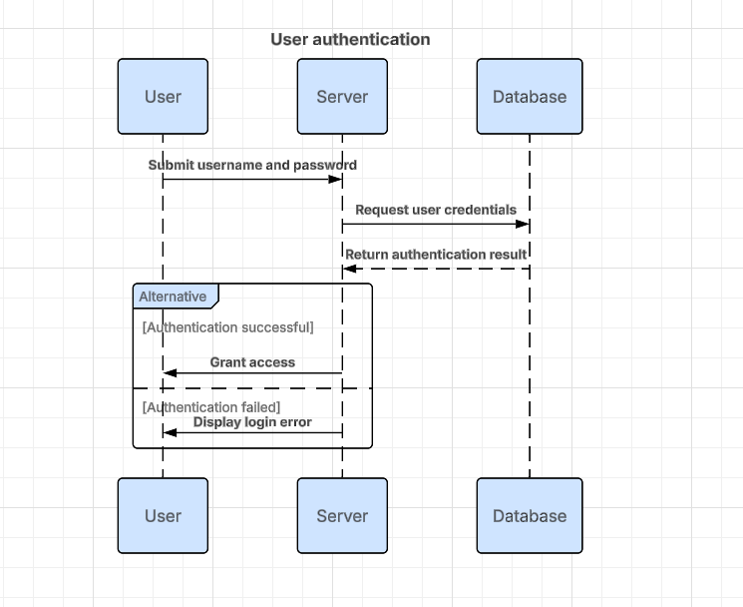

UML Class Diagram
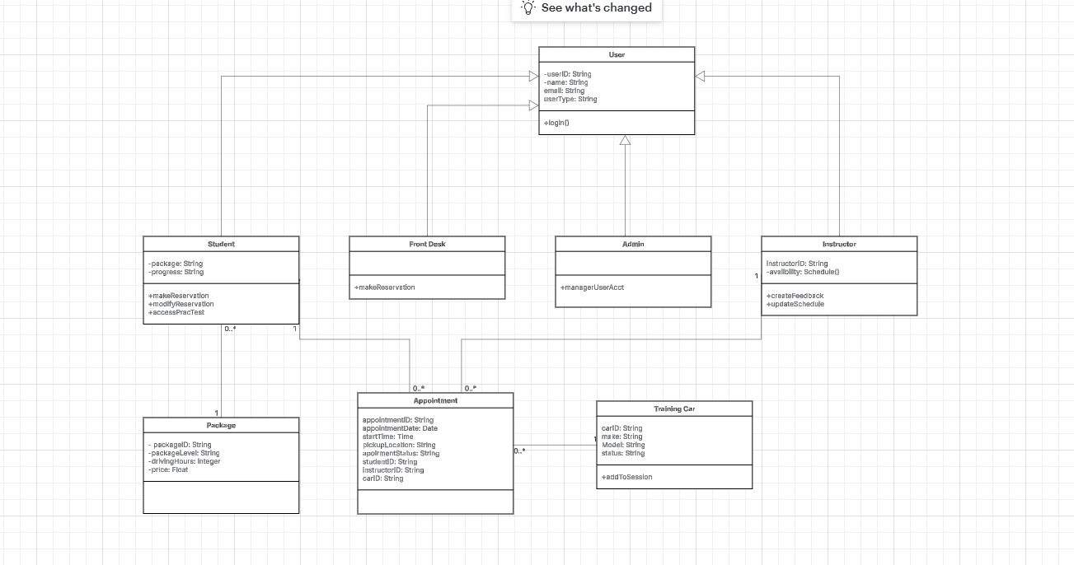

Technical Requirements
Hardware requirement:
- Users will need devices capable of accessing the internet (computer, smartphone, or tablet)
- DriverPass will need a cloud-based server to host the system
Software requirements:
- Will need to support all major browsers, including Chrome, Edge, Safari, and Firefox
- Database to store all needed user information, training packages, appointments, and student progress.
- The system will need secure login authentication and current user role access.
- Payment processing software will be required.
Tools and infrastructure requirements:
- DriverPass will need a reliable internet connection to access the cloud-based system.
- Cloud storage will need regular backups and security.
- The system will need proper encryption.
- The software will need to support the possibility of several users using the system simultaneously.

