# Lab05 : Python Strings

|  |  |
| --- | --- |
| Name | Ben Stobie |
| Date | 05/03/21 |

# Exercise 1:

|  |
| --- |
| Try the following example Python statements from the IDLE shell and note the Unicode values displayed.  Write a program ***lab5ex1.py*** that displays the 10 numeric characters 0 to 9 with their Unicode value. |

Copy your Python code here. Make sure that your code contains your name and date.

def main():

x = 0

for x in range (ord(‘0’), ord(‘10’):

print(x, "<->", chr(x))

main()

Paste screen capture here showing the program being run

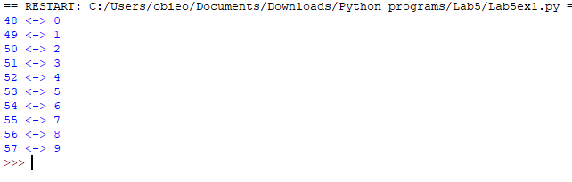

Answer the following questions:

Q1 Briefly explain what the term “**immutable**” means.

Immutable means that the thing in question cannot change.

There is no context to this question, therefore my answer stands, and immutable object or variable cannot

change under any circumstance.

# Exercise 2: String Indexing

|  |
| --- |
| Write a program ***lab5ex2.py*** that asks the user to input a string and then using a for loop displays the characters of the string in reverse order. For example:  Hint – you can use **for i in range(start, stop, step)** format to count down from (length of string-1) by having a negative step value and ensuring that you count all the way down to include the index 0 or you could use the negative indices. |

Copy your Python code here. Make sure that your code contains your name and date.

def main():

i = 0

x = input(str("Enter a string: "))

print("The string written in reverse is: ")

f = len(x)-1

for i in range(len(x), 0, -1):

print(x[f] end = “ ”)

f = f-1

main()

Paste screen capture here showing the program being run

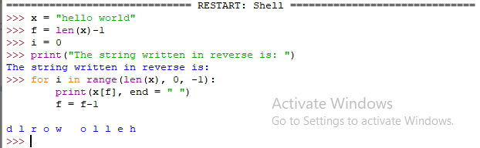

Answer the following questions:

Q2 - Give two examples of how you might display the last character in a string using indices

# Exercise 3: String Slicing

|  |
| --- |
| Write a program ***lab5ex3.py*** that asks the user to input a string and then uses slicing to create a substring from the first 5 characters and display this substring. Then check if the substring contains the string “spam”. |

Copy your Python code here. Make sure that your code contains your name and date.

def main():

x = input(str("Enter a string: "))

sliceVar = str(x[:5])

print(sliceVar)

if “spam” in sliceVar == True:

print("This slice is spam")

main()

Paste screen capture here showing the program being run

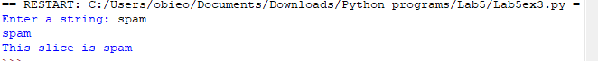

Answer the following questions:

Q3 - What would be displayed when the following Python statements are executed?

my_string = "Python is easy to learn!"

s1 = my_string[7:-1]

print(s1)

s2 = my_string[::-1] # 3rd parameter is the step

print(s2)

s1 will display every portion of the string after the 7th variable

s2 will display the text in reverse.

## Exercise 4 – String Methods

|  |
| --- |
| Write a program ***lab5ex4.py*** that asks the user to input a string. The program should call a string method to converts the string to lowercase and then displays the lowercase string. |

Copy your Python code here. Make sure that your code contains your name and date.

def main():

x = input(str("Enter a string: "))

print(str.lower(x))

main()

Paste screen capture here showing the program being run

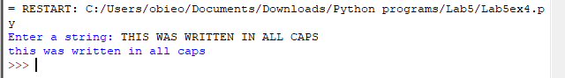

Answer the following questions:

Q4 – What is meant by the term “method” and how is a method called in Python?

They are a way to return variables from a string without changing the original string and they are called with a “.METHOD” following the “str()” variable type declaration.

## Additional Practice Exercises

Log your work on the additional practice exercises here.

## Exercise 5 – String Methods

|  |
| --- |
| Write a program that asks the user to enter a string and then counts how many times the letter ‘T’ appears in the string. |

Copy your Python code here. Make sure that your code contains your name and date.

def main():

x = input(str("Enter a string: "))

y = x.count("t")

print(str.lower(x))

print("T occurs", y )

print("times")

main()

Paste screen capture here showing the program being run

