Lab 10 – Object Oriented Programming Part2
Name | Ben Stobie
Date | 23/04/21

Exercise 1: Classes and Objects
Copy your Python code from the first exercise here. Make sure that your code contains your name and date.
class Rectangle:
def __init__(self, wide=1, high=1):
self.__width = wide
self.__height = high

def setWide(self, wide):
self.__width = wide

def setHigh(self, high):
self.__height = high

def getWide(self):
return self.__width

def getHigh(self):
return self.__height

def getArea(self):
return (int(self.__width) * int(self.__height))

def __str__(self):
return("The width is: " + str(self.__width) + " "
+ "The height is: " + str(self.__height))

def main():
x = Rectangle()

x.setWide(input("Please enter a width value: "))
x.setHigh(input("Please enter a height value: "))
print("Width: ", x.getWide())
print("Height: ", x.getHigh())

print("Area: ", x.getArea())
print("State: ", x)

main()

Paste screen capture here showing some results
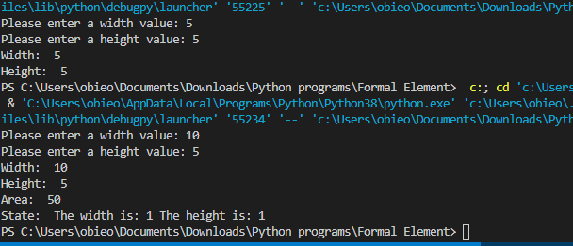
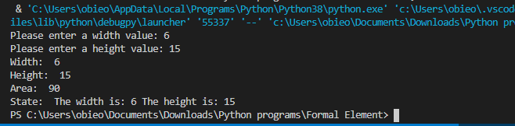
What is the difference between a class and an object? Give an example of each from your code.
The class is the container in which the objects exist, while the objects are the things withing the class that actually are a part of the execution.
Rectangle is a class.
x is an object.

In exercise1 how did you ensure that the instance variables were private?

The two underscores make the instance variables are private.

What is the purpose of the __str__ special method in a Python class? How is this method invoked?

It defines the state of the object in it’s current point, it’s invoked by printing the object without any following calls.

Exercise 2 - Modules
Copy your Python code here for exercise 2. Make sure that your code contains your name and date.
import rectangle as rect

def main():
object1 = rect.Rectangle(input("Wide: "), input("High: "))

print(object1)

print("Area: " + str(object1.getArea()))

main()
import rectangle

def main():
object1 = rectangle.Rectangle(input("Wide: "), input("High: "))

print(object1)

print("Area: " + str(object1.getArea()))

main()
from rectangle import Rectangle

def main():
object1 = Rectangle(input("Wide: "), input("High: "))

print(object1)

print("Area: " + str(object1.getArea()))

main()

Paste screen capture here showing some results
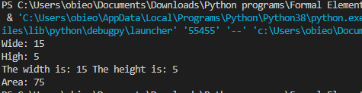

Give three examples of how the Rectangle class can be imported into a Python script.
From the python file with the ‘from’ method
By importing the entire file
Under a nickname using the ‘as’ method

Exercise 3: Inheritance
Copy your Python code here for exercise 3 and 4. Make sure that your code contains your name and date.
class Students(object):
def __init__(self, fname="", lname="", mark=0):
self.__first_name = fname
self.__last_name = lname
self.__mark = mark

def setFirstName(self, fname):
self.__first_name = fname

def setLastName(self, lname):
self.__last_name = lname

def setMark(self, mark):
self.__mark = mark

def getMark(self):
return (self.__mark)

def __str__(self):
return self.__first_name + " " + \
self.__last_name + "\t" + \
self.calcGrade()

class L7Student(Students):
def calcGrade(self):
if self.getMark() < 0 or self.getMark() > 100:
print("Invalid Mark")
return ""
elif self.getMark() < 40:
return "Fail"
elif self.getMark() < 50:
return "Pass"
elif self.getMark() < 60:
return "Lower Merit"
elif self.getMark() < 70:
return "Upper Merit"
else:
return "Distinction"

class L8Student(Students):
def calcGrade(self):
if self.getMark() < 0 or self.getMark() > 100:
print("Invalid Mark")
return ""
elif self.getMark() < 40:
return "Fail"
elif self.getMark() < 50:
return "Pass"
elif self.getMark() < 60:
return "Second Grade Honours Grade 2"
elif self.getMark() < 70:
return "First Grade Honours Grade 1"
else:
return "First Class Honours"

Paste screen capture here showing some results
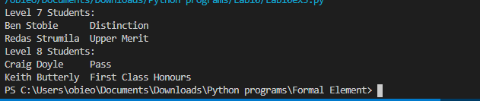

What is the purpose of Inheritance in Object Oriented Programming?

To cut down on repetition in classes.

Explain what the terms “Super Class” and “Sub Class” and give an example of each from exercise3.

The super class contains common operational processes in a class while the subclass contains the unique processes that differentiate the subclasess.

