Lab02 : Introduction to Python
Name | Ben Stobie
Date | 05/02/21

Exercise 1: Commenting Code
Add comments to the following program lab2ex1.py:

name = "Mary"
age = 10
mark = input("Enter mark -> ")
print("Student name is", name)
print("Student age is", age)
print("Student mark is", mark)
Copy your Python code here. Make sure that your code contains your name and date.

# Declare relevant variables
name = "Mary"
age = 10
# Receive input from the user
mark = input("Enter mark -> ")
# Print appropriate variables
print("Student name is", name)
print("Student age is", age)
print("Student mark is", mark)

Paste screen capture here showing the program being run

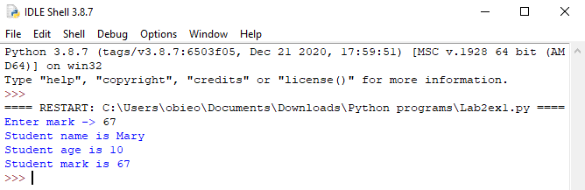

Answer the following questions in it:

- What is the purpose of comments in a program?

To assist in troubleshooting code as to fully understand the operational processes of lines of code.

Exercise 2 – Data Types
Write a program that asks the user to enter a number. Use the data conversion function float() to convert the user input to a floating point number. Compute and display the cube of the number.

Copy your Python code here. Make sure that your code contains your name and date.
x = float(input("Please input an integer number: "))
sqr = x**3
print(sqr)

Paste screen capture here showing the program being run
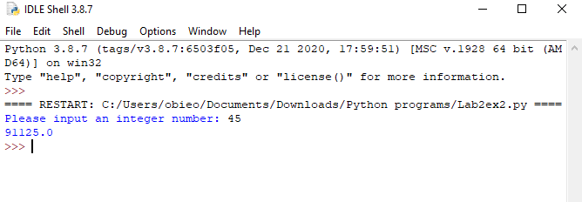

Comment on the Results
- What happens if the user inputs non-numeric data and the program tries to convert this to a number?

Traceback (most recent call last):
File "C:/Users/obieo/Documents/Downloads/Python programs/Lab2ex2.py", line 1, in <module>
x = float(input("Please input an integer number: "))
ValueError: could not convert string to float: 'no'
The preceding error is produced.

Exercise 3 – Open Branch

Write a Python program lab2ex3.py that inputs three numbers from the user and displays the lowest and the highest number entered.

Copy your Python code here. Make sure that your code contains your name and date.
a = input("Input value A: ")
b = input("Input value B: ")
c = input("Input value C: ")

print(a)
print(b)
print(c)

if a > b and a > c:
print("The greatest value is A: ",a)

if b > a and b > c:
print("The greatest value is B: ",b)

if c > a and c > b:
print("The greatest value is C: ",c)

if a < b and a < c:
print("The smallest value is A: ",a)

if b < a and b < c:
print("The smallest value is B: ",b)

if c < a and c < b:
print("The smallest value is C: ",c)

Paste screen capture here showing the program being run

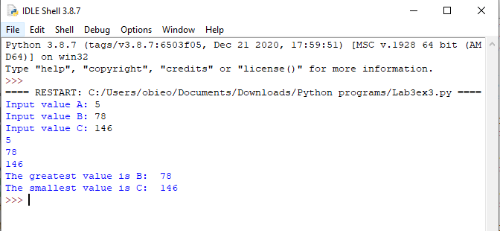

Comment on the Results
- List one key thing you learned from this exercise
The similarities between if statements in python in comparison with C coding.

Exercise 4 – Closed Branch

Write a Python program lab2ex4.py that prompts the user for a mark and then uses the mark to determines the grade.

Copy your Python code here. Make sure that your code contains your name and date.
name = "Ben Stobie"
courseId = "Dt080A/2"
mark = int(input("Please input the student's mark: "))

print("Student name: ", name)
print("Course ID: ",courseId)

if mark < 40:
print("Fail")
elif mark < 50:
print("Pass")
elif mark < 60:
print("Lower Merit")
elif mark < 70:
print("Higher Merit")
else:
print("Distinction")

Paste screen capture here showing the program being run
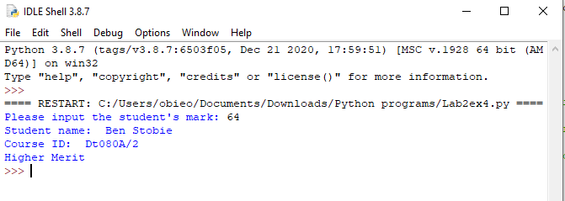

Comment on the Results

- List one key thing you learned from this exercise

The time saving nature in the creation and implementation of python programs.

