Lab03 : Python Loops
Name | Ben Stobie
Date | 12/02/21

Exercise 1: While Loop
Using a while loop, modify the program lab3ex1.py below so that the user is asked to enter a number in the range 1 and 10. If the number enters an out of range number then the program should loop until a valid number is inputted.

Copy your Python code here. Make sure that your code contains your name and date.
val = int(input("Please enter a value: "))
while val <= 0 or val >= 10:
val = int(input("Please enter a valid input (between 1-10): "))

print(val)

Paste screen capture here showing the program being run
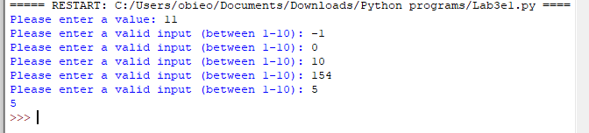

Answer the following questions in it:

- What is the purpose of the loop in your program?
It checks the inputted value to insure it is within the given range.

Exercise 2: Validating User Input
Using a while loop, write a program lab3ex2.py that asks the user for a user name. If the name entered by the user is NOT equal to “Mary” then the program should loop until the user enters the correct name.
Copy your Python code here. Make sure that your code contains your name and date.
storUser = "Mary"
entUser = input("Please enter your name: ")
while entUser != storUser:
entUser = input("Please enter the valid name: ")

print(entUser)

Paste screen capture here showing the program being run
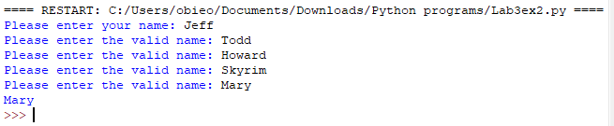

Answer the following questions in it:

- How does Python differ from C when comparing two strings?
You do not need to utilize the strcmp() function as you would normally in C

Exercise 3: Counter Controller Loop
Using a for loop, write a program lab3ex3.py that displays the numbers 0 to 31.
Copy your Python code here. Make sure that your code contains your name and date.
for x in range(32):
print(x)

Paste screen capture here showing the program being run
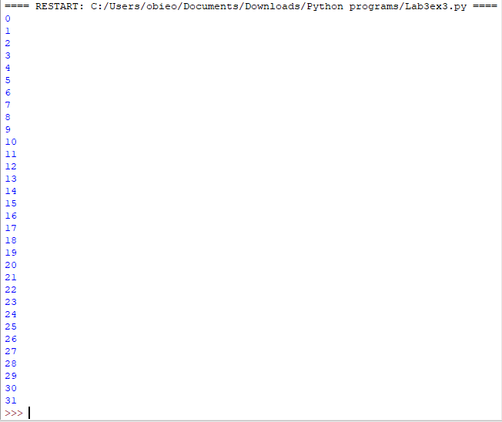

Answer the following questions in it:

- What is meant by a “counter controlled loop”?
It is a loop structure that uses an ever-increasing variable to determine the progress of the loop until it’s completion.

Exercise 4: Counter Controller Loop
Exercise 4
Using a for loop, write a program lab3ex4.py that displays the IP addresses 192.168.1.1 to 192.168.1.63
Copy your Python code here. Make sure that your code contains your name and date.
for x in range(1,64,1):
print("192.168.1.",x)

Paste screen capture here showing the program being run
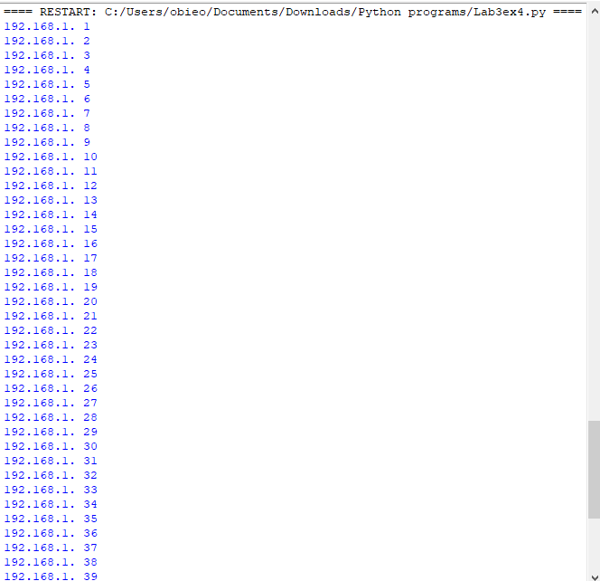

Answer the following questions in it:

- What is meant by concatenation?
A domino effect as such, where multiple events happen and lead to a particular outcome.

Practice Exercise
Using the Python control structures covered in week 2 and week 3, attempt the following exercise to consolidate your understanding of branches and loops.

Exercise 5
Assume we have three login usernames on a system with the following passwords:
username | password
student1 | networking101
student2 | networking102
student3 | networking103
Write a program that asks the user to enter a username and the corresponding password.
If the user enters a correct username and password then the message “Successfully logged in” should be displayed. If the user does not enter a correct username then the program should re-prompt them until they enter a correct username. If a valid username is entered but the password is not correct, then the user should be re-prompted to enter a correct password. The user should not get more than 5 attempts at entering a valid password.

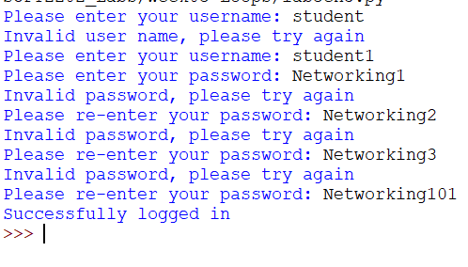

Copy your Python code here. Make sure that your code contains your name and date.
i = 0

login = input("Please enter your username: ")

while i != 1:
if login == "student1":
i = 1
elif login == "student2":
i = 1
elif login == "student3":
i = 1
else:
print("Invalid username!")
login = input("Please enter your username: ")

passwrd = input("Please enter your password: ")

if login == "student1":
while passwrd != "networking101":
print("That's not your password")
passwrd = input("Please enter your password: ")
elif login == "student2":
while passwrd != "networking102":
print("That's not your password")
passwrd = input("Please enter your password: ")
else:
while passwrd != "networking103":
print("That's not your password")
passwrd = input("Please enter your password: ")

print("Succesfully logged in")

Paste screen capture here showing the program being run. Show tests for both valid and invalid user input.

