Lab04 : Python Loops
Name | Ben Stobie
Date | 19/02/21

Exercise 1: Defining and Calling a Void Function
Exercise 1 – void functions
Modify the example code above to generate the following output.

Hint: use a for loop to call the printLine() function the required number of times. Save the modified file as lab4ex1.py

Copy your Python code here. Make sure that your code contains your name and date.
def printLine():
print("--------------------------------")

i = 0
while i!=5:
printLine()
i = i+1

Paste screen capture here showing the program being run
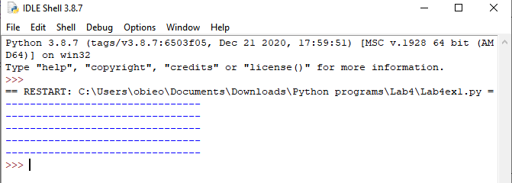

Answer the following questions in it:

- What is the purpose of a function?
To reduce clutter and increase readability of code

Exercise 2: Returning Value from a Function
Create a file as lab4ex2.py that is that asks the user to enter a well known TCP port number in the range 1 to 1023 and then displays the port number.
def userInput():
x = int(input("Please enter a TCP port number: "))
while x < 1 or x > 1023:
x = int(input("Please enter a valid TCP port number (range 1 - 1023): "))

return x

portNum = userInput()
print("The entered port number was: ", portNum)

Paste screen capture here showing the program being run
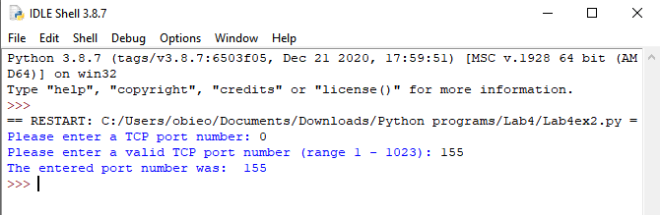

Answer the following questions in it:

- How does Python return a value from a function?
With a return statement

Exercise 3 – Passing values to Function
Create a program as lab4ex3.py that calls a function computeAverage(x, y, z) that when passed three numbers will return the average of these three numbers. The program should display the result on the command line.
[Hint – you computed the average of three numbers in lab1 (lab1ex2.py)
Copy your Python code here. Make sure that your code contains your name and date.
def computeAverage(x, y, z):
totVal = int(x+y+z)
avgVal = int(totVal)/3
return avgVal

x = int(input("Enter an x value: "))
y = int(input("Enter an y value: "))
z = int(input("Enter an z value: "))
avgVal = computeAverage(x, y, z)
print("The average of those 3 values is: ", avgVal)

Paste screen capture here showing the program being run
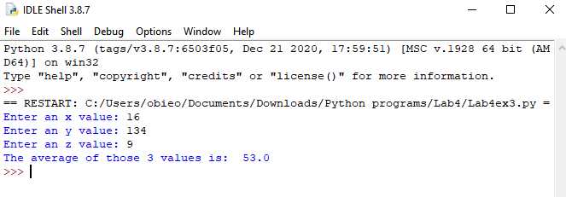

Explain the meaning of the term “argument” and “parameter” in the context of Python functions:

An argument is a value that is being passed to a function while a parameter is a value that is passed by value

Additional Practice Exercises
Log your work on the additional practice exercises here.
Ex4.
def getPort():
x = int(input("Please enter a TCP port number: "))
return x
def isValidPort(x):
if x >= 1 and x <= 1023:
return "True"
else:
print("Invalid Port Number")
return "False"
def displayPort(x):
print("The entered port number was:", x)

def main():
validCheck = "False"
while validCheck != "True":
portNum = getPort()
validCheck = isValidPort(portNum)

displayPort(portNum)
return
main()
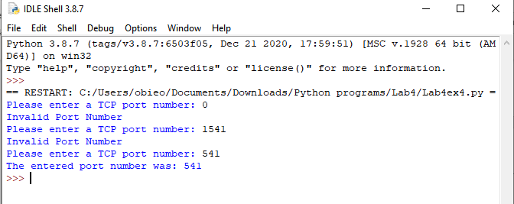
Ex5.
def main():
width = getWidth()
height = getHeight()

doLine(width)
doSides(width, height)
doLine(width)

return

def getWidth():
x = int(input("Input the width of the rectangle: "))
return x

def getHeight():
x = int(input("Input the height of the rectangle: "))
return x

def doLine(x):
i = 0
while i <= x:
print("#", end = " ")
i = i + 1

def doSides(x, y):
space = int(x) - 2
high = int(y) - 2
i = 0
f = 0

while f <= high:
print(" ")
print("#", end = " ")
while i <= space:
print(" ", end = " ")
i = i + 1
print("#")
f = f + 1
i = 0
return
main()
